Agent Policy and Compliance Tower
Feature-Wise Implementation Plan & Deployment Roadmap
Google AI Ecosystem — Gemini Enterprise Agent Platform Transition

Document Version: | 1.2 (Production Feature Roadmap)
Target Platform: | Google Cloud Platform (Gemini Enterprise Agent Platform, Cloud Run, KMS, BigQuery)

Feature 1: Zero-Trust Gateway Ingress & Egress Shield
Establishes a high-throughput server-side middleware gateway positioned between client requests and Google Cloud AI services, ensuring 100% payload inspection, PII/PHI redaction, and prompt injection mitigation.
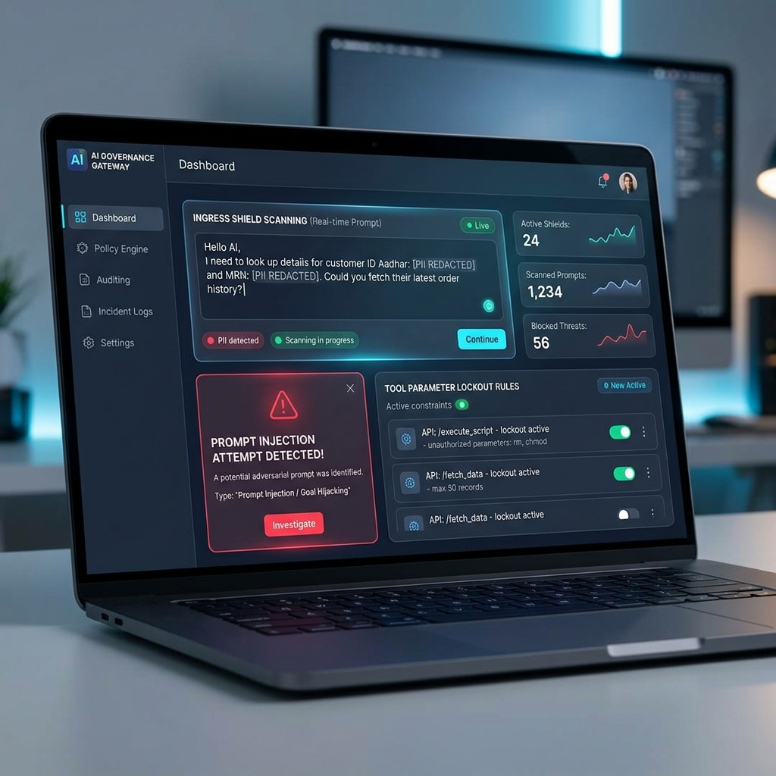
Figure 1: Zero-Trust Policy Ingress & Egress Shield Console (PII Redaction, Prompt Injection Defense, Tool Lockout)
Milestone / Phase | Technical Deliverables & Verification Criteria
Milestone 1.1: High-Throughput Middleware Core | Deploy containerized FastAPI/Go proxy workers on Cloud Run with Always-On CPU allocation. Enforce strict sub-25ms guardrail SLA.
Milestone 1.2: Multi-Framework PII/PHI Redaction Engine | Integrate regex pattern matcher for Aadhaar (\b\d{4}-\d{4}-\d{4}\b), SSN, and MRN. Connect Google Cloud DLP API for contextual entity detection under HIPAA, GDPR, and DPDP Act 2023.
Milestone 1.3: Adversarial Prompt Defense | Implement NeMo Guardrails / LLM-Guard classifier to intercept prompt injection attempts, system instruction escapes, and adversarial prefix overrides.
Milestone 1.4: Tool Call Parameter Lockout | Enforce JSON Schema validation on model tool outputs to block unauthorized system commands (e.g. rm -rf, database drops, bash overrides).

Feature 2: Gemini Enterprise Multi-Agent Network (Fusion AI Ecosystem)
Implements the multi-agent orchestration layer natively within the Gemini Enterprise Agent Platform (Agent Engine / Agent Runtime), supporting specialized agents bound to GCP Service Accounts.
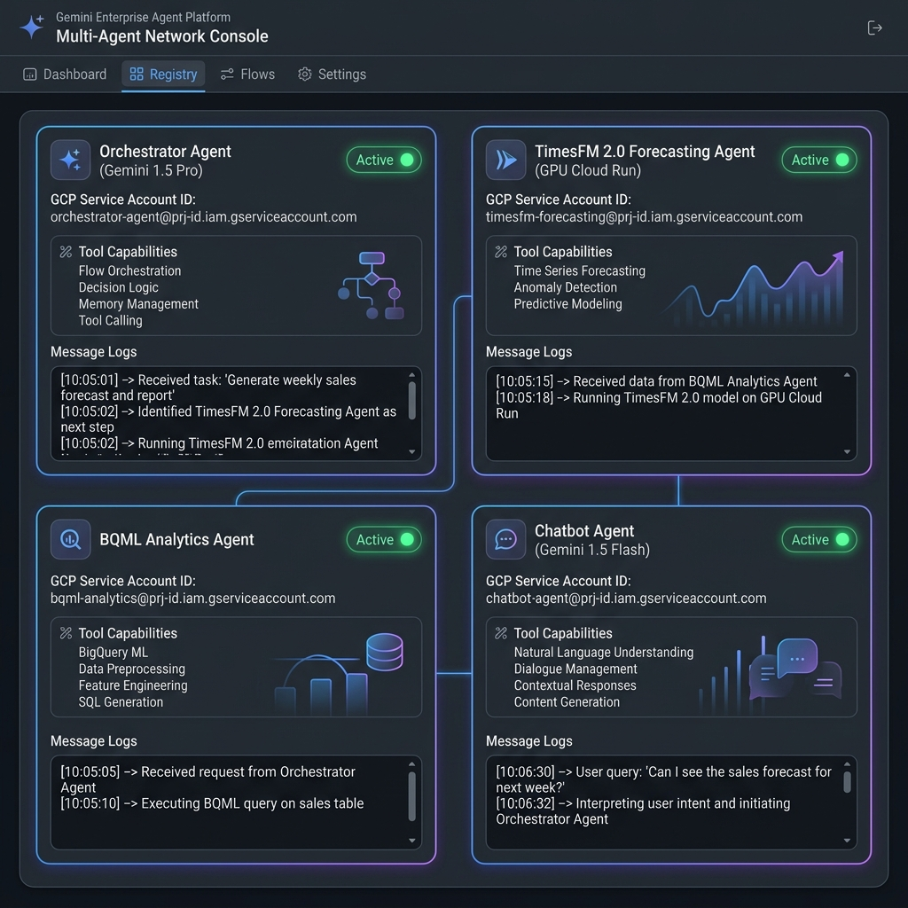
Figure 2: Gemini Enterprise Multi-Agent Network Console (Orchestrator, TimesFM 2.0, BQML, Chatbot Agents)
Milestone / Phase | Technical Deliverables & Verification Criteria
Milestone 2.1: Orchestrator Agent Setup | Configure Orchestrator Agent (sa:fusion-ai-orchestrator) powered by gemini-1.5-pro-002 inside Agent Engine for ReAct multi-step planning.
Milestone 2.2: TimesFM 2.0 Foundation Model Deployment | Deploy Google's TimesFM 2.0 zero-shot forecasting model on GPU Cloud Run (NVIDIA T4/L4) for univariate time-series demand predictions.
Milestone 2.3: BigQuery ML Analytics Agent | Connect BQML Agent (sa:fusion-ai-bqml) to query ARIMA_PLUS baseline models via BigQuery Storage API.
Milestone 2.4: Conversational Chatbot Agent | Deploy low-latency Chatbot Agent (sa:fusion-ai-chatbot) powered by gemini-1.5-flash-002.
Milestone 2.5: Workload Identity & Service Account IAM | Configure Workload Identity Federation binding each agent to dedicated GCP Service Accounts with minimal IAM privileges.

Feature 3: Dynamic Safety Guardrails & Agent Search Grounding
Binds UI security controls directly to native Gemini Safety Guardrails and fact-checks model responses against enterprise data stores using Agent Search Grounding.
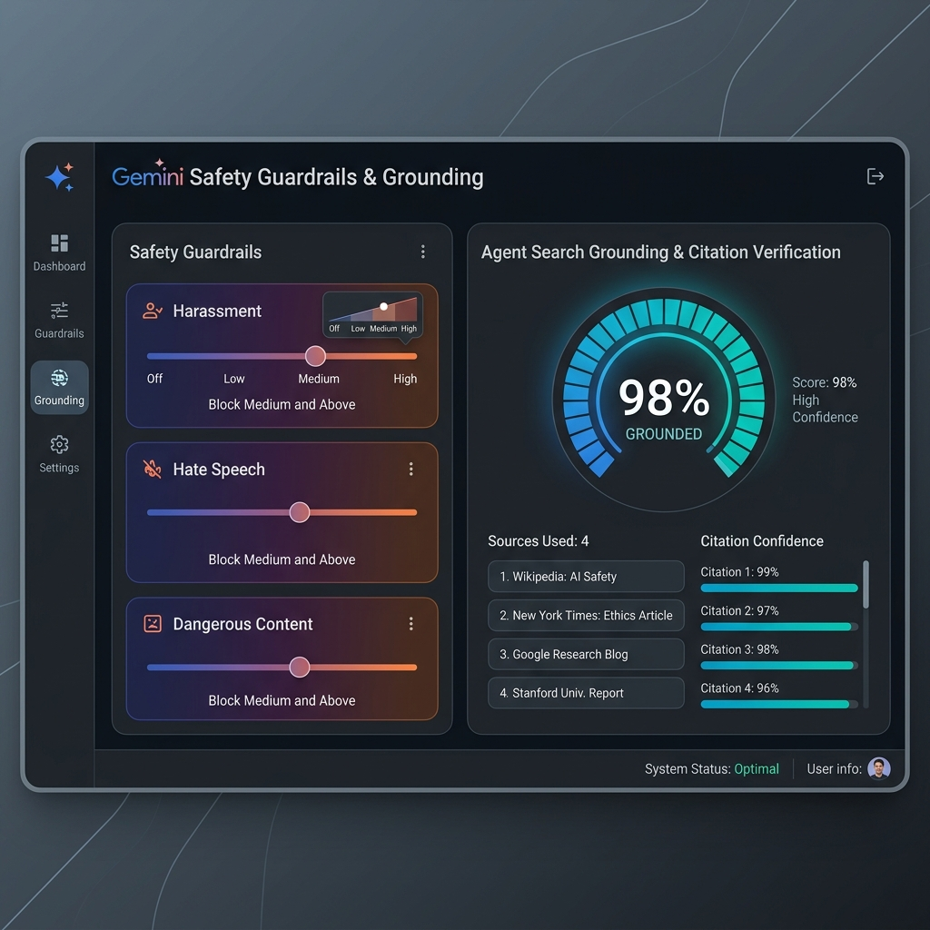
Figure 3: Gemini Safety Guardrails & Agent Search Grounding Verification Console
Milestone / Phase | Technical Deliverables & Verification Criteria
Milestone 3.1: Gemini Safety Guardrail Binding | Map UI threshold controls directly to google.genai.types.SafetySetting across HARM_CATEGORY_HARASSMENT, HATE_SPEECH, DANGEROUS_CONTENT, and SEXUALLY_EXPLICIT.
Milestone 3.2: Agent Search Fact-Checking | Index enterprise knowledge bases into Agent Search Data Stores and compute citation precision scores on model responses.
Milestone 3.3: Grounding Policy Enforcement | Flag outputs falling under 85% grounding confidence with UNGROUNDED_WARNING and trigger automated compliance reviews.

Feature 4: Immutable Cryptographic Audit Ledger & Compliance Exporter
Provides tamper-evident audit trail logging by linking transaction blocks with SHA-256 hashes and signing each entry asynchronously via Google Cloud KMS.
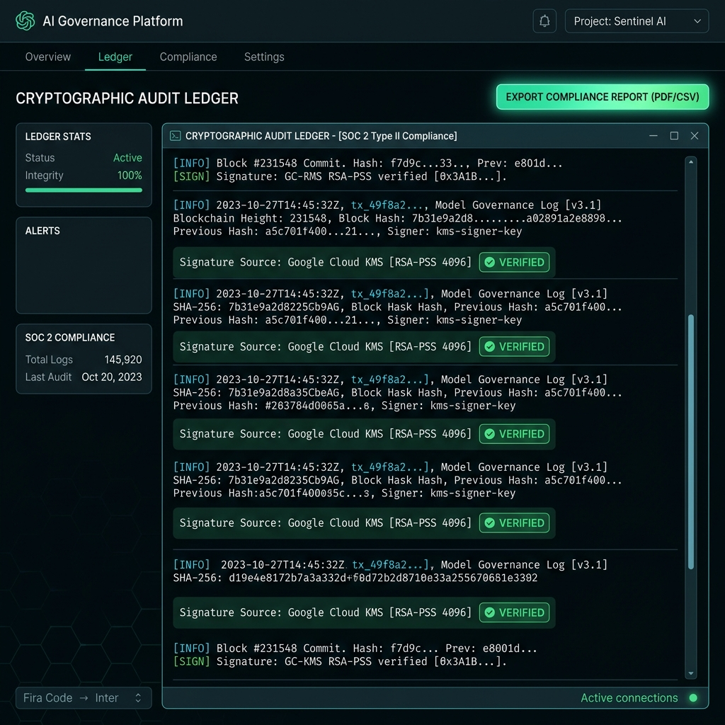
Figure 4: Cryptographic Audit Ledger Console (SHA-256 Block Chain, Cloud KMS RSA-PSS Signatures, Report Exporter)
Milestone / Phase | Technical Deliverables & Verification Criteria
Milestone 4.1: Tamper-Evident SHA-256 Chain | Build block hashing pipeline enforcing current.prev_hash === prev.hash. Provision Cloud KMS Asymmetric Key Rings (RSA_SIGN_PSS_2048_SHA256) for digital signatures.
Milestone 4.2: Append-Only BigQuery Storage | Persist signed block records into BigQuery dataset ai_governance_audit.ledger_blocks with partition expiration locks and Auditor-only IAM access.
Milestone 4.3: Integrity Verifier & Exporter | Build automated integrity verifier to audit cryptographic chains and export signed PDF/CSV reports for SOC 2 Type II compliance audits.

Feature 5: Real-Time Control Tower Console & Telemetry Stream
Delivers a high-fidelity operational console providing live telemetry streams, inter-agent intercept logs, and interactive stress-testing controls.
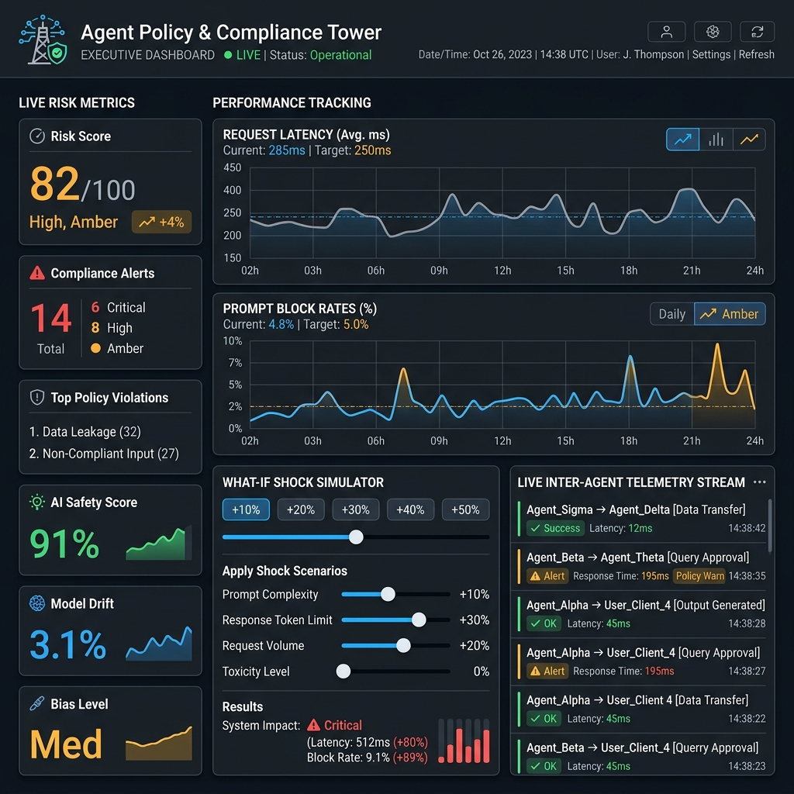
Figure 5: Control Tower Dashboard & Real-Time Telemetry Stream (Live Risk Metrics, What-If Shock Simulator)
Milestone / Phase | Technical Deliverables & Verification Criteria
Milestone 5.1: Cloud Pub/Sub & Telemetry Bridge | Publish governance events to Cloud Pub/Sub and stream real-time Server-Sent Events (SSE) / WebSockets to the web console.
Milestone 5.2: OpenTelemetry Distributed Tracing | Instrument inter-agent requests with OpenTelemetry (traceparent) headers, exporting trace spans to Cloud Trace and Cloud Monitoring.
Milestone 5.3: Interactive Console UI | Integrate real-time risk metric charts, What-If Shock Simulator controls (+10% to +50%), and inter-agent execution logs into the main dashboard UI.

Feature 6: Production CI/CD Infrastructure, Staging & Final Deployment
Manages automated infrastructure provisioning, security red-teaming, and progressive canary rollouts to guarantee zero-downtime production deployment.
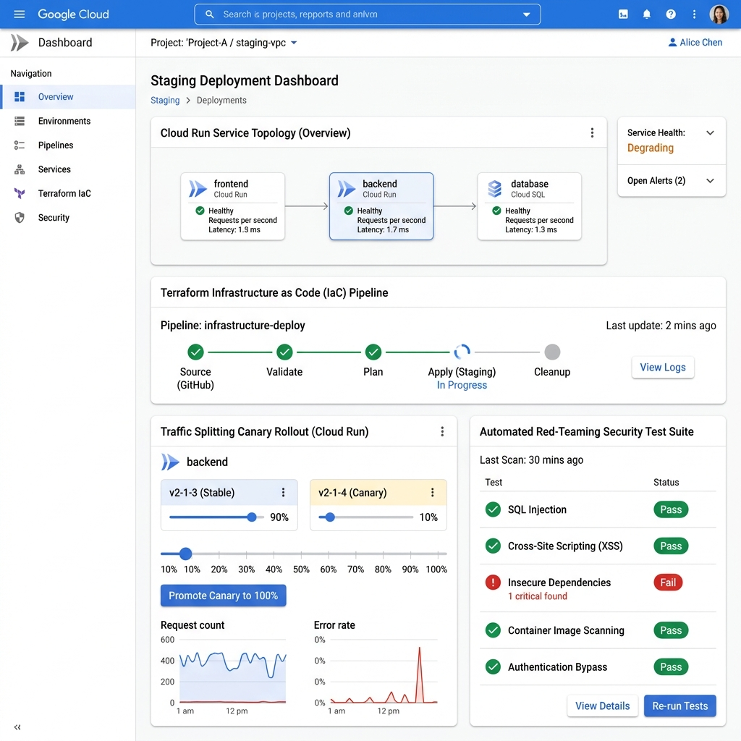
Figure 6: Production CI/CD Infrastructure & Canary Staging Deployment Console (Terraform IaC, Red-Teaming)
Milestone / Phase | Technical Deliverables & Verification Criteria
Milestone 6.1: Terraform IaC Provisioning | Write Terraform scripts provisioning Cloud Run workers, Cloud DLP templates, Cloud KMS key rings, BigQuery tables, and Pub/Sub topics.
Milestone 6.2: Automated Red-Teaming & Security Testing | Execute automated CI/CD security test suites running prompt injection attacks, Aadhaar PII leakage tests, and cryptographic tamper attempts.
Milestone 6.3: Canary Rollout & Final Production Cutover | Deploy Policy Gateway to Cloud Run / GKE with traffic splitting (10% -> 50% -> 100%), obtaining formal SecOps and Compliance production sign-off.

