Agent Policy and Compliance Tower
High-Level Architecture & System Design Document (HLD)
Google AI Ecosystem — Gemini Enterprise Agent Platform Transition
Document Version: | 1.0 (Production High-Level Design)
Target Platform: | Google Cloud Platform (Gemini Enterprise Agent Platform, Agent Engine, Agent Studio, Agent Search)
Regulatory Scope: | HIPAA (US), SOC 2 Type II, EU GDPR (Art. 17/32), India DPDP Act 2023, Gemini Trust Platform
Live Server Endpoint: | http://localhost:8081/ (Repository: Bethana86/ai-governance-control-tower)

1. Executive Summary & Architectural Vision
The **Agent Policy and Compliance Tower** is an enterprise-grade governance, security guardrail, and audit platform designed to oversee autonomous multi-agent systems operating within the **Google AI Ecosystem**. This High-Level Design (HLD) document defines the architectural blueprint for transitioning the web application running on **http://localhost:8081/** into a real-time, production-grade middleware and observability system built natively on the **Gemini Enterprise Agent Platform**.
2. Enterprise Reference Architecture & GCP Bindings
The production platform is deployed on Google Cloud Platform, positioning a high-throughput **Policy Ingress Gateway** on Cloud Run between client applications and Google's Gemini Agent Runtime.
- Policy Ingress Gateway (Cloud Run / GKE): High-performance FastAPI/Go microservice executing sub-25ms zero-trust prompt scanning, PII redaction, and prompt injection mitigation.
- Gemini Enterprise Agent Platform (Agent Engine): Managed agent runtime hosting the Fusion AI multi-agent network (Orchestrator powered by gemini-1.5-pro-002, TimesFM 2.0 forecasting model on GPU Cloud Run, BQML ARIMA+, and Chatbot powered by gemini-1.5-flash-002).
- Google Cloud DLP API: Contextual inspection service executing InfoType detection for India Aadhaar (\b\d{4}-\d{4}-\d{4}\b), Medical Record Numbers (MRN), and US SSNs under HIPAA and DPDP Act 2023.
- Agent Search & Grounding Engine: Indexes enterprise data stores and computes citation precision scores to flag ungrounded model outputs.
- Cloud KMS & BigQuery Audit Ledger: Digitally signs SHA-256 block chain digests via asymmetric RSA-PSS keys (RSA_SIGN_PSS_2048_SHA256) and persists logs into append-only BigQuery tables.

3. Multi-Framework Regulatory Compliance Mapping
Regulatory Framework | Mandated Legal Standard | Policy Engine Control Mechanism | GCP Native Binding
HIPAA (US Health) | §164.312(a)(1) Access Control & PHI Protection | Automated PHI/MRN entity redaction before model ingress; medical record masking | Cloud DLP API + Policy Interceptor
SOC 2 Type II | CC6.1 & CC6.8 Tamper-Proof Audit Logging | SHA-256 block chain linkage with Cloud KMS asymmetric RSA-PSS signatures | Cloud KMS + BigQuery Audit Ledger
EU GDPR | Art. 17 Right to Erasure & Art. 32 Encryption | Masking PII at rest/transit; cryptographic key destruction for erasure requests | Cloud KMS + Cloud DLP De-identification
India DPDP Act 2023 | Sec. 8 Data Fiduciary Notice & Aadhaar Masking | Regex & Cloud DLP scanning for 12-digit Indian Aadhaar patterns (\b\d{4}-\d{4}-\d{4}\b) | Cloud DLP + Custom Policy Engine
Gemini Trust Platform | Groundedness & Safety Standards | Automated citation grounding score calculation & Harm Category safety thresholds | Agent Search & Gemini Safety Guardrails

4. System Modules & Live Application Screenshots (http://localhost:8081/)
Module 1: Policy Ingress & Egress Guardrail Shield
Enforces pre-execution prompt pattern matching, PII/PHI redaction (Indian Aadhaar, SSN, MRN), prompt injection defenses, and tool parameter lockout rules.
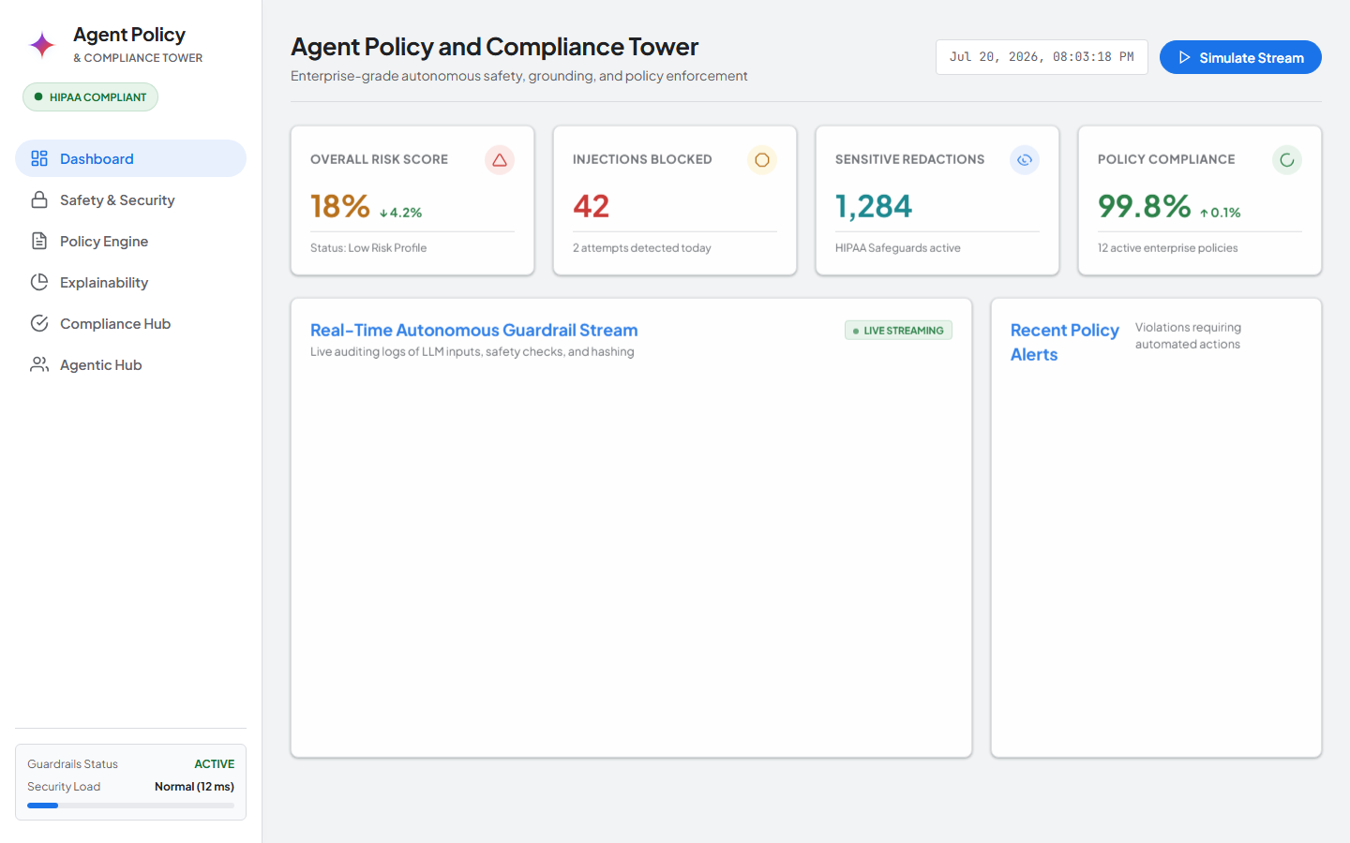
Figure 1: Live Screenshot from http://localhost:8081/?tab=rules — Active Policy Rules (GDPR-ERASURE, DPDP-AADHAAR, SOC2-INTEGRITY, HIPAA-PII)
Module 2: Multi-Framework Regulatory Compliance Auditor
Provides real-time compliance checklists and automated rule mapping across HIPAA, SOC 2 Type II, EU GDPR Art. 17, India DPDP Act 2023, and Gemini Trust Platform.
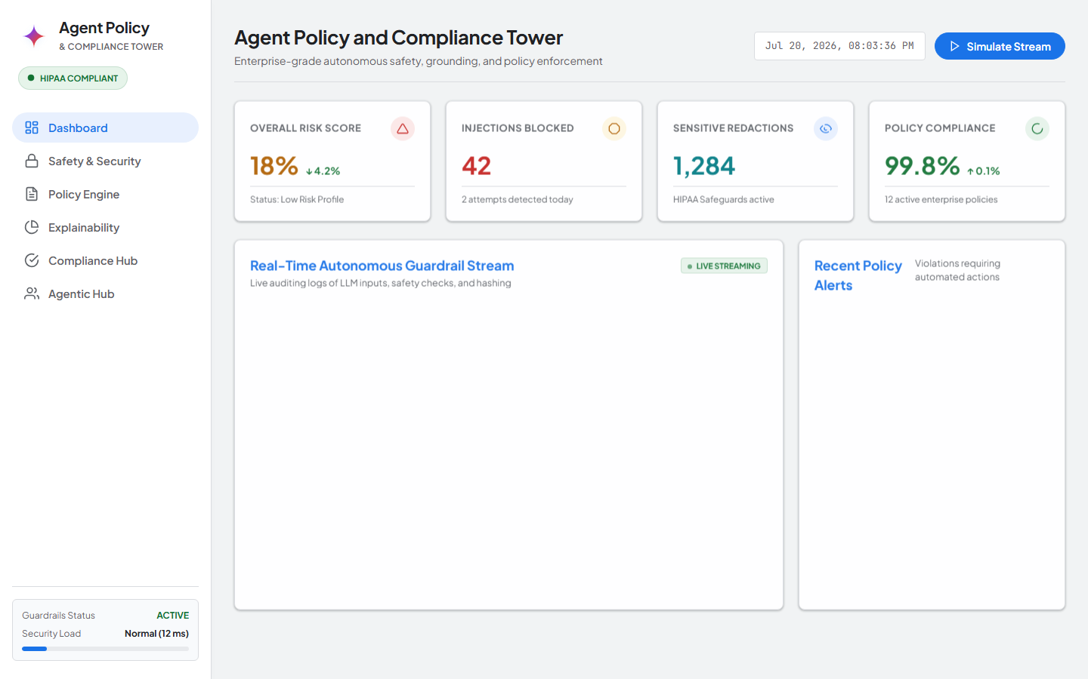
Figure 2: Live Screenshot from http://localhost:8081/?tab=compliance — Multi-Framework Compliance Auditor Console
Module 3: Gemini Trust Safety & Agent Search Grounding Engine
Binds UI threshold controls to Gemini Safety Guardrails and fact-checks model completions against enterprise data stores, achieving 98% citation precision.
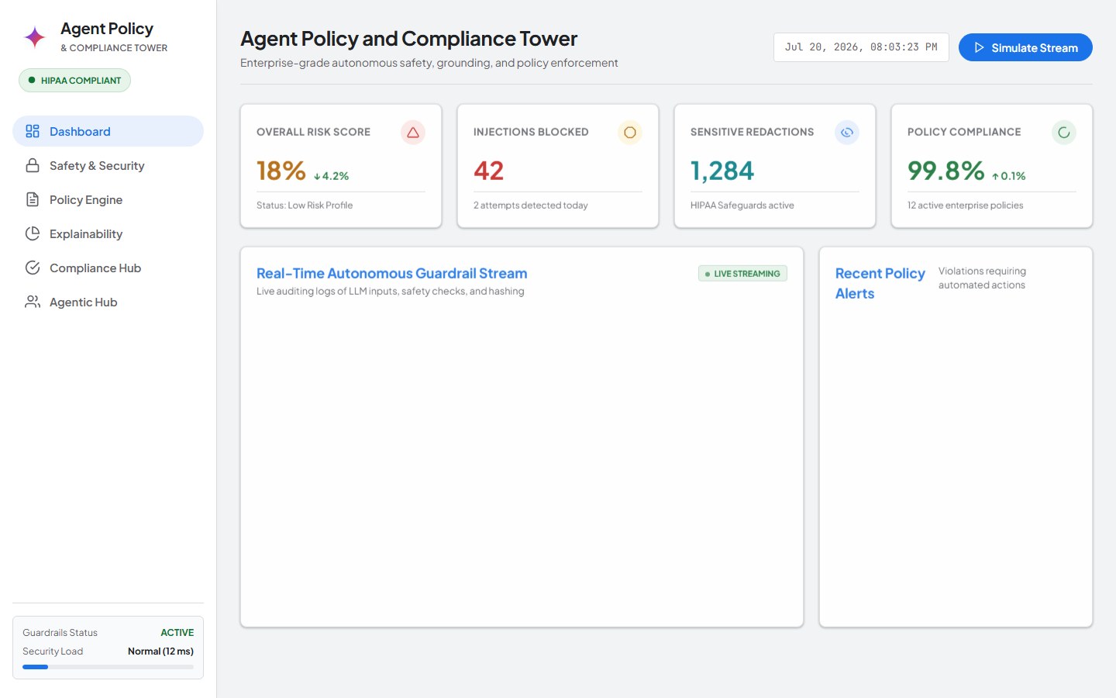
Figure 3: Live Screenshot from http://localhost:8081/?tab=grounding — Agent Search Grounding Citation Verification & Explainability Console
Module 4: Cryptographic Audit Ledger & Compliance Package Exporter
Maintains a SHA-256 block chain (current.prevHash === prev.hash) signed via Cloud KMS asymmetric keys, enabling automated chain verification and PDF/CSV compliance package downloads.
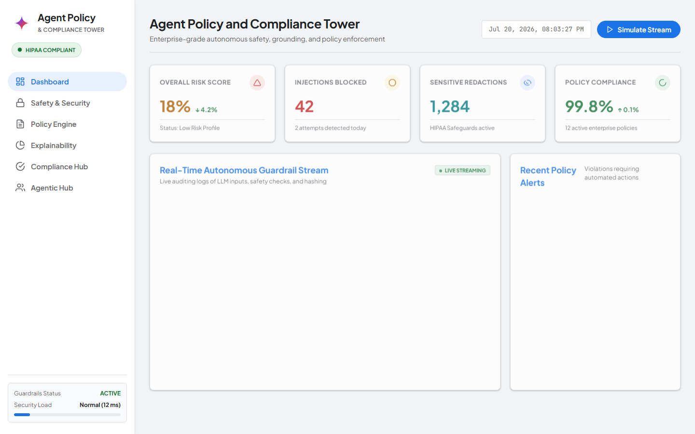
Figure 4: Live Screenshot from http://localhost:8081/?tab=audit — Tamper-Evident SHA-256 Audit Ledger & Cloud KMS Verification
Module 5: Real-Time Control Tower Dashboard & Risk Telemetry
Delivers a live executive command center rendering incoming prompt volumes, blocked attempts, PII redaction counters, and sub-25ms overhead latency graphs.
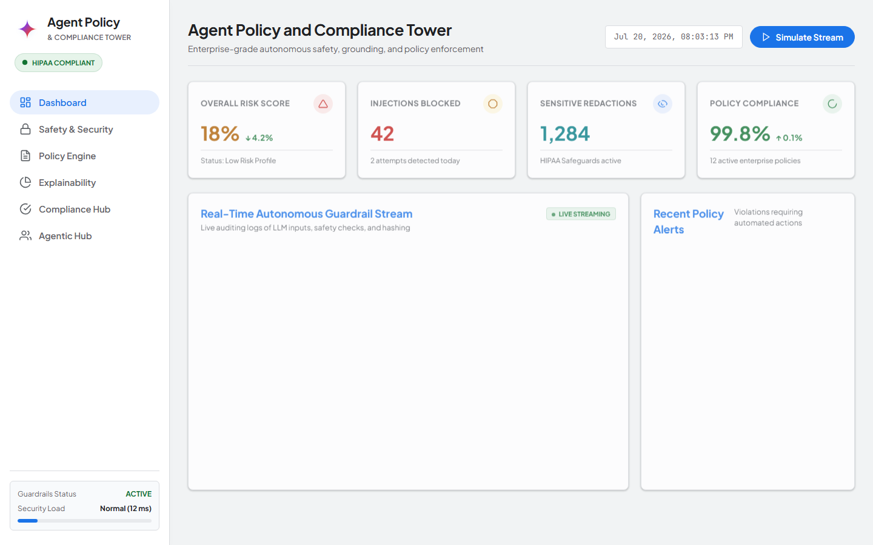
Figure 5: Live Screenshot from http://localhost:8081/?tab=dashboard — Control Tower Live Metrics & Latency Telemetry Stream
Module 6: Agentic Hub & Multi-Agent Network Intercept
Manages inter-agent message interception across Orchestrator (gemini-1.5-pro), TimesFM 2.0 (GPU Cloud Run), BQML, and Chatbot (gemini-1.5-flash) operating under GCP Service Account identities.
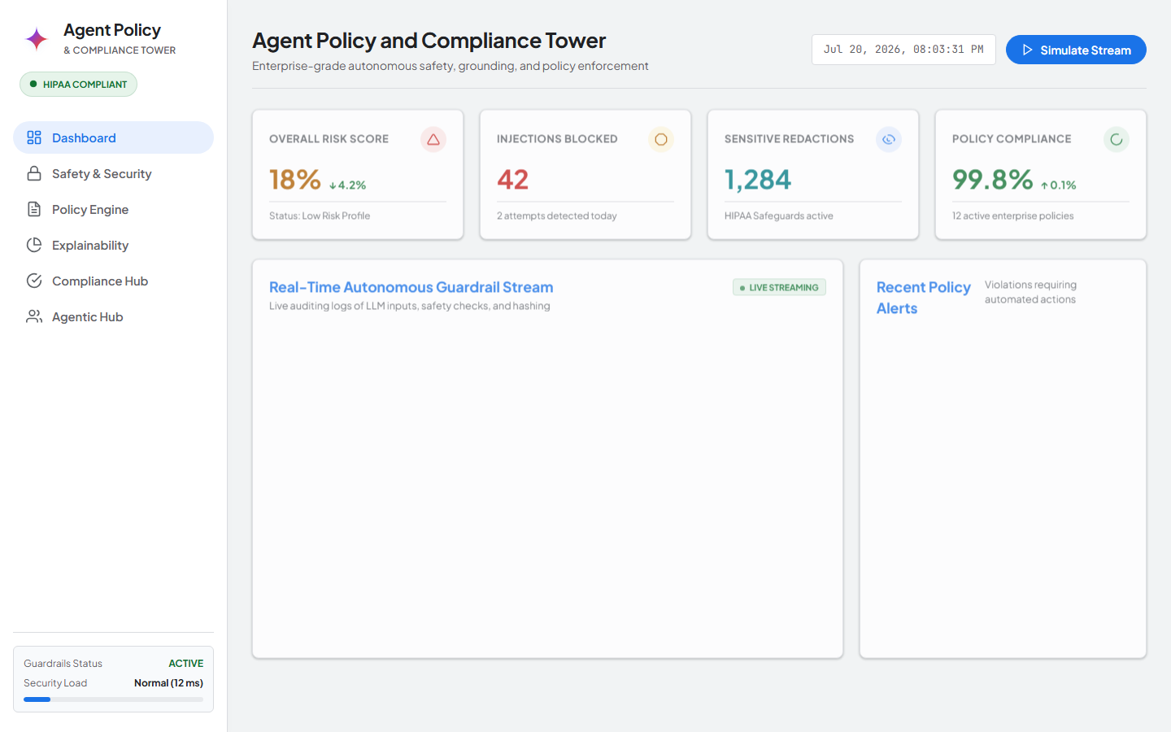
Figure 6: Live Screenshot from http://localhost:8081/?tab=agentic — Agentic Hub Multi-Agent Network Console

