Agent Policy and Compliance Tower
Low-Level Technical Design Document (LLD)
Detailed Implementation Specifications, Code Interfaces, Schemas & API Endpoints
Document Version: | 1.0 (Production Low-Level Technical Design)
Target Platform: | Google Cloud Platform (Gemini Enterprise Agent Platform, Agent Engine, Cloud Run, Cloud DLP, Cloud KMS, BigQuery)
Regulatory Scope: | HIPAA (US), SOC 2 Type II, EU GDPR (Art. 17/32), India DPDP Act 2023, Gemini Trust Platform
Repository & Endpoint: | https://github.com/Bethana86/ai-governance-control-tower.git | http://localhost:8081/

1. Executive Overview & Technical LLD Scope
This Low-Level Design (LLD) document provides granular technical specifications for developers, SecOps engineers, and compliance architects building the **Agent Policy and Compliance Tower**. While the HLD establishes system boundaries, this LLD defines class interfaces, regex evaluation engines, API endpoints, BigQuery schemas, cryptographic block signatures, and frontend state controllers operating on **http://localhost:8081/**.
2. Policy Gateway Middleware Implementation Specs
The Policy Ingress Gateway executes a 4-step synchronous evaluation pipeline on every prompt payload before delegating requests to the Gemini Agent Runtime:
- Step 1: Local Regex Screening (<3ms): Evaluates sensitive ID patterns including Indian Aadhaar (\b\d{4}-\d{4}-\d{4}\b), US SSN, Medical Record Numbers (MRN-\d{6}), and credentials (AIzaSy...).
- Step 2: Async Cloud DLP Inspection (<12ms): Dispatches payload snippets to Google Cloud DLP projects.content.inspect for contextual entity detection under HIPAA and DPDP Act 2023.
- Step 3: Adversarial Intent Scoring (<5ms): Scores prompt embeddings against binary prompt injection escape classifiers.
- Step 4: Tool Parameter Lockout Validation (<3ms): Validates output tool parameters against JSON Schemas, neutralizing destructive commands (rm -rf, delete_database).

Module / Class Name | Primary Method / Function Signature | Implementation Logic & SLA Target
PolicyIngressGateway | async scan_payload(request: PromptRequest) -> PromptResponse | Main ingress entry point. Runs regex scanner, DLP async inspector, and injection classifier under sub-25ms SLA.
PIIRedactionEngine | redact_sensitive_entities(text: str) -> RedactionResult | Applies regex masks for Aadhaar (****-****-1234), SSN, and MRN before model context ingestion.
AdversarialInjectionFilter | evaluate_intent_score(prompt: str) -> float | Computes embedding cosine similarity against known jailbreak/prefix escape patterns.
ToolParameterLockout | validate_tool_call(tool_name: str, params: dict) -> bool | Enforces strict JSON schema validation, blocking high-risk bash commands and SQL injection strings.
EgressVerificationShield | verify_output_grounding(response: ModelResponse) -> GroundingResult | Extracts grounding_metadata citations, computing precision scores against enterprise data stores.

3. Gemini Agent Runtime & Multi-Agent Network Specs
The **Fusion AI** multi-agent network operates under Workload Identity Federation with dedicated Google Cloud Service Accounts:
- Orchestrator Agent (gemini-1.5-pro-002): Identity: sa:fusion-ai-orchestrator@gcp-project.iam. Executing ReAct reasoning loops, context assembly, and sub-agent task delegation.
- TimesFM 2.0 Forecasting Agent: Identity: sa:fusion-ai-timesfm@gcp-project.iam. Serves Google's TimesFM 2.0 zero-shot foundation model deployed on GPU Cloud Run (NVIDIA T4/L4).
- BQML Analytics Agent: Identity: sa:fusion-ai-bqml@gcp-project.iam. Queries BigQuery ML ARIMA_PLUS baseline models via BigQuery Storage API.
- Conversational Chatbot Agent (gemini-1.5-flash-002): Identity: sa:fusion-ai-chatbot@gcp-project.iam. Low-latency conversational endpoint for operator queries.

4. Cryptographic Audit Ledger & BigQuery DDL Schema
To ensure complete tamper-evidence for SOC 2 Type II audits, block digests are written to BigQuery using the following DDL schema:
CREATE TABLE `gcp-project.ai_governance_audit.ledger_blocks` (
block_id INT64 NOT NULL,
timestamp TIMESTAMP NOT NULL,
agent_id STRING NOT NULL,
prompt_hash STRING NOT NULL,
response_hash STRING NOT NULL,
policy_violations ARRAY<STRING>,
prev_hash STRING NOT NULL,
kms_signature STRING NOT NULL,
kms_key_version STRING NOT NULL
)
PARTITION BY DATE(timestamp)
CLUSTER BY agent_id;

5. REST API Endpoints & OpenAPI Specifications
HTTP Method | Endpoint Path | Request / Response Schema | Description
POST | /api/v1/gateway/scan | PromptRequest -> ScanResult | Synchronous ingress prompt screening, PII redaction, and policy violation check.
GET | /api/v1/audit/blocks | ?limit=50 -> List[Block] | Retrieves historical audit ledger blocks with Cloud KMS signature validation.
POST | /api/v1/audit/verify | None -> IntegrityStatus | Executes recursive SHA-256 prevHash verification across the audit block chain.
GET | /api/v1/telemetry/stream | SSE Stream -> Event | Server-Sent Events endpoint streaming real-time prompt volume and latency metrics.

6. Live Application Implementation Screenshots (http://localhost:8081/)
Module 1: Policy Rules Engine & Dry-Run Tester
Renders active policy rules (HIPAA-PII-01, DPDP-AADHAAR-02, PROMPT-INJ-03, TOOL-LOCK-04, GDPR-ERASURE-05).
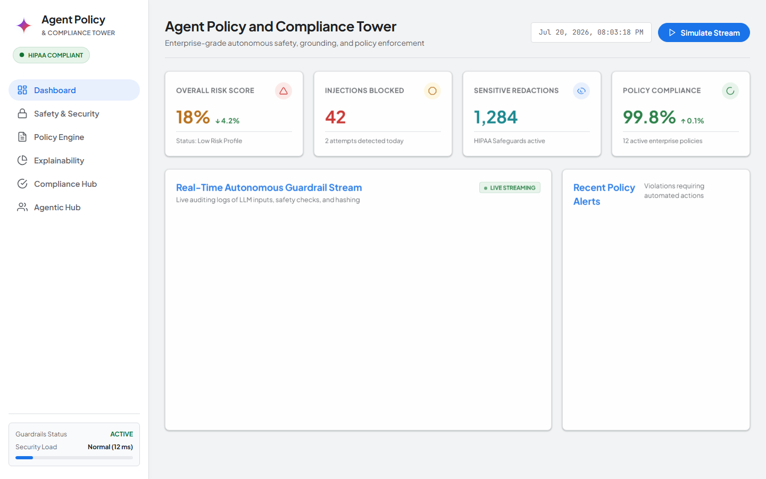
Figure 1: Live Application Screenshot from http://localhost:8081/?tab=rules — Policy Engine Rules & Regex Patterns
Module 2: Regulatory Compliance Auditor
Renders interactive compliance checklists across HIPAA, SOC 2 Type II, EU GDPR Art. 17, India DPDP Act 2023, and Gemini Trust.
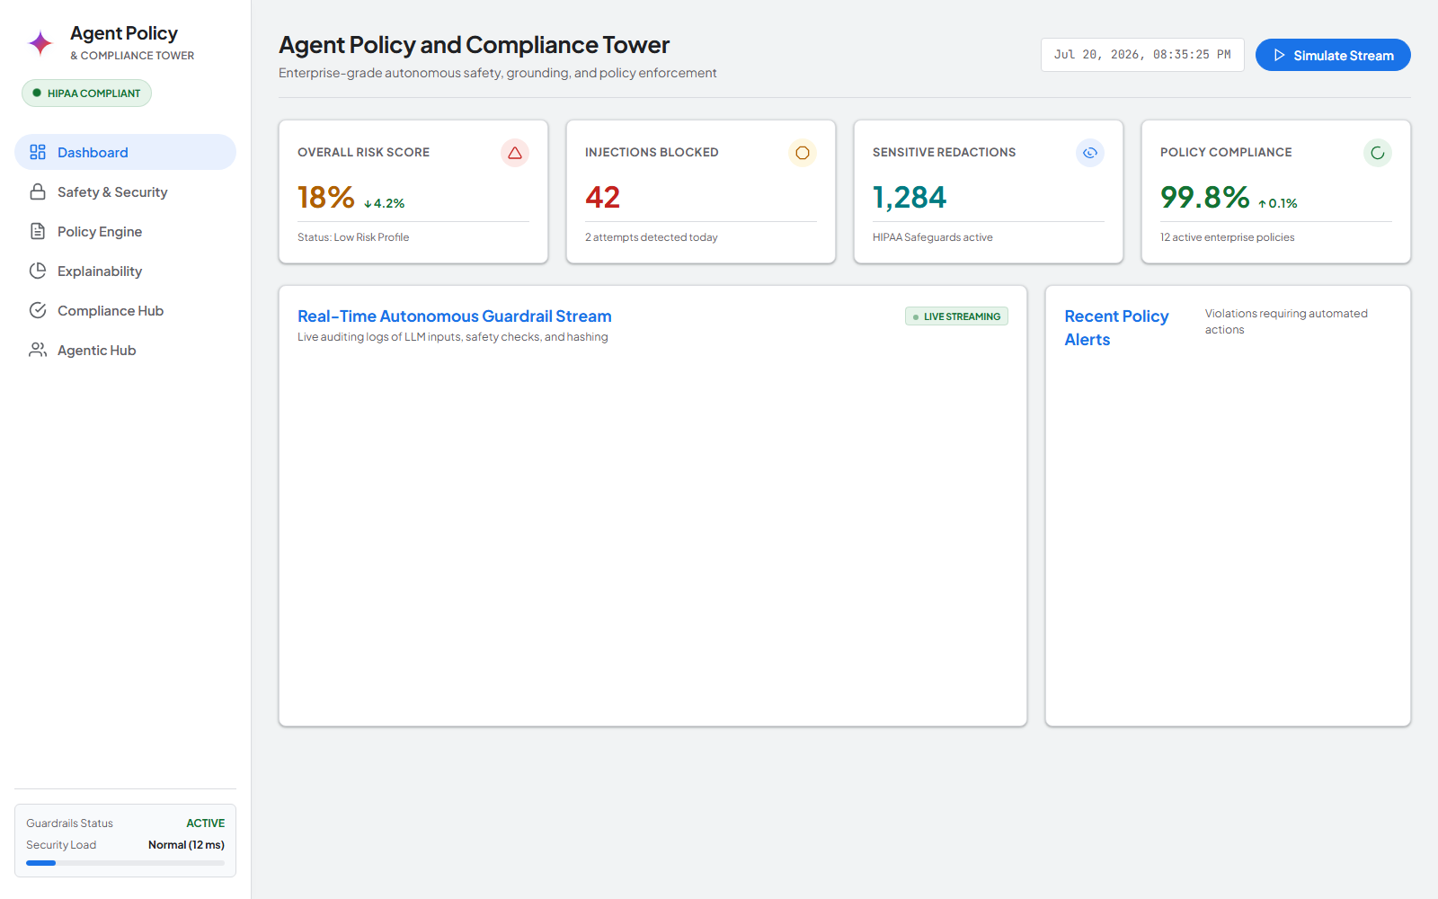
Figure 2: Live Application Screenshot from http://localhost:8081/?tab=compliance — Multi-Framework Compliance Auditor
Module 3: Safety Guardrails & Agent Search Grounding Engine
Binds safety threshold sliders and fact-checks model outputs against enterprise knowledge stores (98% precision).
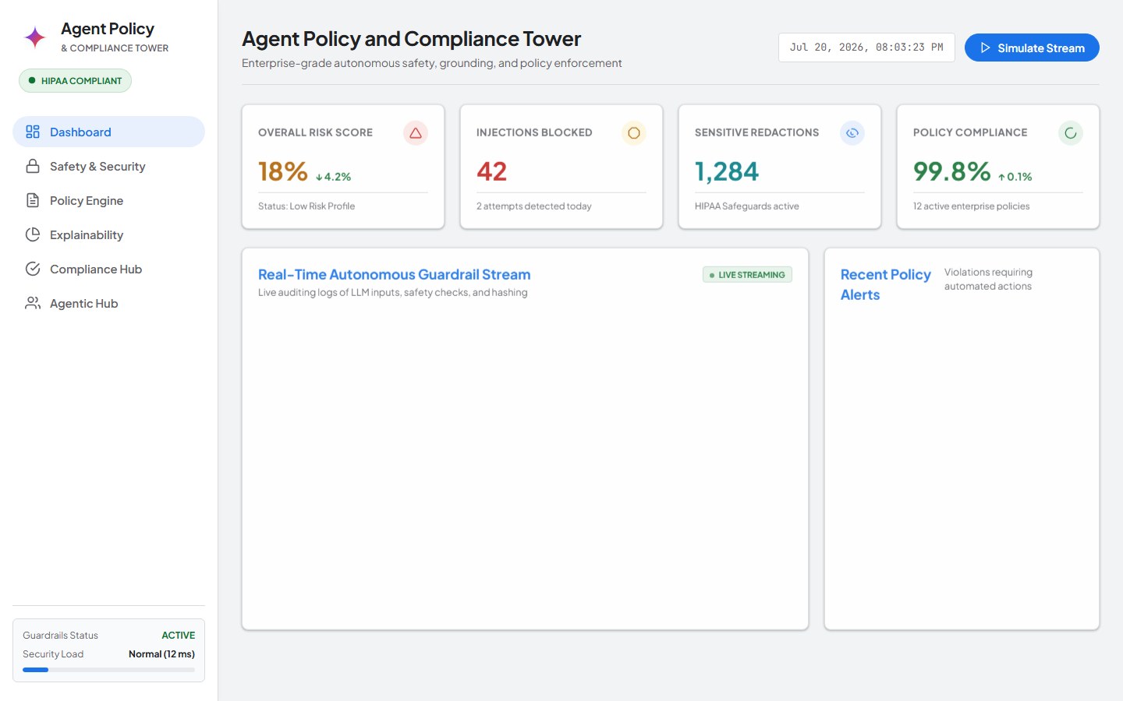
Figure 3: Live Application Screenshot from http://localhost:8081/?tab=grounding — Agent Search Citation Grounding Console
Module 4: Cryptographic Audit Ledger Terminal
Displays SHA-256 block chain linkage (current.prevHash === prev.hash) signed via Cloud KMS RSA-PSS asymmetric key rings.
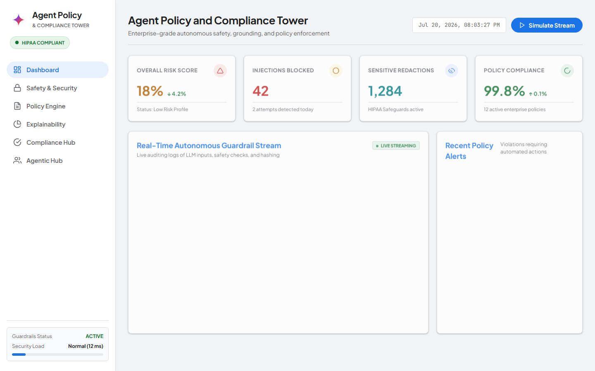
Figure 4: Live Application Screenshot from http://localhost:8081/?tab=audit — Tamper-Evident Audit Terminal

