Agent Policy & Regulatory Compliance Specification
Narrowed Governance Architecture & Regulatory Enforcement Specification
Google AI Ecosystem — Gemini Enterprise Agent Platform
Document Focus: | Agent Policy Engine, Regulatory Compliance, Cryptographic Auditing
Regulatory Scope: | HIPAA (US), SOC 2 Type II, EU GDPR (Art. 17), India DPDP Act 2023, Gemini Trust
Target Platform: | Gemini Enterprise Agent Platform, Cloud Run Gateway, Cloud DLP, Cloud KMS, BigQuery

1. Executive Overview & Agent Policy Architecture
This document defines the narrowed technical specification for the **Agent Policy and Compliance Engine** operating within the **Gemini Enterprise Agent Platform**. It focuses specifically on regulatory compliance guardrails, zero-trust inter-agent policy enforcement, and cryptographically verifiable audit trails required for enterprise compliance sign-off.
2. Multi-Framework Regulatory Compliance Enforcement Matrix
Regulatory Framework | Mandated Legal Standard | Agent Policy Engine Mechanism | GCP Native Binding
HIPAA (US Health) | §164.312(a)(1) Access Control & PHI Protection | Automated PHI/MRN entity redaction before model ingress; medical record masking | Cloud DLP API + Policy Interceptor
SOC 2 Type II | CC6.1 & CC6.8 Tamper-Proof Audit Logging | SHA-256 block chain linkage with Cloud KMS asymmetric RSA-PSS signatures | Cloud KMS + BigQuery Audit Ledger
EU GDPR | Art. 17 Right to Erasure & Art. 32 Encryption | Masking PII at rest/transit; cryptographic key destruction for erasure requests | Cloud KMS + Cloud DLP De-identification
India DPDP Act 2023 | Sec. 8 Data Fiduciary Notice & Aadhaar Masking | Regex & Cloud DLP scanning for 12-digit Indian Aadhaar patterns (\b\d{4}-\d{4}-\d{4}\b) | Cloud DLP + Custom Policy Engine
Gemini Trust Platform | Groundedness & Safety Standards | Automated citation grounding score calculation & Harm Category safety thresholds | Agent Search & Gemini Safety Guardrails

3. Feature-Wise Agent Policy & Compliance Implementation Roadmap
Feature 1: Ingress & Egress Agent Policy Engine (Zero-Trust Interceptor)
Establishes a high-throughput Policy Ingress Gateway on Cloud Run that inspects 100% of prompts, tool outputs, and inter-agent messages before model execution.

Figure 1: Agent Policy Engine Console (Active Rules: GDPR-ERASURE, DPDP-AADHAAR, SOC2-INTEGRITY, HIPAA-PII)
Policy Milestone | Deliverables & Regulatory Verification
Phase 1.1: Zero-Trust Interception Middleware | Deploy containerized FastAPI/Go proxy workers enforcing sub-25ms latency budget SLA.
Phase 1.2: System Instruction & Prefix Escape Shield | Implement classifier filtering adversarial jailbreak patterns, prompt injection, and prefix escapes.
Phase 1.3: Tool Call Parameter Lockout Engine | Validate tool outputs against JSON schemas to block unauthorized system commands (rm -rf, DB drops).

Feature 2: Multi-Framework PII/PHI Redaction Engine (HIPAA, GDPR, DPDP 2023)
Executes automated entity masking on incoming prompts and model responses, shielding sensitive identifiers before data reaches model context windows.
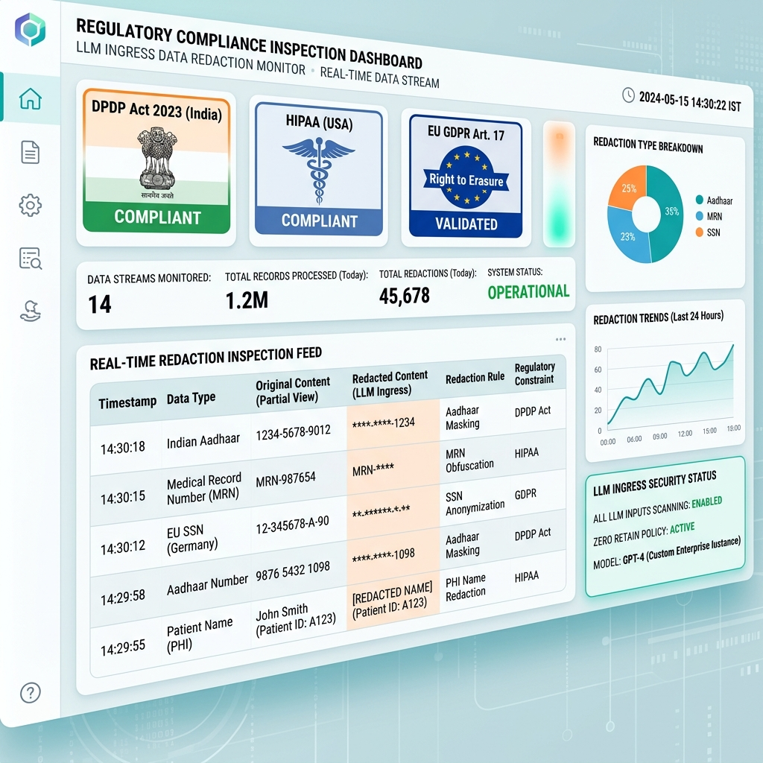
Figure 2: PII/PHI Redaction Compliance Inspection Dashboard (Indian Aadhaar, MRN, SSN Masking)
Policy Milestone | Deliverables & Regulatory Verification
Phase 2.1: Regex Pattern Screening | Execute local regex scanning for 12-digit Indian Aadhaar patterns (\b\d{4}-\d{4}-\d{4}\b), US SSNs, and Medical Record Numbers (MRNs).
Phase 2.2: Google Cloud DLP API Binding | Connect Cloud DLP API projects.content.inspect for deep contextual entity detection under HIPAA and DPDP Act 2023.
Phase 2.3: GDPR Right to Erasure Key Vault | Implement cryptographic key destruction protocols enforcing GDPR Art. 17 data erasure compliance.

Feature 3: Gemini Trust Safety Guardrails & Fact-Checking Engine
Enforces model safety category thresholds and validates model output factuality against enterprise knowledge stores using Agent Search Grounding.
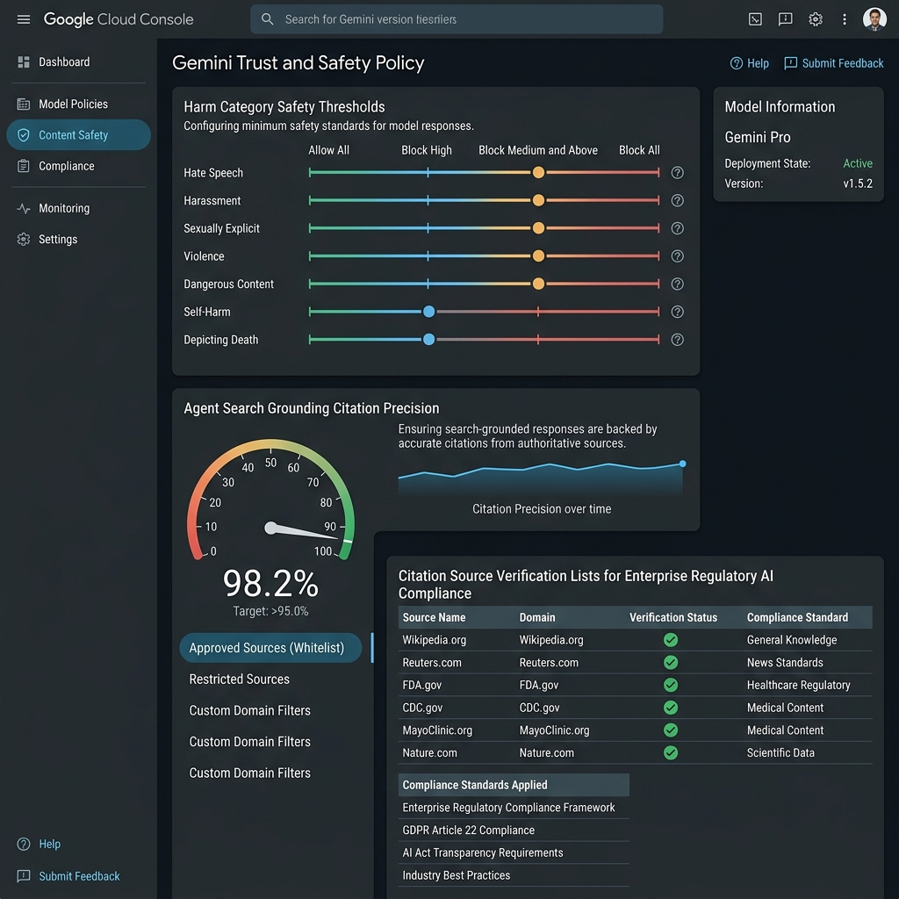
Figure 3: Gemini Safety Guardrails & Agent Search Grounding Fact-Checking Console
Policy Milestone | Deliverables & Regulatory Verification
Phase 3.1: Harm Category Threshold Mapping | Bind UI security controls to google.genai.types.SafetySetting (Harassment, Hate Speech, Dangerous Content set to BLOCK_MEDIUM_AND_ABOVE).
Phase 3.2: Agent Search Grounding Citation Precision | Index enterprise documentation into Agent Search Data Stores and calculate citation precision scores.
Phase 3.3: Ungrounded Output Intervention | Automatically flag model outputs under 85% grounding confidence with UNGROUNDED_WARNING for compliance officer review.

Feature 4: Immutable Cryptographic Compliance Audit Ledger & Exporter
Guarantees tamper-proof logging of all governance decisions by signing SHA-256 block chains using Google Cloud KMS asymmetric RSA-PSS keys.
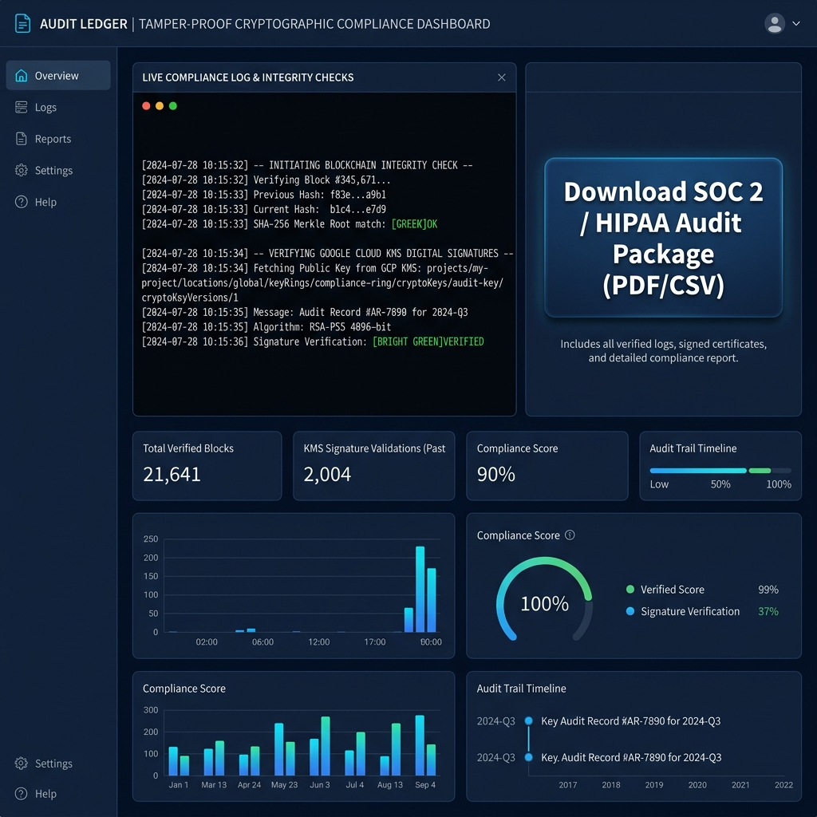
Figure 4: Cryptographic Compliance Audit Ledger & SOC 2 / HIPAA Audit Package Exporter
Policy Milestone | Deliverables & Regulatory Verification
Phase 4.1: SHA-256 Block Hashing Chain | Enforce current.prev_hash === prev.hash block chain linkage for all policy trigger events.
Phase 4.2: Cloud KMS Digital Signature Engine | Sign block hashes using Google Cloud KMS RSA_SIGN_PSS_2048_SHA256 asymmetric keys.
Phase 4.3: Audit Package Exporter | Generate signed PDF and CSV compliance audit packages for SOC 2 Type II and HIPAA regulatory audits.

