**KUBERNETES EXAM**

Betselot Berhanu

Submission Date:

December 30, 2023

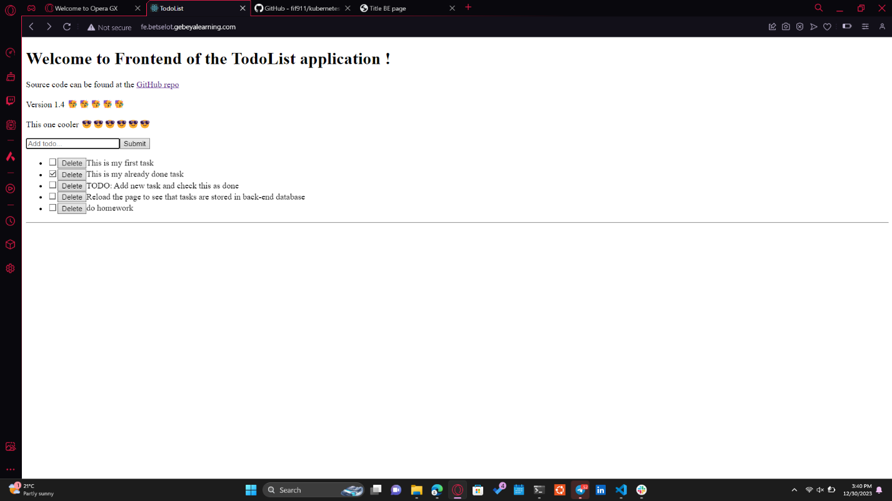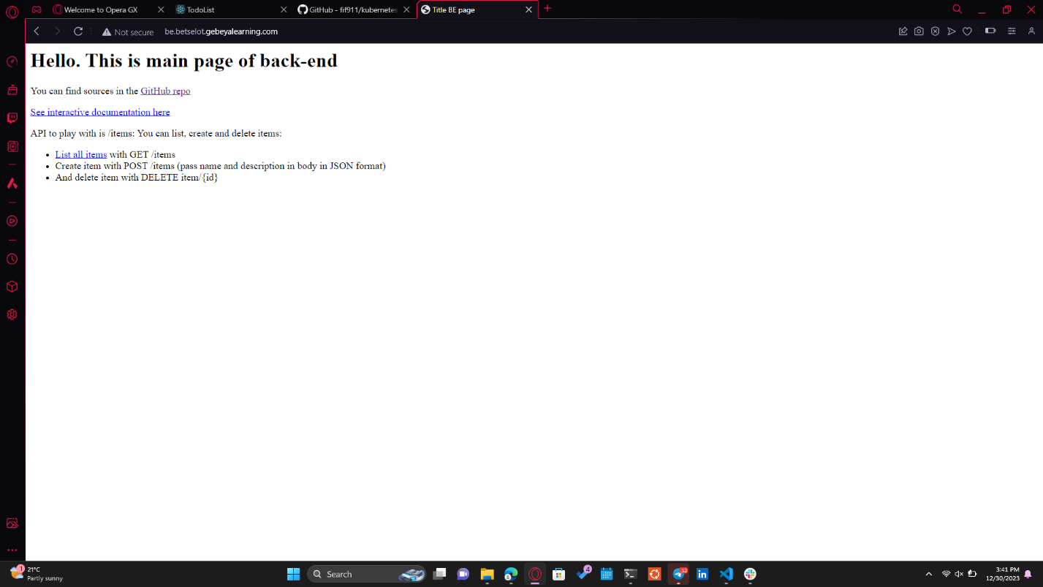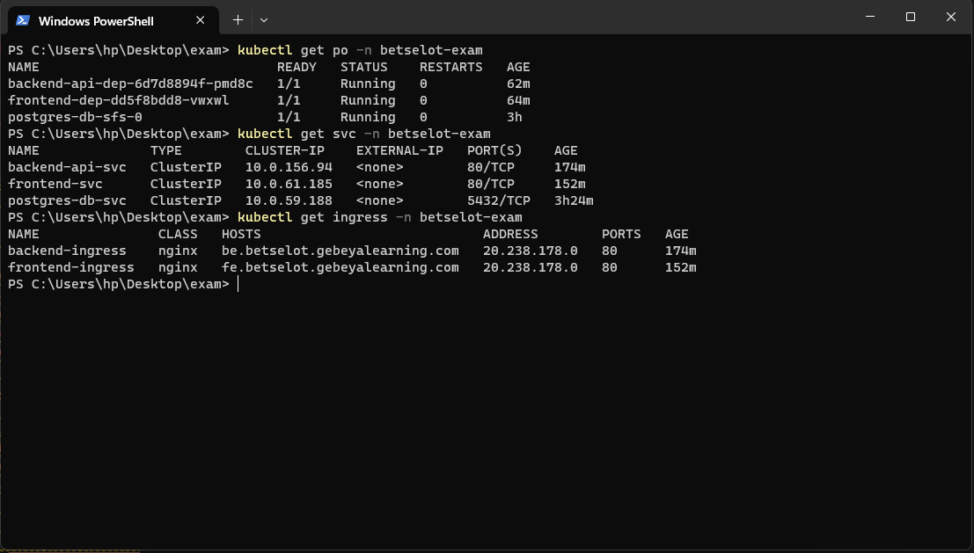

URL for frontend: http://fe.betselot.gebeyalearning.com

URL for backend: http://be.betselot.gebeyalearning.com

Gitlab repository URL: <http://git.gebeya.training/Betselot/kubernetes-exam.git>