Topics: Descriptive Statistics and Probability

- Look at the data given below. Plot the data, find the outliers and find out $μ, σ, σ^{2}$

Name of company | Measure X
Allied Signal | 24.23%
Bankers Trust | 25.53%
General Mills | 25.41%
ITT Industries | 24.14%
J.P.Morgan & Co. | 29.62%
Lehman Brothers | 28.25%
Marriott | 25.81%
MCI | 24.39%
Merrill Lynch | 40.26%
Microsoft | 32.95%
Morgan Stanley | 91.36%
Sun Microsystems | 25.99%
Travelers | 39.42%
US Airways | 26.71%
Warner-Lambert | 35.00%

boxplot(cv$Measure.X)
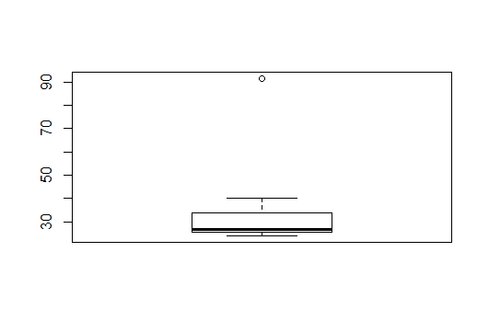

Outlier value:90 which is Morgan Stanley
Mean: 0.332
Variance: .02840286
SD= 0.1685315

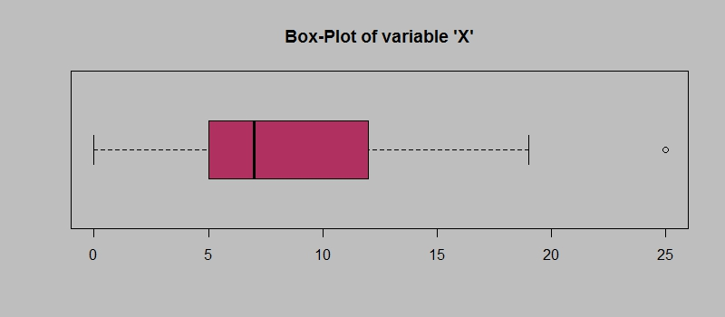
Answer the following three questions based on the box-plot above.
- What is inter-quartile range of this dataset? (please approximate the numbers) In one line, explain what this value implies.
- What can we say about the skewness of this dataset?
- If it was found that the data point with the value 25 is actually 2.5, how would the new box-plot be affected?

Ans(i) IQR=(IQ3-IQ2) (12-5)=7.IQR shows the 50% data
Ans(ii) Right Skewed data. The data has more higher values.
Ans(iii)There will outlier on the lower extreme if 25 is replaced with 2.5

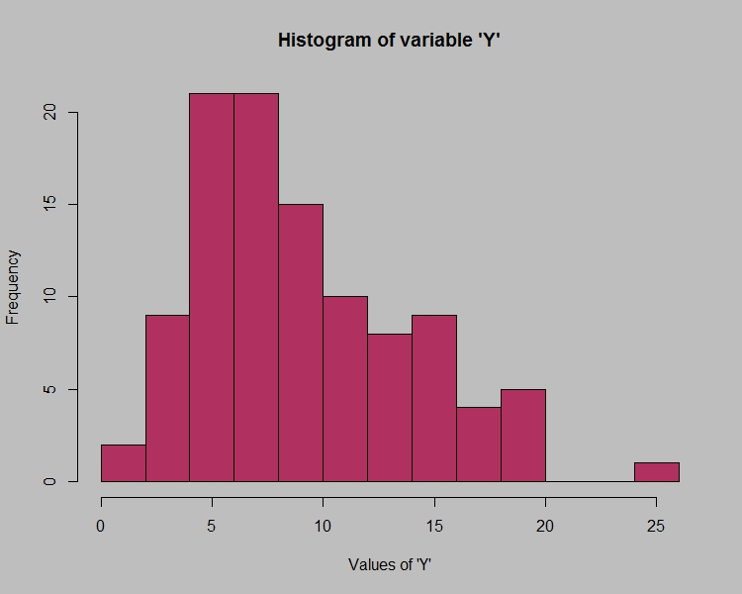

Answer the following three questions based on the histogram above.
- Where would the mode of this dataset lie?
- Comment on the skewness of the dataset.
- Suppose that the above histogram and the box-plot in question 2 are plotted for the same dataset. Explain how these graphs complement each other in providing information about any dataset.

Ans(i): The mode lies Between Bins 4-6 and 6-8.
Ans(ii): Right Skewed dataset
Ans(iii)Both graph gives an idea of skewness and outlier.

- AT&T was running commercials in 1990 aimed at luring back customers who had switched to one of the other long-distance phone service providers. One such commercial shows a businessman trying to reach Phoenix and mistakenly getting Fiji, where a half-naked native on a beach responds incomprehensibly in Polynesian. When asked about this advertisement, AT&T admitted that the portrayed incident did not actually take place but added that this was an enactment of something that “could happen.” Suppose that one in 200 long-distance telephone calls is misdirected. What is the probability that at least one in five attempted telephone calls reaches the wrong number? (Assume independence of attempts.)

Ans: E: The call is misdirected
then probability of the event E is
P(E)= 1/200
Therefore,
Probability that at least one in 5 attempted call reaches the wrong number
= 1 - Probability that no attempted call reaches the wrong number
= 1 – P(E bar)
= 1 – (199/200)* (199/200)* (199/200)* (199/200)* (199/200)
= 1 - (199/200)^5
= 0.025

- Returns on a certain business venture, to the nearest $1,000, are known to follow the following probability distribution
x | P(x)
-2,000 | 0.1
-1,000 | 0.1
0 | 0.2
1000 | 0.2
2000 | 0.3
3000 | 0.1

- What is the most likely monetary outcome of the business venture?
2000
- Is the venture likely to be successful? Explain
Venture has 60% of being successful and 40% of having debts and no profits
- What is the long-term average earning of business ventures of this kind? Explain
2000
((-2000*1)+ (-1000*1)+ (1000*2)+ (2000*3)+ (3000*1) / 6) = 8000/6 = 1333

- What is the good measure of the risk involved in a venture of this kind? Compute this measure

Venture has 60% of being successful and 20% of having debts and 20% if running without any profits

