**Assignment – 1**

• **Install Power BI Desktop and share the final screenshot of the report view page which appears when power desktop starts.**

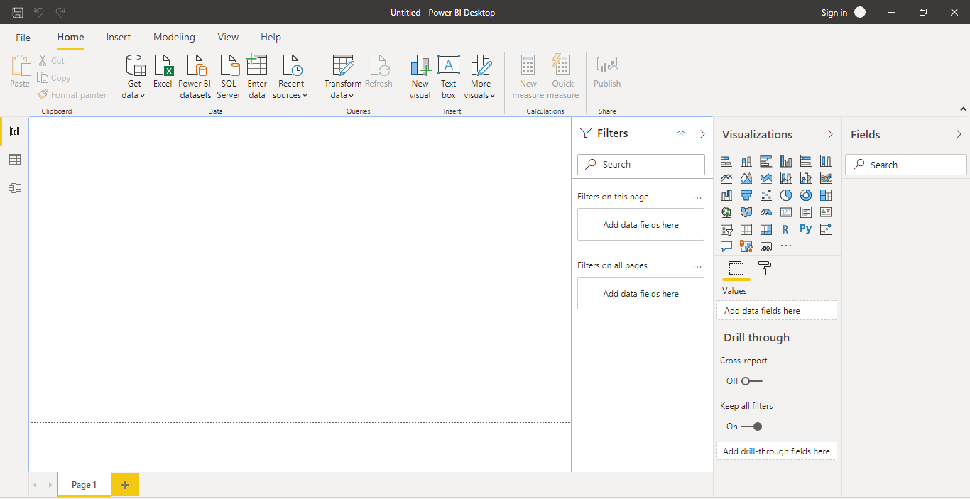

**• Prepare a document and with the following screenshot**

**1.Report View:**



Power BI Desktop includes a *Report view*, where you can create any number of report pages with visualizations. Report view in Power BI Desktop provides a similar design experience to the report's editing view in the *Power BI service*. You can move visualizations around, copy and paste, merge, and so on.

The difference between them is when using Power BI Desktop, you can work with your queries and model your data to make sure your data supports the best insights in your reports. You can then save your Power BI Desktop file wherever you like, whether it's your local drive or to the cloud.

**Let's take a look!**

When you first load data in Power BI Desktop, you'll see the Report view with a blank canvas.

You can switch between **Report**, **Data**, and **Relationship** views by selecting the icons in the left-hand navigation pane

Once you've added some data, you can add fields to a new visualization in the canvas.

To change the type of visualization, you can select it on the canvas, then select a new type in **Visualizations**.

**Tip**

Be sure to experiment with different visualization types. It's important your visualization convey information in your data clearly.

A report will have at least one blank page to start. Pages appear in the navigator pane just to the left of the canvas. You can add all sorts of visualizations to a page, but it's important not to overdo it. Too many visualizations on a page make it look busy and difficult to find the right information. You can add new pages to your report. Just click **New Page** on the ribbon.

To delete a page, click the **X** on the page's tab at the bottom of the Report view.

**Copy and paste between reports**

You can easily take a visual from one Power BI Desktop report and paste it into another report. Simply use the Ctrl+C keyboard shortcut to copy your report visual. In the other Power BI Desktop report, use Ctrl+V to paste the visual into the other report. You can select one visual at a time, or all visuals on a page to copy, then paste into the destination Power BI Desktop report.

The ability to copy and paste visuals is useful for people who build and updates multiple reports frequently. When copying between files, settings and formatting that have been explicitly set in the formatting pane will carry forward, while visual elements relying on a theme or the default settings automatically update to match the theme of the destination report. So when you get a visual formatted and looking just the way you want, you can copy and paste that visual into new reports and preserve all that good formatting work.

If the fields in your model are different, you'll see an error on the visual and a warning about which fields don't exist. The error is similar to the experience you see when you delete a field in the model that a visual is using.

To correct the error, just replace the broken fields with the fields you want to use from the model in the report to which you pasted the visual. If you're using a custom visual, you must also import that custom visual to the destination report.

**Hide report pages**

When you create a report, you can also hide pages from a report. This approach might be useful if you need to create underlying data or visuals in a report, but you don't want those pages to be visible to others, such as when you create tables or supporting visuals that are used in other report pages. There are many other creative reasons you might want to create a report page, then hide it from a report you want to publish.

Hiding a report page is easy. Simply right-click on the report page tab, and select **Hide** from the menu that appears.

There are a few considerations to keep in mind when hiding a report page:

* You can still see a hidden report view when in Power BI Desktop, even though the page's title is grayed out. In the following image, Page 4 is hidden.
* You *cannot* see a hidden report page when viewing the report in the Power BI service.
* Hiding a report page is *not* a security measure. The page can still be accessed by users, and its content is still accessible using drill-through, and other methods.
* When a page is hidden, when in View mode, no view-mode navigation arrows are shown.

**2.Data View:**

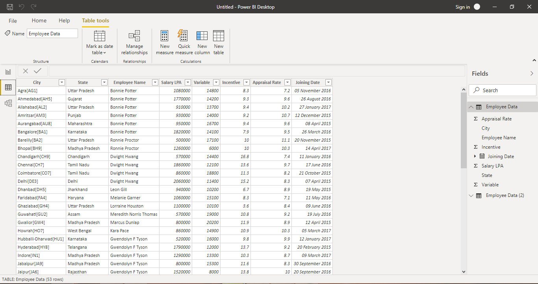

Data view helps you inspect, explore, and understand data in your Power BI Desktop model. It's different from how you view tables, columns, and data in Power Query Editor. With Data view, you're looking at your data after it has been loaded into the model.

When you're modeling your data, sometimes you want to see what's actually in a table or column without creating a visual on the report canvas. You might want to see right down to the row level. This ability is especially useful when you're creating measures and calculated columns, or you need to identify a data type or data category.

Let's take a closer look at some of the elements found in Data view.

1. **Data view icon**. Select this icon to enter Data view.
2. **Data Grid**. This area shows the selected table and all columns and rows in it. Columns hidden from Report view are greyed out. You can right-click on a column for options.
3. **Modeling ribbon**. Here you can manage relationships, create calculations, change data type, format, data category for a column.
4. **Formula bar**. Enter Data Analysis Expression (DAX) formulas for Measures and Calculated columns.
5. **Search**. Search for a table or column in your model.
6. **Fields list**. Select a table or column to view in the data grid.

## Filtering in Data view

You can also filter and sort data in Data view. Each column shows an icon that identifies the sort direction, if applied.

You can filter individual values, or use advanced filtering based on the data in the column.

**3.Model View:**

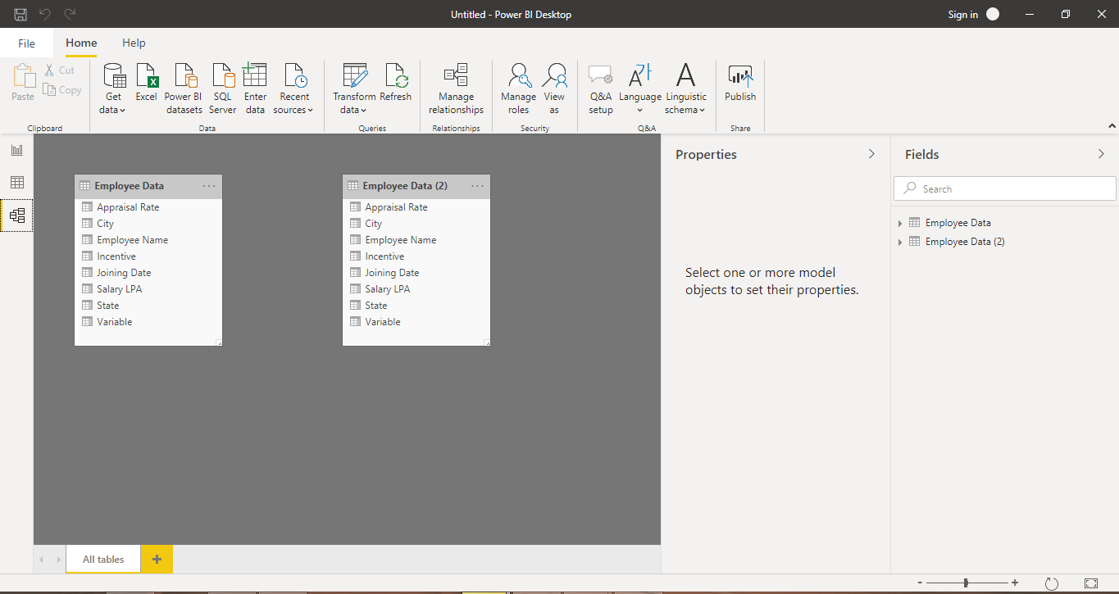

Model view shows all of the tables, columns, and relationships in your model. This view can be especially helpful when your model has complex relationships between many tables.

Select the **Model** icon near the side of the window to see a view of the existing model. Hover your cursor over a relationship line to show the columns that are used.

In the figure, the Stores table has a StoreKey column that’s related to the Sales table, which also has a StoreKey column. The two tables have a Many to One (*:1) relationship. An arrow in the middle of the line shows the direction of the filter context flow. The double arrows mean the cross-filter direction is set to Both.

You can double-click a relationship to open it in the **Edit Relationship** dialog box.

**4.Power Query Editor:**

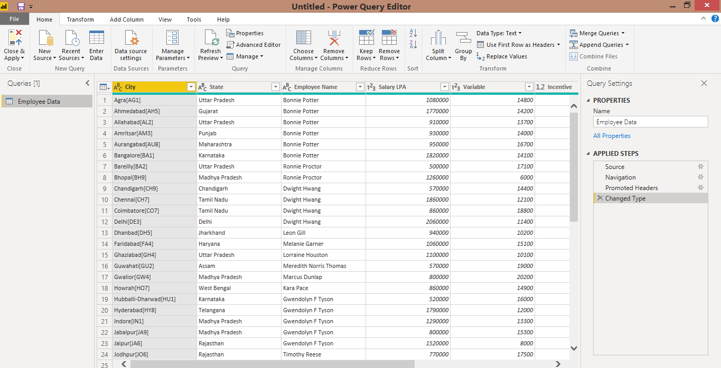

With **Power Query** in **Power BI** you can connect to many different data sources, transform the data into the shape you want, and quickly be ready to create reports and insights. When using Power BI Desktop, **Power Query** functionality is provided in the **Power Query Editor**.

Let’s get acquainted with **Power Query Editor**.

If you're not signed up for Power BI, you can [sign up for a free trial](https://app.powerbi.com/signupredirect?pbi_source=web) before you begin. Also, Power BI Desktop is [free to download](https://go.microsoft.com/fwlink/?LinkId=521662&clcid=0x409).

## Using Power Query Editor

**Power Query** is made available in **Power BI Desktop** through **Power Query Editor**. To launch Power Query Editor, select **Edit Queries** from the **Home** tab of Power BI Desktop.

With no data connections, **Power Query Editor** appears as a blank pane, ready for data.

Once a query is loaded, **Power Query Editor** view becomes more interesting. If you connect to the following Web data source, **Power Query Editor** loads information about the data, which you can then begin to shape.

Here’s how **Power Query Editor** appears once a data connection is established:

* In the ribbon, many buttons are now active to interact with the data in the query.
* In the left pane, queries are listed and available for selection, viewing, and shaping.
* In the center pane, data from the selected query is displayed and available for shaping.
* The **Query Settings** window appears, listing the query’s properties and applied steps.

The following sections describe each of these four areas—the ribbon, the queries pane, the data view, and the Query Settings pane.

## The query ribbon

The ribbon in **Power Query Editor** consists of five tabs—**Home**, **Transform**, **Add Column**, **View**, and **Help**.

The **Home** tab contains the common query tasks, including the first step in any query, which is **Get Data.** The following image shows the **Home** ribbon.

To connect to data and begin the query building process, select the **Get Data** button. A menu appears, providing the most common data sources.

The **Transform** tab provides access to common data transformation tasks, such as adding or removing columns, changing data types, splitting columns, and other data-driven tasks. The following image shows the **Transform** tab.

The **Add Column** tab provides additional tasks associated with adding a column, formatting column data, and adding custom columns. The following image shows the **Add Column** tab.

The **View** tab on the ribbon is used to toggle whether certain panes or windows are displayed. It’s also used to display the Advanced Editor. The following image shows the **View** tab.

It’s useful to know that many of the tasks available from the ribbon are also available by right-clicking a column, or other data, in the center pane.

## The left pane

The left pane displays the number of active queries, as well as the name of the query. When you select a query from the left pane, its data is displayed in the center pane, where you can shape and transform the data to meet your needs. The following image shows the left pane with multiple queries.

## The center (data) pane

In the center pane, or Data pane, data from the selected query is displayed. This is where much of the work of the Query view is accomplished.

In the following image, the Web data connection established earlier is displayed, the **Overall score** column is selected, and its header is right-clicked to show the available menu items. Notice that many of these right-click menu items are the same as buttons in the ribbon tabs.

When you select a right-click menu item (or a ribbon button), Query applies the step to the data, and saves it as part of the query itself. The steps are recorded in the **Query Settings** pane in sequential order, as described in the next section.

## The query settings pane

The **Query Settings** pane is where all steps associated with a query are displayed. For example, in the following image, the **Applied Steps** section of the **Query Settings** pane reflects the fact that the type of the **Overall score** column has changed.

As additional shaping steps are applied to the query, they are captured in the **Applied Steps** section.

It’s important to know that the underlying data is not changed; rather, Power Query Editor adjusts and shapes its view of the data, and any interaction with the underlying data occurs based on Power Query Editor’s shaped and modified view of that data.

In the **Query Settings** pane, you can rename steps, delete steps, or reorder the steps as you see fit. To do so, right-click the step in the **Applied Steps** section, and choose from the menu that appears. All query steps are carried out in the order they appear in the **Applied Steps** pane.

## 5.The Advanced Editor

## 

 

If you want to see the code that **Power Query Editor** is creating with each step, or want to create your own shaping code, you can use the **Advanced Editor**. To launch the advanced editor, select **View** from the ribbon, then select **Advanced Editor**. A window appears, showing the existing query code.

You can directly edit the code in the **Advanced Editor** window. To close the window, select the **Done** or **Cancel** button.

## Saving your work

When your query is where you want it, you can have Power Query Editor apply the changes to the data model into Power BI Desktop, and close Power Query Editor. To do that, select **Close & Apply** from Power Query Editor's **File** menu.

As progress is made, Power BI Desktop provides a dialog to display its status.

Once you have your query where you want it, or if you just want to make sure your work is saved, Power BI Desktop can save your work in a .pbix file.

To save your work, select **File > Save** (or **File > Save As.**

* **Prepare a document with details of the following along with their price**

**− Power BI Desktop**

**− Power BI Pro**

**− Power BI Premium**

**Power BI Desktop** is a free application you install on your local computer that lets you connect to, transform, and visualize your data. ... Transform and clean that data, to create a data model. Create visuals, such as charts or graphs, that provide visual representations of the data.

**Power BI Pro** is an individual user license that lets users read and interact with reports and dashboards that others have published to the **Power BI** service. Users with this license type can share content and collaborate with other **Power BI Pro** users.

**Power BI Premium** is a capacity-based offering that includes: Flexibility to publish reports broadly across an enterprise, without requiring recipients to be licensed individually per user. Greater scale and performance than shared capacity in the **Power BI** service

Power BI has three pricing plans:

* **Power BI Desktop**: This offering is free to any single user and includes data cleaning and preparation, custom visualizations and the ability to publish to the Power BI service.
* **Power BI Pro**: The Pro plan costs $9.99/user/month. It includes data collaboration, data governance, building dashboards with a 360-degree real-time view and the ability to publish reports anywhere. Users can try it a free trial for 60 days before purchasing the subscription.
* **Power BI Premium:** The Premium plan starts at $4,995 a month per dedicated cloud compute and storage resource.