ASSIGNMENT 10

7.Wap to check no is perfect no or not PLSQL.

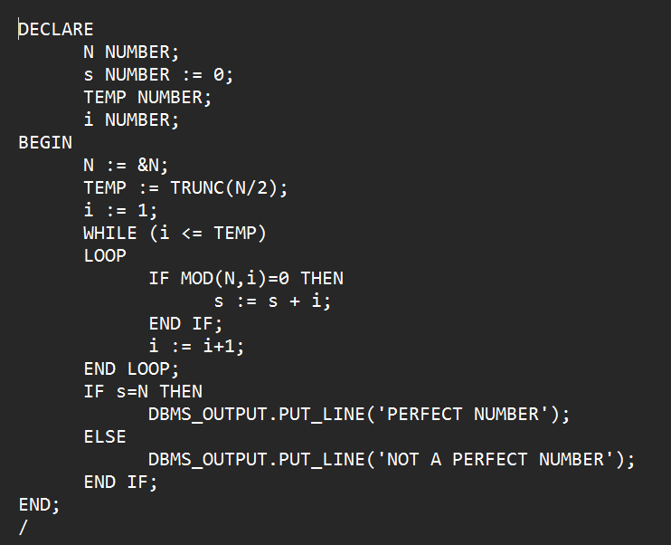

OUTPUT

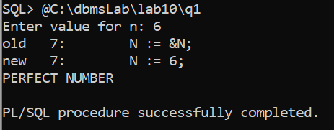

8. Wap to find all prime no between two given range in PLSQL.

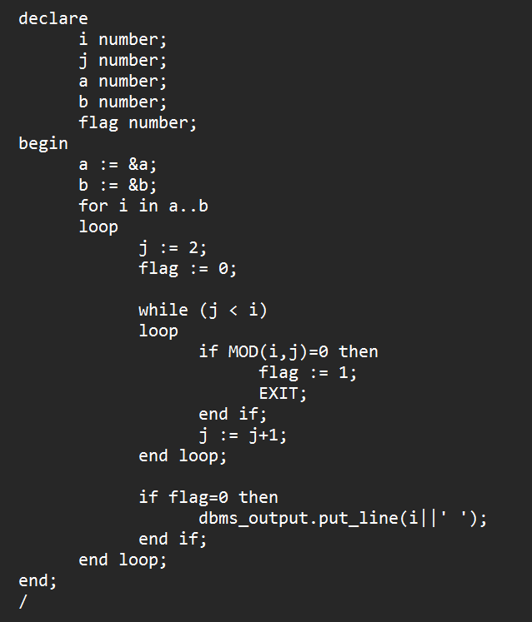

OUTPUT

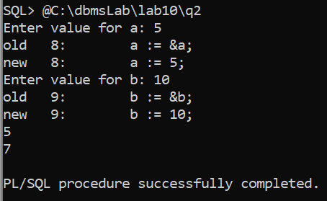

9. Wap to to retrieve mark from student table and find grade for each student.

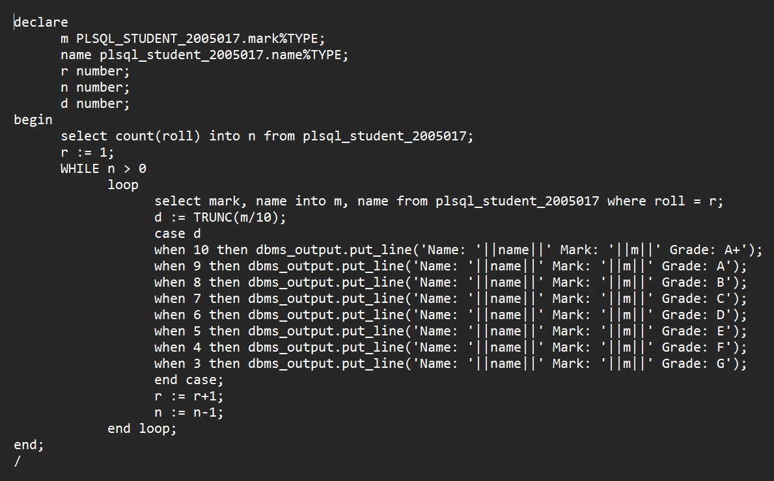

OUTPUT

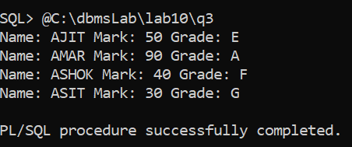

10. Wap to display roll,name, mark & dob from student table of specific roll by using %type attribute.

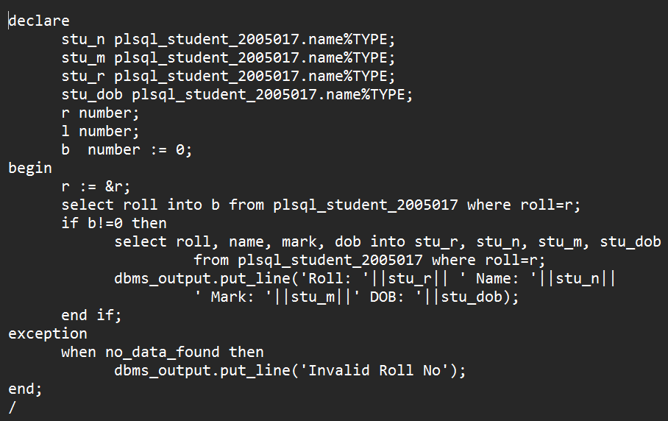

OUTPUT

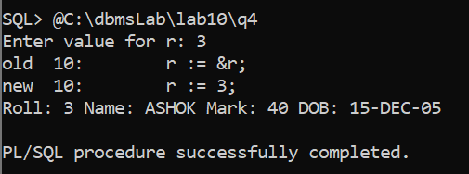

11. Wap to to retrieve mark from student table and find grade for each student by using %rowtype.

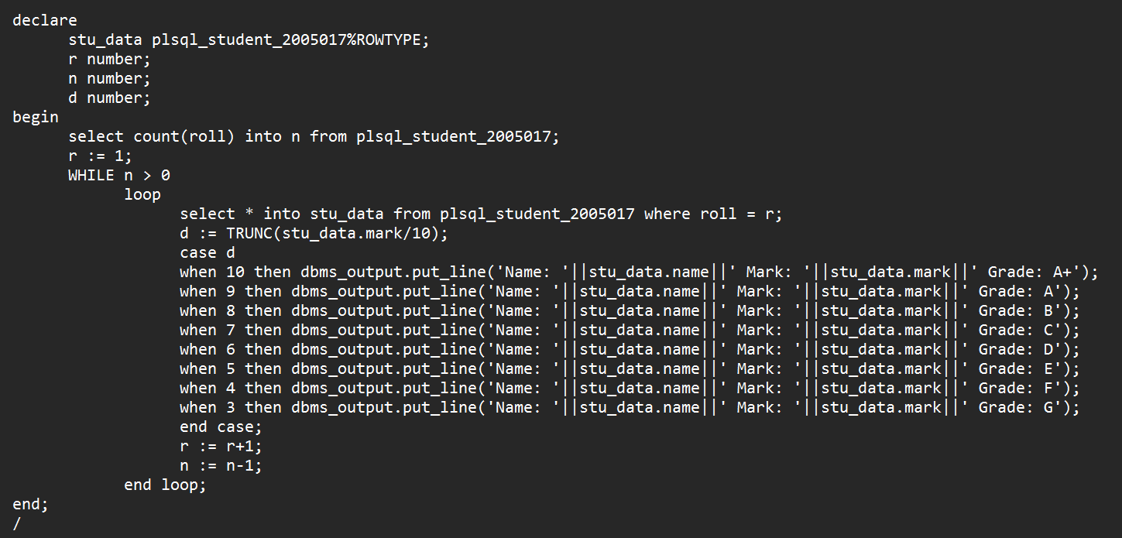

OUTPUT

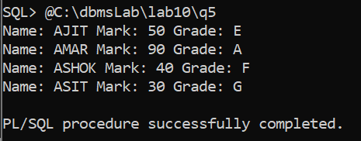

12.Wap to retrieve mark from student table and find CGPA for each student.

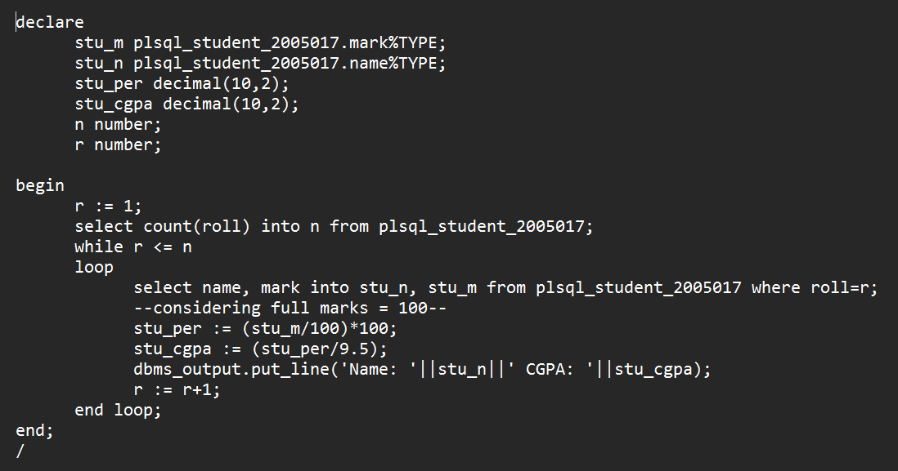

OUTPUT

