**ASSIGNMENT 2**

Q7. Retrieve the name of the customer living in NAGPUR.

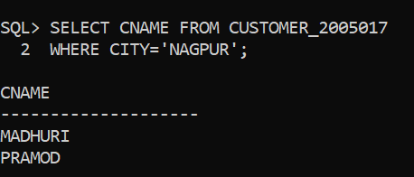

Q8. Retrieve the name of the customers who opened account after 17-NOV-95.

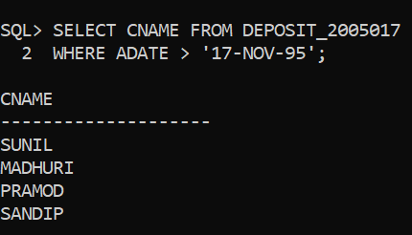

Q9. Retrieve the account number and amount of the customer having account opened between 01-12-95 and 01-06.96

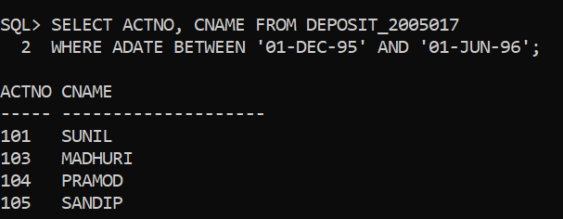

Q10. Retrieve all the records from the table DEPOSIT(roll number) where CNAME begins with C.

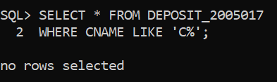

Q11. Retrieve all the records from the table BORROW(roll number) where 2nd character of CNAME is U.

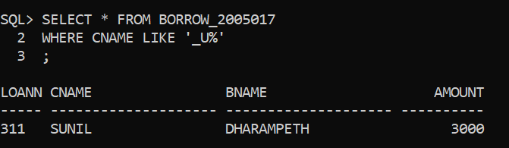

Q12.Retrieve all the records from the table DEPOSIT(roll number) where branch name is CHANDNI or MGROAD.

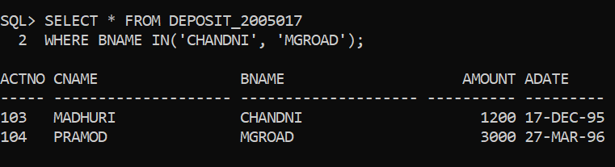

Q13. Retrieve all the records from the table DEPOSIT(roll number) where branch name is not CHANDNI or MGROAD.

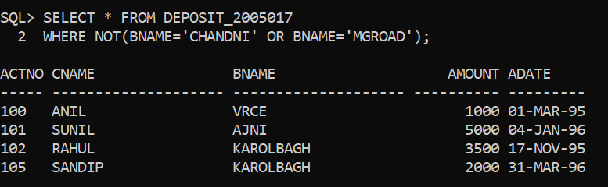

Q14. Retrieve all the records from the table BORROW(roll number) where amount in between 2000 and 3000.

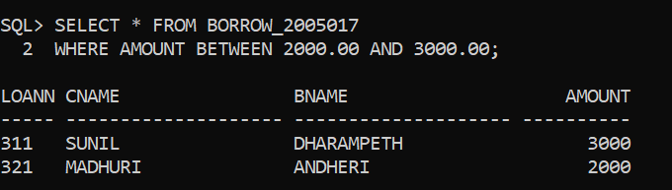

Q15. Calculate TA(10% of amount), DA(20% of amount) and TOTAL of each customer from BORROW(roll number) table also project CNAME & AMOUNT

