ASSIGNMENT 3

Q1. Retrieve all the records from DEPOSIT(roll number) where amount > 1000 and arrange the customer name in ascending order(ques1) and in descending order(ques2)

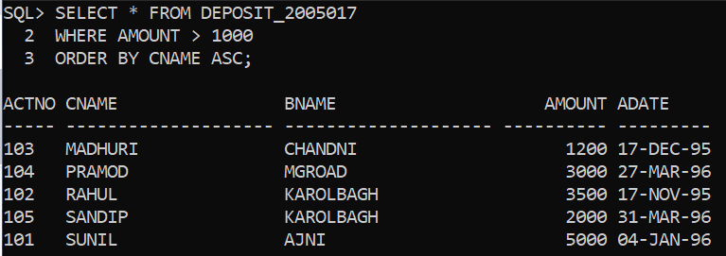

Q2. Retrieve customer details from BORROW(roll number) table where the third character of the customer name is either ‘A’ or ‘D’.

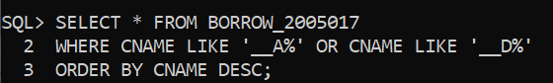

Q3. Retrieve all the records from the table BORROW(roll number) where amount is not between 2000 and 8000.

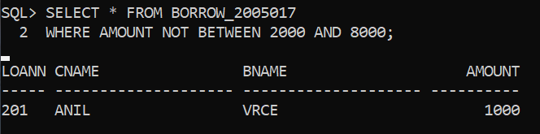

Q4. Find out the unique records from the table DEPOSIT(roll number).

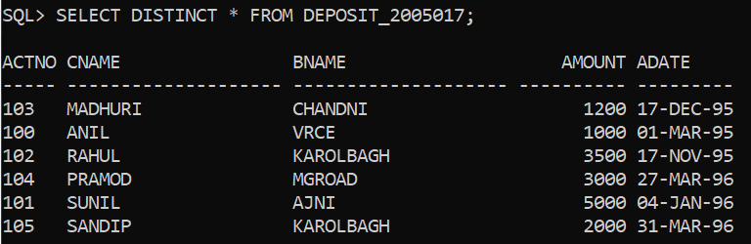

Q5. Update the amount of all depositors in deposit table by giving them 10% interest (i.e. amount=amount \* 0.1) where branch is VRCE.

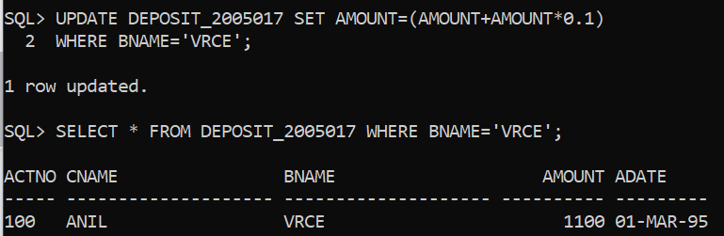

Q6. Update the amount of all depositors in deposit table by giving them 10% interest where branch is VRCE and customer name ANIL.

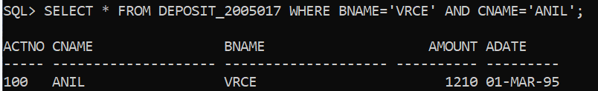

Q7. Create table STUIDENT and insert the following data :-

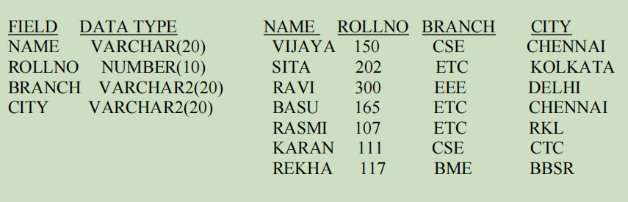

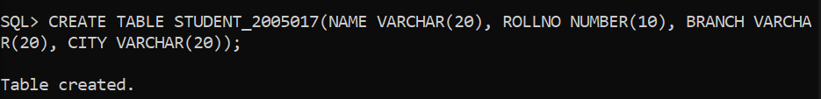

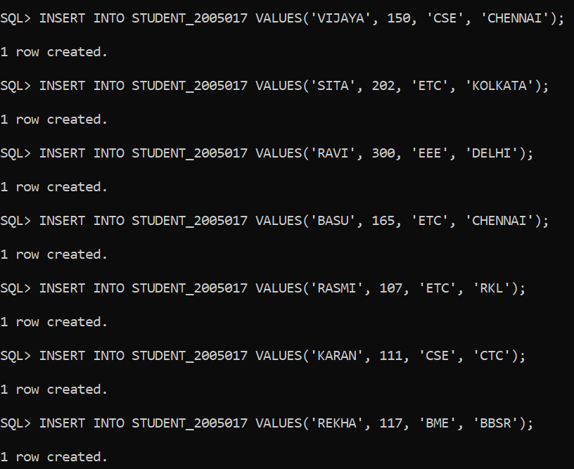

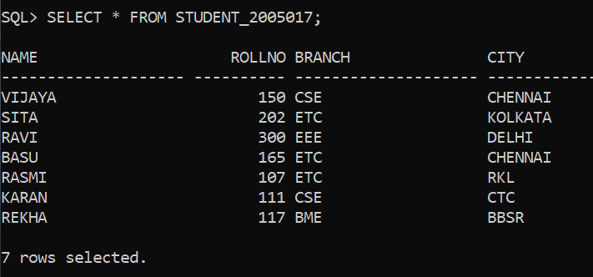

Q8. Count the number of students of each department.

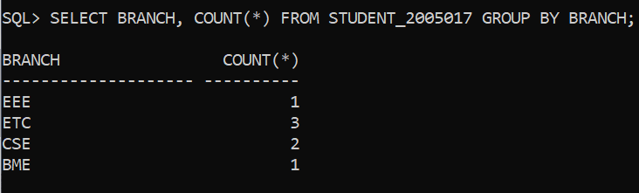

Q9. Count the number of students of each department where the department name starts with ‘E’.

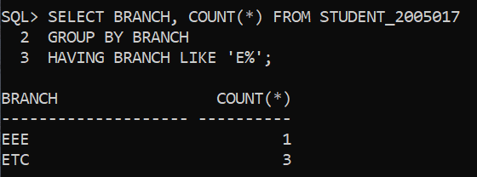

Q10. Add a field called MARKS to the table STUDENT which can hold a number upto 8 digit length.

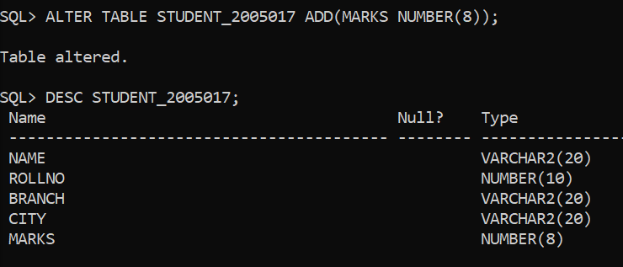

Q11. Modify the field :”NAME” of the table STUDENT to hold a maximum of 25 character.

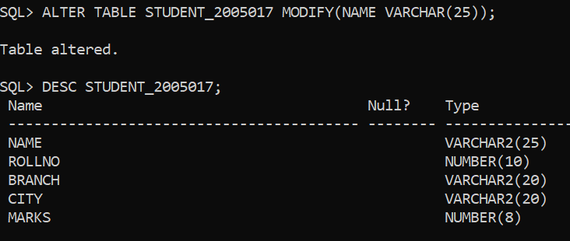

Q12. Delete all rows from the table STUDENT where branch is ETC.

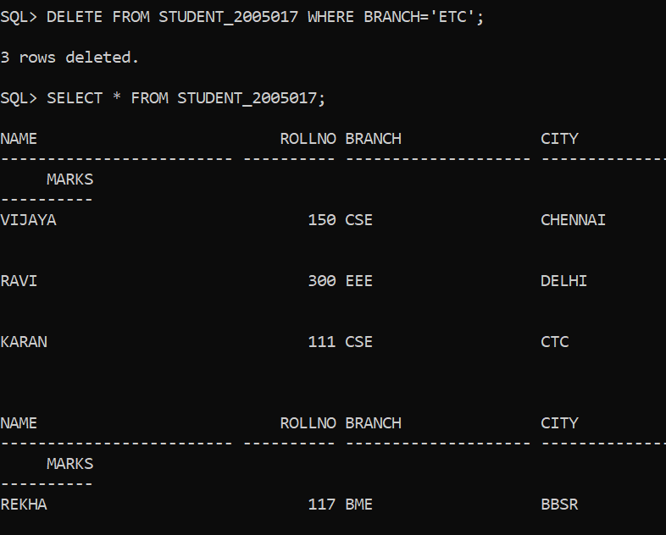

Q13. Rename the table STUDENT to STUDINFORMATION.

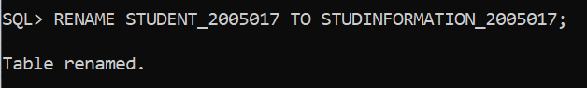

Q14. Delete all the data part from the table STUDENT.

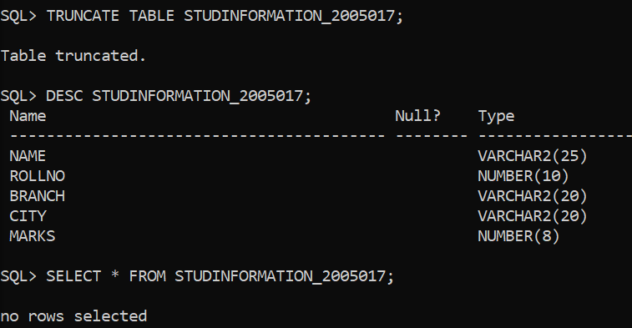

Q15. Destroy the table STUDENT.

