**ASSIGNMENT - 7**

1. List all the depositors having deposit in all the branches where SUNIL is having branch.

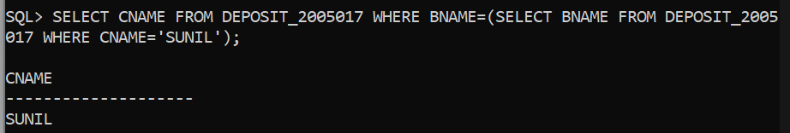

2.Retrieve the account and amount of all the depositors living in city NAGPUR.

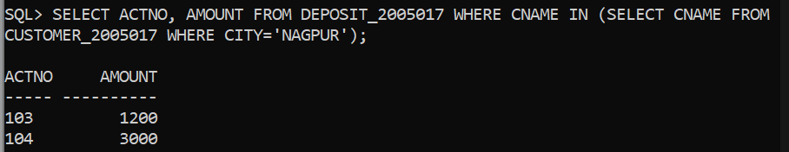

3.List the cities of depositors having branch as KAROLBAGH.

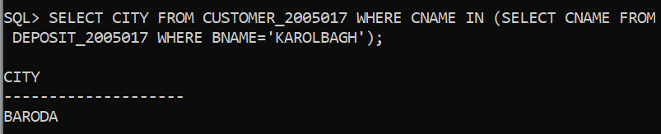

1. List all the cities where branches of Anil & Sunil are located.

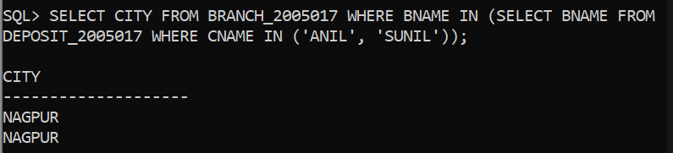

1. List all the customer Name, Amount of depositors living in city where Anil or Sunil is living.

