ASSIGNMENT 8

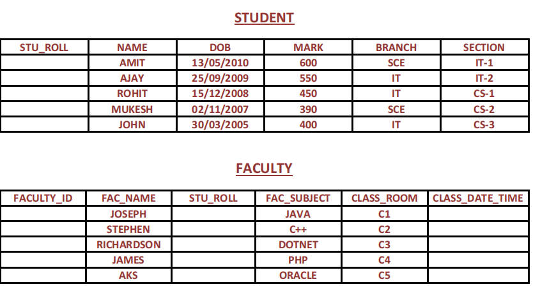

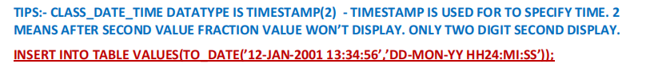

**TABLE CREATION**

1. **STUDENT**



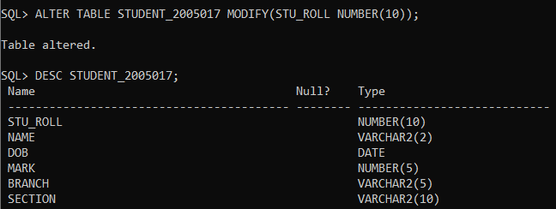

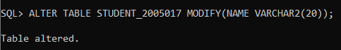

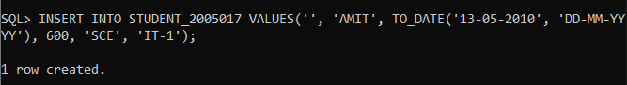

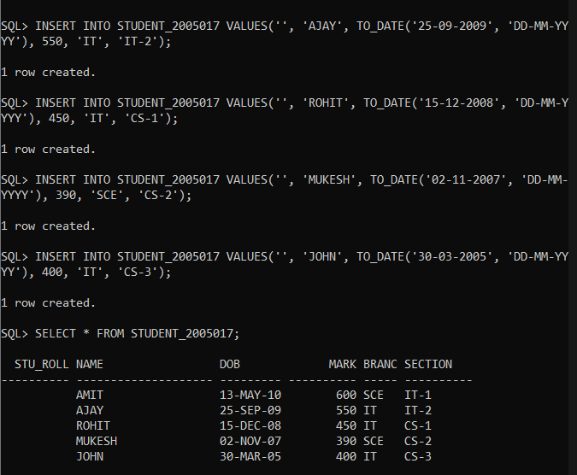

1. **FACULTY**

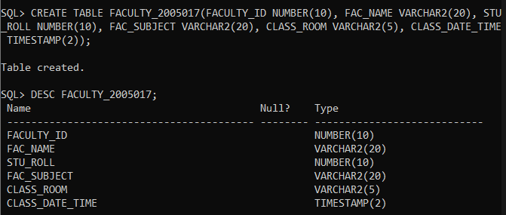

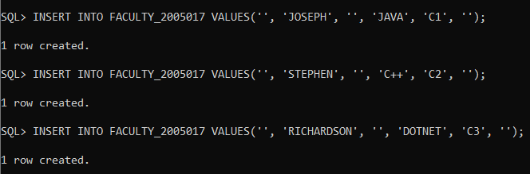

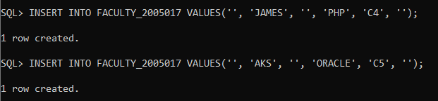

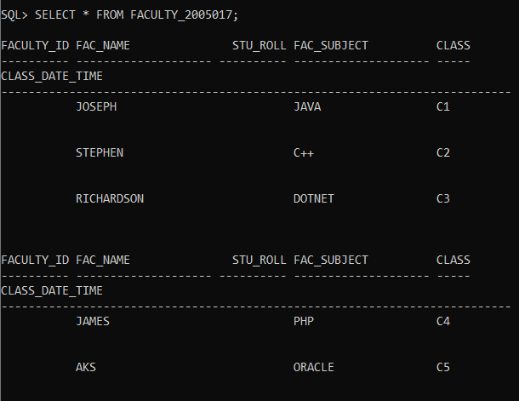

1. Enter exact data into student table. But roll should insert using sequence, it should start from 1 and

increment by 1.[total 5 records]

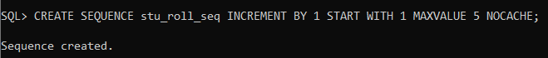

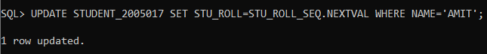

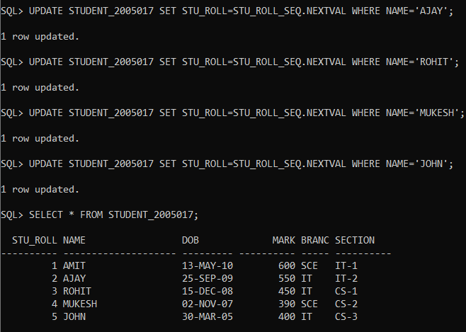

2. Enter exact data into faculty table. But faculty id should insert using sequence, it should start from 1

and increment by 3[total 5 records]. E.g. 1, 4, 7, 10, 13 Also enter student roll into faculty table using

sequence but it should be increment by 2. E.g. 1, 3, 5, 7, 9 [total 5 records].

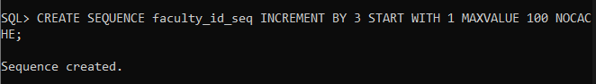

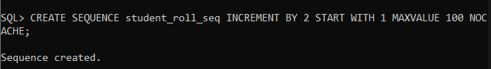

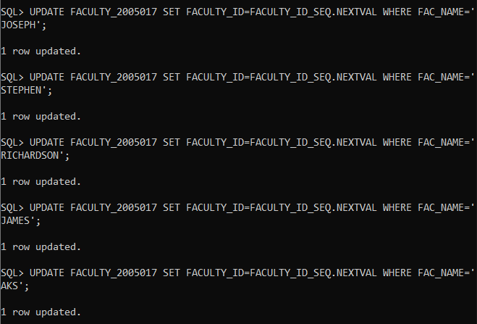

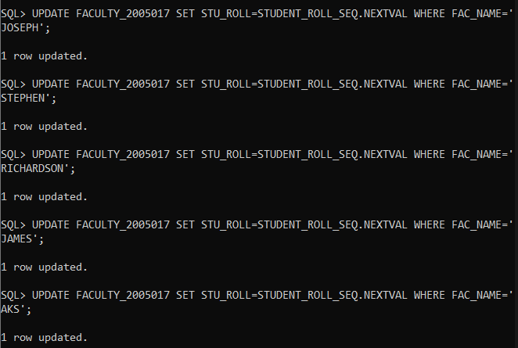

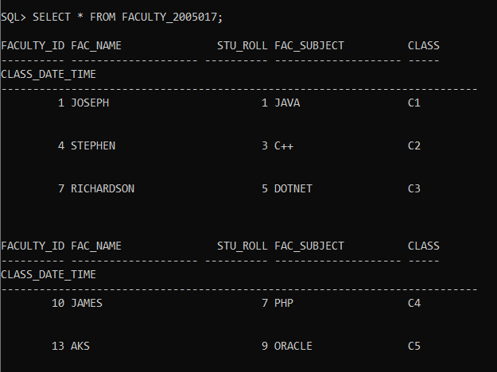

3.Waq to display sequence name, minimum value, maximum value from all created sequences.

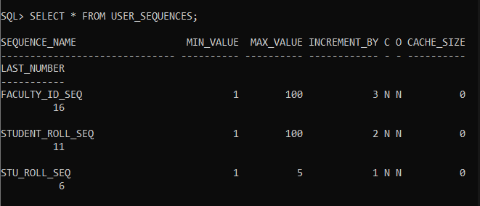

1. Waq to drop these two sequences.

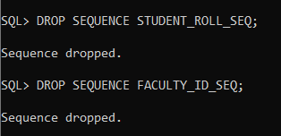

1. Create synonym s55 for student table. And query all rows from synonym. Then drop it.

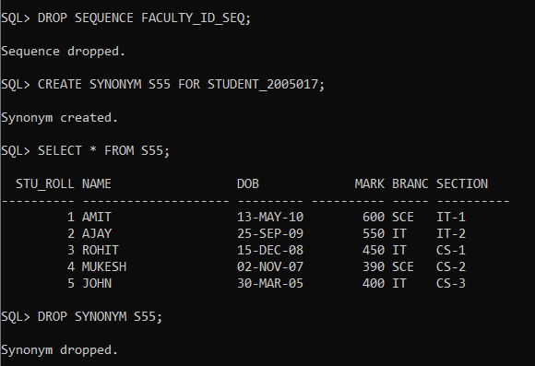

1. Create view stv1 from student table by selecting roll, name , mark & branch column.

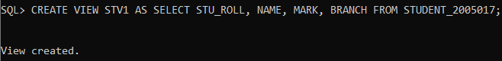

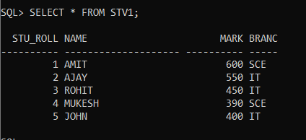

8. Waq to create view stv2 from student table selecting roll, name, dob & mark of rollno 3 which can’t be

deleted from view.

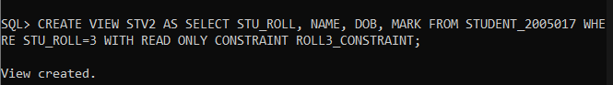

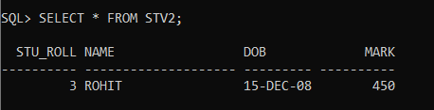

1. Drop these two view from database.

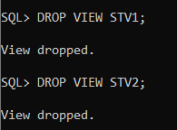

10. Waq to create view st_fa from student & faculty selecting stu_roll, stu name, faculty id, faculty name

where rollno of student table should same to student roll of faculty table.

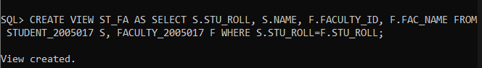

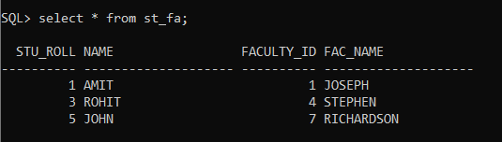

11.Select and drop st_fa view.

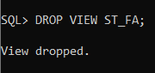

12. Waq to display the student roll, name, dob, mark and faculty name, subject, classroom, from student,

faculty table those student rollno are common to student rollno of faculty table using equi join.

