**ASSIGNMENT 9**

1. Wap to find area of circle in PLSQL.

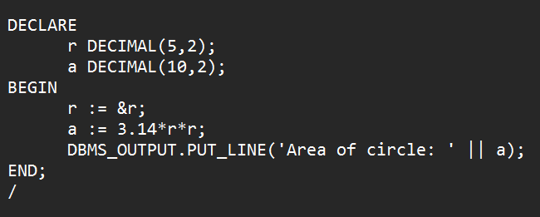

OUTPUT

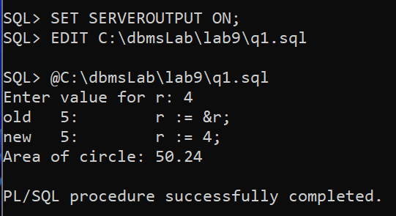

1. Wap to check no is odd or even PLSQL.

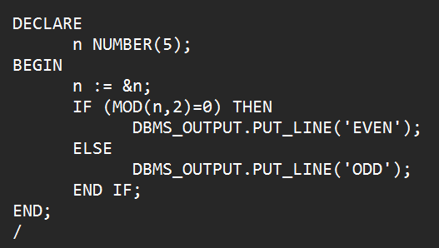

OUTPUT

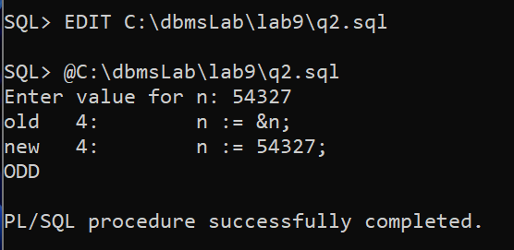

1. Wap to check greatest no among three No. In PLSQL.

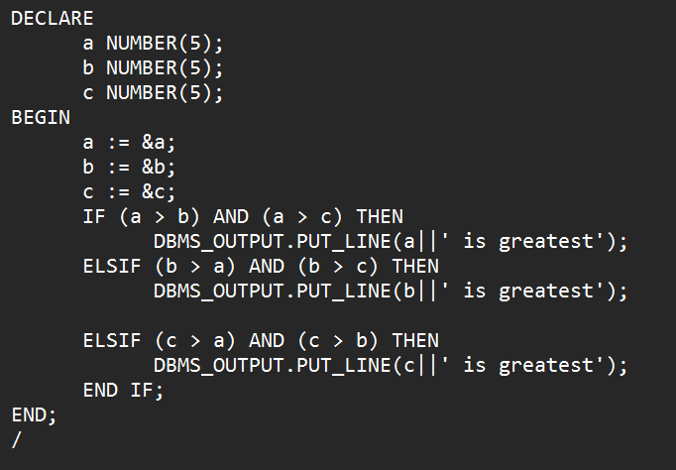

OUTPUT

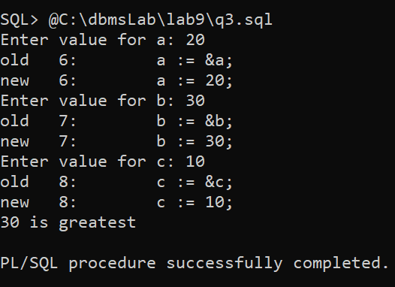

1. Wap to enter character and check it is vowel or consonant in PLSQL.

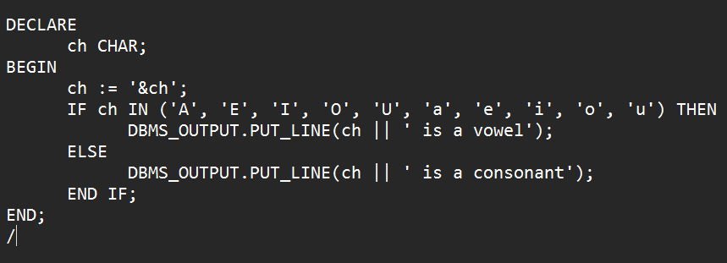

OUTPUT

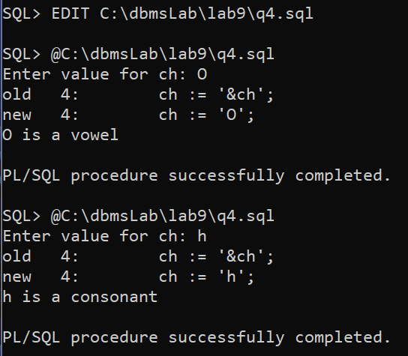

1. Wap to find the multiplication table in PL/SQL.

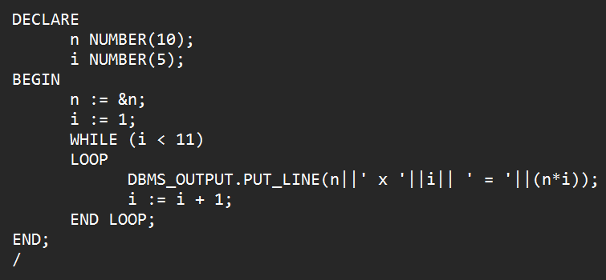

OUTPUT

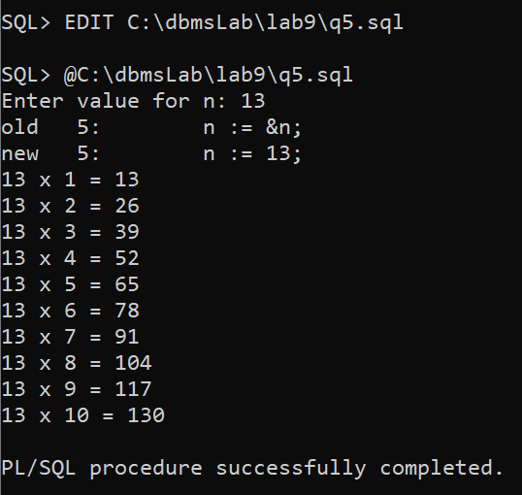

1. Wap to check no is Armstrong no or not in PLSQL.

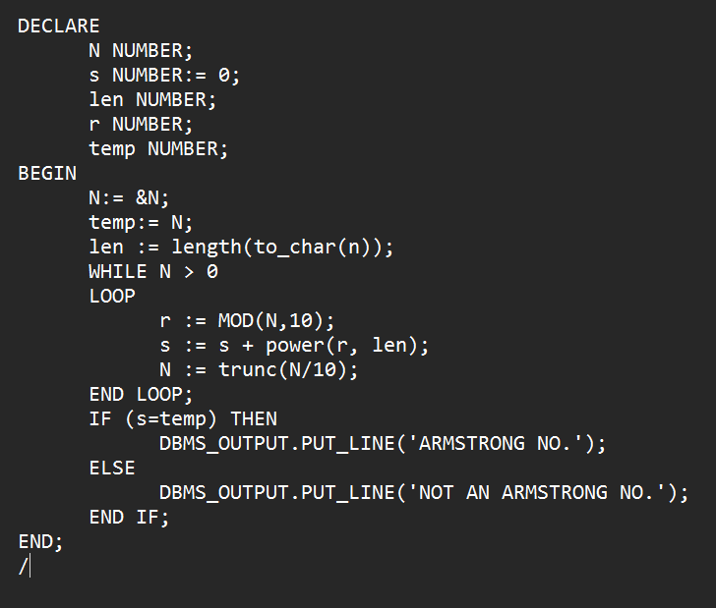

OUTPUT

