

**School of Advanced Technology**

**Project 1 Report**

Project Title: Assignment 1: Web Scraping & Data Analysis

Student Name: Yihan Zhang

Student ID: 1823149

Project field: Web Scraping; Data Analysis

Supervisor: Jia Wang

Co-supervisor (if applicable):

Chinese film industry still has a long way to go

## 1. Introduction

According to a piece of news from BBC [1], the Chinese propaganda film *The Battle at Lake Changjin* ’s box office had beaten Marvel’s *Shang-Chi* and the *Legend of the Ten Rings*. However, since it is a propaganda movie, the patriotism might be the main reason for the high income. Therefore, this news motivates me to check whether Chinese films have really surpassed western films, since the length of the report cannot exceed 2 pages, it is not possible to cover too much overall information, therefore, this report will mainly analyze 100 best classical movies of MaoYan [2] based on regions, especially for China and American.

## 2. Data and Analysis

### 2.1 Region quantity analysis

The first analysis is based on the quantity of the top movies, since it is the most important feature that can judge whether the movie industry is thriving or not. However, it is inevitable that one film can involve more than one country, so the sum of movies is larger than 100. In addition, Hongkong and Taiwan movies are all categorized as Chinese movies.

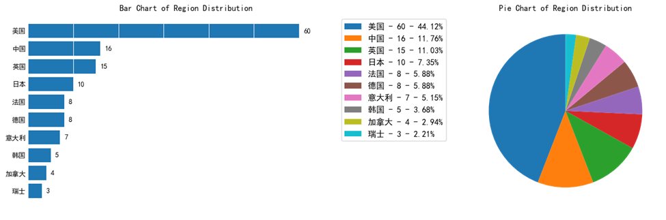

Fig 1. Region distribution of movies

From these two charts, it is clear that American movies occupy the majority (44%) of the top movies, while China ranks the second. Moreover, in addition to the United States, the proportion of other western countries such as UK, is also high. This phenomenon is not surprising because the film technology is invented in western country.

### 2.2 Region quality analysis

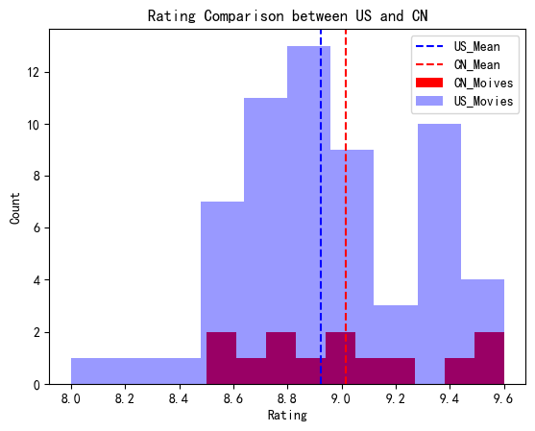

Fig 2. Rating comparison between Chinese and US movies

The second analysis is based on the quality, which is the ratings of the US and China. The dash lines are the mean values of movies. By comparing the ratings, it is lucid to find that though the number of Chinese top movies is less than that of the US, the average rating of Chinese films is higher than that of the United States, which means Chinese movies’ quality can be compared to American movies, or even better.

### 2.3 Region year analysis

From the line graph, it is clearer to see the development of film industry in China and US. In the early years, China did not make good films because of its immature film technology and during that period, Chinese still have to concentrate on the material needs such as the food first and then the spiritual needs such as the films can be considered. China’s reform and opening-up policies have promoted the film industry deeply, including some comprehensive external factors affect the creation and theme expression of domestic films. As the result, after 1980s, Chinese movies have been widely recognized by the world and many of them were in the top list.

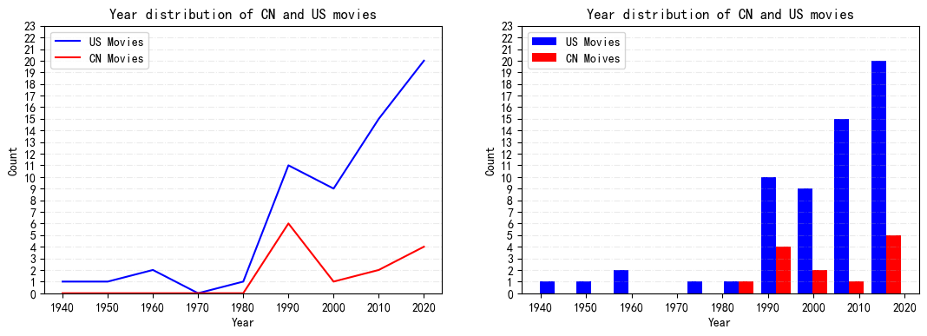

Fig 3. Year comparison between Chinese and US movies

## 3. Conclusion and consideration

It is the truth that the film technology is invented in Western countries and they have dominated the film industry for a long time. Although Chinese film industry has made some achievements in the past decade, considering MaoYan is a domestic website, the comments are mostly from the Chinese audiences, therefore, the ratings might not be neutral. Furthermore, 100 pieces of data are probably not huge enough to summarize the universality of the patterns.

## 4. References

[1] W. Yip, *The Chinese film beating Bond and Marvel at the box office,* 2021, Accessed on: Oct. 22, 2021. [Online]. Available: <https://www.bbc.com/news/world-asia-china-58868854>.

[2] Top100 movies, *MaoYan,* [Online]. Available: <https://maoyan.com/board/4>.