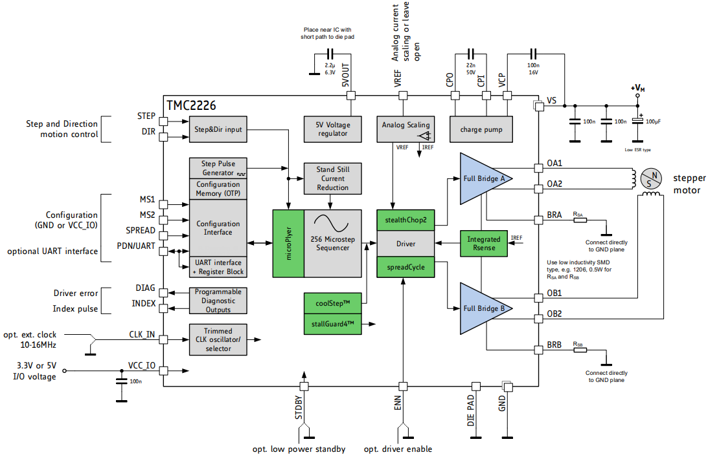

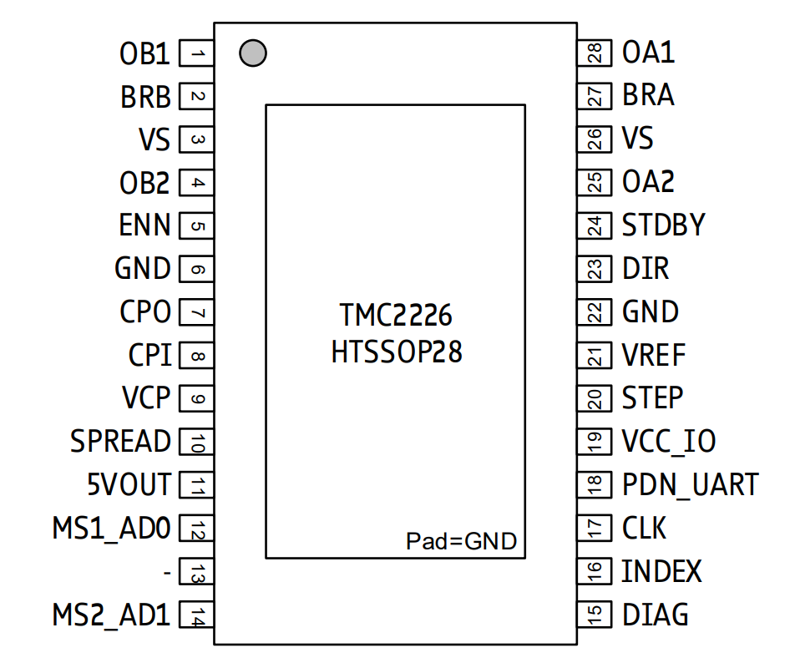

|  |  |  |  |
| --- | --- | --- | --- |
| **Pin** | **Number** | **Type** | **Function** |
| OB1 | 1 |  | Motor coil B output 1 |
| BRB | 2 |  | Sense resistor connection for coil B. Place sense resistor to GND near pin. Tie to GND when using internal sense resistor. |
| VS | 3, 26 |  | Motor supply voltage. Provide filtering capacity near pin with shortest possible loop to GND pad. |
| OB2 | 4 |  | Motor coil B output 2 |
| ENN | 5 | DI | Enable not input. The power stage becomes switched off (all motor outputs floating) when this pin becomes driven to a high level. |
| GND | 6, 22 |  | GND. Connect to GND plane near pin. |
| CPO | 7 |  | Charge pump capacitor output. |
| CPI | 8 |  | Charge pump capacitor input. Tie to CPO using 22nF 50V capacitor. |
| VCP | 9 |  | Charge pump voltage. Tie to VS using 100nF capacitor. |
| SPREAD | 10 | DI (pd) | Chopper mode selection: Low=StealthChop, High=SpreadCycle (may be left unconnected) |
| 5VOUT | 11 |  | Output of internal 5V regulator. Attach 2.2µF to 4.7µF ceramic capacitor to GND near to pin for best performance. Provide the shortest possible loop to the GND pad. |
| MS1_AD0 | 12 | DI (pd) | Microstep resolution configuration (internal pull-down resistors)  MS2, MS1: 00: 1/8, 01: 1/32, 10: 1/64 11: 1/16  For UART based configuration selection of UART Address 0…3 |
| MS2_AD1 | 14 | DI (pd) |
| DIAG | 15 | DO | Diagnostic and StallGuard output. Hi level upon stall detection or driver error. Reset error condition by ENN=high. |
| INDEX | 16 | DO | Configurable index output. Provides index pulse. |
| CLK | 17 | DI | CLK input. Tie to GND using short wire for internal clock or supply external clock. |
| PDN_UART | 18 | DIO | Power down not control input (low = automatic standstill current reduction).  Optional UART Input/Output. Power down function can be disabled in UART mode. |
| VCC_IO | 19 |  | 3.3V to 5V IO supply voltage for all digital pins. |
| STEP | 20 | DI | STEP input |
| VREF | 21 | AI | Analog reference voltage for current scaling or reference current for use of internal sense resistors (optional mode) |
| DIR | 23 | DI (pd) | DIR input (internal pull-down resistor) |
| STDBY | 24 | DI (pd) | STANDBY input. Pull up to disable driver internal supply regulator.  This will bring the driver into a low power dissipation state.  100kOhm pulldown. (may be left unconnected)  *Hint: Also shut down VREF voltage and ENN to 0V during standby.* |
| OA2 | 25 |  | Motor coil A output 2 |
| BRA | 27 |  | Sense resistor connection for coil A. Place sense resistor to GND near pin. Tie to GND when using internal sense resistor. |
| OA1 | 28 |  | Motor coil A output 1 |
| - | 13 | unused | May be connected to GND for better PCB routing |
| Exposed die pad | - |  | Connect the exposed die pad to a GND plane. Provide as many as possible vias for heat transfer to GND plane. Serves as GND pin for power drivers and analogue circuitry. |

|  |  |
| --- | --- |
| **PDN_UART: CONFIGURATION OF STANDSTILL POWER DOWN** | |
| **PDN_UART** | **Current Setting** |
| GND | Enable automatic power down in standstill periods |
| VCC_IO | Disable |
| UART interface | When using the UART interface, the configuration pin should be disabled via *GCONF.pdn_disable* = 1. Program *IHOLD* as desired for standstill periods. |

|  |  |  |
| --- | --- | --- |
| **MS1/MS2: CONFIGURATION OF MICROSTEP RESOLUTION FOR STEP INPUT** | | |
| **MS2** | **MS1** | **Microstep Setting** |
| GND | GND | 8 microsteps |
| GND | VCC_IO | 32 microsteps (different to TMC2208!) |
| VCC_IO | GND | 64 microsteps (different to TMC2208!) |
| VCC_IO | VCC_IO | 16 microsteps |

|  |  |
| --- | --- |
| **SPREAD: SELECTION OF CHOPPER MODE** | |
| **SPREAD** | **Chopper Setting** |
| GND or Pin open / not available | StealthChop is selected. Automatic switching to SpreadCycle in dependence of the step frequency can be programmed via OTP. |
| VCC_IO | SpreadCycle operation. |