# SMP Ninja 1.0

SMP Ninja is a program that “listens” for you to copy information from SMP and formats it into a more useful form; it scans for MIBs out of spec and returns the OOS values for TX, RX, and SNR if any out of spec values are found, and the first found values if not, and it retrieves the modem model, MAC, and what package the customer is on. MIBs are formatted in the format required for truck rolls.

There are two columns in the program as this tool was developed for use by Live Chat, but non chat agents can still use it by simply ignoring the second column after their second call (or filling the 3 main memo fields with gibberish and never clearing them)

## Using SMP Ninja

Simply copy the application to a location where you have write access (such as your My Documents folder) and double-click smpninja.exe. You will be presented with a screen like the following:

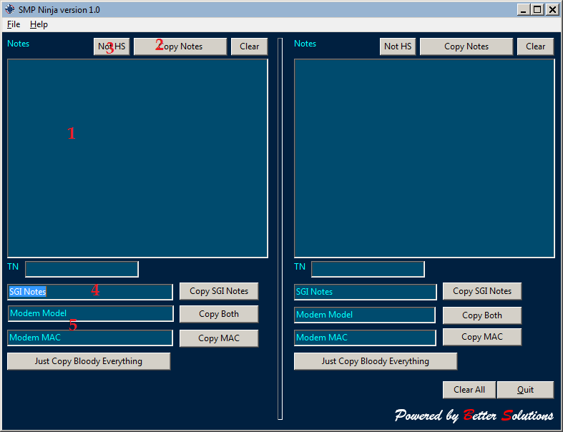

1. This is the Notes field; where you can enter any notes for ICM. If you are using the Bold application, highlight the entire column for the chat you are on and press CTRL+C to autopopulate the first empty notes field with the chat details. (Note: the Reverse IP and Chat ID columns must be enabled for this to be effective).  
   If you are using Web Bold, ensure that the “Web Bold Scraping” option in the File menu is checked (on by default) and copy the Web Bold chat header. Web Bold Scraping can be disabled for users also using Dave Lowe’s ct-lc, as its autocopy feature conflicts with SMP Ninja’s.
2. Copy Notes button. Just what it says on the tin. It will move everything in the Notes field to your Clipboard so you can paste them into ICM
3. Not HS button: This button prevents the Paste RHSI Check MIBS and Paste Subscriber Info memos from automatically populating when information is copied from SMP, ensuring that your Notes column aligns with the SMP data for that customer, and not the home phone customer you were serving before that chat came in.
4. When RHSI check MIBS is copied, this will create a note in the form TX=#/Rx=#/SNR=# for use in SGI when booking a truck. If any MIBs are out of spec, those are the ones that will appear in this note, so there is no need to scroll through a document approximately the length of the Constitution Act of 1867 in order to see if anything is out of spec.
5. Model and MAC populate when subscriber info is copied.

## Getting Info from SMP

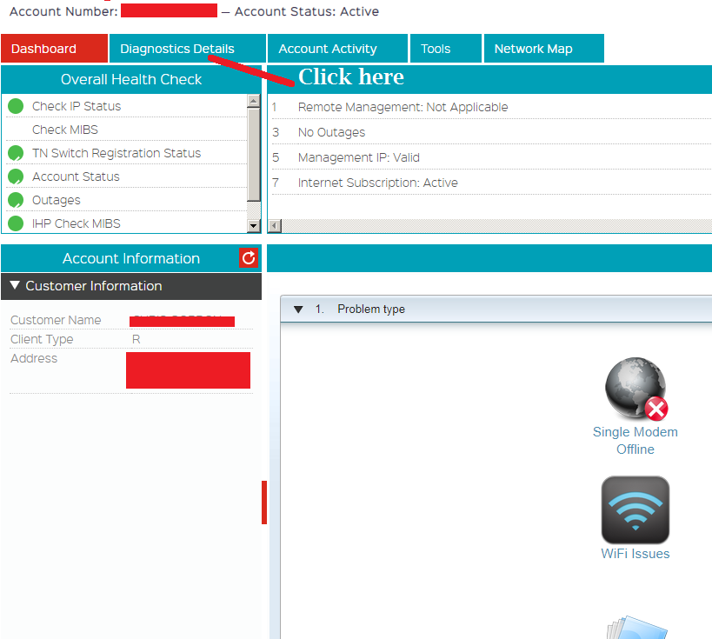

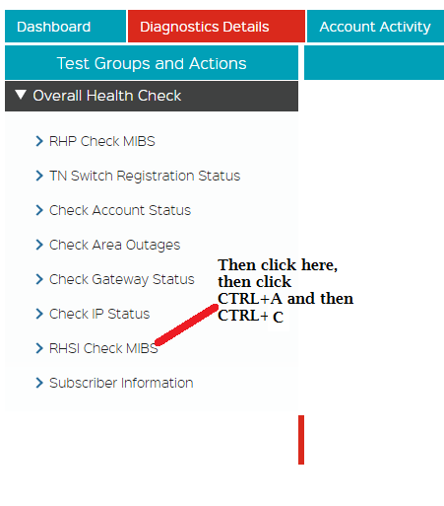

You’ll get something like this:

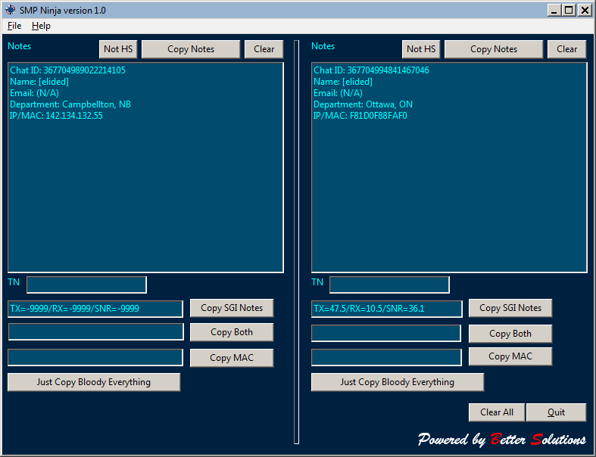

Notice the MIBs are filled out. (They did not go into the first column because that was a home phone chat so I had pressed “Not HS”)

Now do the same with Subscriber Information that you did with RHSI check mibs to get this:

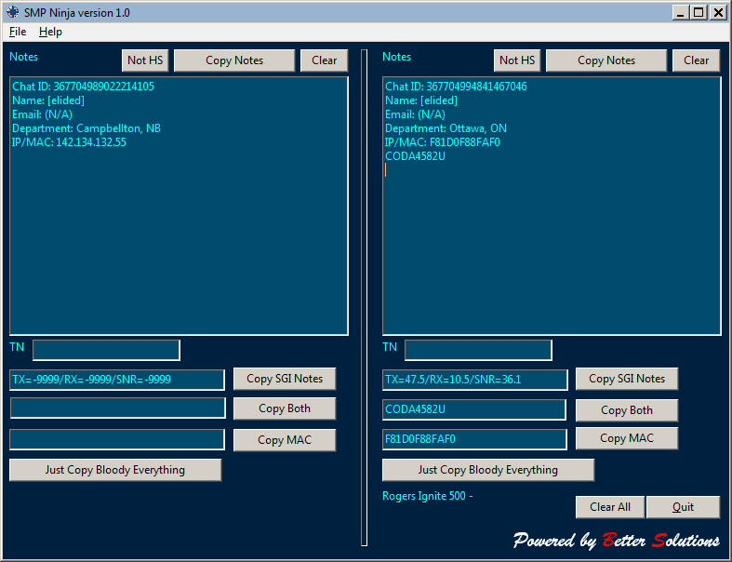

## SMP Ninja Extras

### The TN Field

The TN field doesn’t deal with SMP at all – It’s simply a holding pen for phone numbers. I find when booking a truck that I am entering usually the same number for SMS to call in ICM, then again in SGI for the number the tech calls on the way, and a third time for the EnRoute notification – and I *always* need to use the clipboard in between each of those times, so I have to scroll up two pages to where the user has entered their number as “++1-(555) 555,5555” (and whatever else they can think of to sabotage people using copy/paste). When you paste a number into the TN field and then interact with any other part of the form (such as clicking a blank area), it will automatically remove anything that isn’t a number, and if the first digit is a 1, it removes it. As an added bonus, when you click in the TN field, if it’s not blank, it automatically copies its contents to the clipboard, so you don’t even need to highlight it and press CTRL+C. (If it is blank, it does nothing, otherwise clicking on it to paste the number in would blank out your clipboard…which I found out the hard way)

### Themes

Don’t like my colour scheme? Want an eyeball-searingly bright scheme instead? No problem! In the File menu, there’s a Themes option. You can keep the default theme, or use a cream-coloured Light theme, a copy of the dark theme from CT-LC, a couple of Remembrance Day themes, or a very well-named horror called ed’s Technicolour Nightmare. As I add more themes, they will automatically appear next time you restart the program.

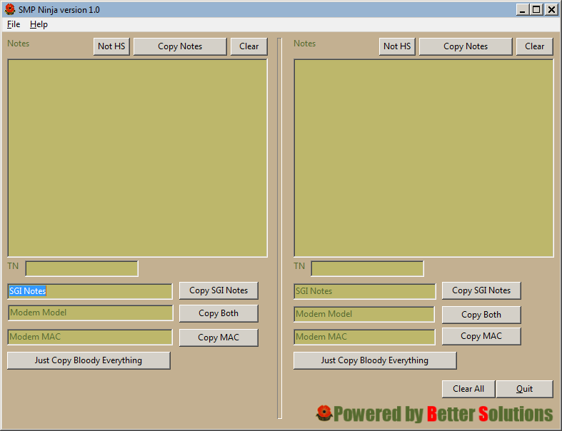

The Lest We Forget theme