**2017ICS_Lab01**

**PB16030899 Zhu Heqin**

1. **PURPOSE**This lab makes us use machine language, namely 0&1, to write programs. Through this experience, we can have a deep understanding of the ISA and use machine language more proficiently.
2. **PRINCEPLE**  
   I wrote program by using the instructions of ISA of LC-3,  
   such as: LEA ADD LDR STR BR HALT  
   Once I wrote this program by binary or hexes or assemble language, I can convert it into executable object file. Then I load this file in the LC-3 simulator and it will execute the program and get the result.
3. **PROCEDURE**Firstly, I learned the ISA hardly and painfully. Because the instructions introduced by the book I borrowed has some rules mismatch the rules of LC-3.   
   Once I knew the instructions, I can quickly and correctly write the program.  
   Then, I knew how to use the simulator, such as registers , PC ,memory etc.  
   At last, I chose some test cases and ran the program .It got the right result.
4. **RESULT**Before executing the program: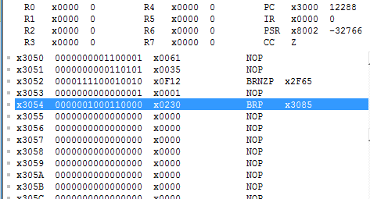  
   After executing the program: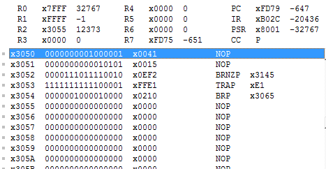  
   It works well. Through this lab , I learned a lot. (When learning new things, choosing a good book is the most important thing.)