# TERMS OF REFERENCE

Affordable Housing Pty Ltd, a new real estate company requires advise, design and development of a database system to meet their needs. The database system should store information about individuals with intentions to sell or rent their properties. It should also be able to keep records of buyers of the properties or the tenants renting the properties.

# DATABASE ENTITIES

* Entity: Owner

Attributes:id, firstname, lastname, address

* Entity: Property

Attributes: property id, propertytype, city, number of rooms, sale price, rent price

* Entity: buyer

Attributes: omang, firstname, lastname, address

* Entity: Tenant

Attributes: omang, firstname, lastname, address

Relationships

* Owner can sell or rent Property.
* Buyer can buy property.
* Tenant can rent property.

I assume the entities are going to relate through tables carrying information of the relation. For instance, when a tenant rents a property the database has to keep record of the tenantid, property id, start date and expected end date and actual end date. When a buyer purchases a property the database has to keep record of the  buyerid,propertyid, purchasedate.The database should be able to show which the owners and the properties that they own.

# BUSINESS RULES

There should be primary keys to uniquely identify the entities in the Database System. The primary Keys cannot be null. Owner can be identified by the owner id, Property by the property id, the buyer by their omang number and the tenant also by their omang number. The primary Key Constraint.

The omang columns for the buyer and the tenant should be unique. The Not Null Constraint-the database relations should not have null values.

Foreign Key Constraint to make sure that the the values from the property id, owner id, buyer id and tenant id are uniquely referenced from the tables which holds relationship information. Or where information is referenced.

The property size should be more than 60m2 therefore there is need for a check constraint to make sure the property size being input is above 60m2.

Check constraints to check if the right values for rent are input in the database relation.

# ENTITY RELATIONSHIP DIAGRAM

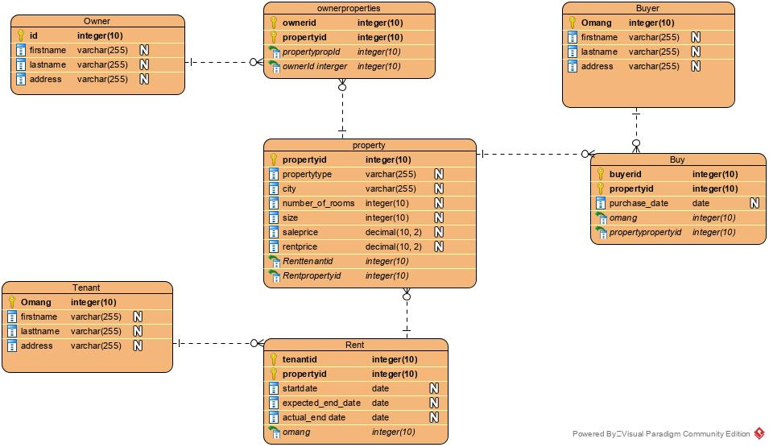

# RESOURCES

Human Resources-This refers to the database administrator affordable housing who will be using working on the database schema. Handling the kind of data being passed to the database and monitoring database progress. Writes and Enforces database Procedures and standards.

Software-Oracle is used to create the database system. The scripts will be written in visual studio code and executed on Oracle sql plus.

Hardware-to Back up the scripts they are to be kept in a Hard drive which is kept separate from where the database is being kept. The Database is built using a desktop computer.

Data-information that is going to be stored in the database. It is data about Affordable Housing Clients.

Procedures- For manipulating and using the data from AFFORDABLE Housing Clients.