**TASK TWO**

a)

I) Table scripts

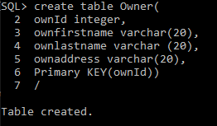

The owner table was created for storing all the owners in the database.

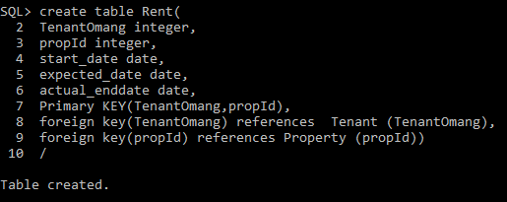

Rent table created from that script above.

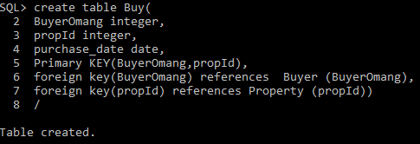

Composite table created called buy referencing other tables like property and Buyer as seen from above.

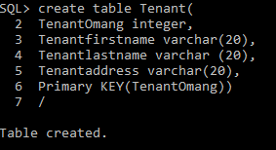

Tenant table was created.

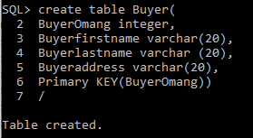

Buyer Table was being created.

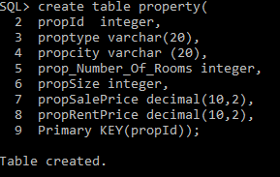

Property table created.

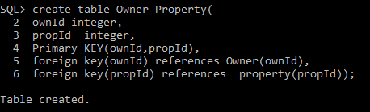

Composite table Owner property which has ownId and prepaid .

II)Minimum of property size which is eligible for rent is 60m2 .

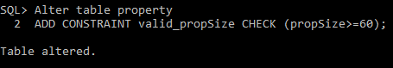

Check constraint called valid_propSize has an expression which check if the value entered eligible to be entered in the database.

III) Minimum rent accepted is P2000.00.

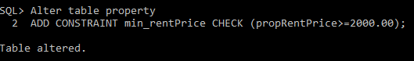

Another check constraint called min_rentPrice has expression which check if the rent money entered is correct to be inserted into property.

**B) Drafted sql statements.**

**I)** Houses listed for rent in a specific (Certain Location).

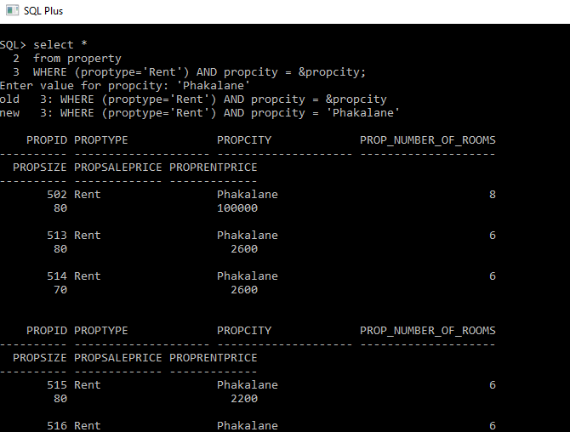

Property for are selected by certain location here I used Phakalane.

**II)Owner with only one property**

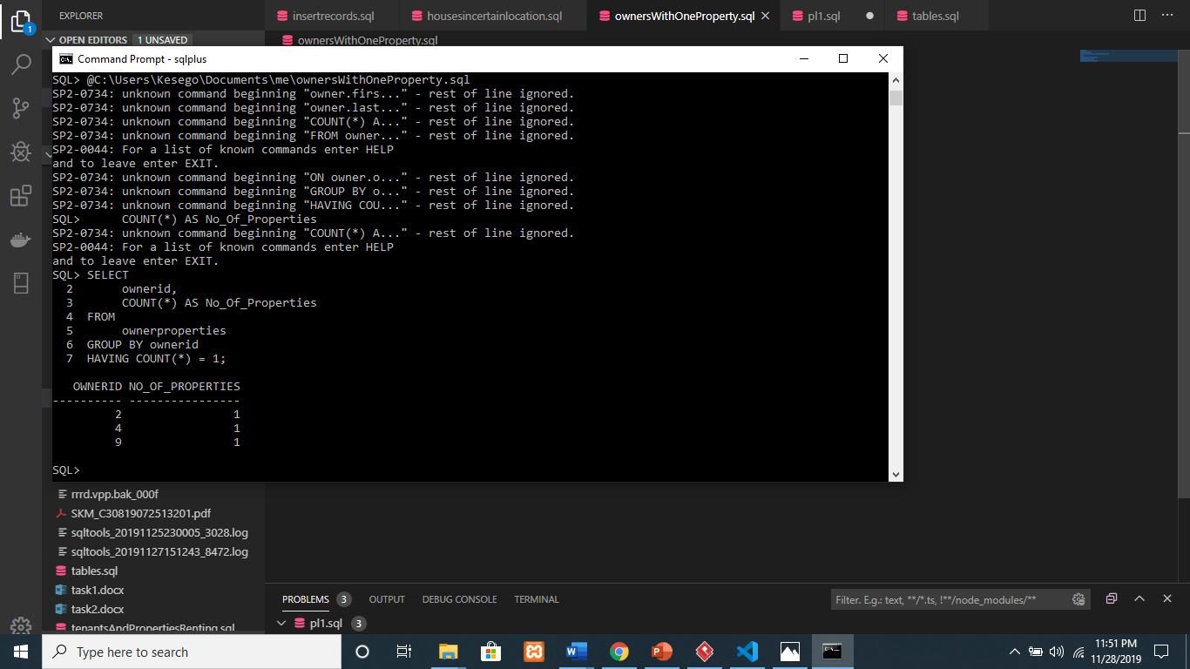

**III)Properties rented and the names of tenants**

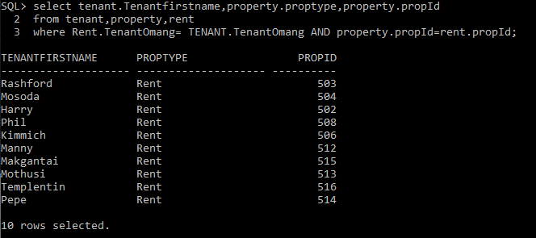

The sql statement which show all the properties tenants are renting and their names.

**IV)Sale price greater than average sale price**

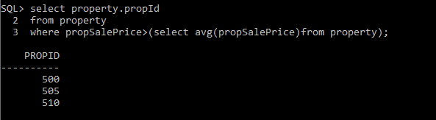

The statements select properties over average price .

**V) average Prices of houses for sale per location.**

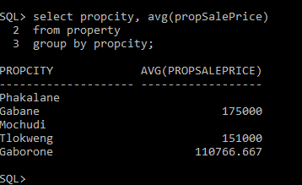

The places like Phakalane and Mochudi does not have places for rent as for now but the rest are given their average prices.

**VI)specific house prices lowered by 10 Percent.**

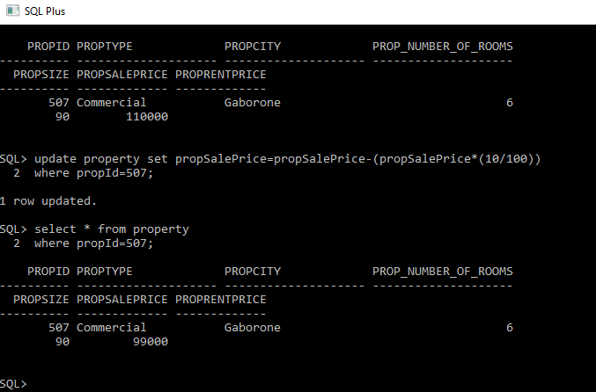

The sql statements above show before the update statement then after being lowered by 10%.

**TASK THREE**

**a)**

