The Azure CLI is used to create and manage Azure resources from the command line or in scripts. This quickstart details using the Azure CLI to deploy a virtual machine running Ubuntu server. Once the server is deployed, an SSH connection is created, and an NGINX webserver is installed.

If you don't have an Azure subscription, create a [free account](https://azure.microsoft.com/free/?WT.mc_id=A261C142F) before you begin.

[!INCLUDE [cloud-shell-try-it.md](https://github.com/MicrosoftDocs/azure-docs/blob/master/includes/cloud-shell-try-it.md)]

If you choose to install and use the CLI locally, this quickstart requires that you are running the Azure CLI version 2.0.4 or later. Run az --version to find the version. If you need to install or upgrade, see [Install Azure CLI 2.0](https://github.com/MicrosoftDocs/azure-docs/blob/master/cli/azure/install-azure-cli).

**Create a resource group**

Create a resource group with the [az group create](https://github.com/MicrosoftDocs/azure-docs/blob/master/cli/azure/group#az_group_create) command. An Azure resource group is a logical container into which Azure resources are deployed and managed.

The following example creates a resource group named *myResourceGroup* in the *eastus* location.

az group create --name myResourceGroup --location eastus

**Create virtual machine**

Create a VM with the [az vm create](https://github.com/MicrosoftDocs/azure-docs/blob/master/cli/azure/vm#az_vm_create) command.

The following example creates a VM named *myVM* and creates SSH keys if they do not already exist in a default key location. To use a specific set of keys, use the --ssh-key-value option.

az vm create --resource-group myResourceGroup --name myVM --image UbuntuLTS --generate-ssh-keys

When the VM has been created, the Azure CLI shows information similar to the following example. Take note of the publicIpAddress. This address is used to access the VM.

{

"fqdns": "",

"id": "/subscriptions/d5b9d4b7-6fc1-0000-0000-000000000000/resourceGroups/myResourceGroup/providers/Microsoft.Compute/virtualMachines/myVM",

"location": "eastus",

"macAddress": "00-0D-3A-23-9A-49",

"powerState": "VM running",

"privateIpAddress": "10.0.0.4",

"publicIpAddress": "40.68.254.142",

"resourceGroup": "myResourceGroup"

}

**Open port 80 for web traffic**

By default only SSH connections are allowed into Linux virtual machines deployed in Azure. If this VM is going to be a webserver, you need to open port 80 from the Internet. Use the [az vm open-port](https://github.com/MicrosoftDocs/azure-docs/blob/master/cli/azure/vm#az_vm_open_port) command to open the desired port.

az vm open-port --port 80 --resource-group myResourceGroup --name myVM

**SSH into your VM**

Use the following command to create an SSH session with the virtual machine. Make sure to replace **publicIpAddress** with the correct public IP address of your virtual machine. In our example above our IP address was *40.68.254.142*.

ssh publicIpAddress

**Install NGINX**

Use the following commands to update package sources and install the latest NGINX package.

# update package source

sudo apt-get -y update

# install NGINX

sudo apt-get -y install nginx

**View the NGINX welcome page**

With NGINX installed and port 80 now open on your VM from the Internet - you can use a web browser of your choice to view the default NGINX welcome page. Be sure to use the *publicIpAddress* you documented above to visit the default page.

[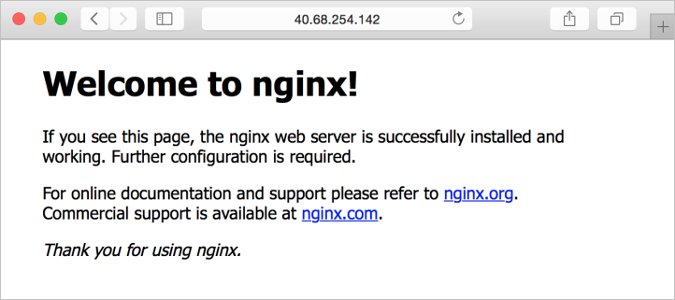](https://github.com/MicrosoftDocs/azure-docs/blob/master/articles/virtual-machines/linux/media/quick-create-cli/nginx.png)

**Clean up resources**

When no longer needed, you can use the [az group delete](https://github.com/MicrosoftDocs/azure-docs/blob/master/cli/azure/group#az_group_delete) command to remove the resource group, VM, and all related resources. Exit the SSH session to your VM, then delete the resources as follows:

az group delete --name myResourceGroup

**Next steps**

In this quick start, you’ve deployed a simple virtual machine, a network security group rule, and installed a web server. To learn more about Azure virtual machines, continue to the tutorial for Linux VMs.

[!div class="nextstepaction"] [Azure Linux virtual machine tutorials](https://github.com/MicrosoftDocs/azure-docs/blob/master/articles/virtual-machines/linux/tutorial-manage-vm.md)