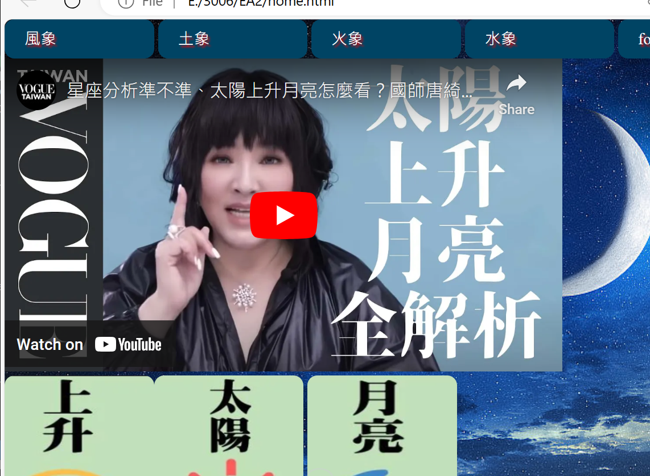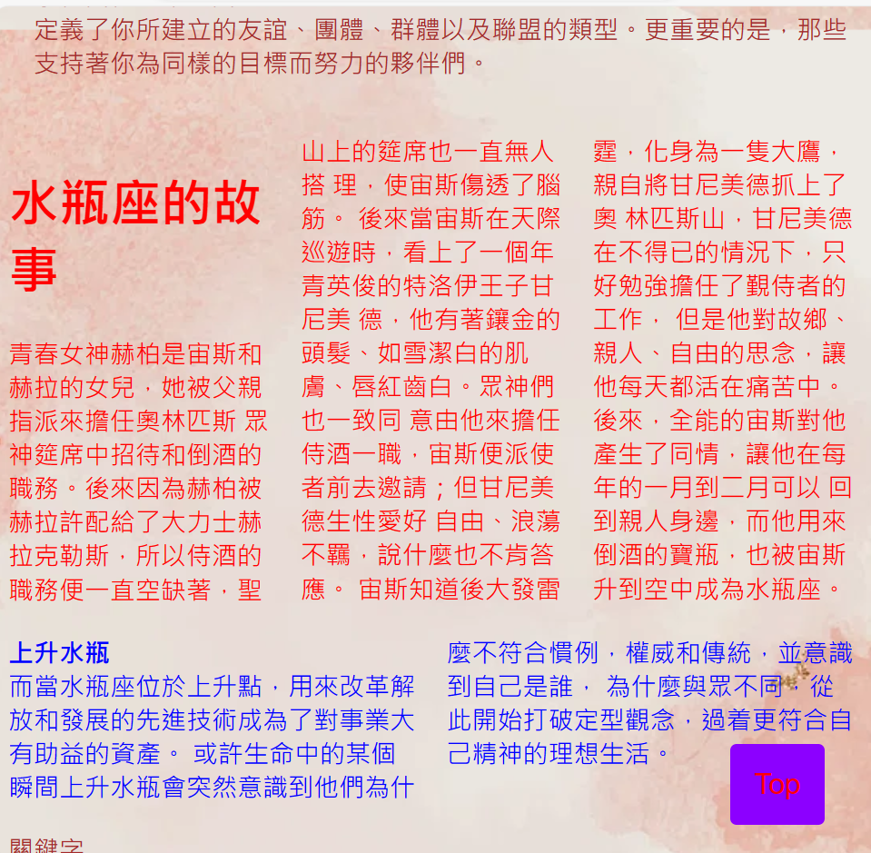

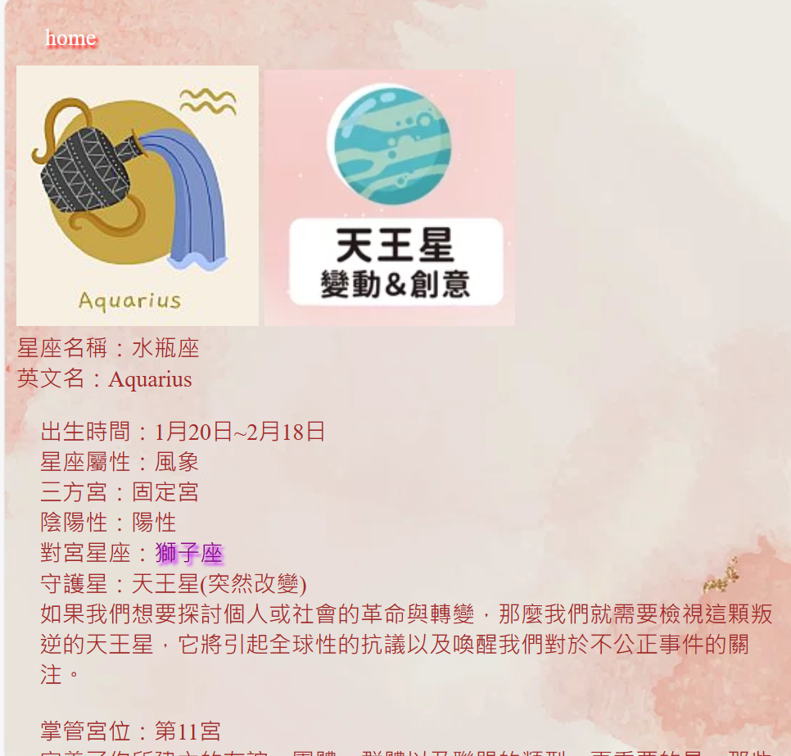

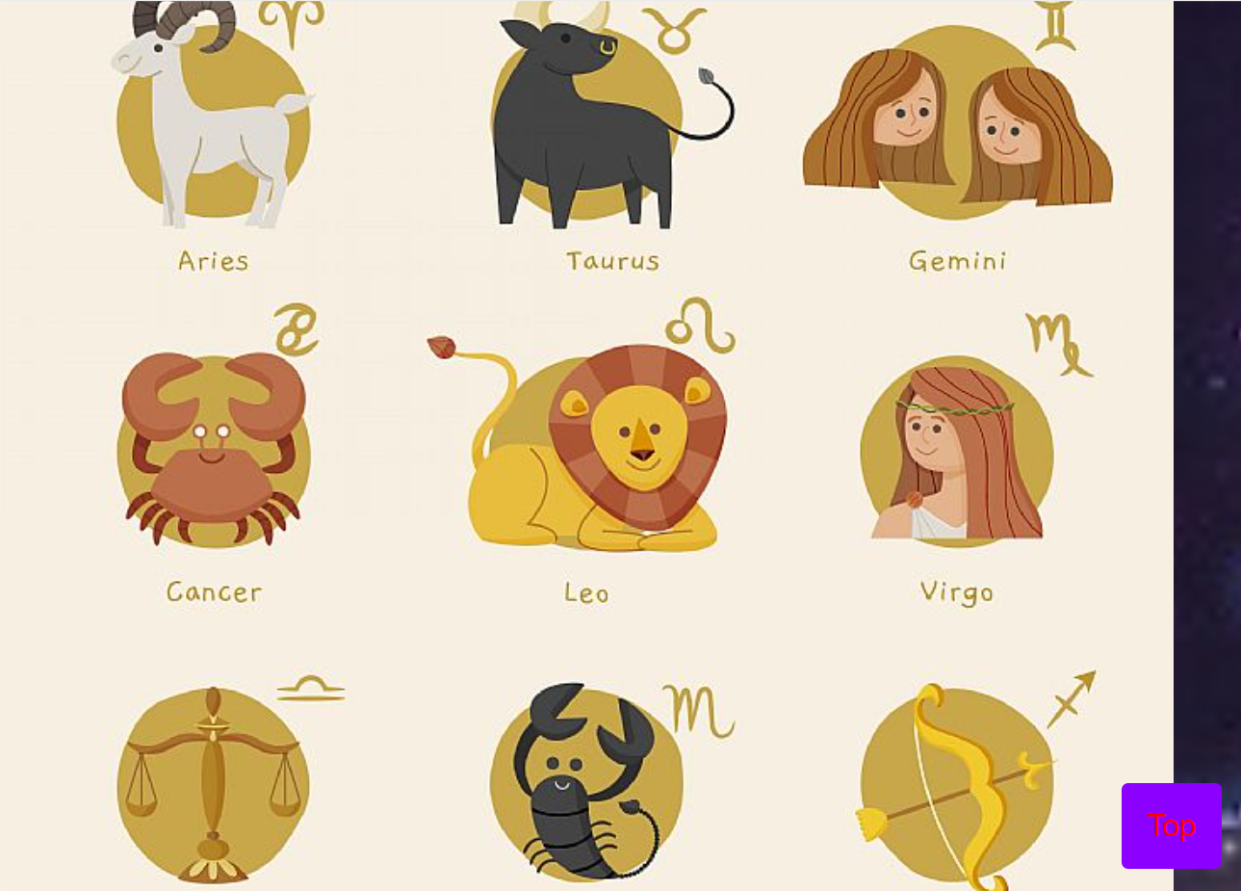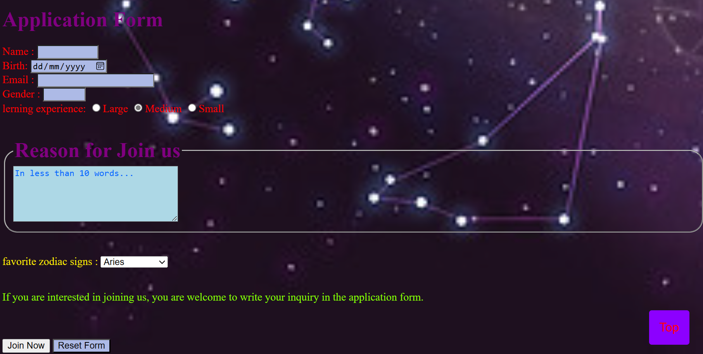

Here is a report on the design concept of a constellation-themed website that aims to provide comprehensive information about the twelve zodiac signs and the stories behind them, allowing users to effectively understand the characteristics of each sign. By incorporating a starry background on the homepage, the website enhances the sense of mystery and highlights the distinct qualities of each zodiac sign. It serves as a platform for users to learn about astrology and zodiac signs. This report will introduce the design concept, features, user experience of the website and how to achieve these goals. The design style of the website will reflect a mysterious and comfortable approach to provide an enjoyable user experience.

First, the homepage will have a clear layout with concise icon categories for the three elements: Earth, Water, Wind, and Fire, symbolizing the energy radiating from the universe, such as the fiery passion and impulsive energy. Fire signs reflect high spiritual power, strong confidence, limitless energy, and straightforward honesty. They aspire to make life more meaningful and influence the external world with their own power but often overlook the subtle needs of themselves and others.

Earth signs heavily rely on sensory and practical matters. They are born with an understanding of how the real world operates, which makes them patient and disciplined. The Earth element represents prudence, thoughtfulness, conservatism, and reliability. Knowing their place in the world is important for Earth signs, as they strive for a sense of security throughout their lives.

Air signs release life energy like breath, transcending the material world and representing the prototype of the conceptual world. In the Air element, cosmic energy manifests through thought patterns. The inner needs of Air signs involve distancing themselves from the present daily life to objectively and macroscopically perceive and handle everything in a rational and detached manner. They possess a natural ability to communicate with others and understand different perspectives.

Water signs rely on a life guided by emotions. They can perceive subtle differences that others often overlook. The Water element represents deep emotions and responsive feelings, ranging from obsessive passion to destructive fears and encompassing great love for everything in the world. Water signs are naturally aware of their deepest desires and must protect themselves from external influences to ensure deep introspection, inner peace, and keen awareness. They rely on intuition and have a profound healing energy.

Secondly, the homepage and table will have an attractive dark background and colors to allow users to easily browse and access information, increasing visual appeal. The selected images and illustrations of the twelve zodiac signs will be adorable and symbolize the world of constellations that the website will create. Users can participate in astrology and communicate with like-minded people by filling out a simple form. To ensure a consistent experience across different devices, the website will have a responsive design that adapts to various screen sizes and device types, including desktop computers, tablets, and mobile phones. The website will provide detailed descriptions of each zodiac sign, including date ranges, major planets, and character traits. By browsing this information, users can better understand their own characteristics and those of other signs. The twelve houses will also correspond to different zodiac signs. The website serves as an introduction for beginners to understand the theme of astrology, leading users to delve into the theory and applications of astrology themselves. For example, the rising sign is innate and represents the personal image perceived by others when they haven't actually interacted with each other. It is easy to deceive others in terms of temperament and appearance.

The Sun sign represents self-awareness and, in simple terms, embodies the ideal self. It primarily represents the external impression one makes. The focus of the Sun is the core traits of oneself. The Sun represents pursuit, while the Moon represents needs. The Moon sign represents the subconscious inner self, such as emotional reactions, life needs, personal life, and sense of security, all reflected in the Moon sign.

The Sun sign and Moon sign exert a pulling force on each other. The website will also emphasize the significance of zodiac signs in daily life. To facilitate communication and sharing among users, the website will include forms for joining astrology communities. Users can engage in discussions and share experiences with other astrology enthusiasts. The website will have user-friendly navigation, allowing users to easily browse through various pages and features. Clear layouts and well-defined navigation menus will help users quickly find the desired information and features.

Different colors of text allow users to separate different contents and pay more attention. Because each page is too long, there is a button in the lower right corner that can be clicked to go up. Users can click on the homepage to go to different pages. The first house of the zodiac is [life] Palace], also known as the Ascendant Palace, is originally the fixed position of Aries. It represents personality, intention, attitude, vitality, early environment, body appearance, physical condition, and self-development ability.

The second house is [Money and Silk Palace], which is originally the fixed position of Taurus. Represents a person's material and resources - "I own", representing wealth, desires, resources, values, earning power, material life, securities (stocks, bonds), etc.

The third house is the [House of Brothers], which is originally the fixed position of Gemini. It represents a person's environment, representing speech, thinking, communication, learning, examinations, brothers and sisters, interpersonal relationships, short-distance travel, and education below university.

The fourth house is [Tian Zhai Palace], which is originally the fixed position of Cancer. It represents a person's inner emotions and family, and represents private life, real estate, mood feelings, safety awareness, parental discipline, later life, family life and affairs.

The fifth house is [the palace of children], which is originally the fixed position of Leo. The fifth house represents a person's attitude and expression of feelings. Represents children, love, passion, pregnancy, sexual relations, speculation, private social interaction, leisure and entertainment, creative or artistic abilities.

The Sixth House is the House of Servants, which is originally the fixed position of Virgo. In the past, the sixth house represented one's attitude towards servants, but now it has been transformed into one's attitude towards employees. It also shows one's work, involuntary labor, service, subordinates, health and diet, etc.

The seventh house [marriage palace] is originally the fixed position of Libra. Represents a person's "one-on-one relationship" attitude. It shows relationships such as marriage, partnership, trade, social interaction, contract, litigation, etc.

The eighth house [Palace of Disasters] is originally the fixed position of Scorpio. It represents "regeneration ability" and things obtained from others (whether tangible or intangible), showing a person's inheritance, insurance, trust, taxes and dowry, etc. And since the ruler of Scorpio is Pluto, the eighth house also represents a person's attitude towards death and mysterious things. The ninth house is the [Migration Palace], which is originally the fixed position of Sagittarius. Represents law, religion, belief, philosophy, long-distance travel, foreign affairs (trade, immigration), and education above graduate school.

The tenth house is [Guanlu Palace], which is originally the fixed position of Capricorn. Represents goals, ambition, responsibility, authority, credibility, career, politics, boss, fame and reputation, achievement and status.

The eleventh house [Fortune Palace] is originally the fixed position of Aquarius. It represents a person's attitude and relationship with the group. It shows a person's friendship status, social outlook, ideals, dreams, charity activities, etc.

The Twelfth House [Mysterious Palace] is originally the fixed position of Pisces. The twelfth house represents a person's unknown strength or weakness. It shows a person's limitations, secrets, subconsciousness, sacrifices, unpaid services, secret enemies, etc.

The design concept of the constellation-themed website aims to provide users with comprehensive zodiac information. Through comfortable design, visual appeal, and rich features, the website will be the ideal choice for astrology enthusiasts. Users will be able to explore zodiac overviews and join astrology communities, providing them with an engaging, useful, and inspiring experience to better understand themselves and the world of zodiac signs