


DS311 / DS241
System Modeling and Simulation
Project Report
Problem I [Bank Multi-Channel Queue]
Problem II [Newspapers Seller]

Supervised by:
Dr. Ayman Sabry Ghoneim

Team Members
ID | Name | #
20200776 | Mariam Khaled Mohamed | 1
20201067 | Rana Ashraf Mohamed | 2
20200375 | Fatma Khaled Mohamed | 3
20200646 | Youssef Gamal Abd El-Zaher | 4

Table of Contents
Problem I [Bank Multi-Channel Queue] 3
Part 1 3
Problem: 3
objective: 3
Part 2 3
System Components: 3
System analysis: 4
Part 3 5
Part 4 5
Results Analysis: 6
Conclusion: 8
Problem II [Newspapers Seller] 9
Part 1 9
1. Problem statement: 9
2. Problem objectives: 9
3. Problem formulation: 9
Part 2 10
1. System components: 10
2. System analysis: 10
Part 3 14
1. Experimental design parameters: 14
2. Justification of experimental design parameters: 14
Part 4 14
- Simulation results: 14
- Plots: 15
- Conclusion: 16

Problem I [Bank Multi-Channel Queue]

Part 1

Problem:
The problem here for that project it's for determining the average waiting time before and after adding additional teller to serve the distinguished customers only to make all customers satisfied.

objective:
Determining if the bank should add additional teller to serve the distinguished customers only or leave everything as it is.

Part 2

System Components:

System | Entity | Attributes | Activities | Events | States
Banking | customers | -Customer type.  -Customer’s arrival time.  -Customer’s service start time.  -Customer’s completion time. | Waiting time. | -Inter-arrival time.  -Service time. | -teller idle.  -teller busy.  -no.of customers in the ordinary queue.  -no.of customers in the distinguished queue.

System analysis:
Ordinary Customer

Time between Arrivals (Minutes) | Probabilities | Cumulative  Probabilities | Service Time (Minutes) | Probabilities | Cumulative  Probabilities
0 | 0.09 | 0.09 | 1 | 0.20 | 0.2
1 | 0.17 | 0.26 | 2 | 0.40 | 0.6
2 | 0.27 | 0.53 | 3 | 0.28 | 0.88
3 | 0.20 | 0.73 | 4 | 0.12 | 1
4 | 0.15 | 0.88
5 | 0.12 | 1

theoretical AVG IAT = 2.5
theoretical AVG ST = 2.5

Distinguished Customer

Time between Arrivals (Minutes) | Probabilities | Cumulative  Probabilities | Service Time (Minutes) | Probabilities | Cumulative  Probabilities
1 | 0.1 | 0.1 | 1 | 0.10 | 0.1
2 | 0.2 | 0.3 | 2 | 0.30 | 0.4
3 | 0.3 | 0.6 | 3 | 0.38 | 0.78
4 | 0.4 | 1 | 4 | 0.22 | 1

theoretical AVG IAT = 2.5
theoretical AVG ST = 2.5

Ordinary Customer | Distinguished Customer

IAT | AT | ST | SST | WT | CT | TIS | IAT | AT | ST | SST | WT | CT | TIS
1 | 1 | 2 | 4 | 3 | 6 | 5 | 1 | 1 | 3 | 1 | 0 | 4 | 3
5 | 6 | 2 | 31 | 25 | 33 | 27 | 4 | 5 | 3 | 6 | 1 | 9 | 4
4 | 10 | 2 | 33 | 23 | 35 | 25 | 1 | 6 | 3 | 9 | 3 | 12 | 6
5 | 15 | 3 | 35 | 20 | 38 | 23 | 2 | 8 | 2 | 12 | 4 | 14 | 6
4 | 19 | 2 | 38 | 19 | 40 | 21 | 3 | 11 | 2 | 14 | 3 | 16 | 5
5 | 24 | 2 | 40 | 16 | 42 | 18 | 4 | 15 | 4 | 16 | 1 | 20 | 5
3 | 27 | 3 | 42 | 15 | 45 | 18 | 3 | 18 | 3 | 20 | 2 | 23 | 5
4 | 31 | 1 | 45 | 14 | 46 | 15 | 2 | 20 | 4 | 23 | 3 | 27 | 7
1 | 32 | 3 | 46 | 14 | 49 | 17 | 2 | 22 | 1 | 27 | 5 | 28 | 6
2 | 34 | 2 | 49 | 15 | 51 | 17 | 4 | 26 | 3 | 28 | 2 | 31 | 5

Part 3
- Experimental Design Parameters : Inter-arrival time \ Service time
- Justification of experiment parameters values :
- Ordinary customer inter-arrival time range [0,1,2,3,4,5] follows cumulative distribution.
- Distinguished customer inter-arrival time range [1,2,3,4] follows cumulative distribution.
- Ordinary customer service time range [1,2,3,4] follows cumulative distribution.
- Distinguished customer service time range [1,2,3,4]follows cumulative distribution.

Part 4

Results Analysis:

The system runed for 1000 times and I got these results:

- One teller for both types of customers

- The average service time of the teller :2.636
- average waiting time in the ordinary customers queue: 1157.22
- average waiting time in the distinguished customers queue: 2.19
- The maximum ordinary customers queue length:879
- The maximum distinguished customers queue length:4
- The probability that an ordinary customer wait in the queue: 0.99
- The probability that an distinguished customer wait in the queue: 0.79

 | ordinary customers | distinguished customer
Inter-arrival time | Theoretical average: 2.5  Experimental average: 2.47 | Theoretical average: 2.5  Experimental average: 2.47
Service time | Theoretical average: 2.5  Experimental average: 2.63 | Theoretical average: 2.5  Experimental average: 2.56

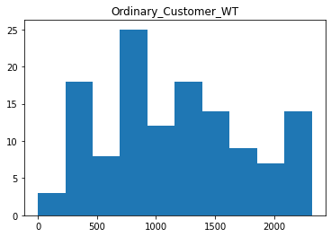
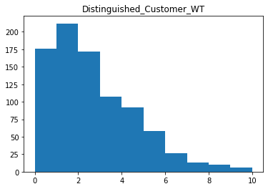

- Teller for each type of customers
- average waiting time in the ordinary customers queue : 6.65
- average waiting time in the distinguished customers queue: 2.24
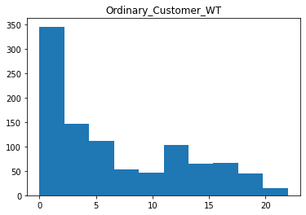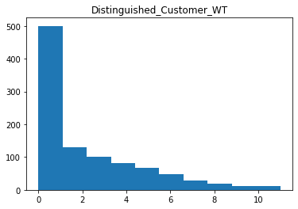

Conclusion:
According to the previous results the bank should add additional teller to serve the distinguished customers only.

Problem II [Newspapers Seller]

Part 1

Problem statement:
Newspapers seller buys the newspaper with 50 cents each and sells them for 70 cents
each. Newspapers not sold at the end of the day are sold as scrap for 15 cents each.
Newspapers can be purchased in bundles of 20. Thus, the seller can buy 40, 60, and so
on. There are three types of Newsday, “Excellent”, “good”, “fair”, and “poor” with
probabilities of 0.18, 0.42, 0.32, and 0.08 respectively. The distribution of papers
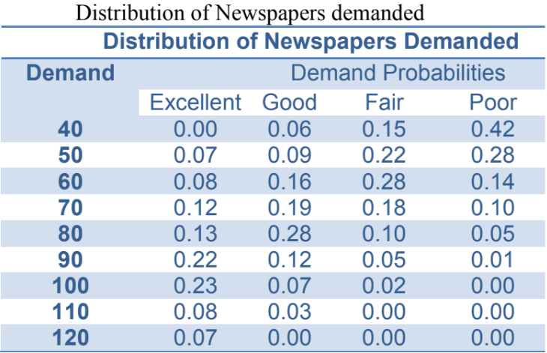
demanded on each of these days is given in the table below:

Assumption: the profits are given by the following relationship:
Profit = [(revenue from sales) – (cost of newspapers) – (lost profit from excess
demand) + (salvage from sale of scrap papers)].

Problem objectives:
- Determine the optimal number of newspapers the seller should purchase to increase his profit.
- Determine the relationship between the price of selling the newspaper and of selling the unsold newspapers as a scrap on total profit, therefore determine the optimal number of newspapers.
- Determine the relationship between the size of bundle and the optimal number to purchase.

Problem formulation:
- Profit could be calculated in two ways; both are implemented in the code:
- The first way is Profit = [(revenue from sales) – (cost of newspapers) – (lost profit from excess demand) + (salvage from sale of scrap papers)]. However, this formula does not clearly state the relationship between the cost of newspaper and the price of selling newspaper as scrap. Scrap price is typically lower than the regular price, in this scenario it is even lower than the cost of newspaper, so it results in shortage and must be minimized.
- The second way is formulated as:
- In case that supply is greater than demand i.e., excess newspapers:
Profit=revenue- (cost of one newspaper*demand) - ((cost of one newspaper - price of selling one newspaper as scrap) * (supply quantity -demand)).
- In case that supply is less than or equal to demand:
Profit=revenue-cost-lost profit due to excess demand.
- Revenue= price of selling one newspaper * quantity sold.
- Cost= cost of buying one newspaper * supply quantity.
- Lost profit due to excess demand= (demand - supply quantity) * (price - cost).

Part 2

System components:

System | Entities | Attributes | Events | Activities | State variables
Newspaper seller simulation system | Newspapers | -Price.  -Scrap price. | Demand | -Selling newspapers with regular price.  -Selling newspapers as scrap. | -Quantity.  -Bundle size.

System analysis:
- System inputs:
- Distribution of newspaper demanded.
- Distribution of type of news days.
- Cost of one newspaper.
- Selling price of one newspaper.
- Bundle size.

- Demand cumulative distribution table:

- News days cumulative distribution table:

- Calendar table for 10 days:

Newsday  RDA | Newsday  Type | Demand  RDA | Supply | Demand | Sales Revenue | Lost Profit From  Excess Demand | Salvage | Daily Profit | Cost
14 | Excellent | 68 | 40 | 100 | 28 | 12 | 0 | -4 | 20
46 | Good | 86 | 40 | 90 | 28 | 10 | 0 | -2 | 20
35 | Good | 36 | 40 | 70 | 28 | 6 | 0 | 2 | 20
48 | Good | 44 | 40 | 70 | 28 | 6 | 0 | 2 | 20
49 | Good | 11 | 40 | 50 | 28 | 2 | 0 | 6 | 20
27 | Good | 4 | 40 | 40 | 28 | 0 | 0 | 8 | 20
62 | Fair | 98 | 40 | 90 | 28 | 10 | 0 | -2 | 20
37 | Good | 82 | 40 | 90 | 28 | 10 | 0 | -2 | 20
58 | Good | 70 | 40 | 80 | 28 | 8 | 0 | 0.00E+00 | 20
42 | Good | 72 | 40 | 80 | 28 | 8 | 0 | 0 | 20
74 | Fair | 69 | 40 | 70 | 28 | 6 | 0 | 2 | 20
16 | Excellent | 20 | 40 | 70 | 28 | 6 | 0 | 2 | 20
55 | Good | 85 | 40 | 90 | 28 | 10 | 0 | -2 | 20
86 | Fair | 14 | 40 | 40 | 28 | 0 | 0 | 8 | 20
30 | Good | 40 | 40 | 70 | 28 | 6 | 0 | 2 | 20
68 | Fair | 62 | 40 | 60 | 28 | 4 | 0 | 4 | 20
24 | Good | 66 | 40 | 80 | 28 | 8 | 0 | 0 | 20
77 | Fair | 30 | 40 | 50 | 28 | 2 | 0 | 6 | 20
99 | Poor | 67 | 40 | 50 | 28 | 2 | 0 | 6 | 20
66 | Fair | 87 | 40 | 80 | 28 | 8 | 0 | 0 | 20
11 | Excellent | 92 | 60 | 110 | 42 | 10 | 0 | 2 | 30
70 | Fair | 73 | 60 | 70 | 42 | 2 | 0 | 10 | 30
58 | Good | 37 | 60 | 70 | 42 | 2 | 0 | 10 | 30
25 | Good | 30 | 60 | 60 | 42 | 0 | 0 | 12 | 30
27 | Good | 81 | 60 | 90 | 42 | 6 | 0 | 6 | 30
29 | Good | 44 | 60 | 70 | 42 | 2 | 0 | 10 | 30
4 | Excellent | 42 | 60 | 90 | 42 | 6 | 0 | 6 | 30
54 | Good | 15 | 60 | 50 | 35 | 0 | 1.5 | 6.5 | 30
56 | Good | 97 | 60 | 100 | 42 | 8 | 0 | 4 | 30
39 | Good | 8 | 60 | 50 | 35 | 0 | 1.5 | 6.5 | 30
31 | Good | 72 | 60 | 80 | 42 | 4 | 0 | 8 | 30
27 | Good | 81 | 60 | 90 | 42 | 6 | 0 | 6 | 30
74 | Fair | 32 | 60 | 50 | 35 | 0 | 1.5 | 6.5 | 30
8 | Excellent | 22 | 60 | 70 | 42 | 2 | 0 | 10 | 30
29 | Good | 90 | 60 | 90 | 42 | 6 | 0 | 6 | 30
83 | Fair | 94 | 60 | 90 | 42 | 6 | 0 | 6 | 30
65 | Fair | 93 | 60 | 80 | 42 | 4 | 0 | 8 | 30
99 | Poor | 20 | 60 | 40 | 28 | 0 | 3 | 1 | 30
54 | Good | 45 | 60 | 70 | 42 | 2 | 0 | 10 | 30
32 | Good | 34 | 60 | 70 | 42 | 2 | 0 | 10 | 30
58 | Good | 81 | 80 | 90 | 56 | 2 | 0 | 14 | 40
89 | Fair | 35 | 80 | 50 | 35 | 0 | 4.5 | -0.5 | 40
97 | Poor | 0 | 80 | 40 | 28 | 0 | 6 | -6 | 40
26 | Good | 11 | 80 | 50 | 35 | 0 | 4.5 | -0.5 | 40
69 | Fair | 19 | 80 | 50 | 35 | 0 | 4.5 | -0.5 | 40
21 | Good | 13 | 80 | 50 | 35 | 0 | 4.5 | -0.5 | 40
59 | Good | 52 | 80 | 80 | 56 | 0 | 0 | 16 | 40
1 | Excellent | 44 | 80 | 90 | 56 | 2 | 0 | 14 | 40
13 | Excellent | 4 | 80 | 50 | 35 | 0 | 4.5 | -0.5 | 40
77 | Fair | 22 | 80 | 50 | 35 | 0 | 4.5 | -0.5 | 40
48 | Good | 99 | 80 | 110 | 56 | 6 | 0 | 10 | 40
51 | Good | 86 | 80 | 90 | 56 | 2 | 0 | 14 | 40
98 | Poor | 35 | 80 | 40 | 28 | 0 | 6 | -6 | 40
6 | Excellent | 60 | 80 | 90 | 56 | 2 | 0 | 14 | 40
13 | Excellent | 61 | 80 | 90 | 56 | 2 | 0 | 14 | 40
12 | Excellent | 28 | 80 | 80 | 56 | 0 | 0 | 16 | 40
71 | Fair | 16 | 80 | 50 | 35 | 0 | 4.5 | -0.5 | 40
10 | Excellent | 13 | 80 | 60 | 42 | 0 | 3 | 5 | 40
47 | Good | 52 | 80 | 80 | 56 | 0 | 0 | 16 | 40
30 | Good | 73 | 80 | 80 | 56 | 0 | 0 | 16 | 40
8 | Excellent | 1 | 100 | 50 | 35 | 0 | 7.5 | -7.5 | 50
91 | Fair | 30 | 100 | 50 | 35 | 0 | 7.5 | -7.5 | 50
23 | Good | 9 | 100 | 50 | 35 | 0 | 7.5 | -7.5 | 50
22 | Good | 43 | 100 | 70 | 49 | 0 | 4.5 | 3.5 | 50
63 | Fair | 47 | 100 | 60 | 42 | 0 | 6 | -2 | 50
64 | Fair | 40 | 100 | 60 | 42 | 0 | 6 | -2 | 50
11 | Excellent | 46 | 100 | 90 | 63 | 0 | 1.5 | 14.5 | 50
73 | Fair | 79 | 100 | 70 | 49 | 0 | 4.5 | 3.5 | 50
57 | Good | 61 | 100 | 80 | 56 | 0 | 3 | 9 | 50
43 | Good | 97 | 100 | 100 | 70 | 0 | 0 | 20 | 50
29 | Good | 15 | 100 | 50 | 35 | 0 | 7.5 | -7.5 | 50
79 | Fair | 14 | 100 | 40 | 28 | 0 | 9 | -13 | 50
57 | Good | 21 | 100 | 60 | 42 | 0 | 6 | -2 | 50
88 | Fair | 67 | 100 | 70 | 49 | 0 | 4.5 | 3.5 | 50
26 | Good | 74 | 100 | 80 | 56 | 0 | 3 | 9 | 50
66 | Fair | 4 | 100 | 40 | 28 | 0 | 9 | -13 | 50
63 | Fair | 6 | 100 | 40 | 28 | 0 | 9 | -13 | 50
1 | Excellent | 54 | 100 | 90 | 63 | 0 | 1.5 | 14.5 | 50
2 | Excellent | 49 | 100 | 90 | 63 | 0 | 1.5 | 14.5 | 50
24 | Good | 25 | 100 | 60 | 42 | 0 | 6 | -2 | 50
10 | Excellent | 39 | 120 | 80 | 56 | 0 | 6 | 2 | 60
86 | Fair | 98 | 120 | 90 | 63 | 0 | 4.5 | 7.5 | 60
19 | Good | 48 | 120 | 70 | 49 | 0 | 7.5 | -3.5 | 60
55 | Good | 66 | 120 | 80 | 56 | 0 | 6 | 2 | 60
37 | Good | 84 | 120 | 90 | 63 | 0 | 4.5 | 7.5 | 60
93 | Poor | 78 | 120 | 60 | 42 | 0 | 9 | -9 | 60
97 | Poor | 1 | 120 | 40 | 28 | 0 | 12 | -20 | 60
87 | Fair | 27 | 120 | 50 | 35 | 0 | 10.5 | -14.5 | 60
29 | Good | 67 | 120 | 80 | 56 | 0 | 6 | 2 | 60
81 | Fair | 55 | 120 | 60 | 42 | 0 | 9 | -9 | 60
51 | Good | 40 | 120 | 70 | 49 | 0 | 7.5 | -3.5 | 60
52 | Good | 68 | 120 | 80 | 56 | 0 | 6 | 2 | 60
54 | Good | 49 | 120 | 70 | 49 | 0 | 7.5 | -3.5 | 60
68 | Fair | 45 | 120 | 60 | 42 | 0 | 9 | -9 | 60
90 | Fair | 79 | 120 | 70 | 49 | 0 | 7.5 | -3.5 | 60
56 | Good | 87 | 120 | 90 | 63 | 0 | 4.5 | 7.5 | 60
61 | Fair | 9 | 120 | 40 | 28 | 0 | 12 | -20 | 60
2 | Excellent | 5 | 120 | 50 | 35 | 0 | 10.5 | -14.5 | 60
77 | Fair | 96 | 120 | 90 | 63 | 0 | 4.5 | 7.5 | 60
45 | Good | 72 | 120 | 80 | 56 | 0 | 6 | 2 | 60

- Extra statistics:

Part 3

Experimental design parameters:
- News days random generated number.
- Demand random generated number.

Justification of experimental design parameters:
- Both news days and demand random generated number values are between 0 and 100 to follow news days and demand RDAs tables.

Part 4

1.Simulation results:
- The following results are according to the parameters stated in the problem statement.
- The simulation system is run 1 time.
- Each value of supply is run for 10 times (days).
- Values given by the user: Price= 0.7, cost=0.5, scrap price=0.15, bundle size=20, demand, and news days distribution tables.
- After running for 1 time, we find that:
- The optimal number of newspaper supply to maximize total profit with the given bundle size (20) = 60 newspapers.
- Total profit from selling 60 newspapers for 10 days= 73.0$.
- However, the system found that the average demand from running the simulation = 70, so the system tests whether selling 70 newspapers could further maximize the total profit or not.
- Total profit from selling 70 newspapers for 10 days = 83.5$, which is greater than the profit from 80 newspapers.
- Bundle did affect the optimal quantity, so the system suggests other sizes= [1,2,5,7,10,14, 35,70].

- Conclusion table:

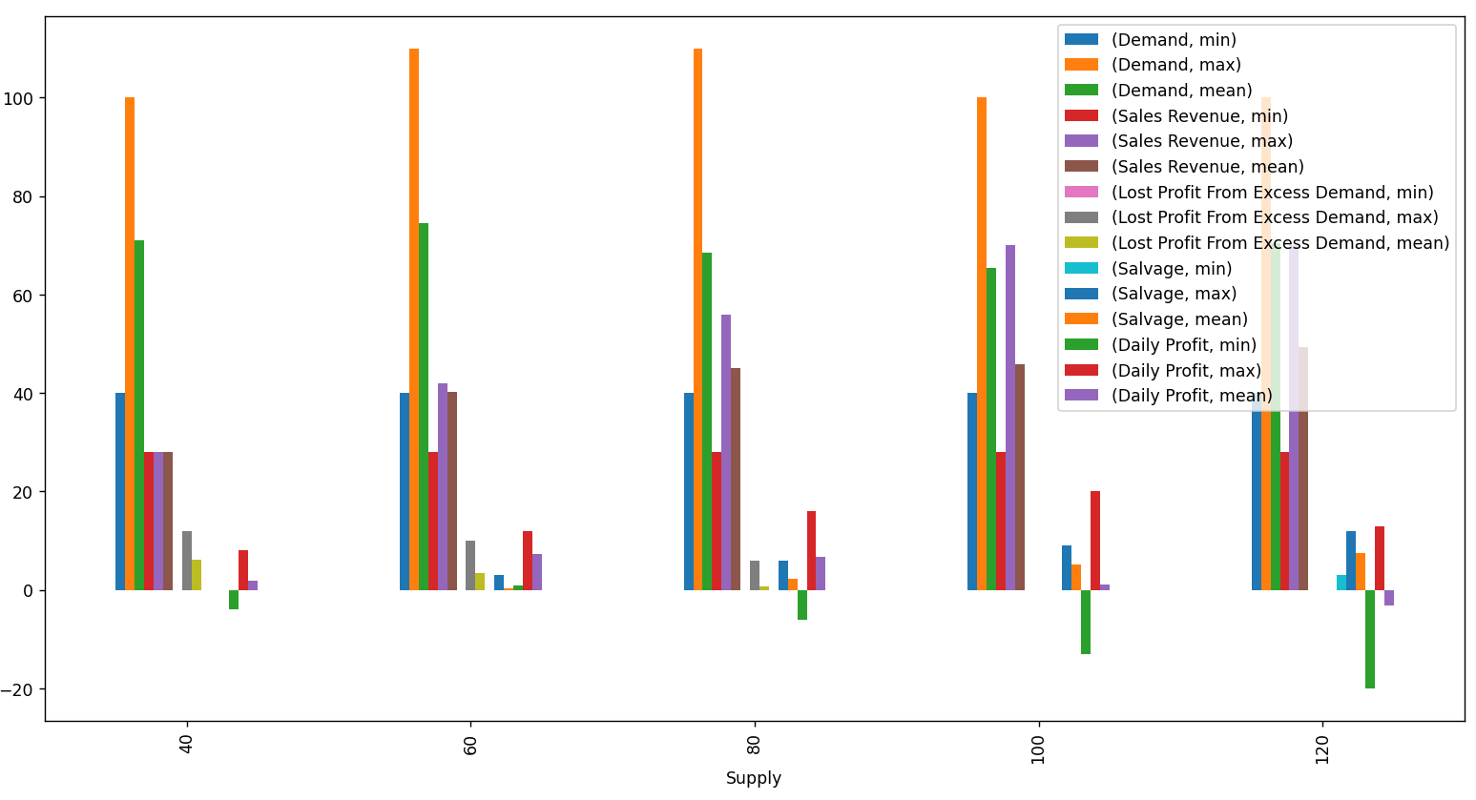
2.Plots:
Figure 1- Plotting mean, min, max of demand, revenue, lost profit, total profit, and salvage
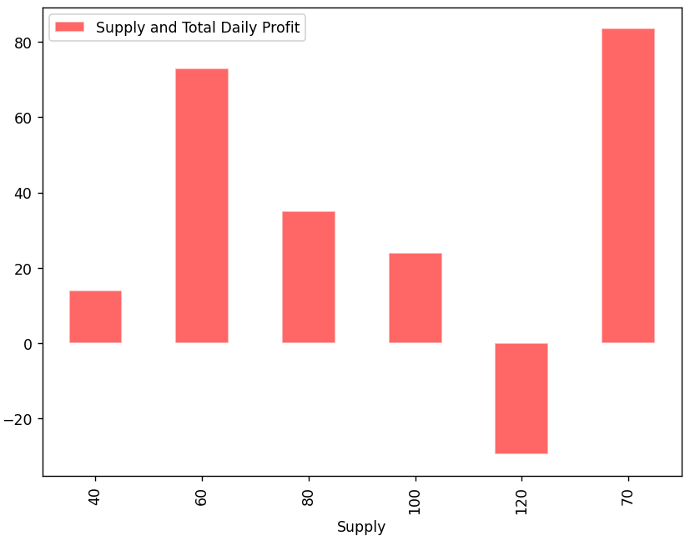
Figure 2-supply and total daily profit
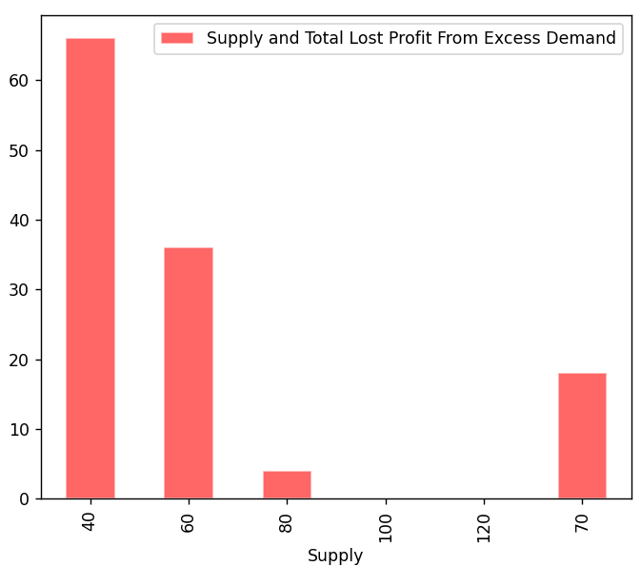
Figure 3-Supply and total lost profit from excess demand

3.Conclusion:
- The worst supply values are 120 then 40 then 100.
- The system suggests buying 70 newspapers with bundle sizes of [1,2,5,7,10,14, 35,70] to increase total profit.

