# Problem 3 - Fire the Arrows

We are given a matrix containing arrows that need to be moved. The arrows are the following: '**<**' (ASCII code **60**), '**>**' (ASCII code **62**), '**^**' (ASCII code **94**), '**v**' (ASCII code **118**). Respectively pointing **left**, **right**, **up** and **down**. There are also blank spaces that are indicated by '**o**' (ASCII code **111**). There will be no other characters in the matrix.

Your task is to move all arrows, **one at a time**, in the direction they point to until there are no more possible moves.

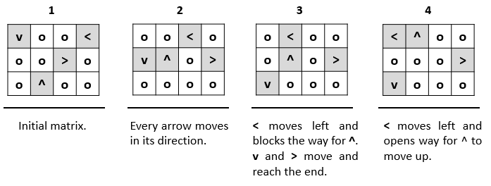

The arrows should be moved in the following order: first the ones in the **uppermost row** and the **leftmost** **column**.

**Note**: Arrows cannot move if their way is **blocked** by other arrows or if they reach the end of the matrix.

### Input

The input data should be read from the console. At the first input line you will be **given a** **number** **n** specifying **how many rows** after it will follow. At the next **n** lines you will be **given the** **matrix with the arrows that need to be moved**.

The input data will always be valid and in the format described. There is no need to check it explicitly.

### Output

The output should be the new matrix with all the arrows moved to the direction they're facing.

### Constraints

* The **count** of the rows will be in the range [1…10].
* The **only characters** that will be present in the matrix will be '**<**', '**>**', '**^**', '**v**' and '**o**'.
* Time limit: 0.3 sec. Memory limit: 16 MB.

### Examples

|  |  |  |  |  |  |  |  |
| --- | --- | --- | --- | --- | --- | --- | --- |
| **Input** | **Output** |  | **Input** | **Output** |  | **Input** | **Output** |
| 3  voo<  oo>o  o^oo | <^oo  ooo>  vooo |  | 3  oov  oo<  oo^ | oov  <o^  ooo |  | 4  ooo<  oovo  ^ooo  oo^o | ^<oo  oooo  oovo  oo^o |