# Problem 3 – Lego Blocks

You are given two **jagged arrays**. Each array represents a **Lego block** containing integers. Your task is first to **reverse** the second jagged array and then check if it would **fit perfectly** in the first jagged array. 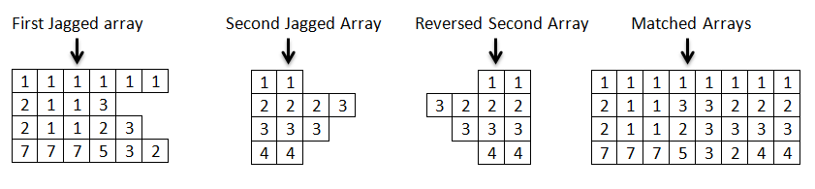

The picture above shows exactly what fitting arrays mean. If the arrays fit perfectly you should **print out** the newly made rectangular matrix. If the arrays do not match (they do not form a rectangular matrix) you should print out the **number of cells** in the first array and in the second array combined. The examples below should help you understand more the assignment.

### Input

The first line of the input comes as an **integer** **number n** saying how many rows are there in both arrays. Then you have **2 * n** lines of numbers separated by whitespace(s). The first **n** lines are the rows of the first jagged array; the next **n** lines are the rows of the second jagged array. There might be leading and/or trailing whitespace(s).

### Output

You should print out the combined matrix in the format:  
**[*elem, elem, …, elem*]  
[*elem, elem, …, elem*]  
[*elem, elem, …, elem*]**If the two arrays do not fit you should print out : **The total number of cells is: *count***

### Constraints

* The number n will be in the range [2…10].
* Time limit: 0.3 sec. Memory limit: 16 MB.

### Examples

|  |  |
| --- | --- |
| **Input** | **Output** |
| 2  1 1 1 1 1 1  2 1 1 3  1 1  2 2 2 3 | [1, 1, 1, 1, 1, 1, 1, 1]  [2, 1, 1, 3, 3, 2, 2, 2] |
| 2  1 1 1 1 1  1 1 1  1  1 1 1 1 1 | The total number of cells is: 14 |