Dustin Betuzzi

1)

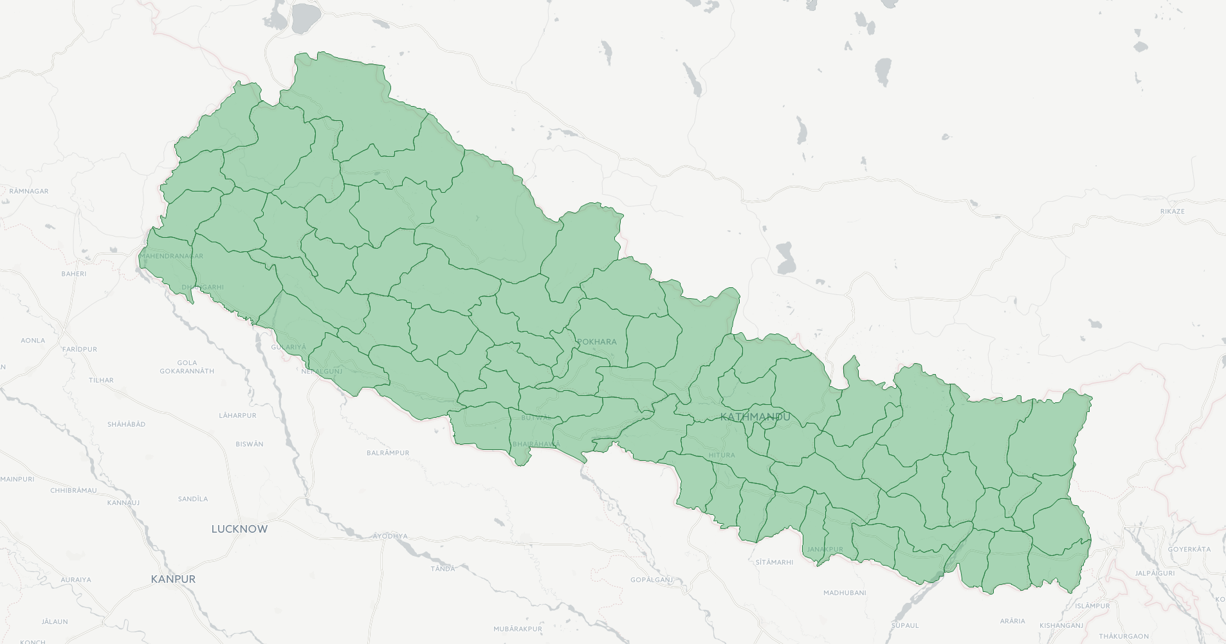

2)CPR

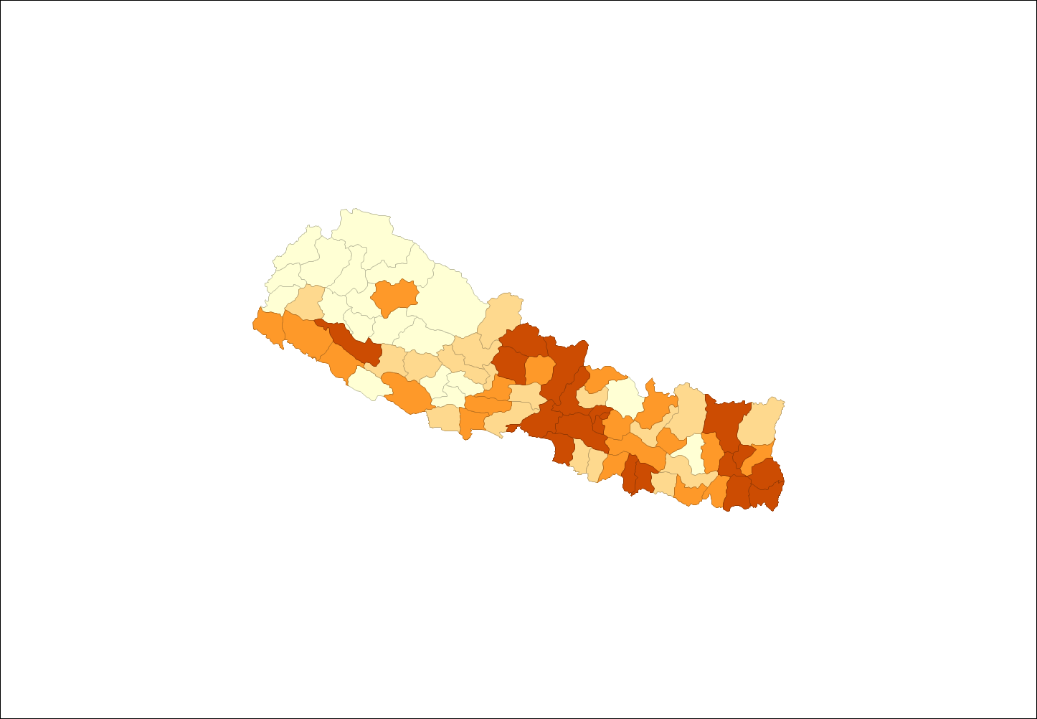

ALF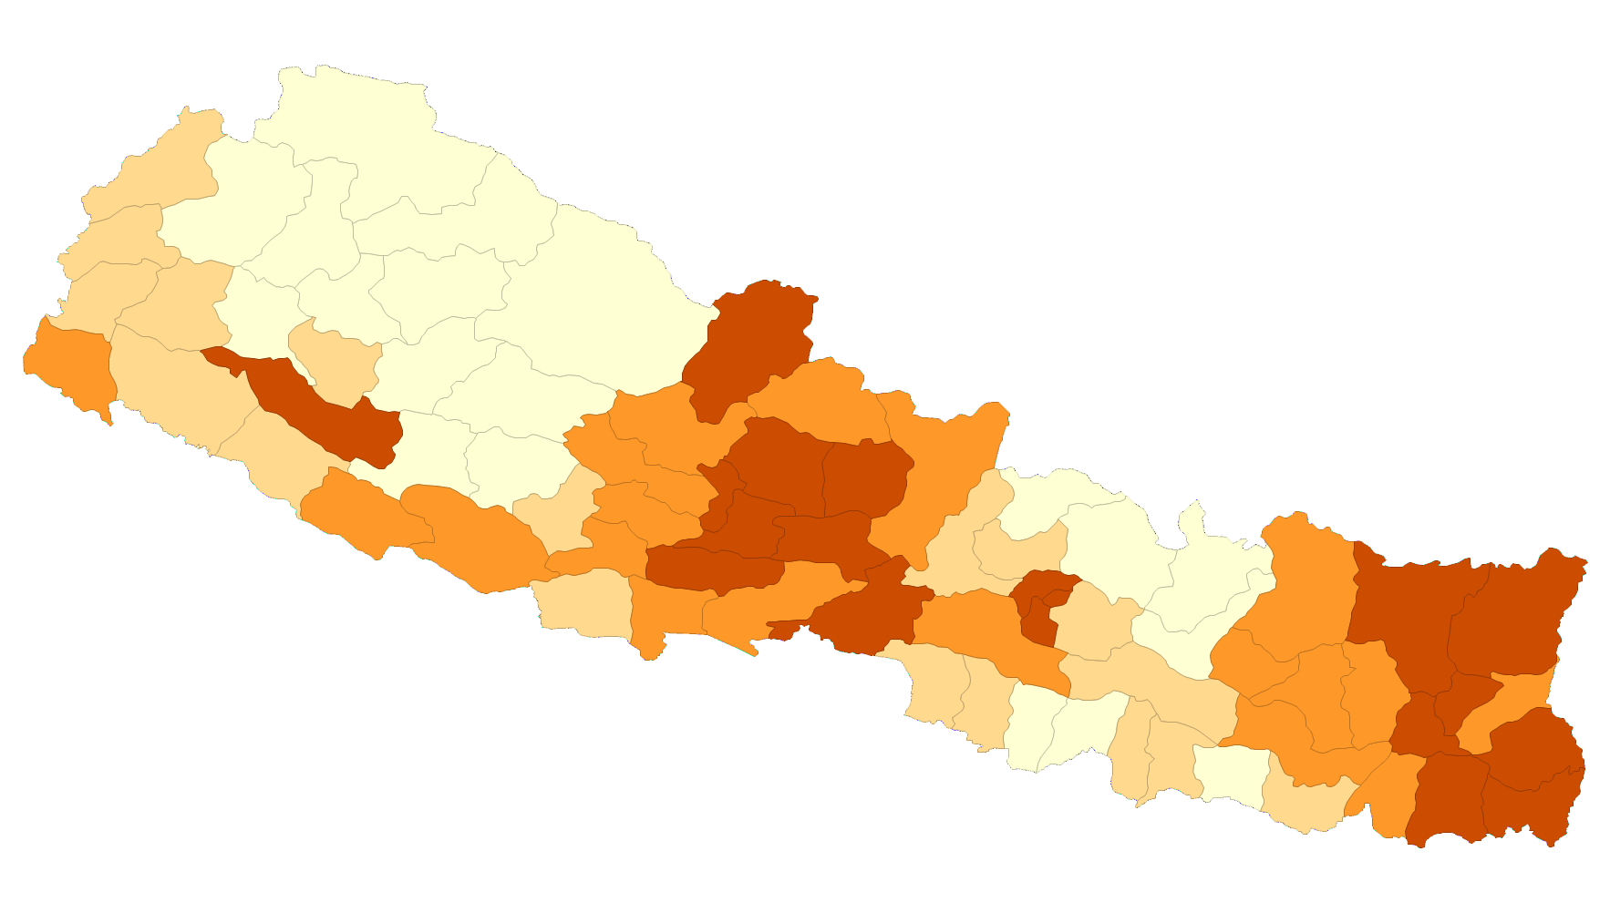

The darker the shade, the higher the rate of ALF and CPR. The spatial distribution in the maps seem quite similar with a few exceptions. The factors causes higher ALF could also be causing CPR within general areas. Also, ALF and CPR could be caused by each other.

3)

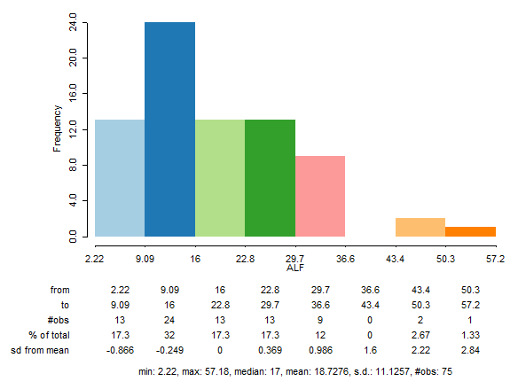

**It looks like the histogram has positive skew. The mean rate of female literacy in Nepal is 18.73. Finish question**

4)

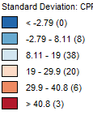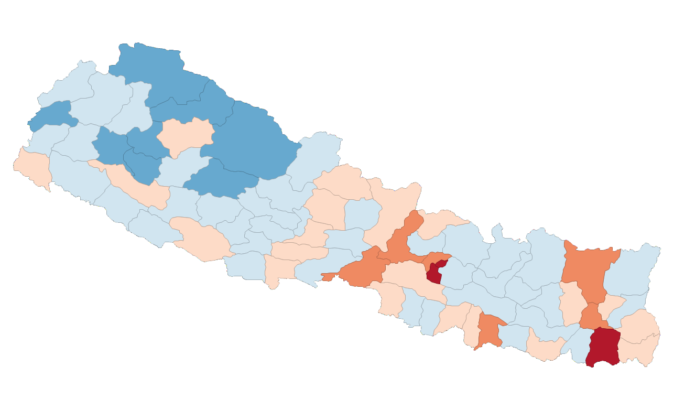

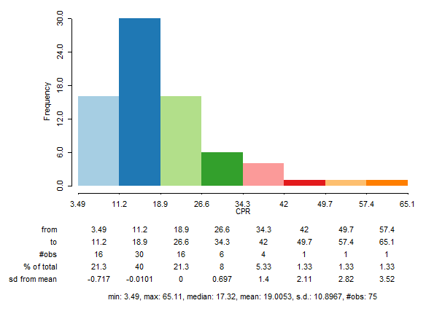

Finish question