## *JS UI and DOM*

## *Team "Between The Sheets"*

# **Team members:**

|  |  |  |  |
| --- | --- | --- | --- |
| **Adrian.bozhankov -** **Адриан Божанков** | **Alex_H - Александрина Хаджигеоргиева** | **kamendd1 -** **Камен Дамянов** | **LaForce -** **Александър Овчаров** |
| **steff.dimitrov -****Стефан Димитров** | **emil.nik -****Емил Николов** | **Stelamat -** **Стела Матеева** |  |

# **Game description:**

This is an amazing application to test your knowledge about cocktails mixing.

As we know the great sense of humor of our trainers, we decided to test their bartender's experience, and also to make the game closer to the Telerik Academy spirit.

Please choose you favorite trainer, to shake your favorite shake!!

He will greet you in his unique style!

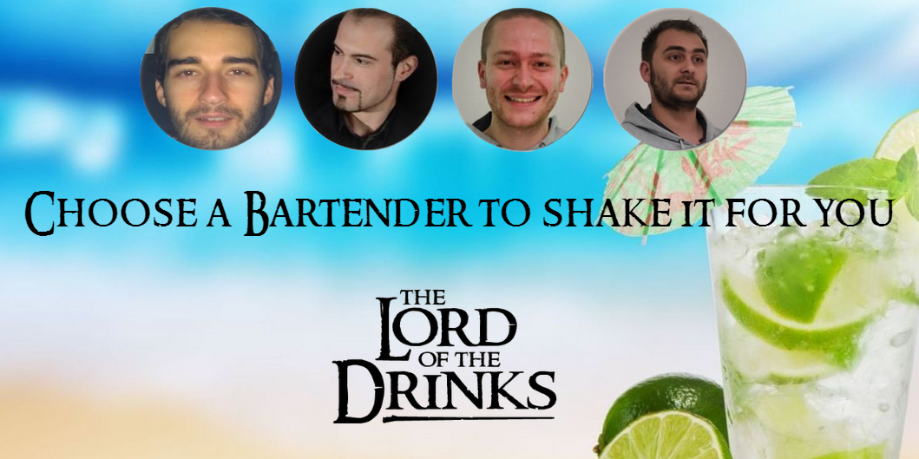

# **Technical description:**

The playfield of the game consists of wooden shelves - shown on the left hand of the playfield, filled with alcohol, non-alcohol drinks and other needed substances like lime and mint .

On the main part of the playfield, is shown a beach bar, with the bartender you choose, and the cocktail that is desired.

Shelves with cocktail ingredients. Drag the ingredients to the shaker

The name of cocktail that should be shacked

Shaker

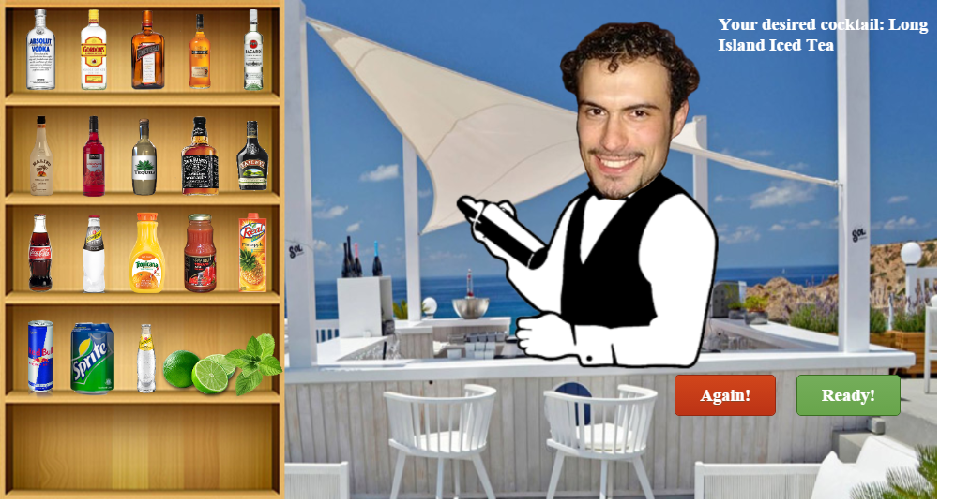

control buttons

Please **read** carefully the name of the Cocktail and **drag the drinks** and the substances **close to the shaker**. When you finished, click on the green "READY" button.

If you want to start a new game, click on the red "Again" button.

# **Business logic:**

The game is organized in folders, as follows:

- **images** - included alcohol, non-alcohol drinks images; bartender images; background images; logo image;

- **libs** - containing KineticJs lybrary;

- **sounds** - containing audio effects of the game;

There are 2 JS files:

- **bar.js** - containing .............. **functions**/methods

- **returning arrays** of alcohol drinks, Non-alcohol drinks, Substances and array with Recipes. - **Function getSounds** returning Object with bartenders sounds;

- Function getConstant - containing Stage and Bottle Images dimensions

and so on........

**- main.js -**

**- loading start screen**

**- after choosing a bartender,**

* **loading background layers - using KineticJs**
* **chosen bartender's face,**
* **chosen bartender greeting - applied by random,**
* **loading a desired shake name -by random**
* **loading and sorting drinks and Substances on the shelves - using cycles and a set of constants to create and sort drinks (KineticJs objects) .**
* **loading background music**

**- the player choose a bottle/substance**

* **when the player "steps" on the shelves,**

**....... and so on**

+ End Screen ScreenShot

# Git repository:

https://github.com/Between-The-Sheets/Lord-Of-The-Drinks-Project