AI Assisted Problem Solving Using Python

Date: 18/11/25
Name: Beulah Sathuluri
Mtech – 1st Year
HTNO: 2503B05123

Lab 13 – Code Refactoring: Improving Legacy Code with AI Suggestions

Task Description-1 –Remove Repetition
Task: Provide AI with the following redundant code and ask it to refactor
Python Code
def calculate_area(shape, x, y=0):
if shape == "rectangle":
return x * y
elif shape == "square":
return x * x
elif shape == "circle":
return 3.14 * x * x
Expected Output
- Refactored version with dictionary-based dispatch or separate functions.
- Cleaner and modular design.
Code:
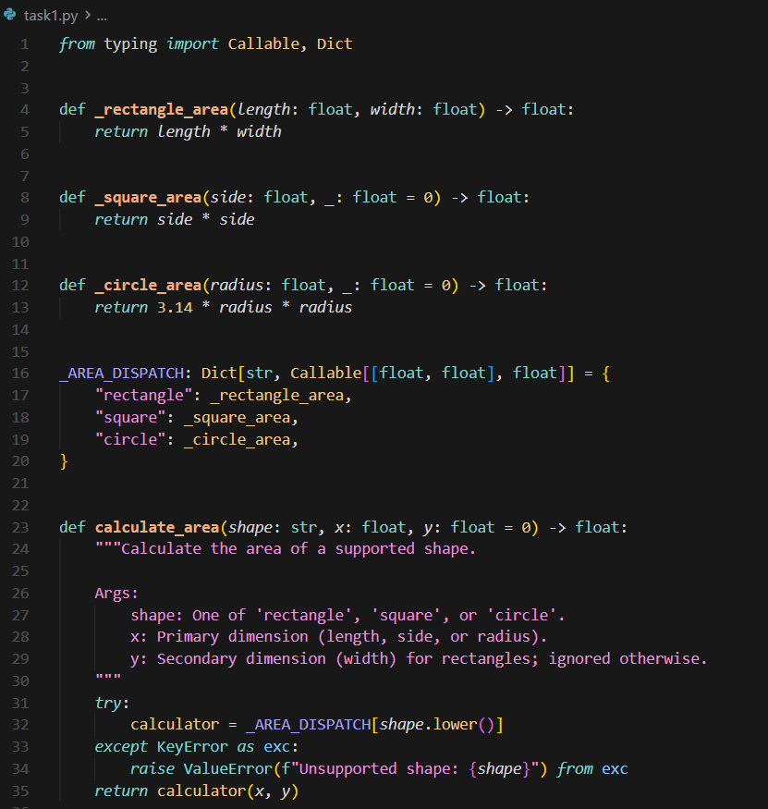
Task Description-2 –Error Handling in Legacy Code
Task: Legacy function without proper error handling

Python Code
def read_file(filename):
f = open(filename, "r")
data = f.read()
f.close()
return data

Expected Output:
AI refactors with withopen() and try-except:

Code:
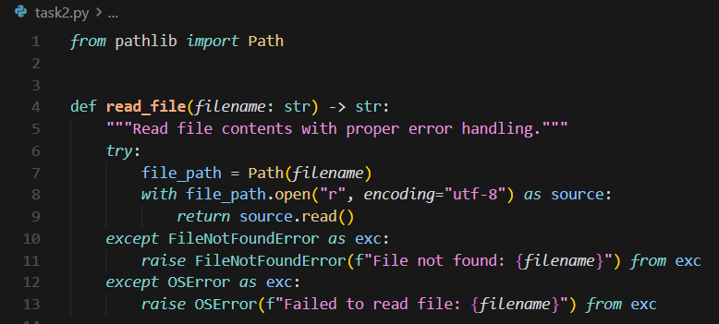

Task Description-3 –Complex Refactoring
Task: Provide this legacy class to AI for readability and modularity improvements:

Python Code
class Student:
def __init__(self, n, a, m1, m2, m3):
self.n = n
self.a = a
self.m1 = m1
self.m2 = m2
self.m3 = m3
def details(self):
print("Name:", self.n, "Age:", self.a)
def total(self):
return self.m1+self.m2+self.m3
Expected Output:
- AI improves naming (name, age, marks).
- Adds docstrings.
- Improves print readability.
- Possibly uses sum(self.marks) if marks stored in a list.
Code:
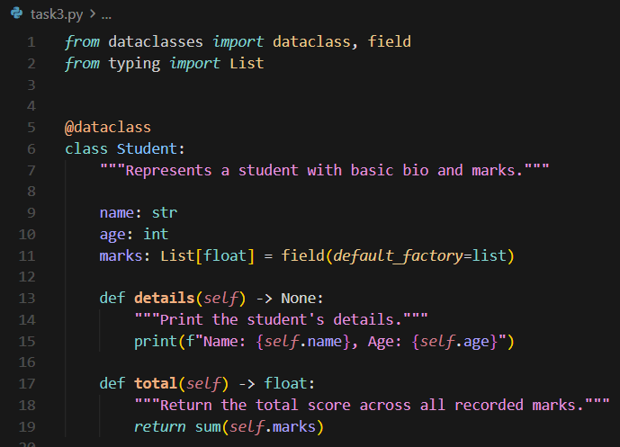

Task Description-4 –Inefficient Loop Refactoring
Task: Refactor this inefficient loop with AI help

Python Code
nums = [1,2,3,4,5,6,7,8,9,10]
squares = []
for i in nums:
squares.append(i * i)
Expected Output: AI suggested a list comprehension

Code:
