AI Assisted Problem Solving Using Python

Date: 10/11/25
Name: Beulah sathuluri
Mtech – 1st Year
HTNO: 2503B05123

Lab 3: Application for TGNPDCL

Objective: Build an application using Python program for TGNPDCL, to generate the bill based on energy consumption and type of customer with the help of AI tools.

- Build a python application as per below instructions
- Read all the required data like PU,CU and Type of customer
- Calculate bill amount based on number of units consumed, type of customer and other charges
- Finally print the values of EC(Energy Charges),FC(Fixed Charges),CC(Customer Char-ges),ED(Electricity Duty Charges),bill as per expected output

Requirements:
VS Code with Github Copilot and/or Google Colab with Gemini
Students should bring power bill from their home

Deliverables:
Print energy bill for given inputs and verify with bill taken by students

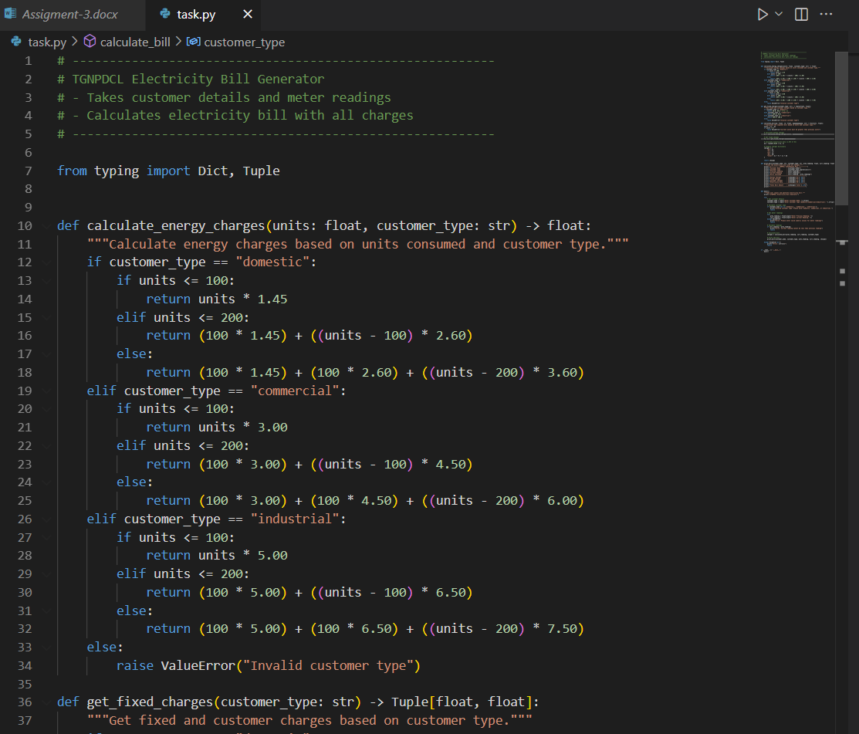

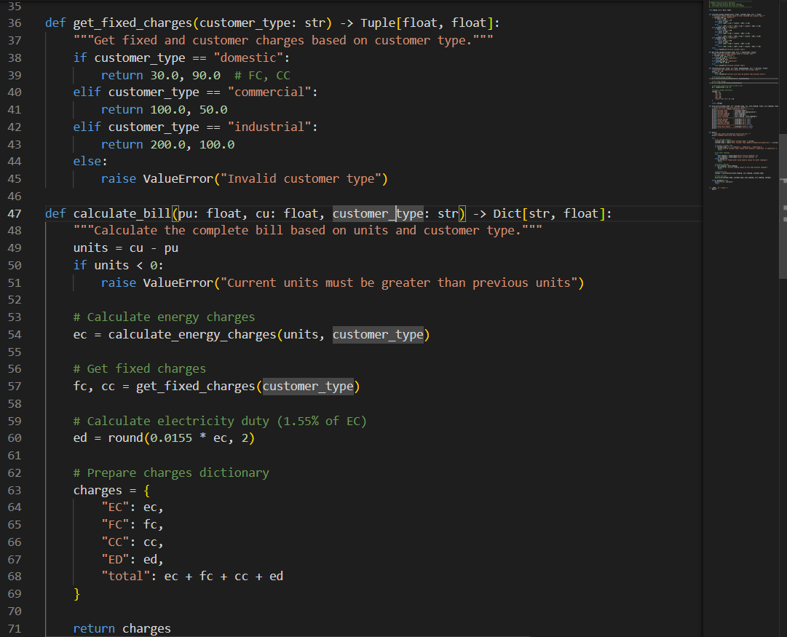

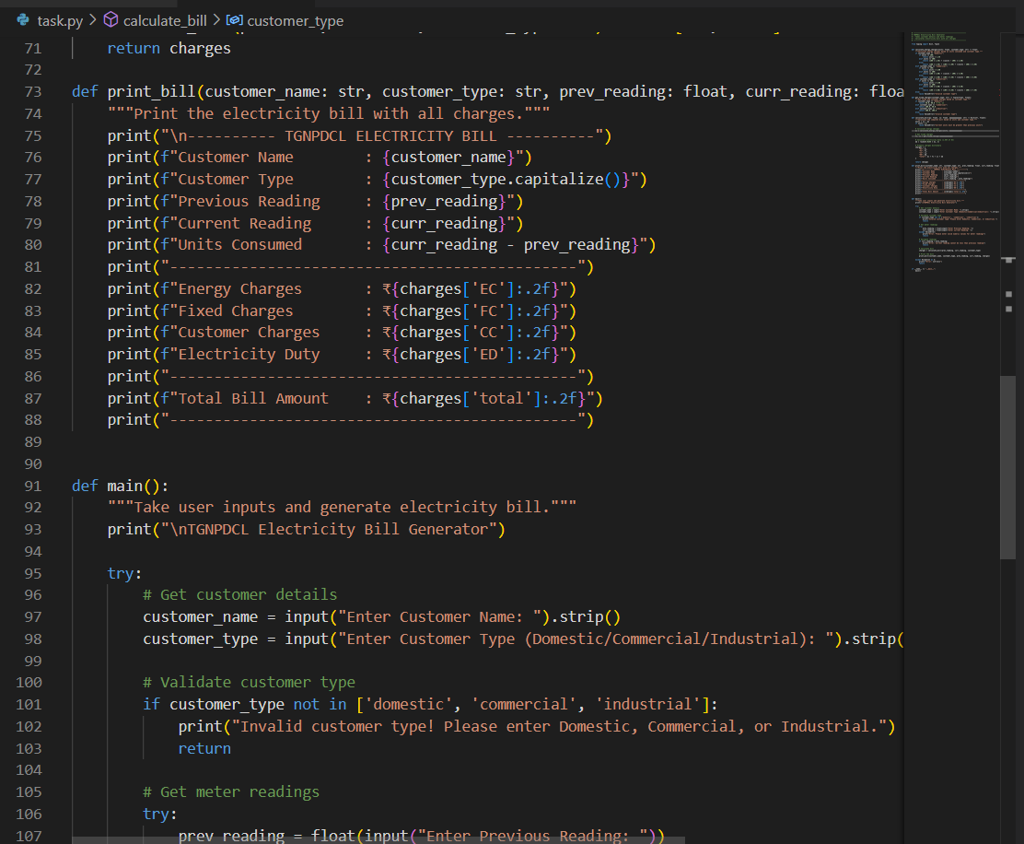

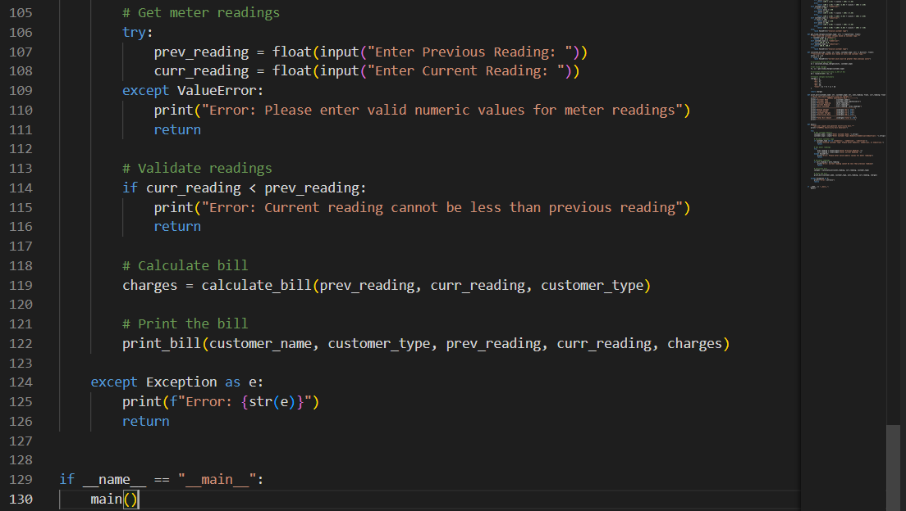

Output:

