AI Assisted Problem Solving Using Python

Date: 01-12-2025
Name:Beulah Sathuluri
Mtech – 1st Year
HTNO: 2503B05123

Lab 18 – API Integration: Connecting to External Services with Error Handling

Task 1: Connect to a Public API
- Instructions:
  - Use Python (or Node.js/JavaScript) to connect to a public API (e.g., OpenWeatherMap or JSONPlaceholder).
  - Send a simple GET request to retrieve data.
  - Display the response in a readable format (pretty JSON).
- Expected Output:
  - Program prints API response (e.g., weather data or posts from JSONPlaceholder).
  - Output should be properly formatted JSON (not raw).

Prompt:write a python function that display weather details of a city using weather api without error handling. Display weather details as JSON output

To use this code:
- First, you'll need to sign up for a free API key at OpenWeatherMap: https://openweathermap.org/api
- Replace 'YOUR_API_KEY' in the code with your actual API key
- Install the required requests package by running:

pip install requests

You can then run the script and enter any city name to get its current weather details. The output will look something like this:

Code:
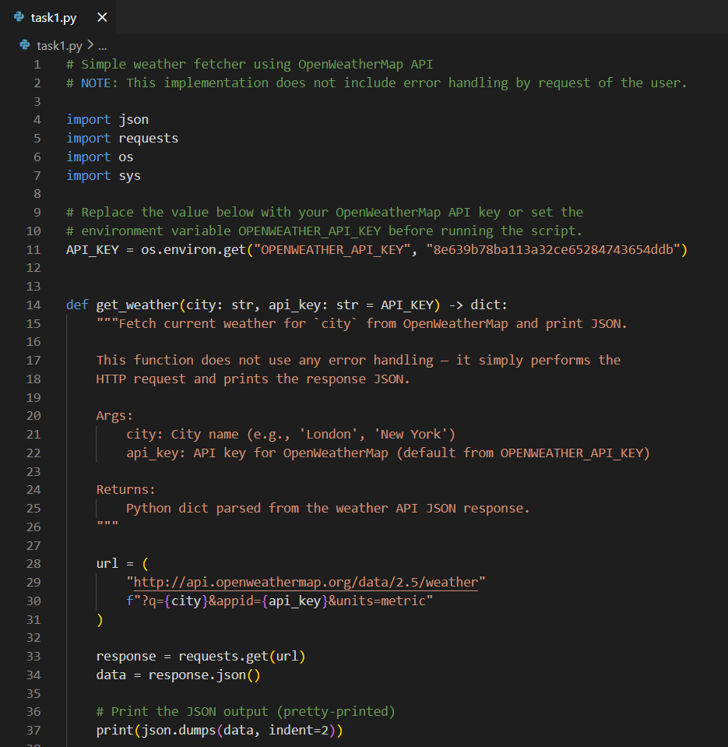
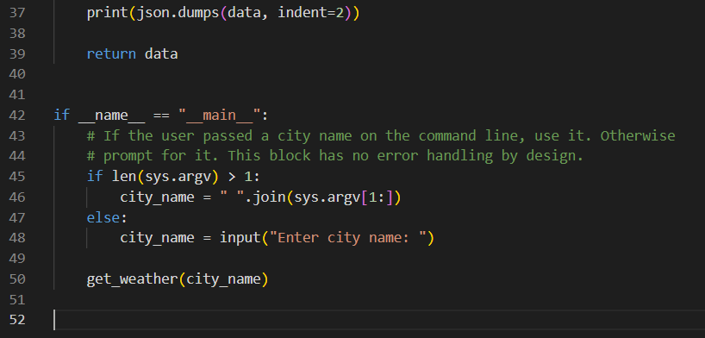
Output:
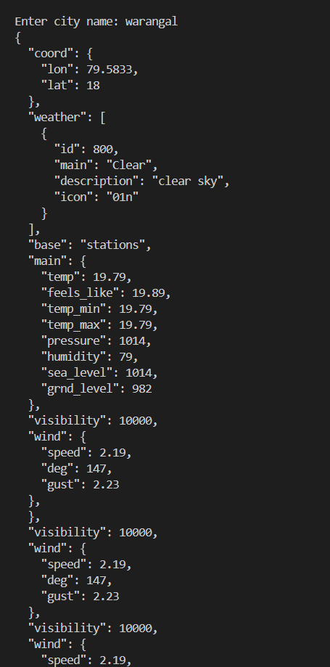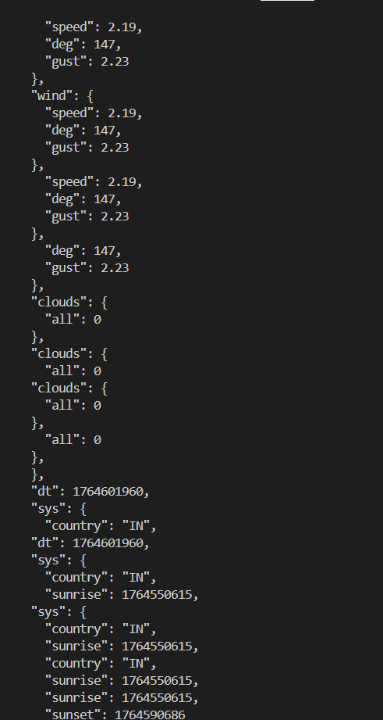

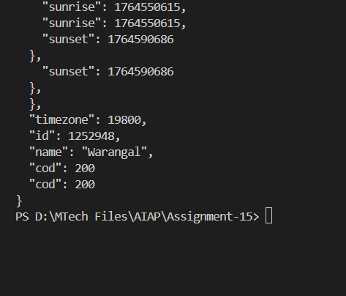

Task 2: Add Error Handling for Invalid API Calls
- Instructions:
  - Modify your code from Task 1 to handle errors.
  - Include try/except (Python) or try/catch (JavaScript) blocks.
  - Handle cases like:
    - Invalid URL
    - Network timeout
    - Wrong API key (if required)
  - Print user-friendly error messages.
- Expected Output:
  - If the API works, the result is shown as in Task 1.
  - If there’s an error, output:
Error: Could not connect to API. Check your API key or network connection.
Prompt:write a python function that display weather details of a city using weather api with error handling. Display weather details as JSON output
To use this code:
- First, you'll need to sign up for a free API key at OpenWeatherMap: https://openweathermap.org/api
- Replace 'YOUR_API_KEY' in the code with your actual API key
- Install the required requests package by running:
Code:
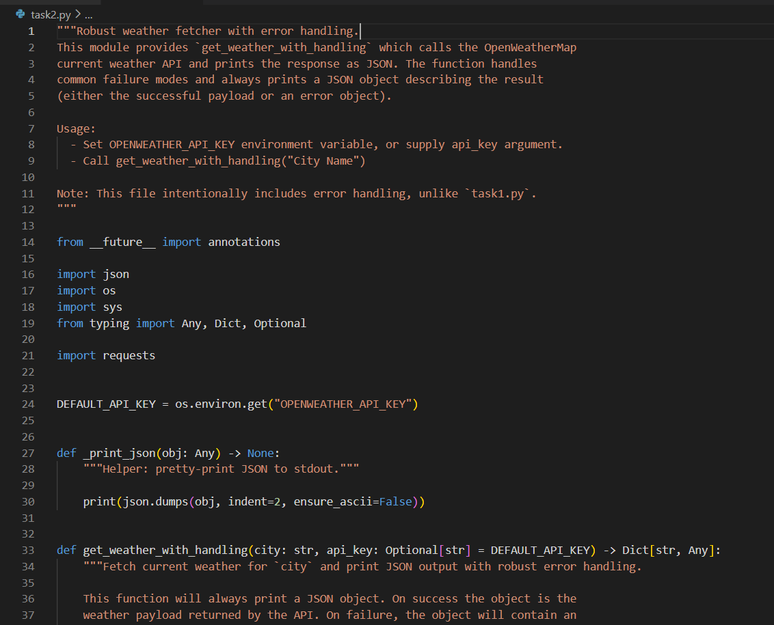
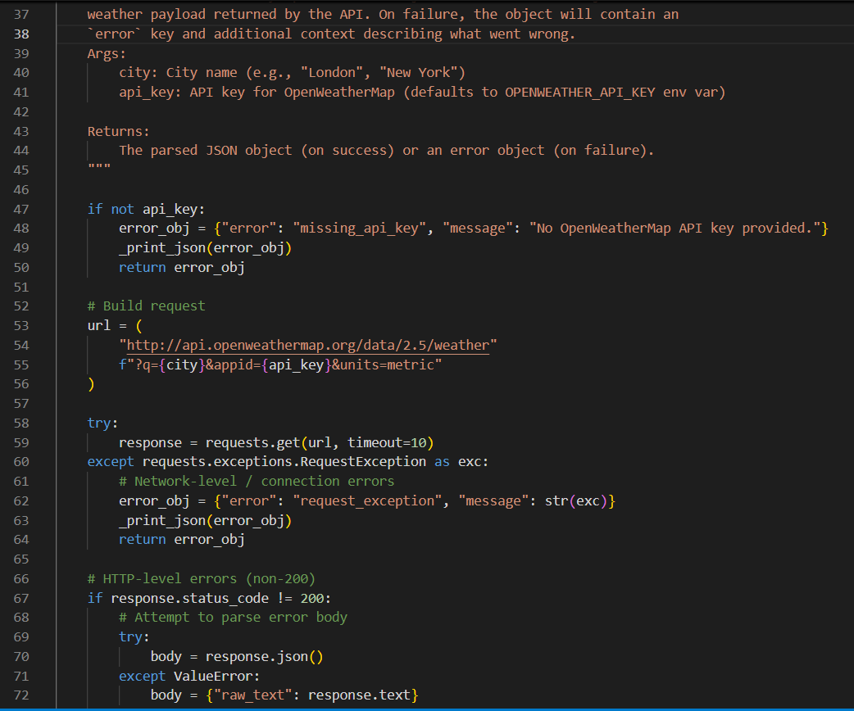
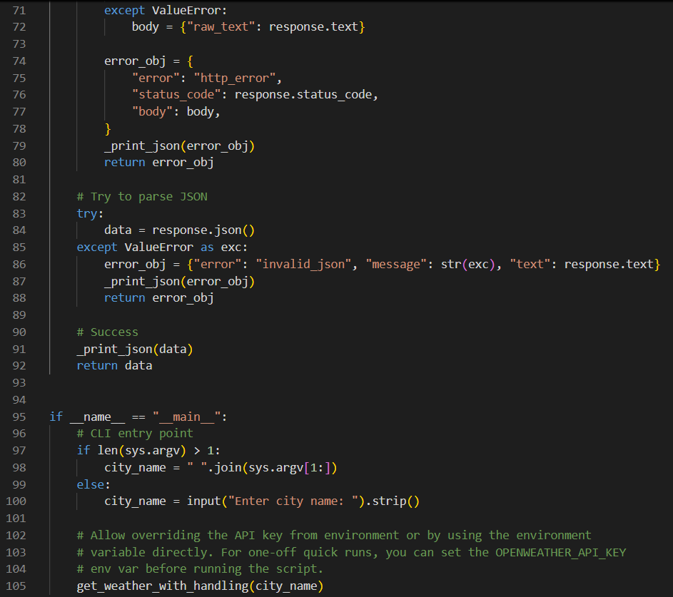

Output:
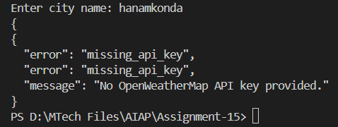

Task 3: Extract and Display Specific Data
- Instructions:
  - From the API response (e.g., weather API), extract specific fields (temperature, humidity, description).
  - Display them in a user-friendly format (not raw JSON).
- Expected Output:
- City: London
- Temperature: 18°C
- Humidity: 60%
Weather: Clear sky

Code:
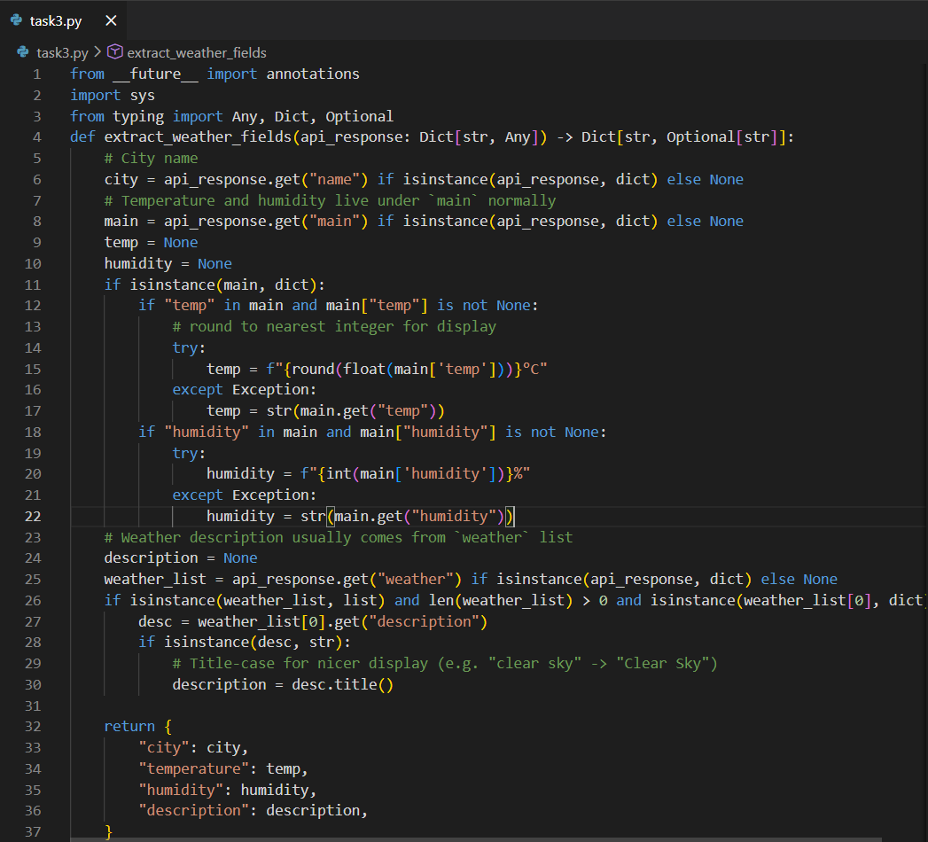
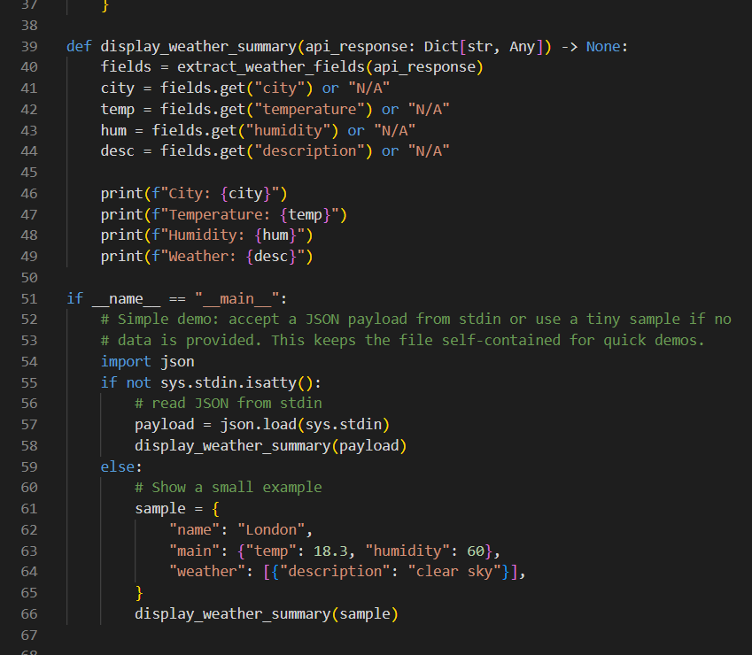
Output:
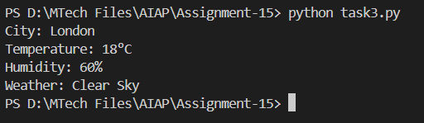

Task 4: Build a Function with Parameters
- Instructions:
  - Write a function that accepts a parameter (e.g., city name for weather API).
  - The function should call the API dynamically based on user input.
  - Include error handling if the city is invalid.
- Expected Output:
  - Input: "New York"
  - Output:
  - City: New York
  - Temperature: 22°C
  - Humidity: 55%
  - Weather: Few clouds
  - Input: "xyz123"
  - Output:
Error: City not found. Please enter a valid city.
Prompt:write a python function that display weather details of a city using weather api with error handling. Display weather details in user friendly format

Code:
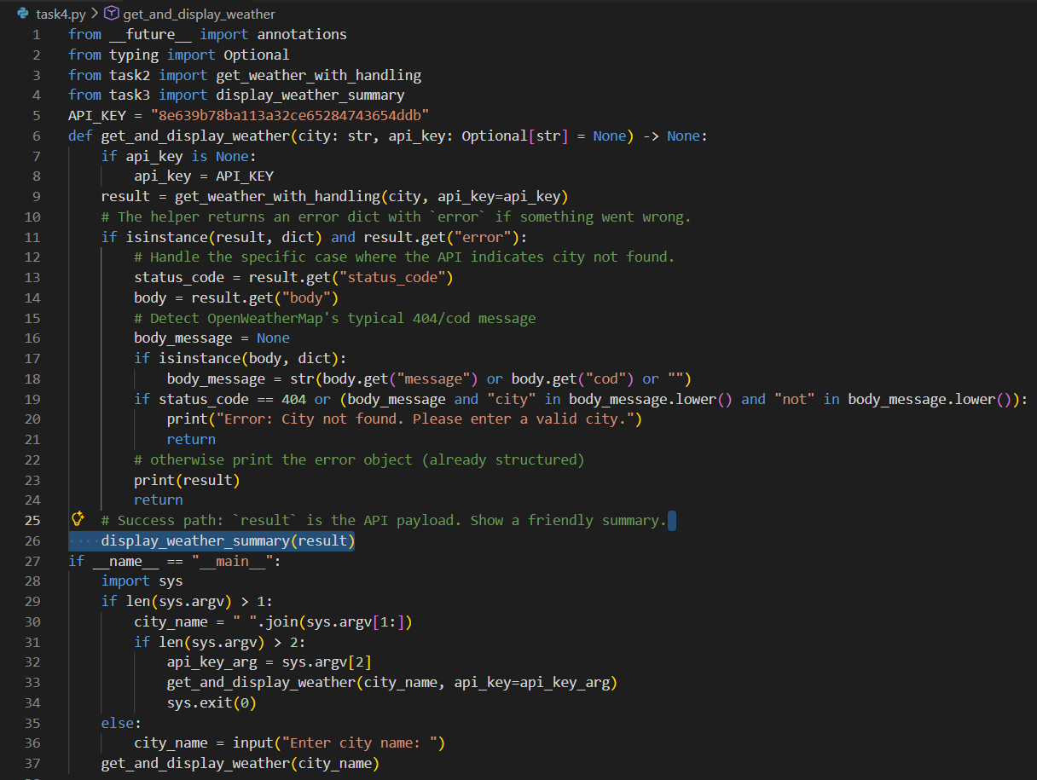

Output:
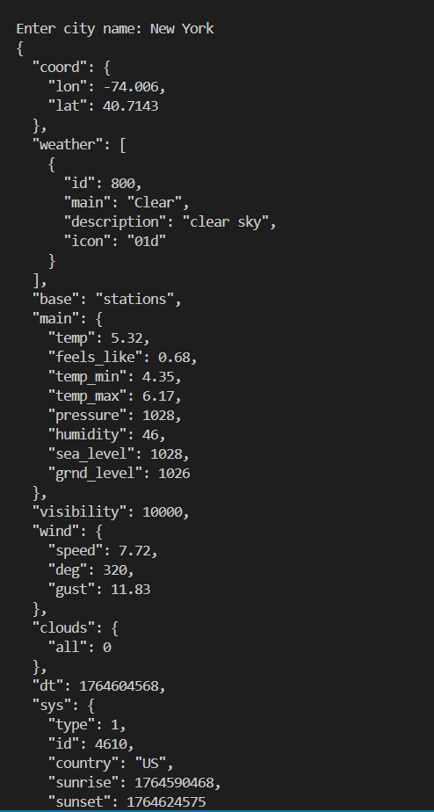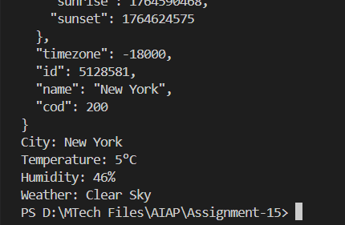

Task 5: Store API Results Locally
- Instructions:
  - Extend your function from Task 4.
  - Save the extracted API results into a local file (results.json or results.txt).
  - Each new request should append results without overwriting old ones.
- Expected Output:
  - Console still shows formatted output.
  - A local file results.json is created/updated with stored responses like:
  - [
  - {"city": "London", "temp": 18, "humidity": 60, "weather": "Clear sky"},
  - {"city": "New York", "temp": 22, "humidity": 55, "weather": "Few clouds"}
]

Prompt:write a python function that display weather details of a city using weather api with error handling. Display weather details as JSON output. Store the weather details in current directory as text file, every run output will append

Code:
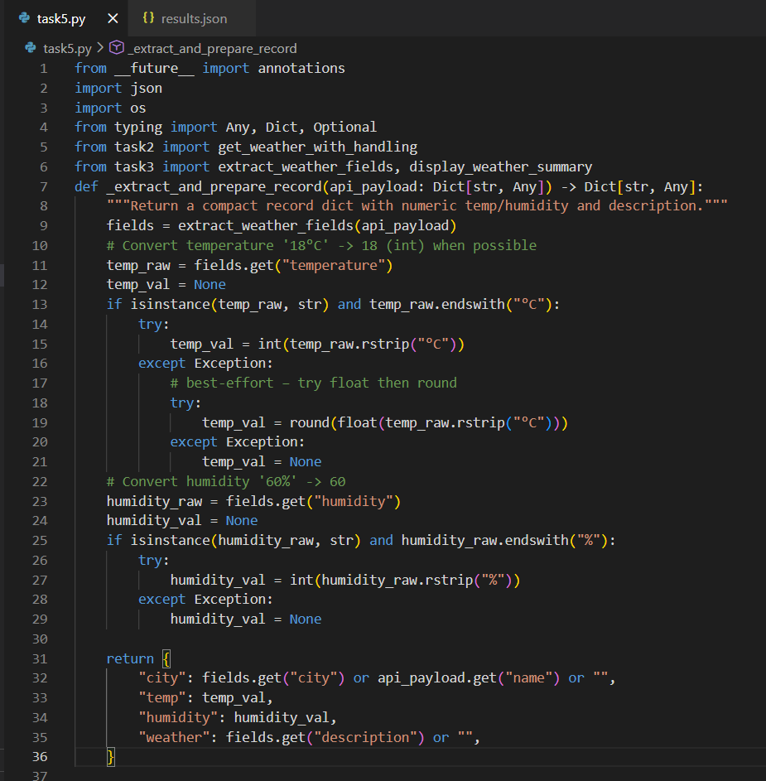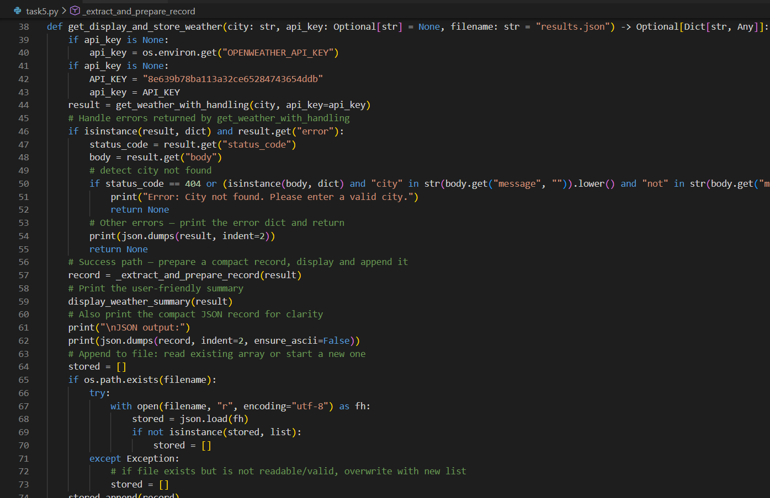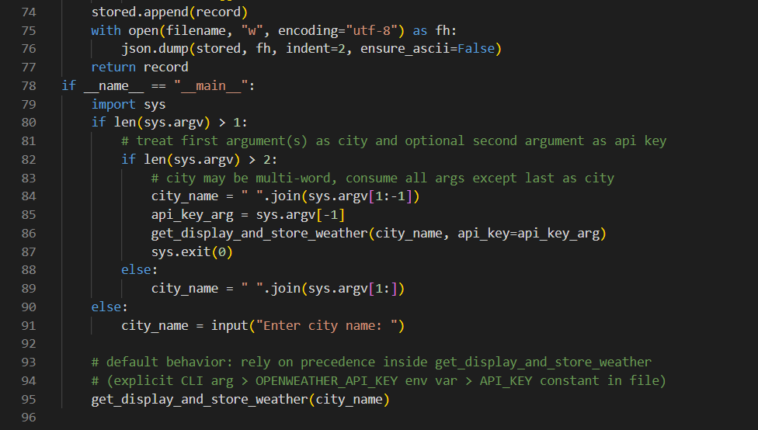

Output:

