AI Assisted Problem Solving Using Python

Date: 10/11/25
Name: Beulah
Mtech – 1st Year
HTNO: 2503B05123

Lab 2: Exploring Additional AI Coding Tools – Gemini (Colab) and Cursor AI

Task Description-1
- Use Google Gemini in Colab to write a function that reads a CSV file and calculates mean, min, max.
Expected Output-1
- Functional code with output and screenshot

Prompt
Create a CSV file and write a function that reads a CSV file and calculates mean, min, max and print output.

CSV file

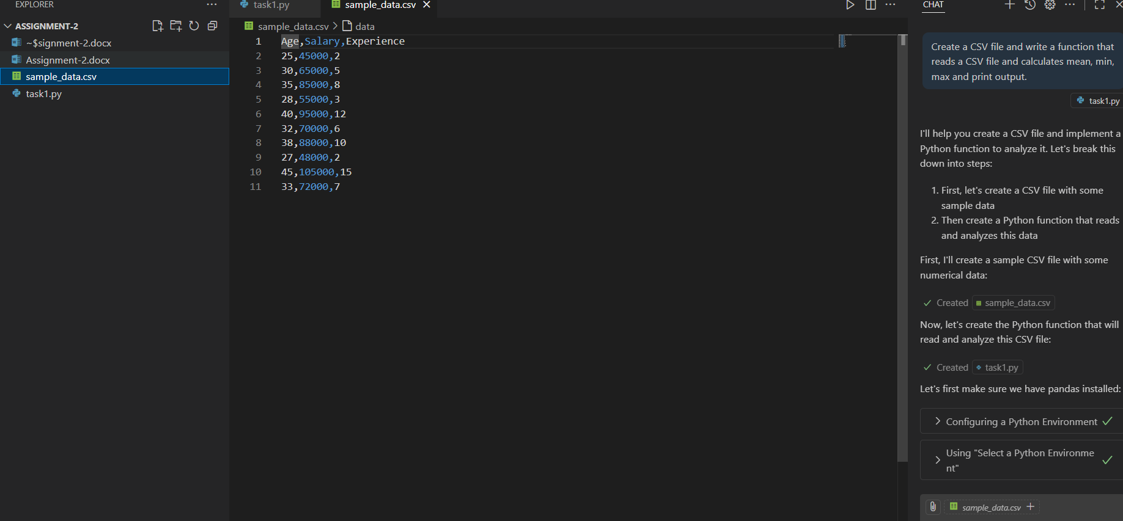

Code:
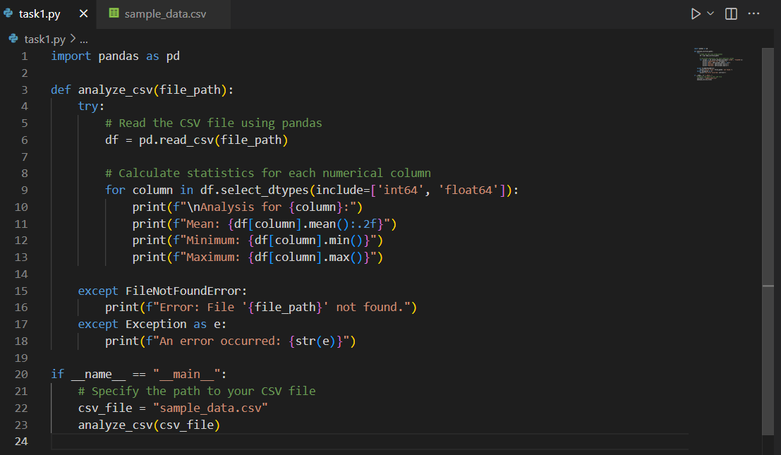

Output:
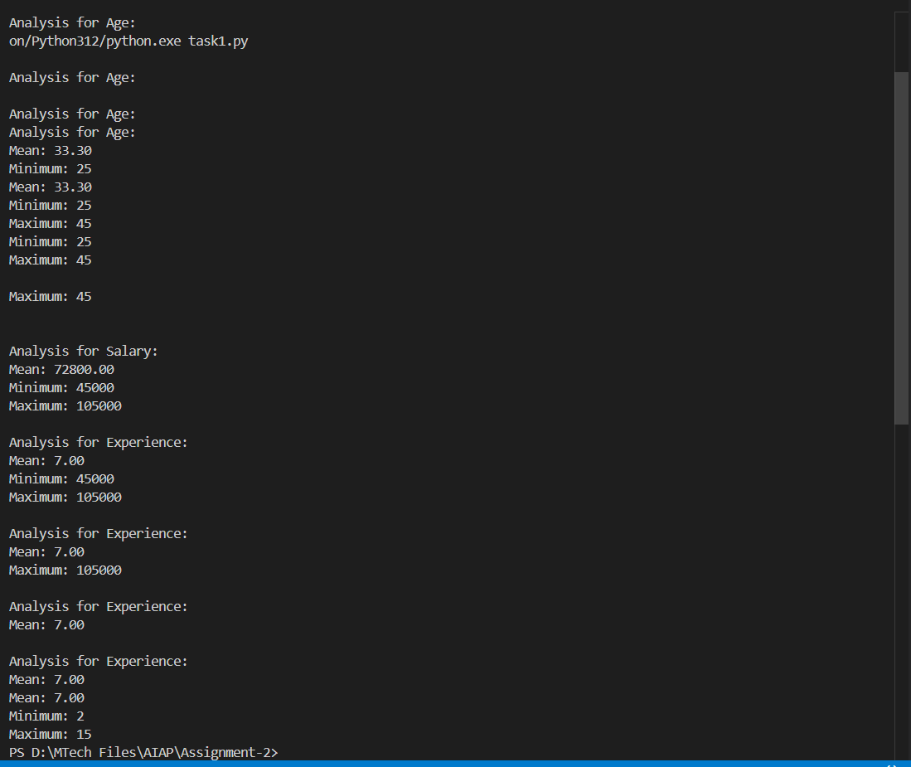

Task Description-2
- Compare Gemini and Copilot outputs for a palindrome check function.
Expected Output-2
- Side-by-side comparison and observations

Prompt
Generate a python function to check palindrome function by taking user input manually.

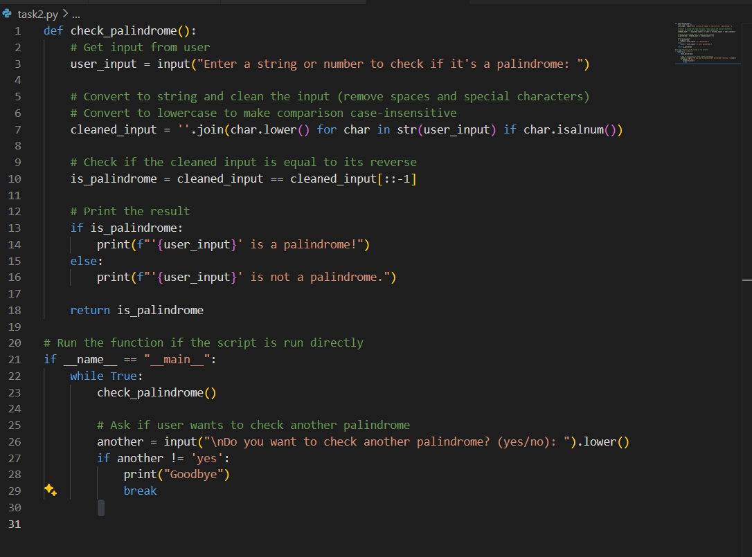

Output:

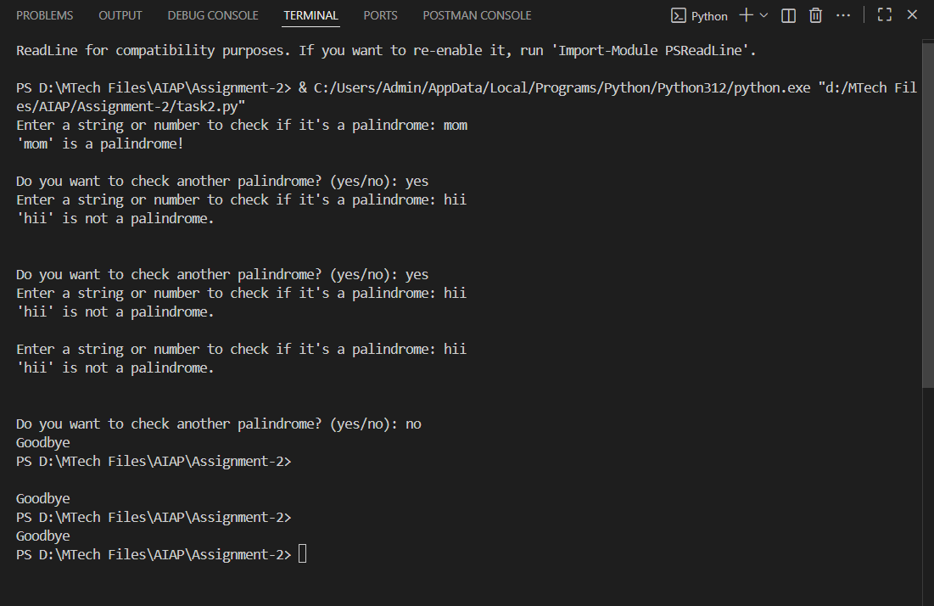

Task Description-3
- Ask Gemini to explain a Python function (to calculate area of various shapes) line by line..
Expected Output-3
- Detailed explanation with code snippet

Prompt
Write a Python function to calculate area of various shapes and explain line by line.

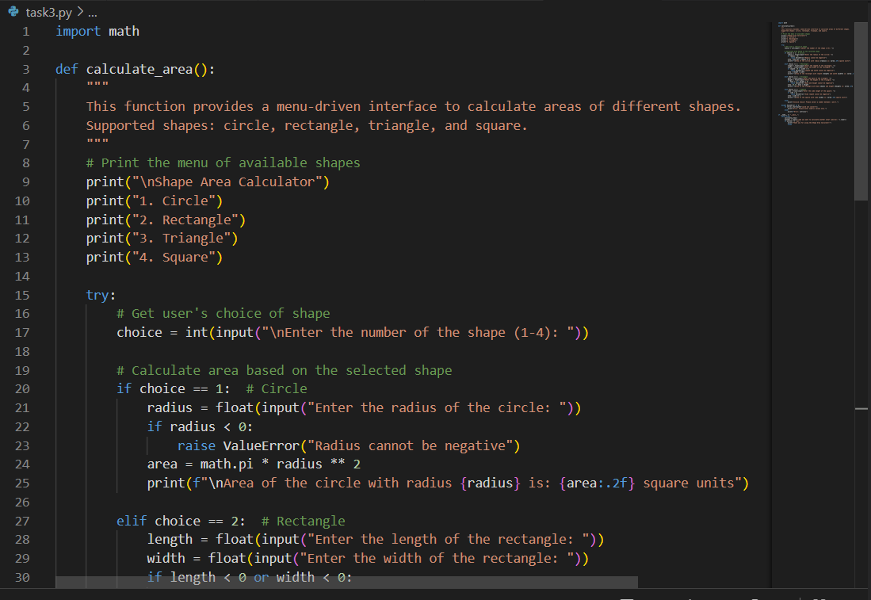

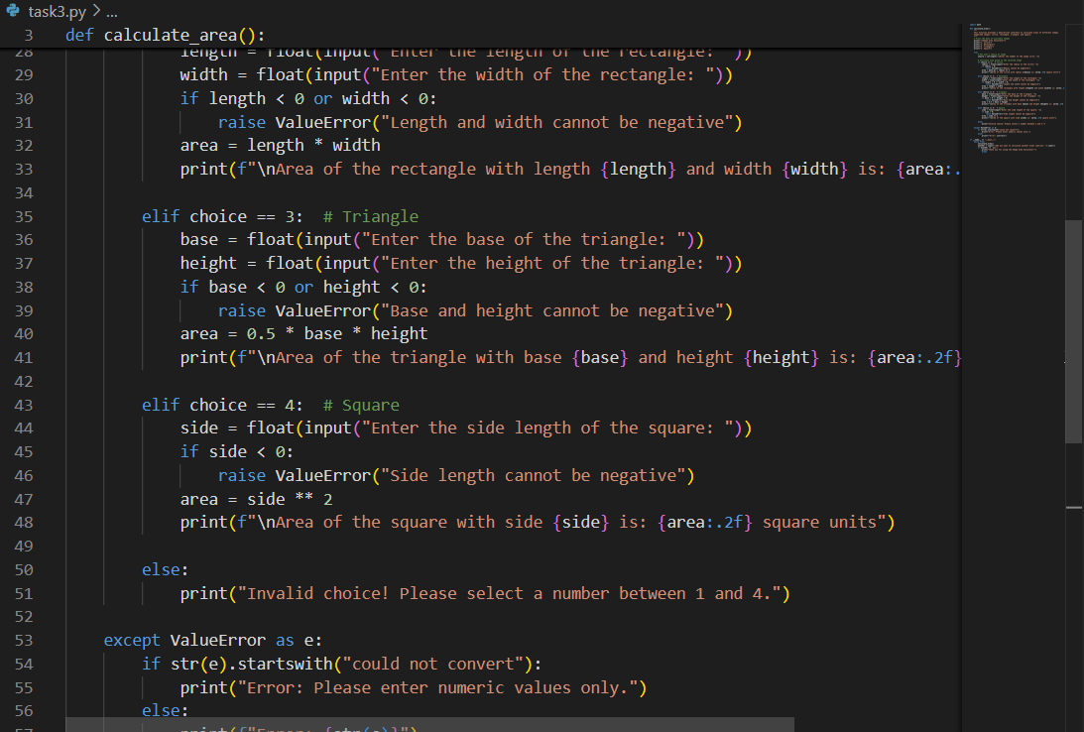
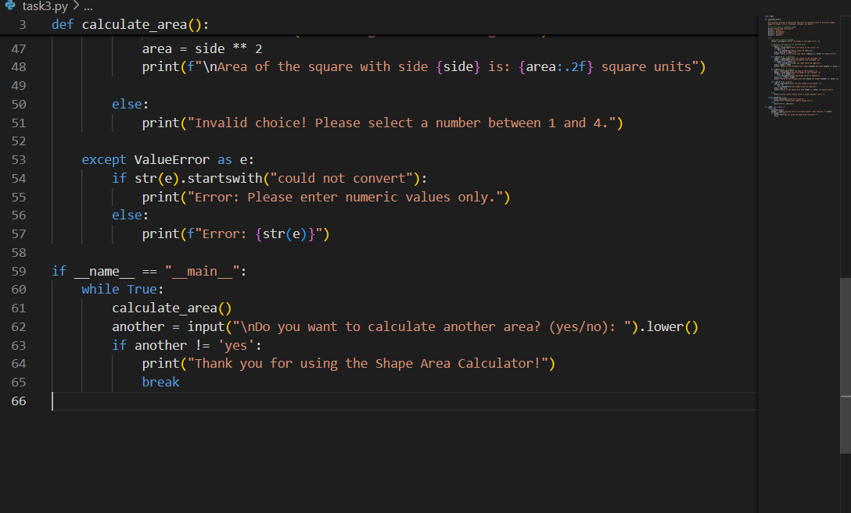

Output:
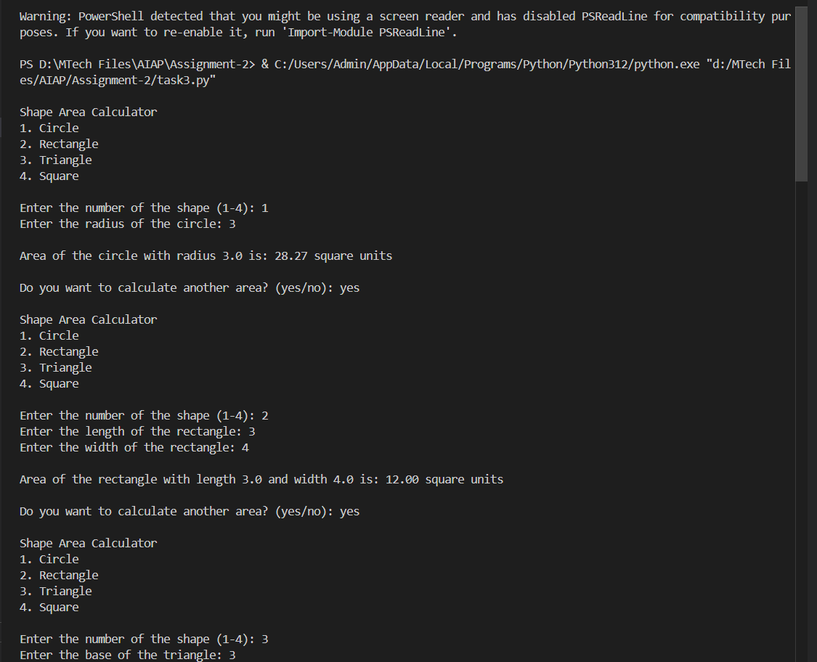

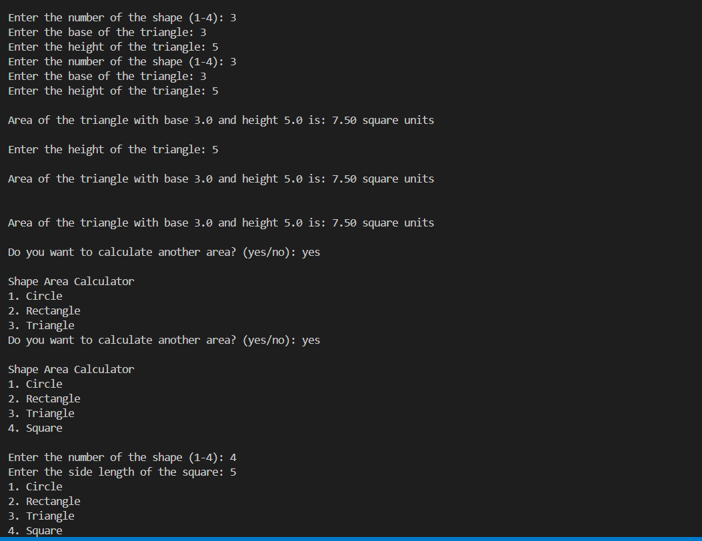

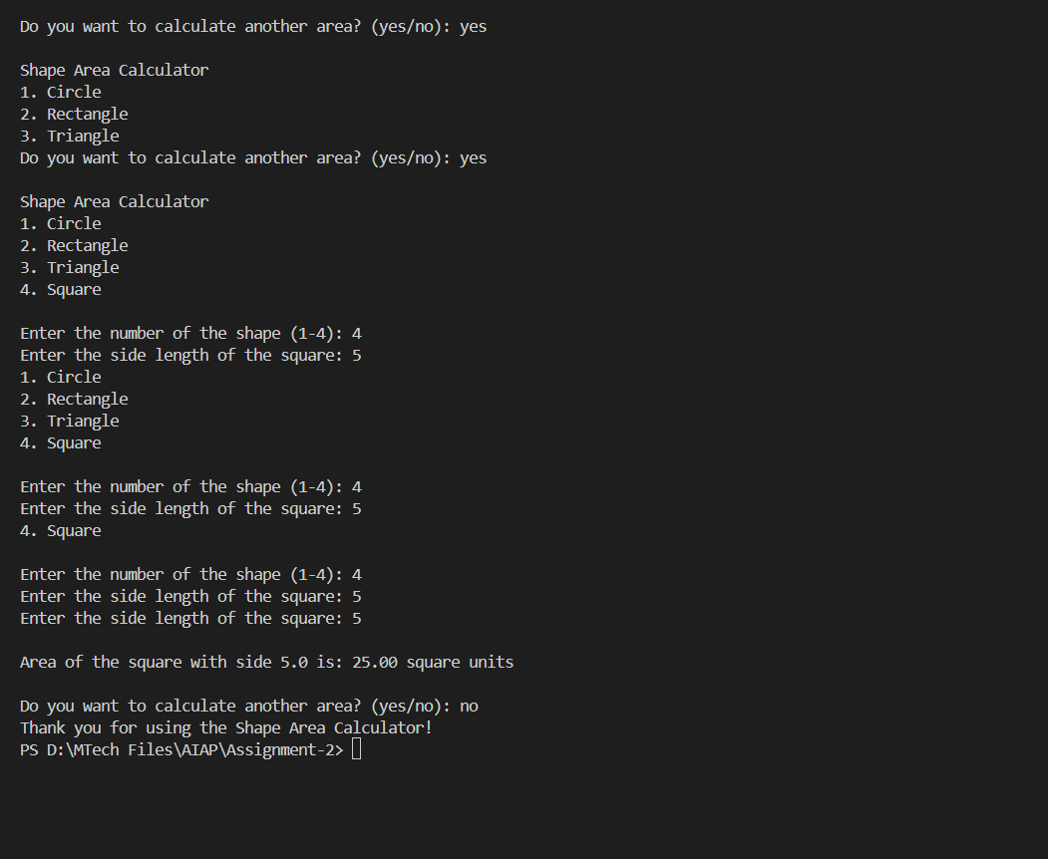

Task Description-4
- Install and configure Cursor AI. Use it to generate a Python function (e.g., sum of squares).
Expected Output-4
- Screenshots of working environments with few prompts to generate python code

Prompt
Generate a Python function sum of squares by taking user input manually.

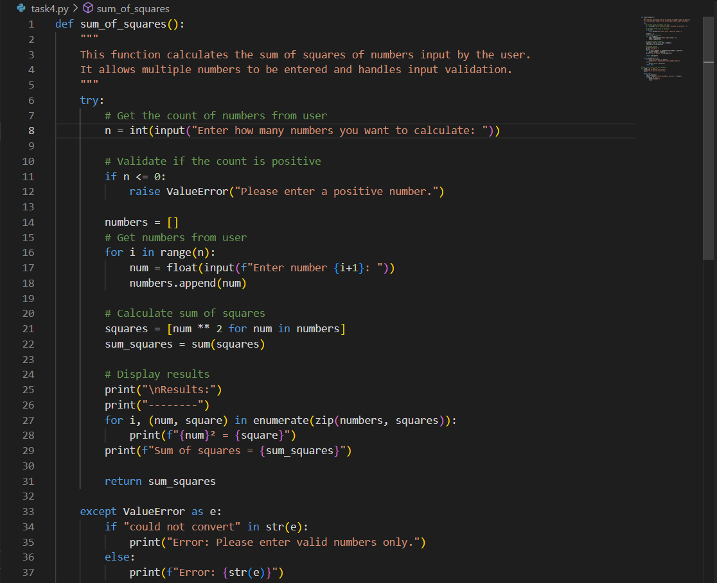

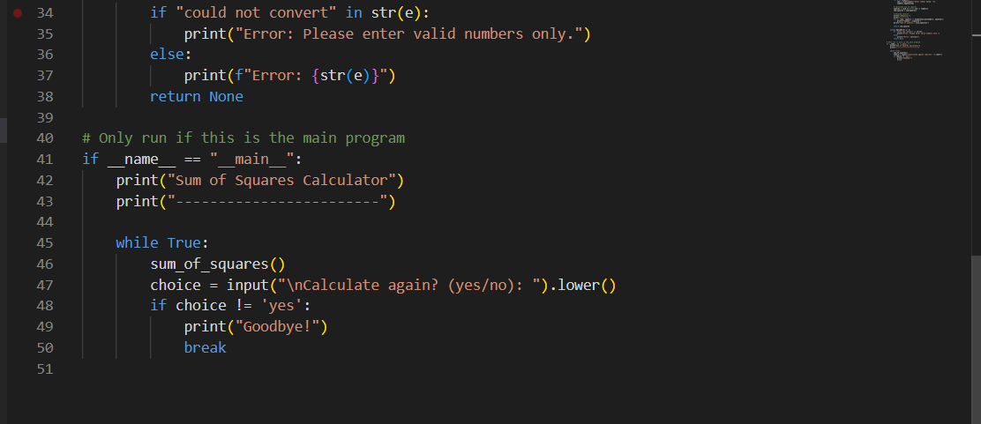

Output:

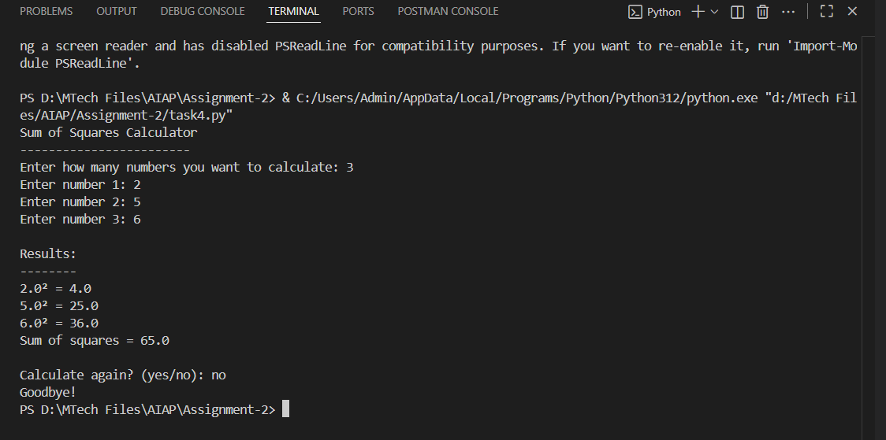

Task Description-5
- Student need to write code to calculate sum of odd number and even numbers in the list
Expected Output-5
- Refactored code written by student with improved logic

Prompt-1
write code to calculate sum of odd number and even numbers in the list by taking user input manually.

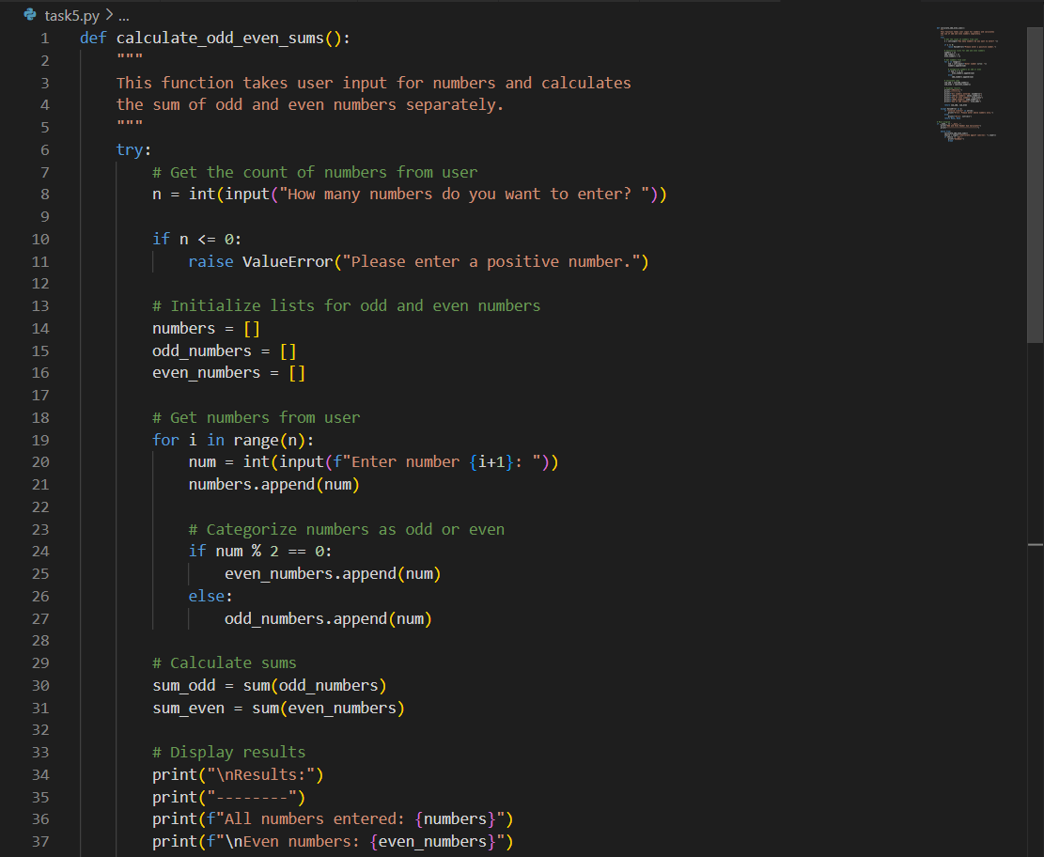

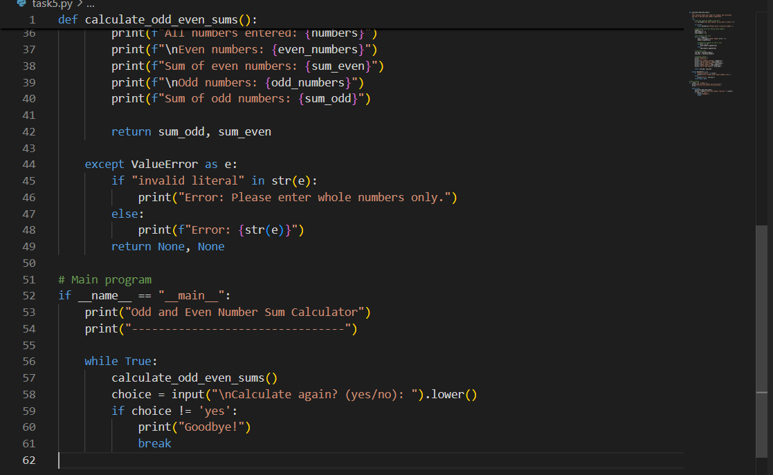

Output

