Date: 24/11/25
Name: Beulah Sathuluri
Mtech – 1st Year
HTNO: 2503B05123

Set3
A stack is a fundamental linear data structure that follows the Last-In, First-Out (LIFO) principle. This means the last element added to the stack is the first one to be removed, much like a stack of plates where you can only add a new plate to the top and only remove the topmost plate.

A stack is a fundamental linear data structure that follows the Last-In, First-Out (LIFO) principle. This means the last element added to the stack is the first one to be removed, much like a stack of plates where you can only add a new plate to the top and only remove the topmost plate.
The main improvement in using a Python list for a stack is ensuring O(1) time complexity for all core operations:
- push (using list.append()): Appending to the end of a Python list is amortized O(1).
- pop (using list.pop()): Removing from the end of a Python list is O(1).
- peek (using list[-1]): Accessing the last element by index is O(1).
- Applications:
- • Function Call Management: Compilers and operating systems use a "Call Stack" to manage function calls, local variables, and return addresses.⁶ When a function is called, its state is pushed; when it returns, its state is popped.
- • Expression Evaluation: Used to convert infix expressions (e.g., ⁷$A + B$) to postfix (e.g., ⁸$AB+$) and evaluate them.⁹
- • Undo/Redo Mechanisms: Stacks store the sequence of operations performed in applications (like text editors) to allow users to undo or redo actions.¹⁰
- • Backtracking Algorithms: Used in algorithms (like finding a path in a maze) to keep track of the previously visited states.¹¹

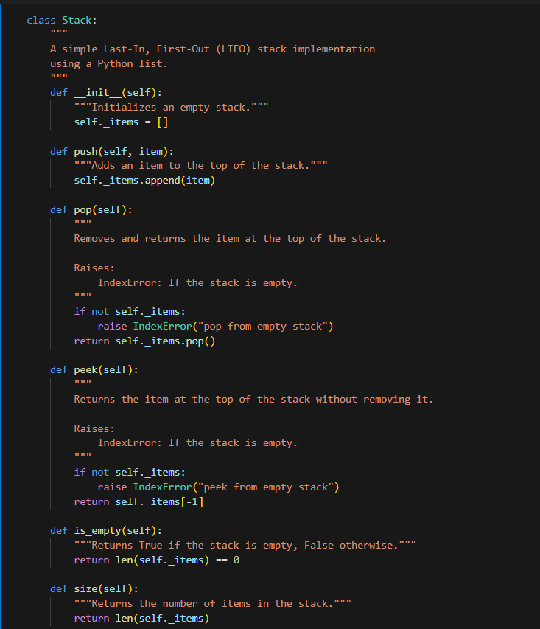

Output:

Stack after pushes: [10, 20, 30]
Peek: 30
Pop: 30
Stack after pop: [10, 20]
Error: Pop from empty stack
Error: Peek from empty stack

- Q2. Refactor a poorly commented Python function using an AI assistant for automatic documentation. Evaluate clarity and completeness versus manual comments.
