AI Assisted Problem Solving Using Python

Name: Beulah sathuluri
Mtech – 1st Year
HTNO: 2503B05123

Lab 6: AI-Based Code Completion – Classes, Loops, and Conditionals

Task Description-1 (Classes)
- Use AI to complete a Student class with attributes and a method.
- Check output
- Analyze the code generated by AI tool

Expected Output-1
- Class with constructor and display_details() method

Prompt
Complete a Student class with attributes and a method

Code:
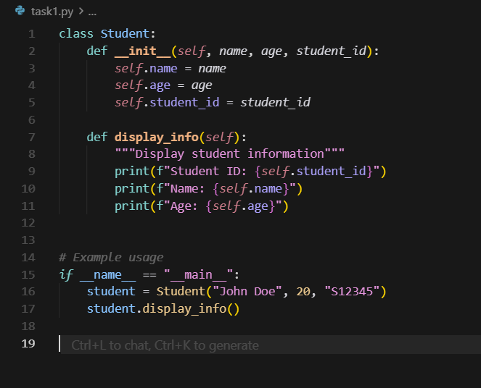

Output

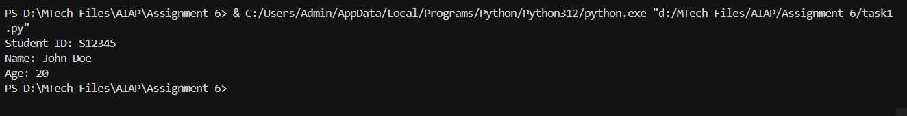

Task Description-2 (Loops)
- Prompt AI to complete a function that prints the first 10 multiples of a number using a loop.
- Analyze the generated code
- Ask AI to generate code using other controlled looping
Expected Output-2
- Correct loop-based implementation

Prompt-1
Complete a function that prints the first 10 multiples of a number using a loop.
Prompt-2
Generate the code using other controlled looping

Code-1:
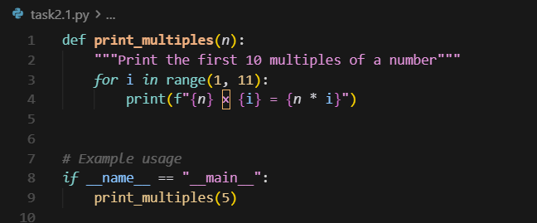

Output-1

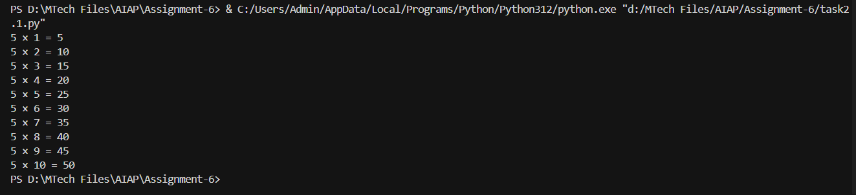

Code-2

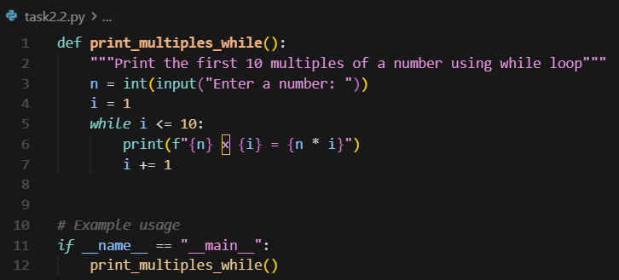

Output-2
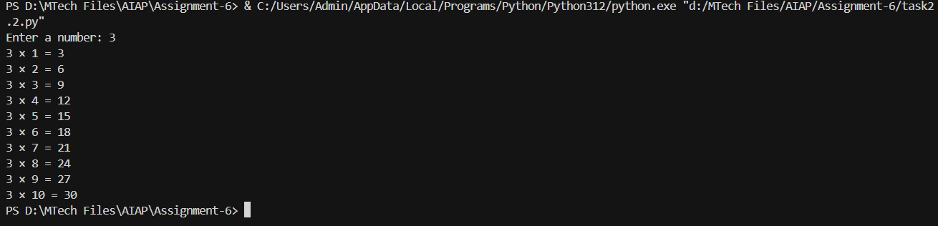

Task Description-3 (Conditional Statements)
- Ask AI to write nested if-elif-else conditionals to classify age groups.
- Analyze the generated code
- Ask AI to generate code using other conditional statements
Expected Output-3
- Age classification function with appropriate conditions and with explanation

Prompt
Write nested if-elif-else conditionals to classify age groups.

Code-1:
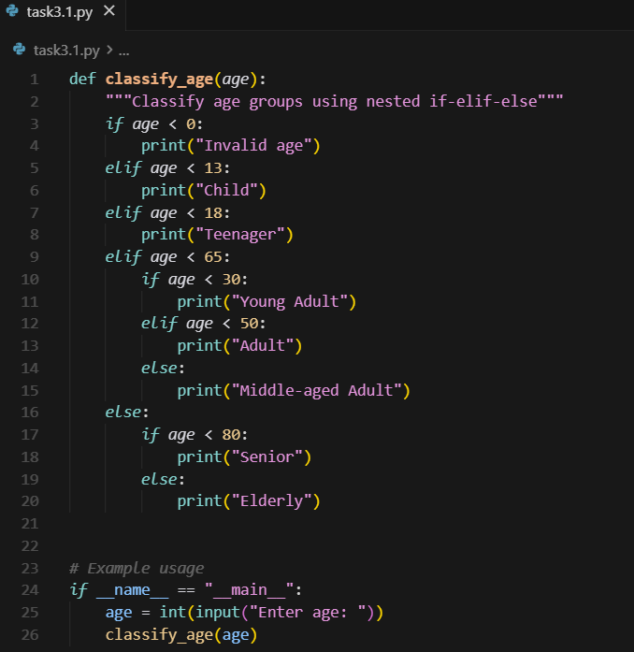

Output-1
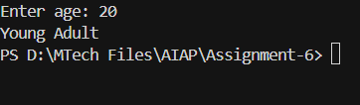

Code-2
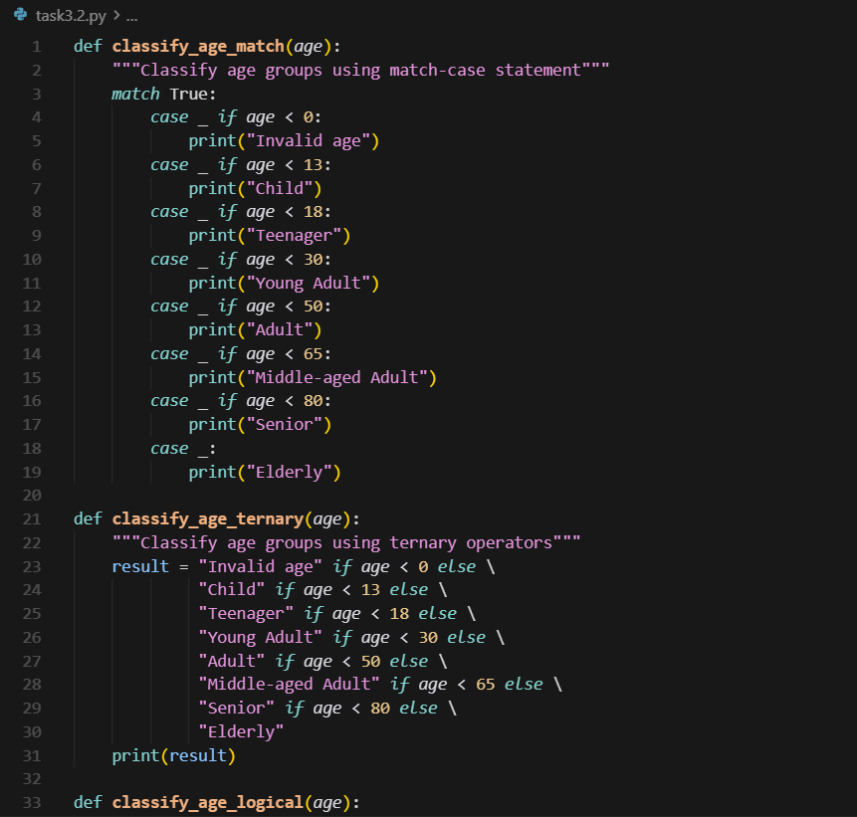
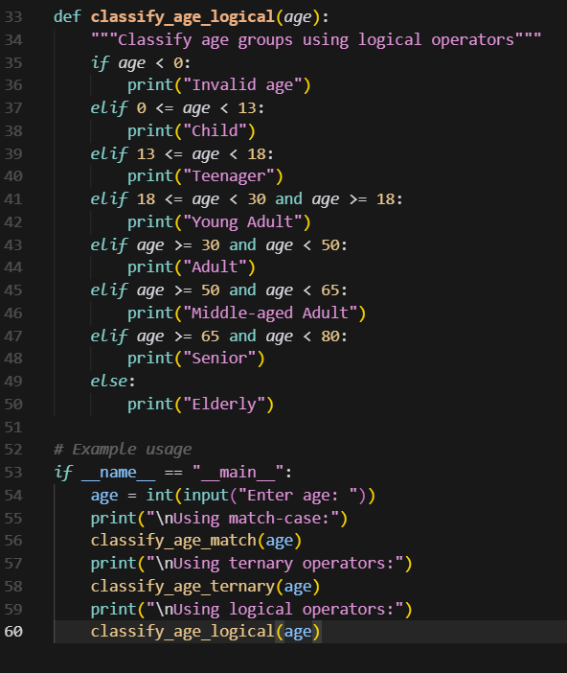
Output-2
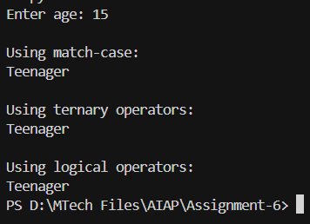

Task Description-4 (For and While loops)
- Generate a sum_to_n() function to calculate sum of first n numbers
- Analyze the generated code
- Get suggestions from AI with other controlled looping

Expected Output-4
- Python code with explanation

Prompt
Generate a sum_to_n() function to calculate sum of first n numbers

Code:
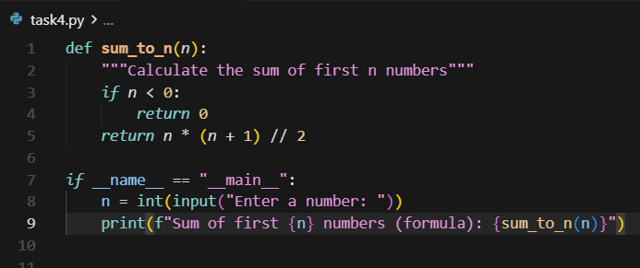

Output
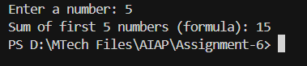

Explaination:
AI has suggested with for loop and while loop in order to calculate sum of first n numbers to achieve the same result.

Task Description-5 (Class)
- Use AI to build a BankAccount class with deposit, withdraw, and balance methods.
- Analyze the generated code
- Add comments and explain code

Expected Output-5
Python code with explanation
Prompt
Build a BankAccount class with deposit, withdraw, and balance methods and add comments and explain the code

Code:

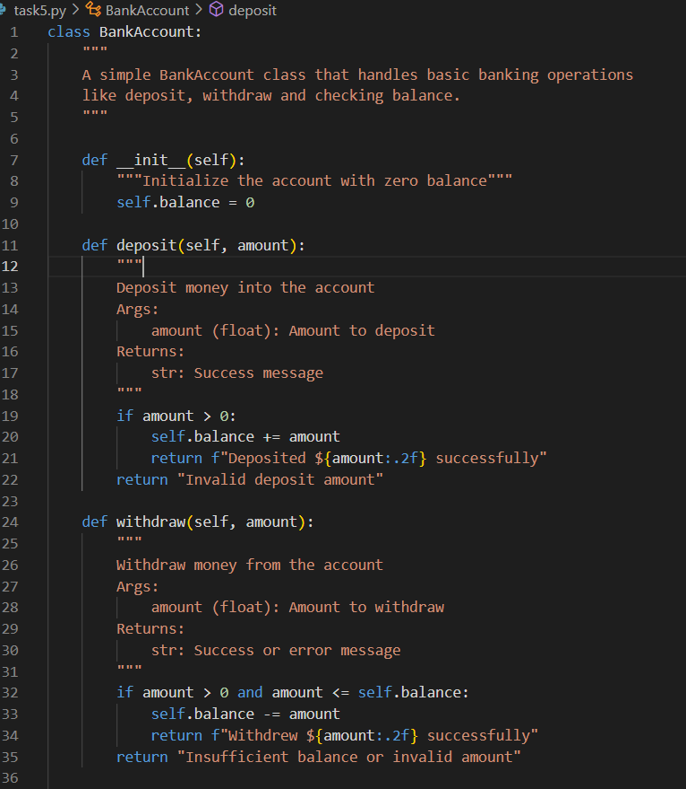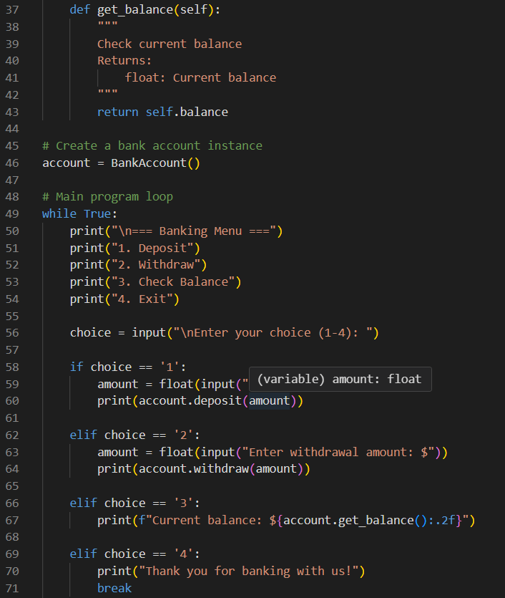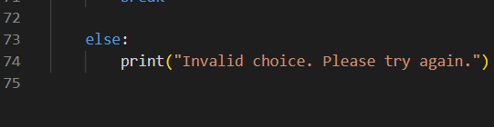

Output

