AI Assisted Problem Solving Using Python

Date: 18-11-2025
Name: Beulah sathuluri
Mtech – 1st Year
HTNO: 2503B05123

Lab 12 – Algorithms with AI Assistance: Sorting, searching, and optimizing algorithms

Task Description-1 –Linear Search implementation
Task: Write python code for linear_search () function to search a value in a list and extract its index.
Code:
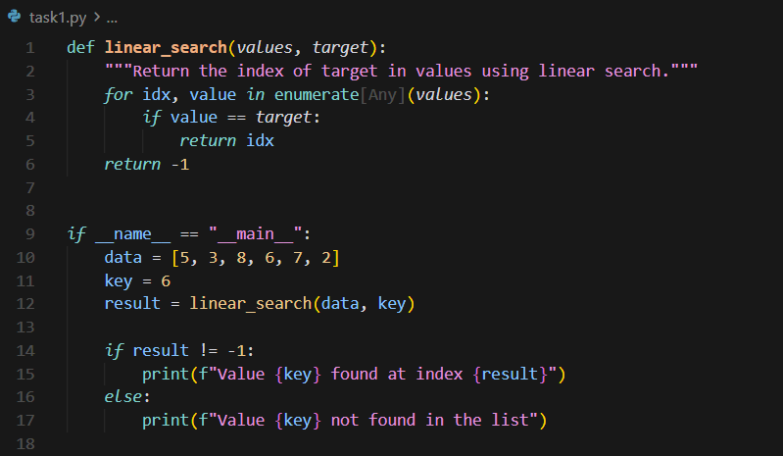
Output:
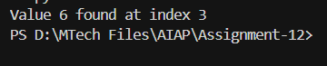

Task Description-2 –Sorting Algorithms
Task: Ask AI to implement Bubble Sort and check sorted output
Code:
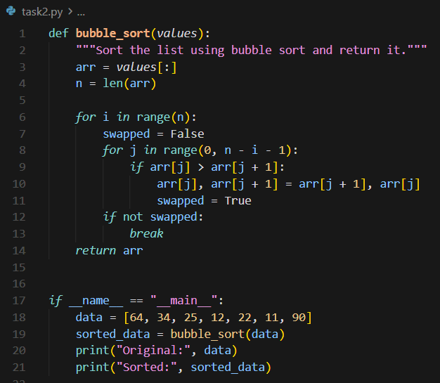

Output:
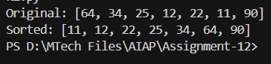

Task Description-3 –Optimization
Task: Write python code to solve below case study using linear optimization
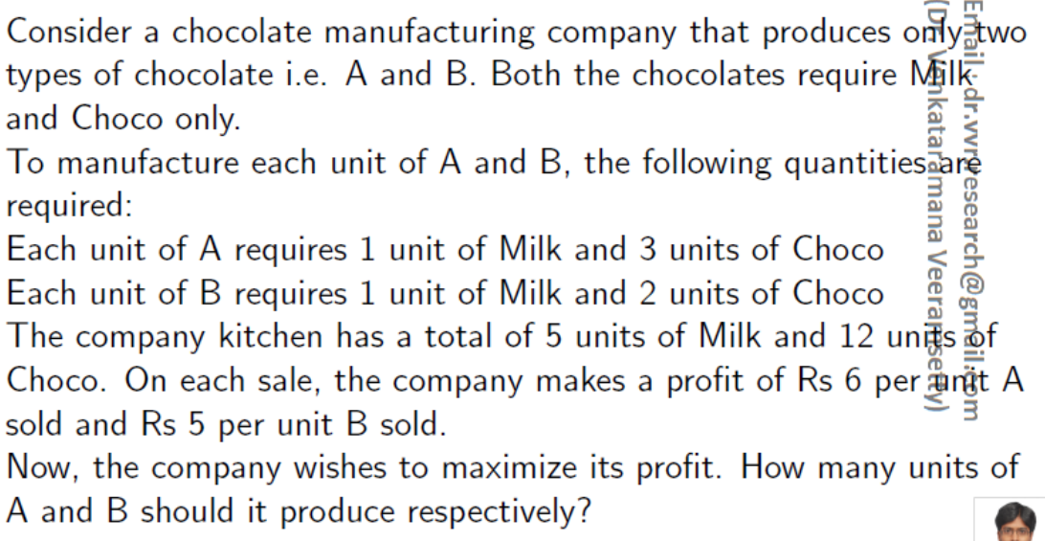

Code:
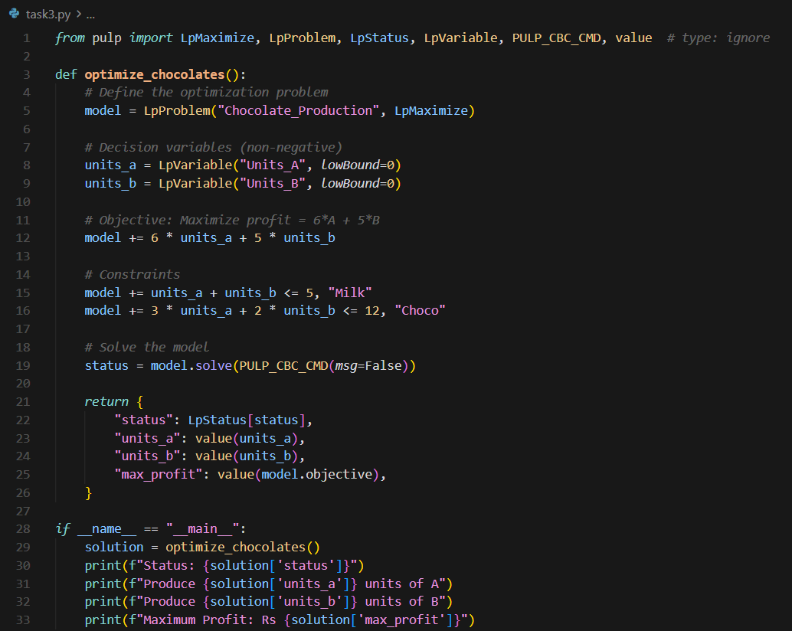

Output:
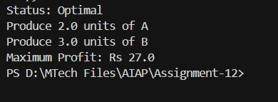

Task Description-4 –Gradient Descent Optimization
Task: Write python code to find value of x at which the function f(x)=2X³+4x+5 will be minimum

Code:
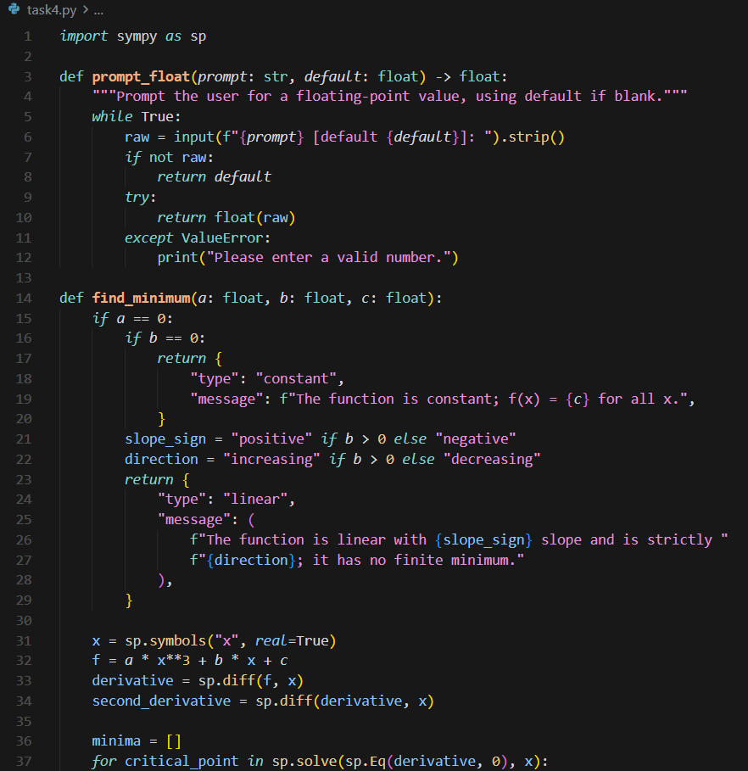
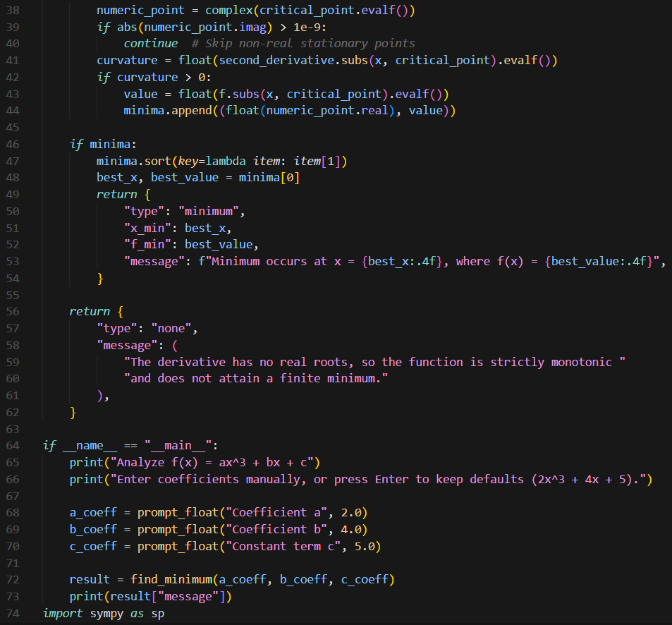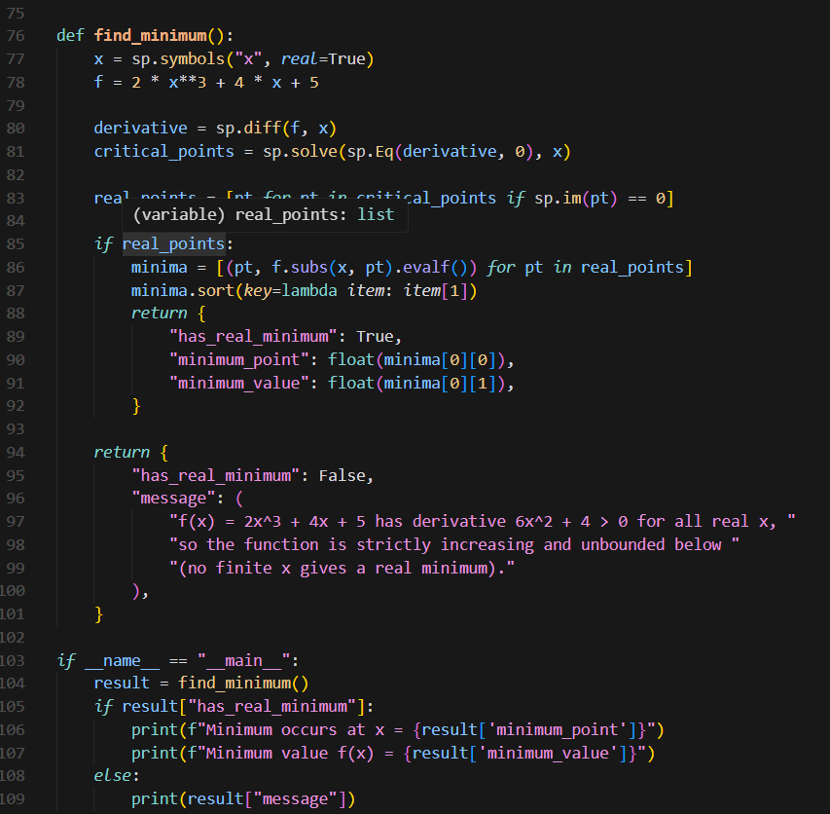

Ouput:
