AI Assisted Problem Solving Using Python

Name: Beulah Sathuluri
Mtech – 1st Year
HTNO: 2503B05123

Lab 8: Test-Driven Development with AI – Generating and Working with Test Cases

Task Description-1
Use AI to generate test cases for is_valid_email(email) and then implement the validator function.
Requirements:
- Must contain @ and . characters.
- Must not start or end with special characters.
- Should not allow multiple @.

Expected Output-1
- Email validation logic passing all test cases

Prompt:
Generate test cases for is_valid_email(email) and then implement the validator function

Code:
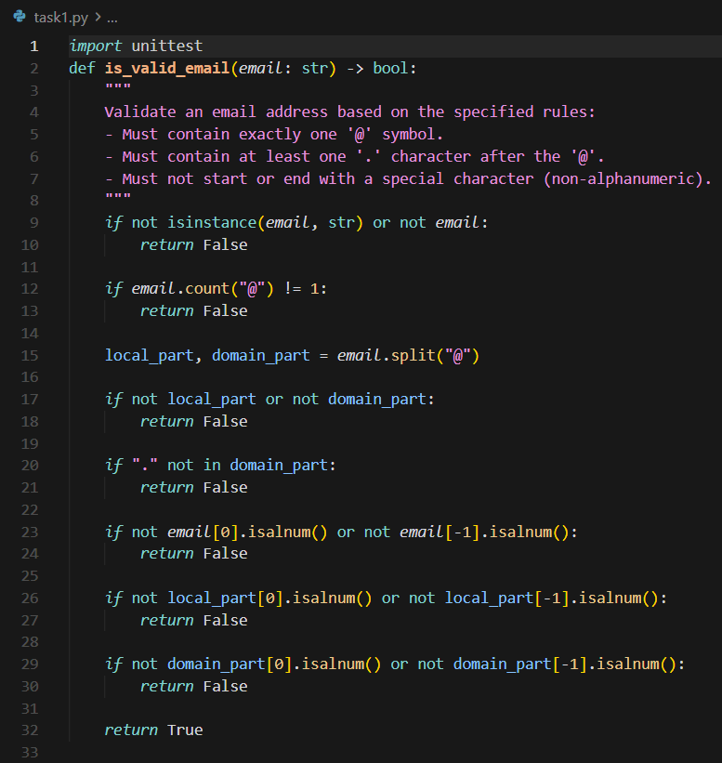
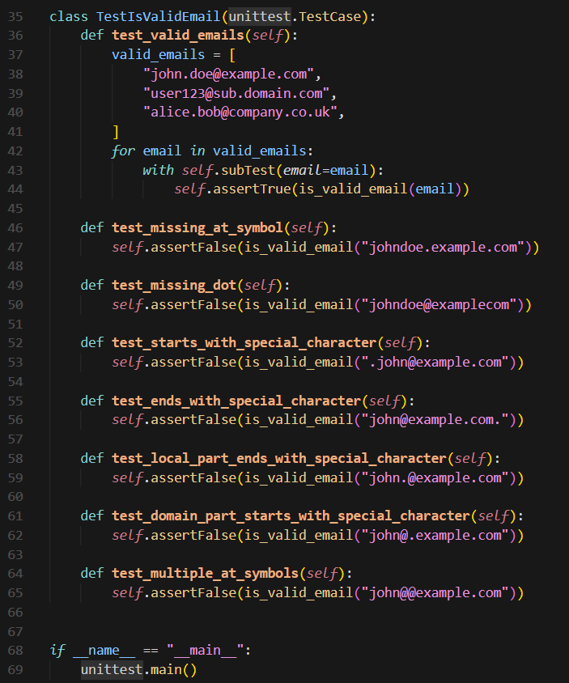
Output:
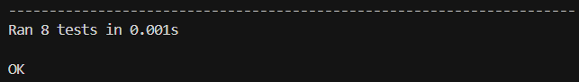

Task Description-2 (Loops)
- Ask AI to generate test cases for assign_grade(score) function. Handle boundary and invalid inputs.
Requirements
- AI should generate test cases for assign_grade(score) where: 90-100: A, 80-89: B, 70-79: C, 60-69: D, <60: F
- Include boundary values and invalid inputs (e.g., -5, 105, "eighty").

Expected Output-2
Grade assignment function passing test suite

Prompt:
Generate test cases for assign_grade(score) function. Handle boundary and invalid inputs.

Code:
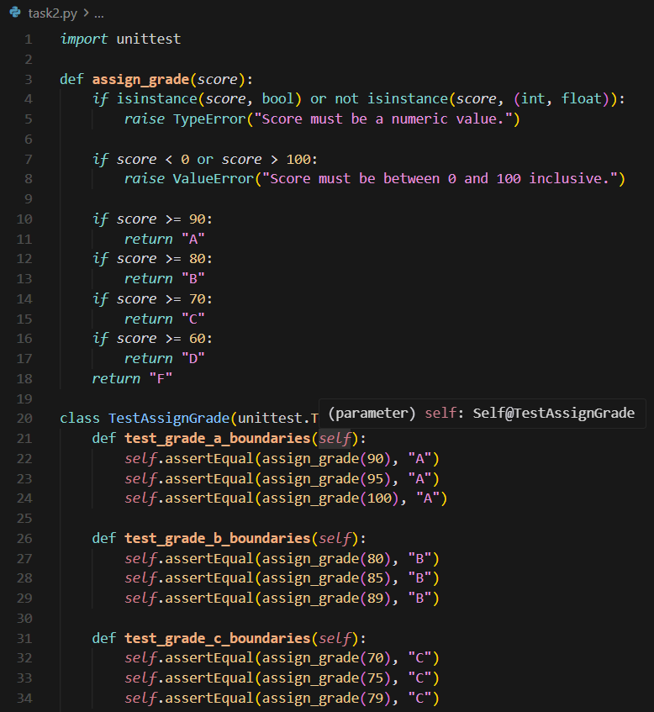
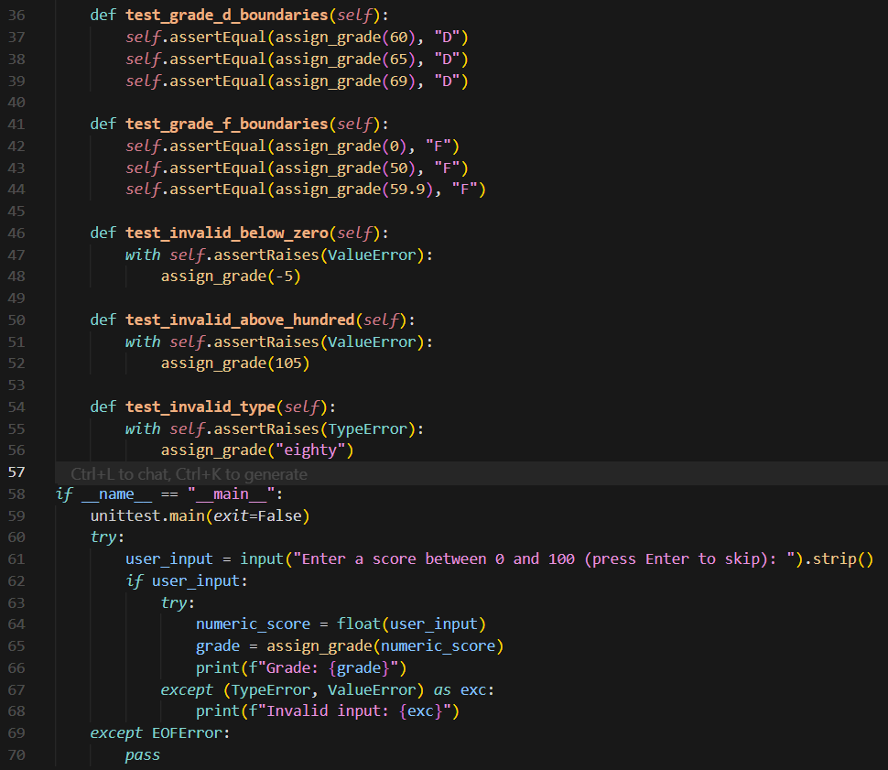

Output:
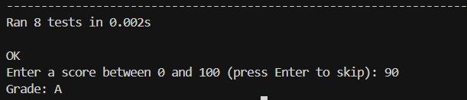

Task Description-3
- Generate test cases using AI for is_sentence_palindrome(sentence). Ignore case, punctuation, and spaces

Requirement
- Ask AI to create test cases for is_sentence_palindrome(sentence)
(ignores case, spaces, and punctuation).
- Example:
"A man a plan a canal Panama" → True

Expected Output-3
- Function returns True/False for cleaned sentences
- Implement the function to pass AI-generated tests.

Prompt:
Generate test cases for is_sentence_palindrome(sentence). Ignore case, punctuation, and spaces

Code:
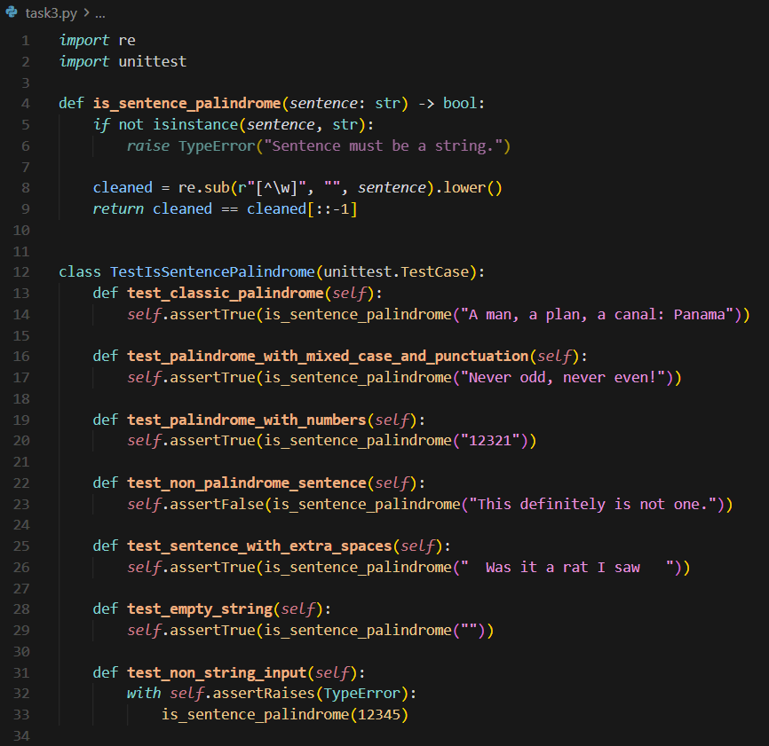
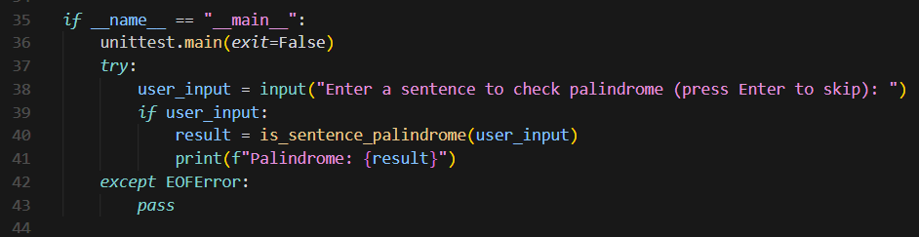

Output:
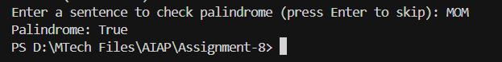

Task Description-4
- Let AI fix it Prompt AI to generate test cases for a ShoppingCart class (add_item, remove_item, total_cost).

Methods:
Add_item(name,orice)
Remove_item(name)
Total_cost()

Expected Output-4
- Full class with tested functionalities
Code:
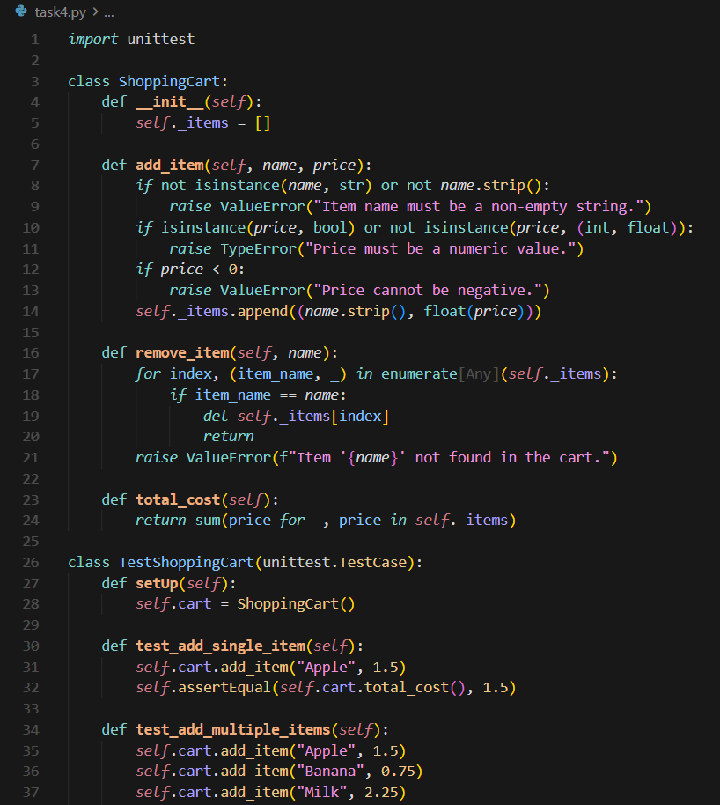
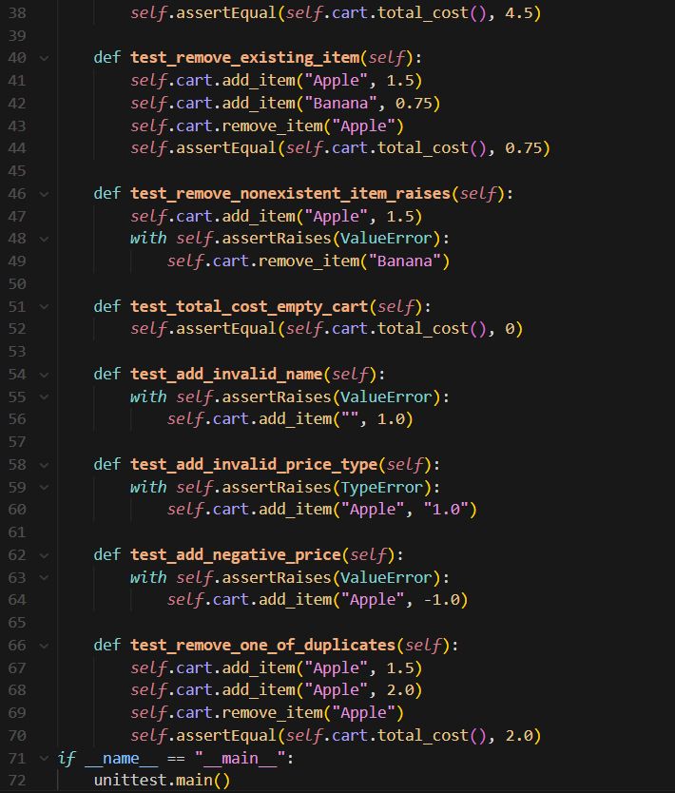

Task Description-5
- Use AI to write test cases for convert_date_format(date_str) to switch from "YYYY-MM-DD" to "DD-MM-YYYY".
Example: "2023-10-15" → "15-10-2023"

Expected Output-5
- Function converts input format correctly for all test cases

Prompt:
Write test cases for convert_date_format(date_str) to switch from "YYYY-MM-DD" to "DD-MM-YYYY".
Example: "2023-10-15" → "15-10-2023"

Code:
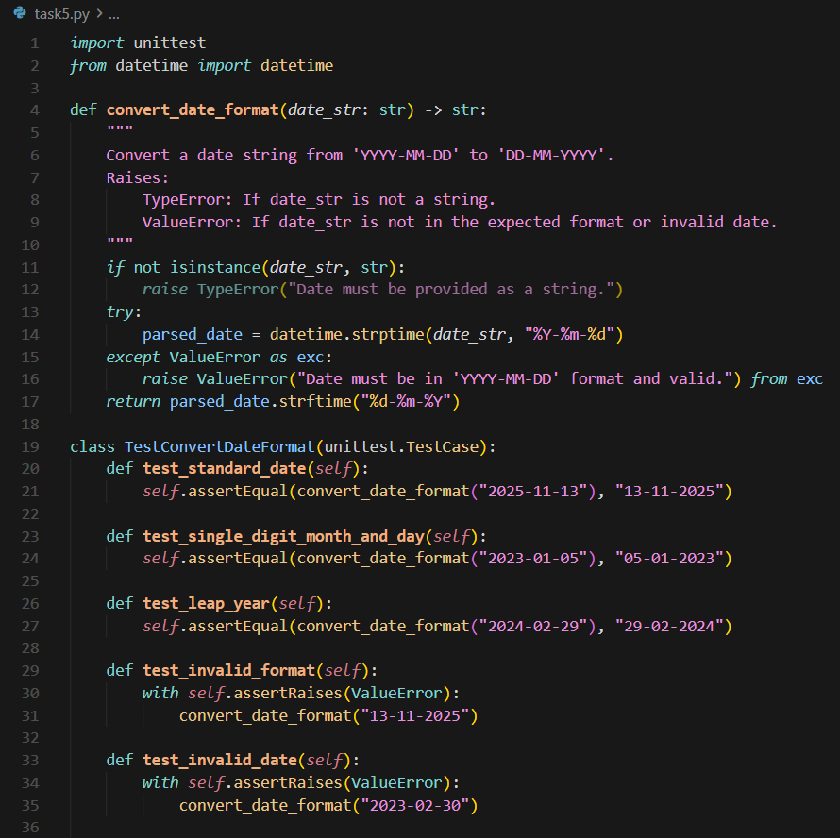
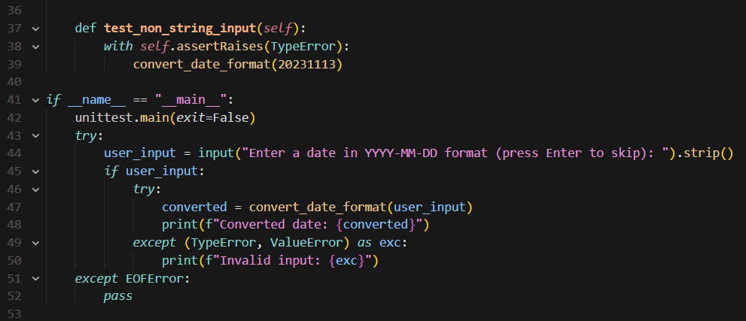

Output:
