AI Assisted Problem Solving Using Python

Name: Beulah Sathuluri
Mtech – 1st Year
HTNO: 2503B05123

Lab 17 – AI for Data Processing: Data Cleaning and Preprocessing Scripts

Task 1 – Social Media Data Cleaning
Task: Clean raw social media posts dataset.
Instructions:
- Remove stopwords, punctuation, and special symbols from post text.
- Handle missing values in likes and shares columns.
- Convert timestamp to datetime and extract features (hour, weekday).
- Detect and remove spam/duplicate posts.
Expected Output: A cleaned dataset with structured features for sentiment/engagement analysis.

Code:
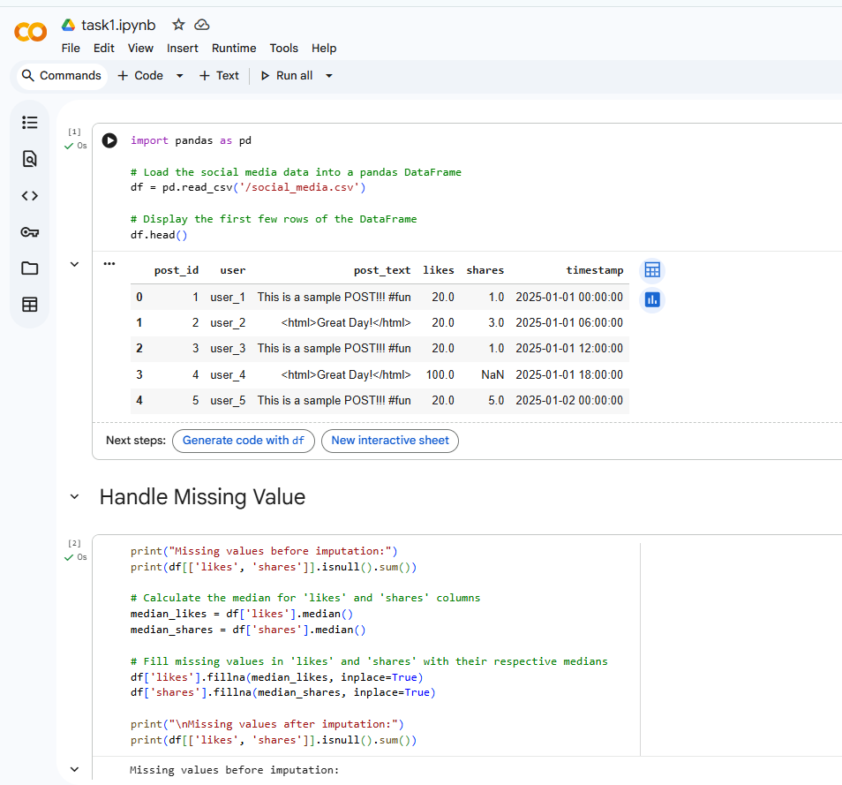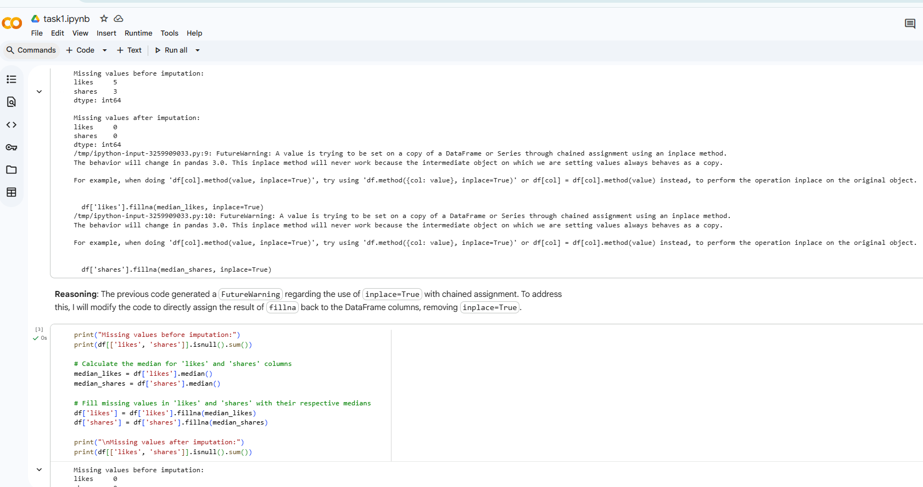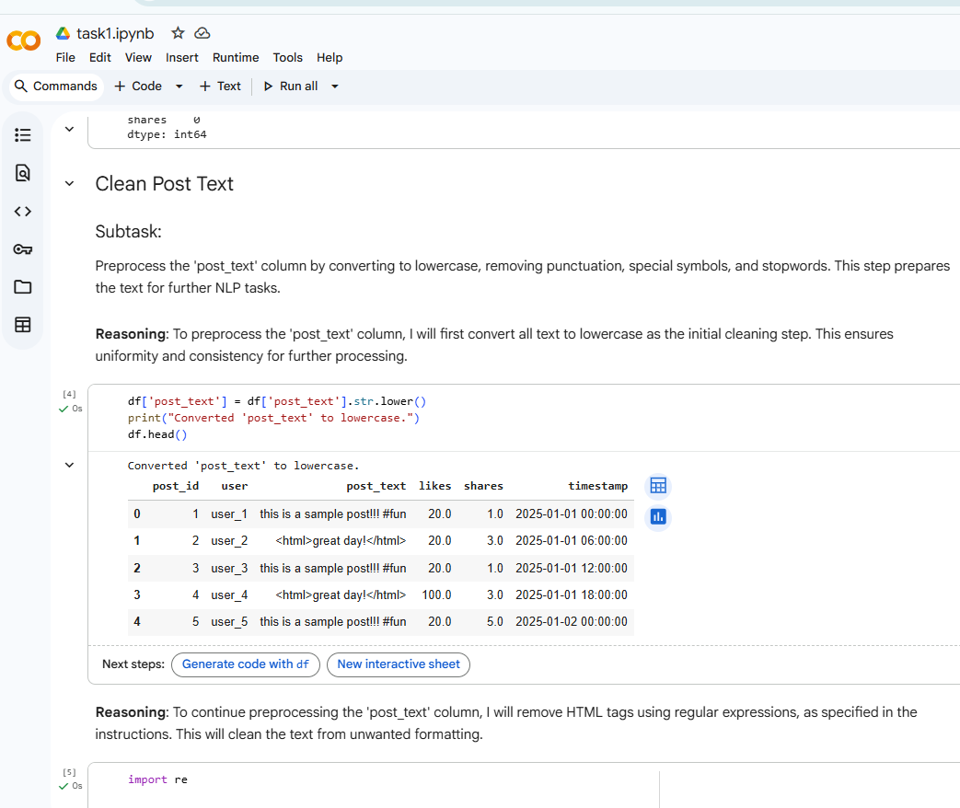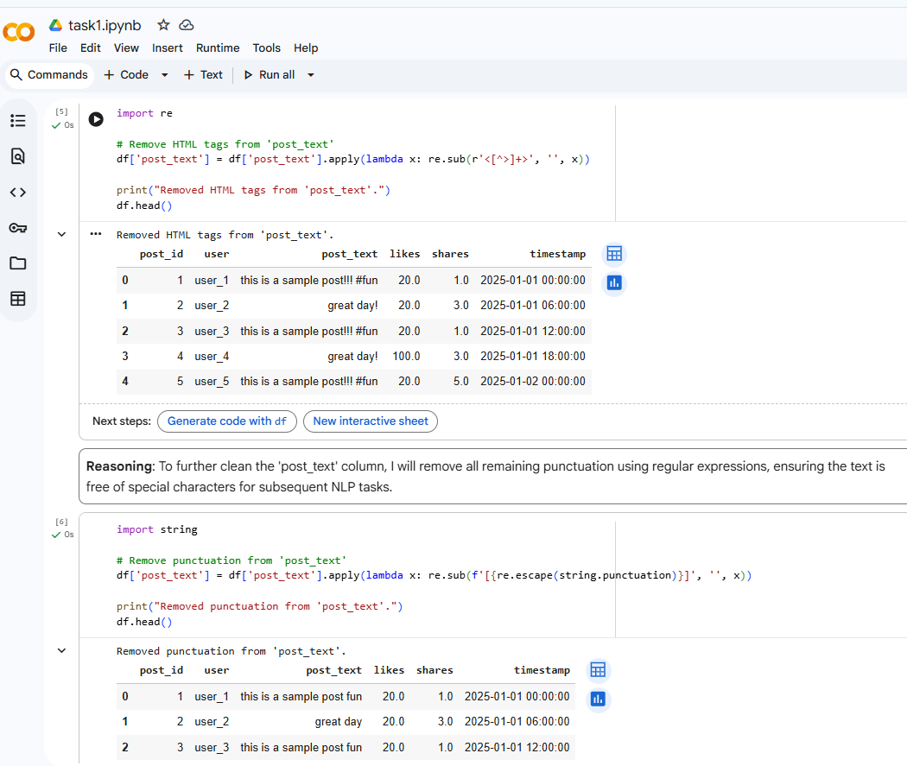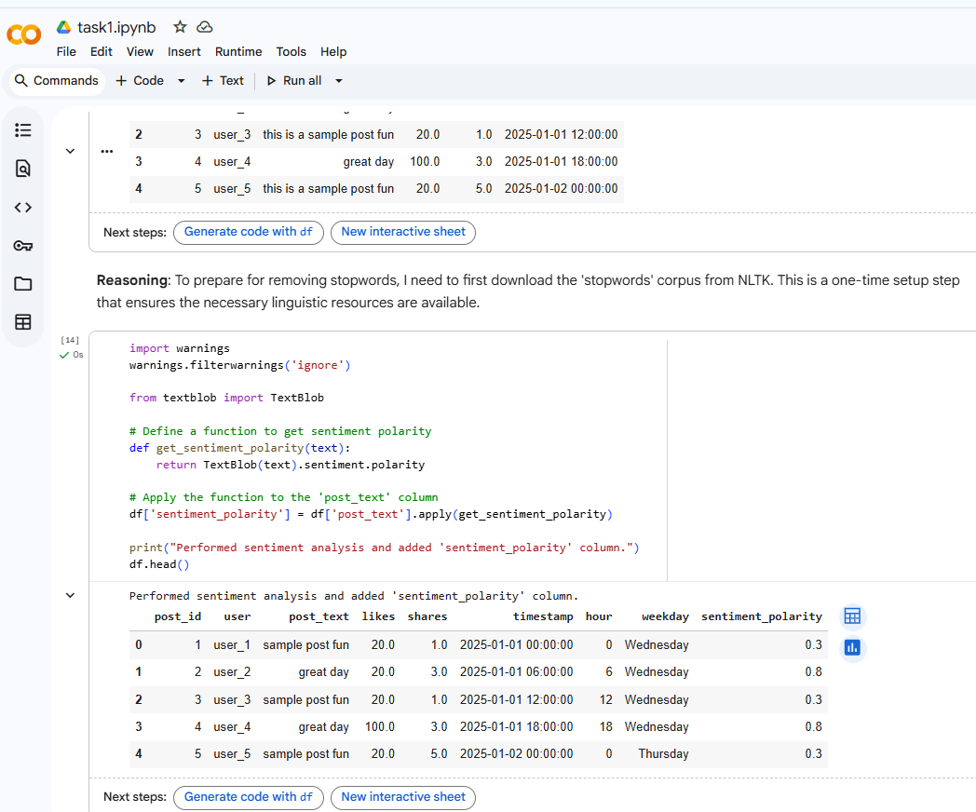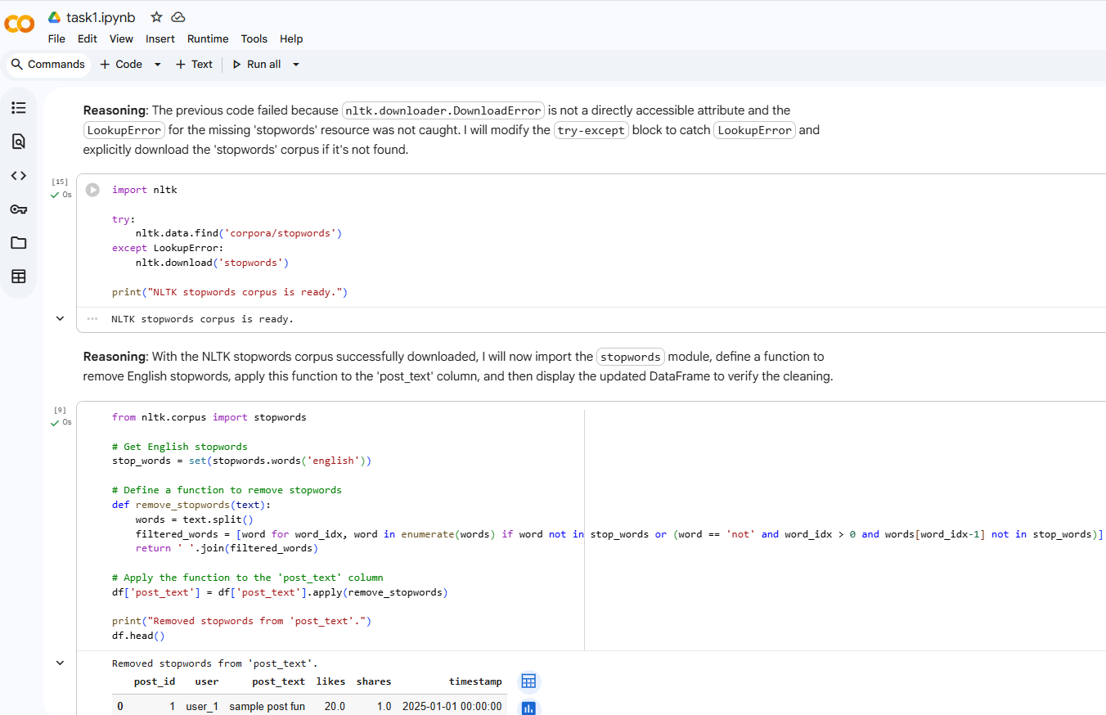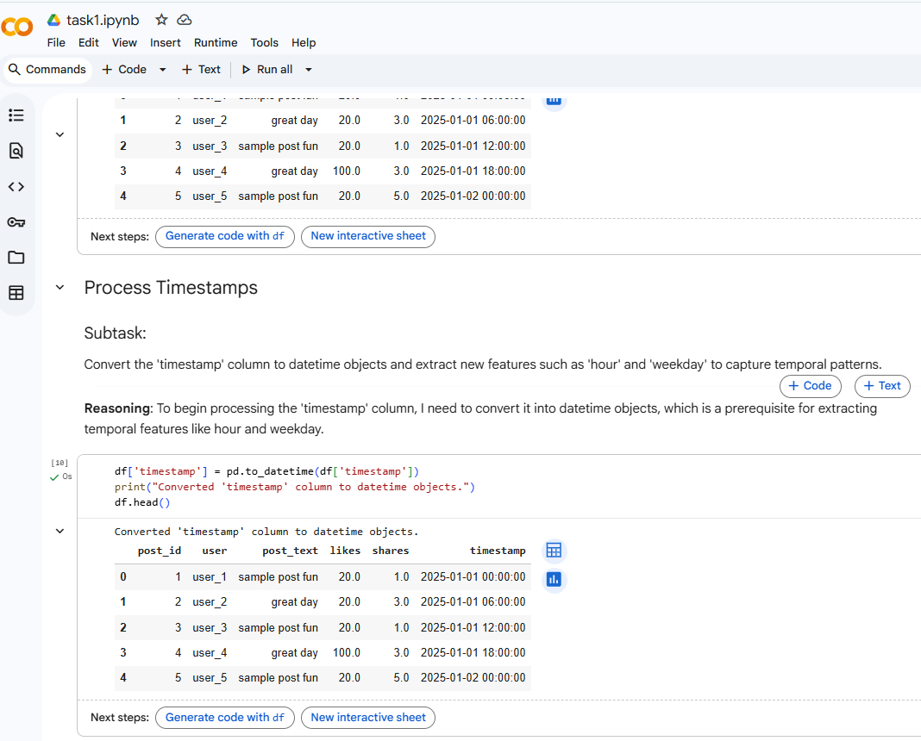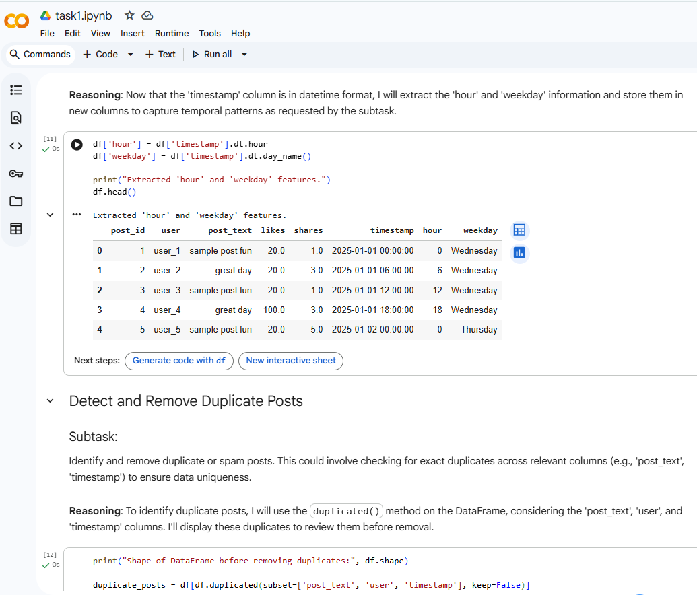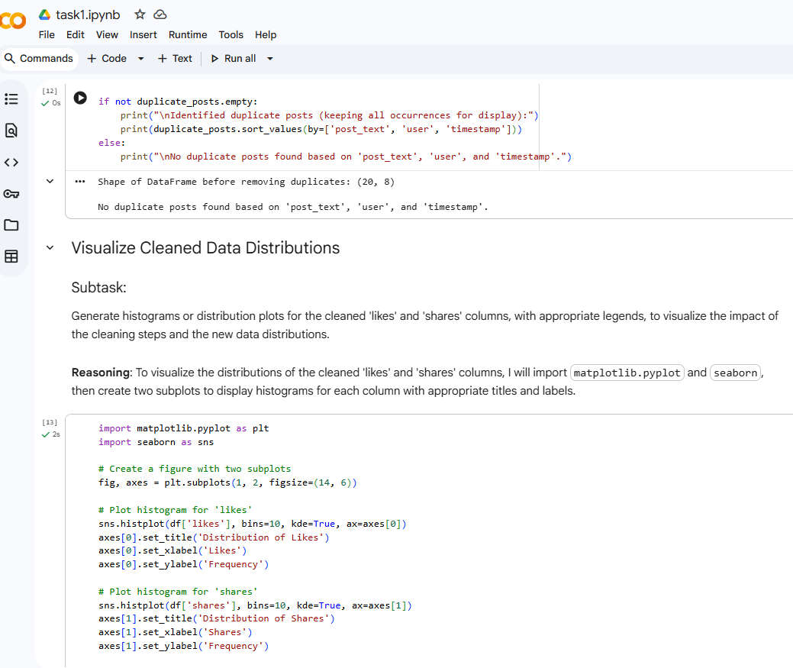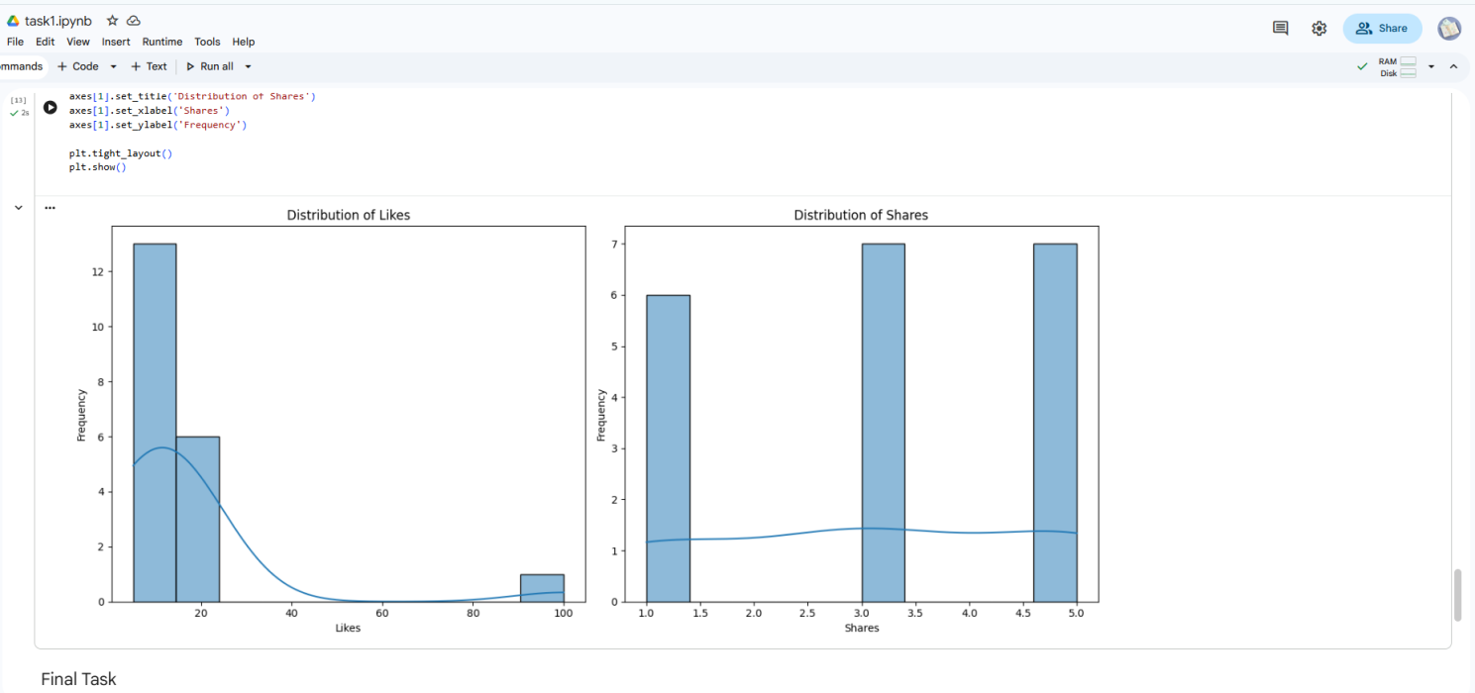

Task 2 – Financial Data Preprocessing
Task: Preprocess a stock market dataset.
Instructions:
- Handle missing values in closing_price and volume.
- Create lag features (1-day, 7-day returns).
- Normalize volume column using log-scaling.
- Detect outliers in closing_price using IQR method.
Expected Output: A time-series dataset ready for forecasting models.

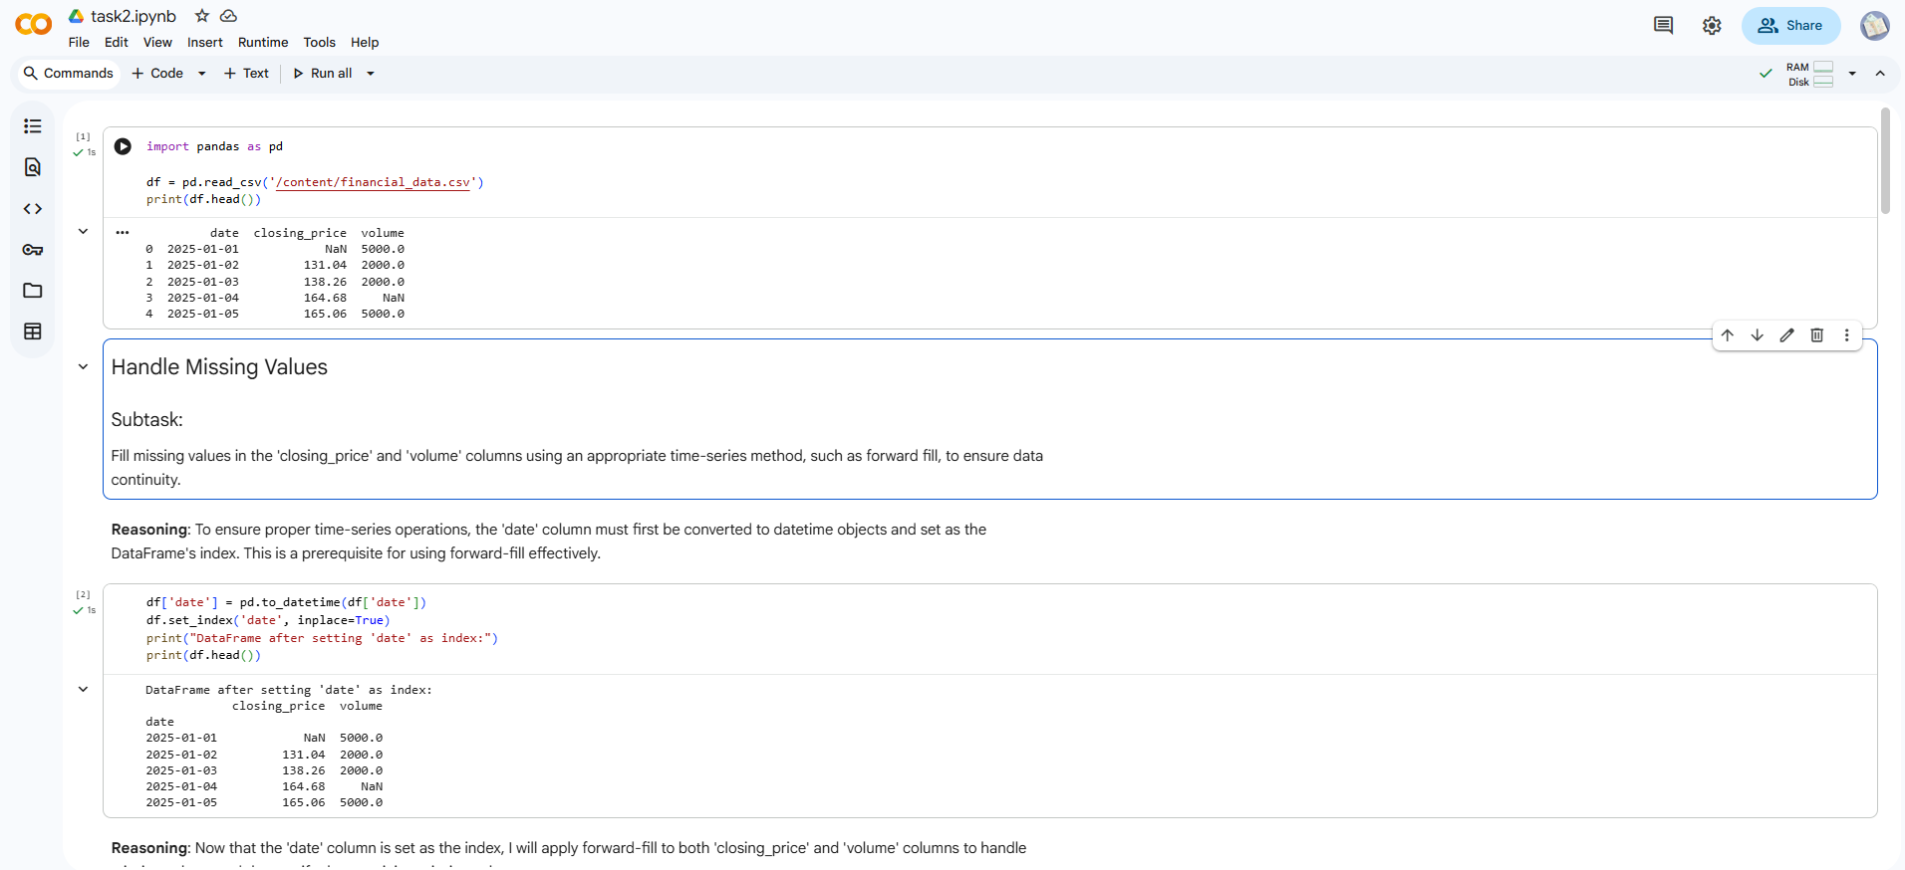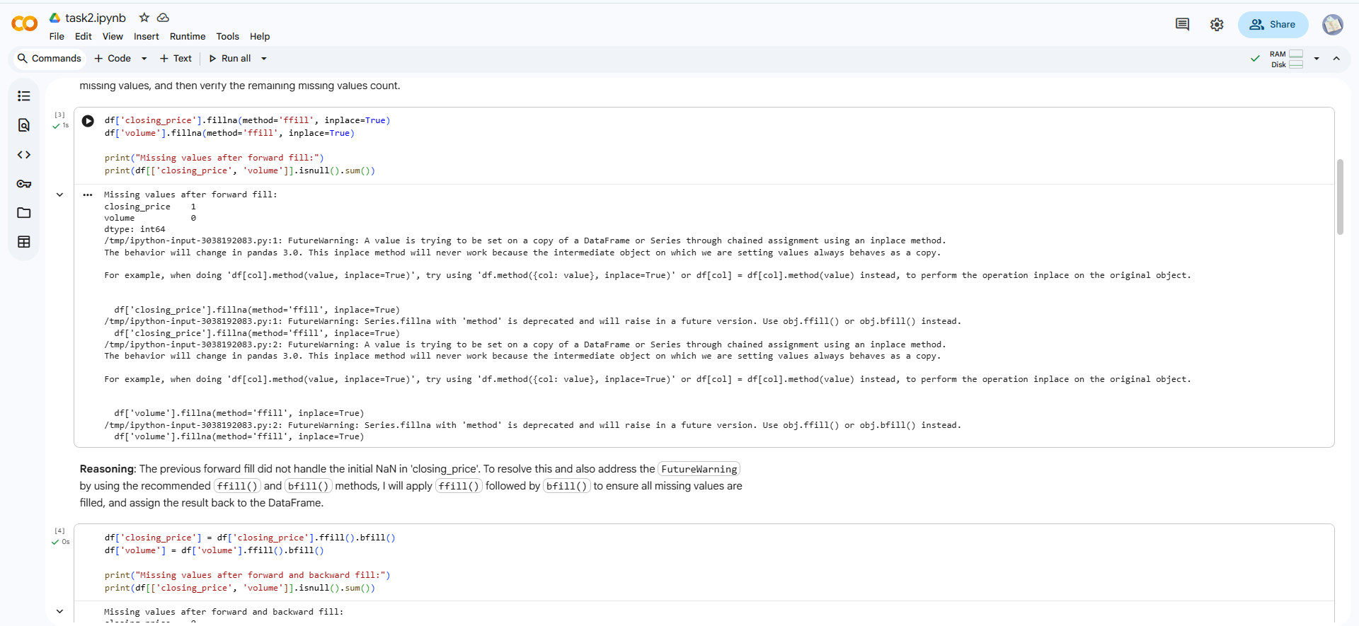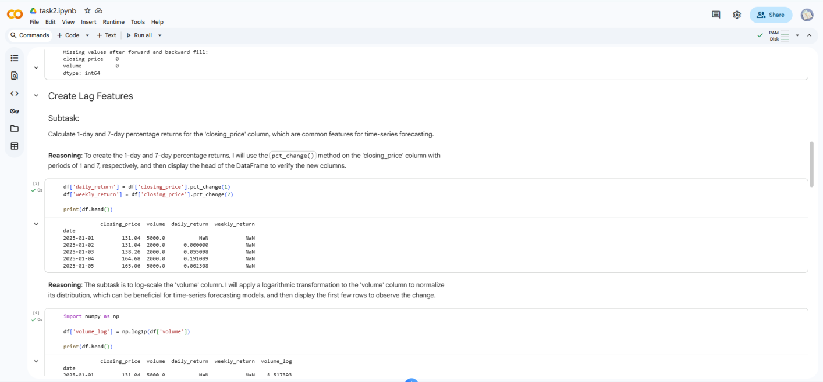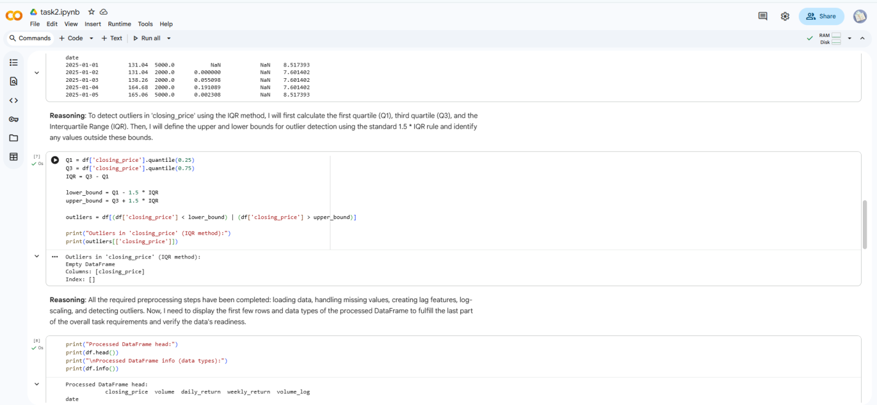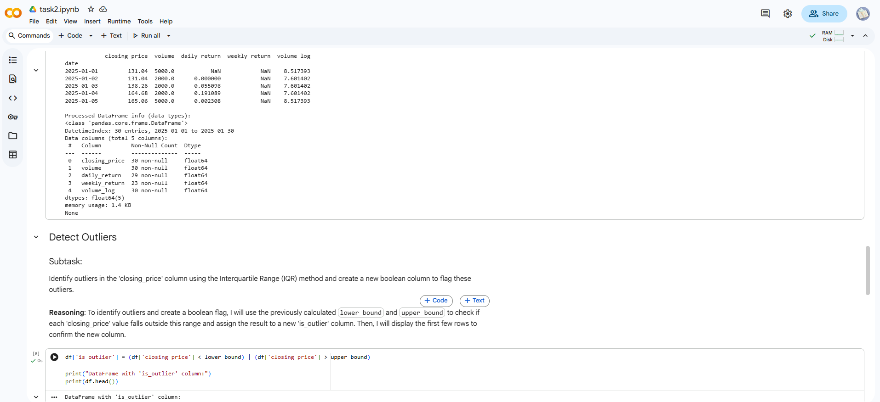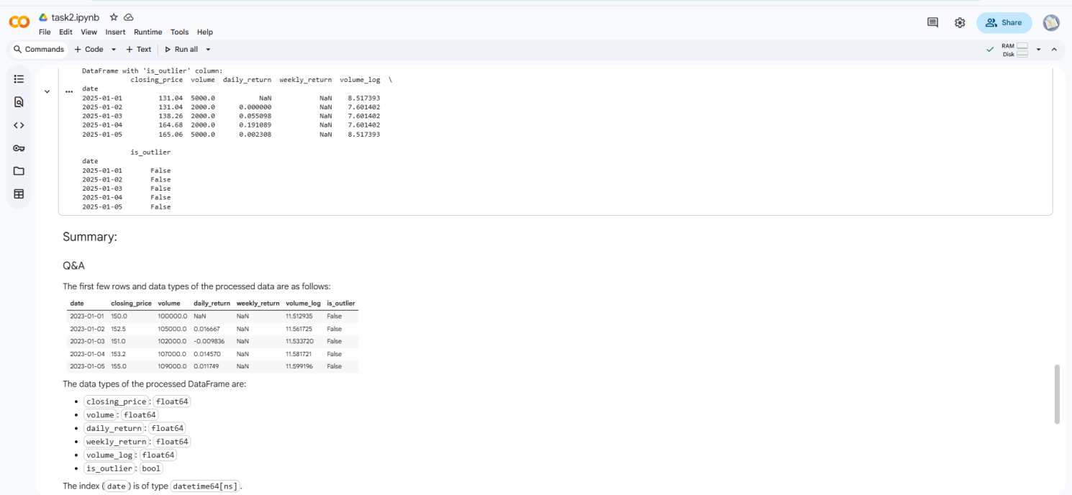
Task 3 – IoT Sensor Data Preparation
Task: Clean and preprocess IoT temperature and humidity logs.
Instructions:
- Handle missing values using forward fill.
- Remove sensor drift (apply rolling mean).
- Normalize readings using standard scaling.
- Encode categorical sensor IDs.
Expected Output: A structured dataset optimized for anomaly detection.
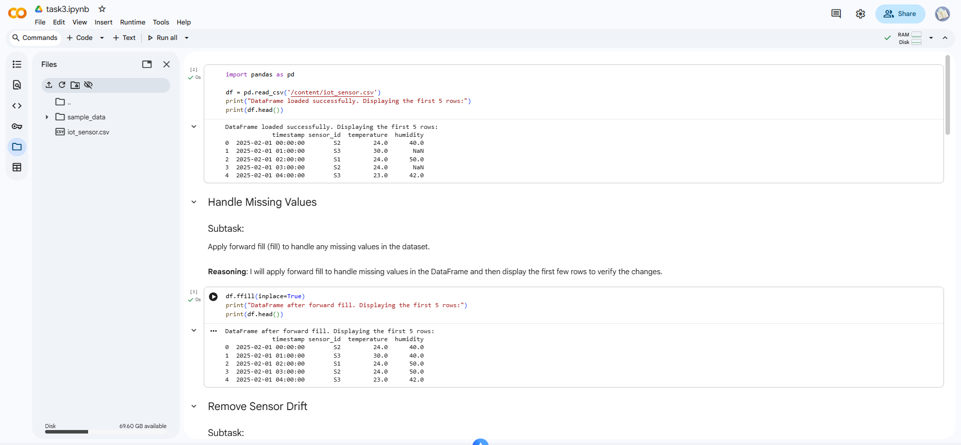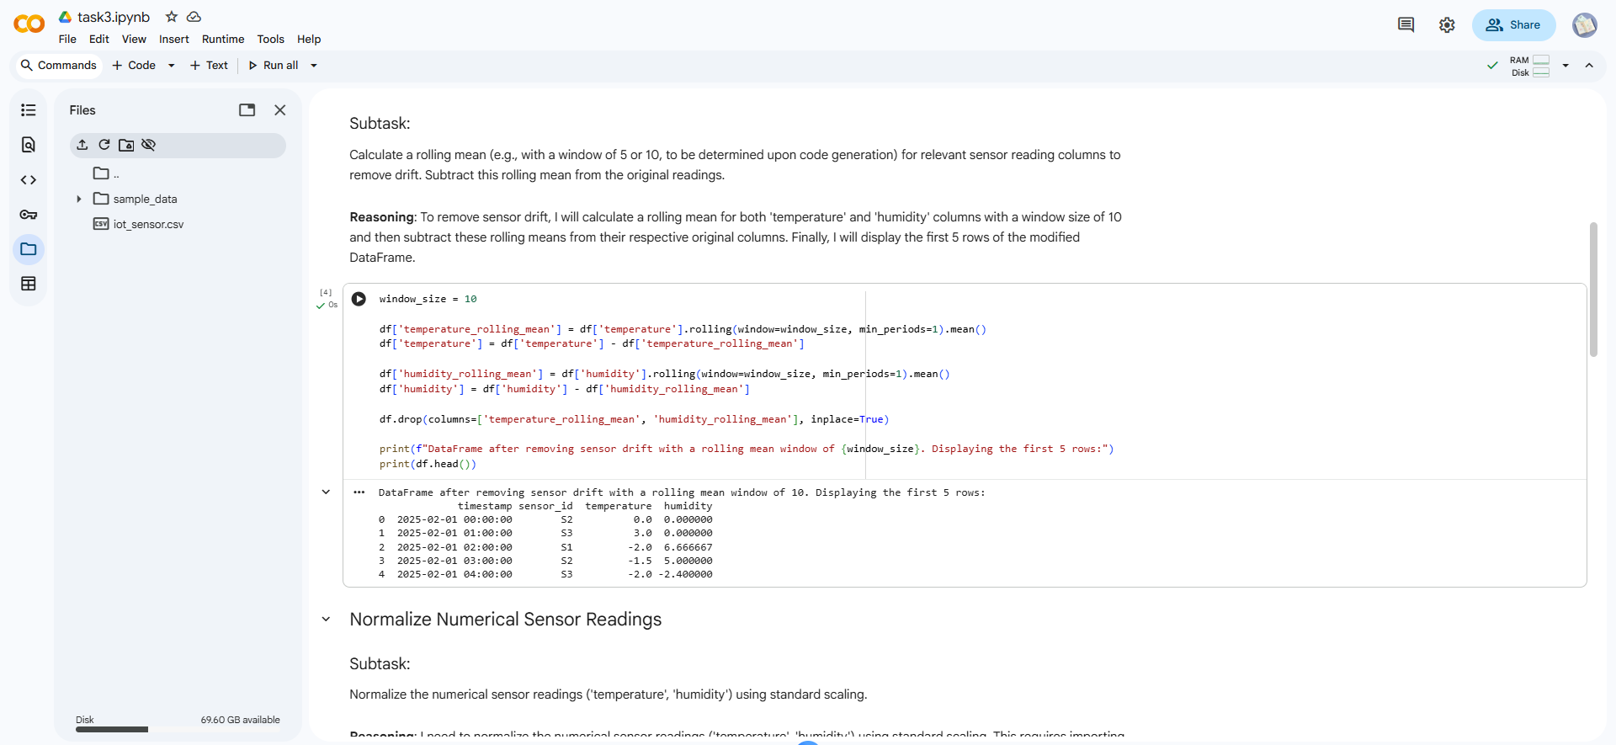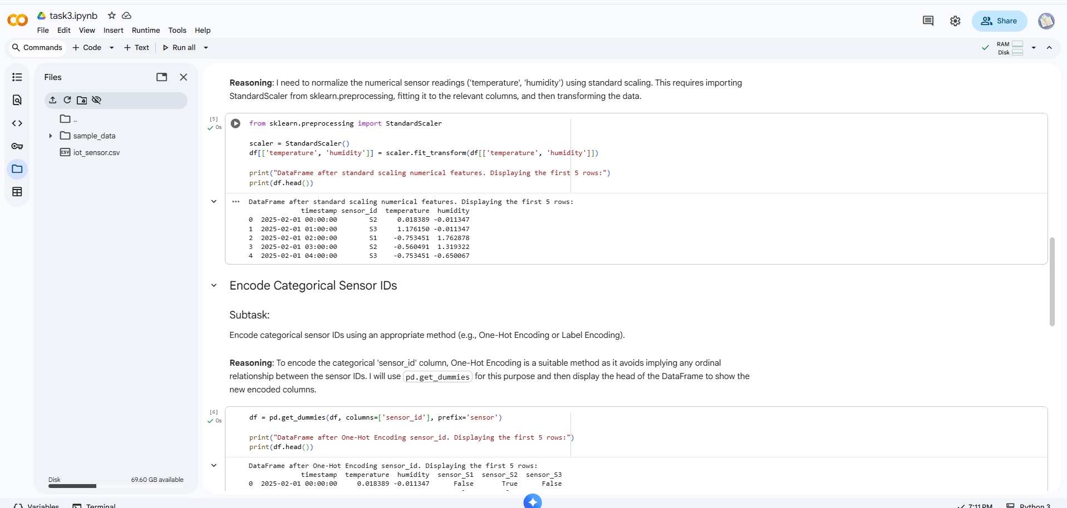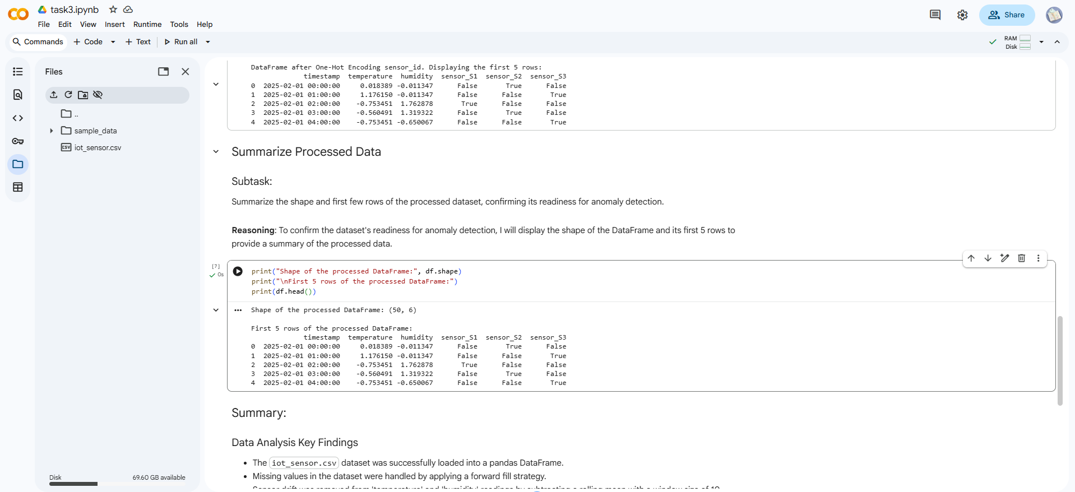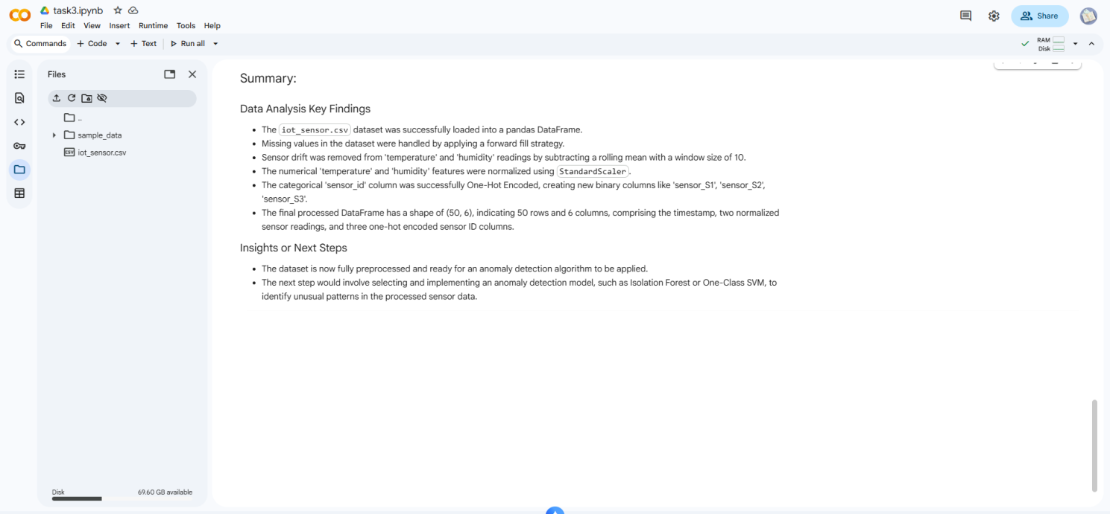
Task 4 – Real-Time Application: Movie Reviews Data Cleaning
Task: A streaming platform wants to analyze customer reviews.
Instructions:
- Standardize text (lowercase, remove HTML tags).
- Tokenize and encode reviews using AI-assisted methods (TF-IDF or embeddings).
- Handle missing ratings (fill with median).
- Normalize ratings (0–10 → 0–1 scale).
- Generate a before vs after summary report

