AI Assisted Problem Solving Using Python

Name: Beulah Sathuluri
Mtech – 1st Year
HTNO: 2503B05123

Lab 7: AI-Error Debugging with AI: Systematic approaches to finding and fixing bugs

Task Description-1
- Paste a function with a missing colon (add(a, b)), and let AI fix the syntax error.
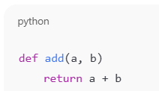

Expected Output-1
- Corrected function with syntax fix

Prompt
def add(a,b)
return a+b
Fix the syntax error

Code:
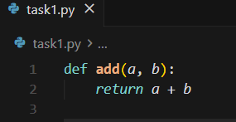

Task Description-2 (Loops)
- Identify and fix a logic error in a loop that causes infinite iteration.
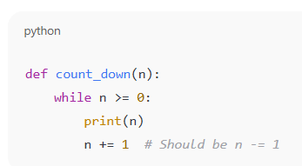

Expected Output-2
- AI fixes increment/decrement error

Prompt
def count_down(n):
while n >= 0:
print(n)
n+=1 # Should be n = 1
Fix a logic error in a loop that causes infinite iteration

Code:
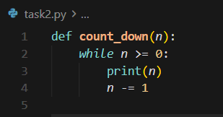

Task Description-3
- Debug a runtime error caused by division by zero. Let AI insert try-except.
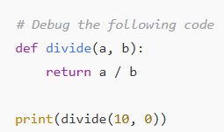
Expected Output-3
- Corrected function with safe error handling
Prompt
Debug a runtime error caused by division by zero
def divide(a, b):
Return a/b
Print(divide(10, 0))

Code:
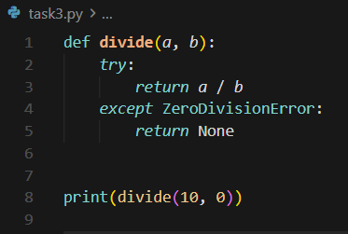

Output:
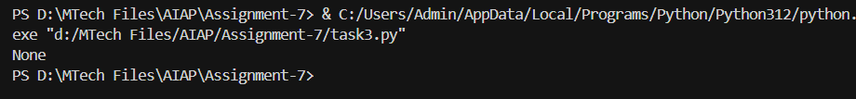

Task Description-4
- Provide a faulty class definition (missing self in parameters). Let AI fix it

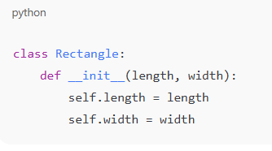
Expected Output-4
- Correct __init__() method and explanation
Prompt:
Write code to fix missing self in parameters

Code:
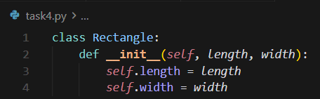

Output:
- Added self parameter: The __init__ method now has self as the first parameter: def __init__(self, length, width)
- Fixed syntax: Changed Class to class, Def to def, and Self to self

Task Description-5
- Access an invalid list index and use AI to resolve the Index Error.
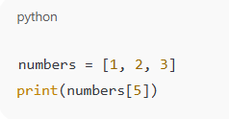

Expected Output-5
- AI suggests checking length or using safe access logic

Prompt:
Write code to Access an invalid list index and use AI to resolve the Index Error.

Code:
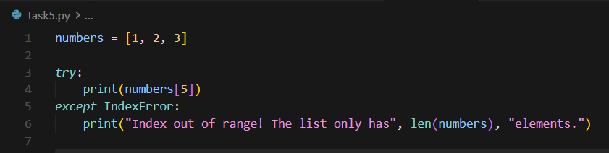

Output:
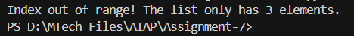

Explaination:
- Fixed syntax: Changed Numbers to numbers and Print to print
- Added error handling: Wrapped print(numbers[5]) in a try-except block to catch IndexError
- User-friendly message: On error, prints a message indicating the list length

