AI Assisted Problem Solving Using Python

Date: 17-11-2025
Name:Beulah Sathuluri
Mtech – 1st Year
HTNO: 2503B05123

Lab 11 – Data Structures with AI: Implementing Fundamental Structures

Task Description-1 – Stack class implementation
Task: Ask AI to implement a stack class with push(), pop(), peek() and is_empty() methods

Prompt:
Implement a stack class with push(), pop(), peek() and is_empty() methods
Code:
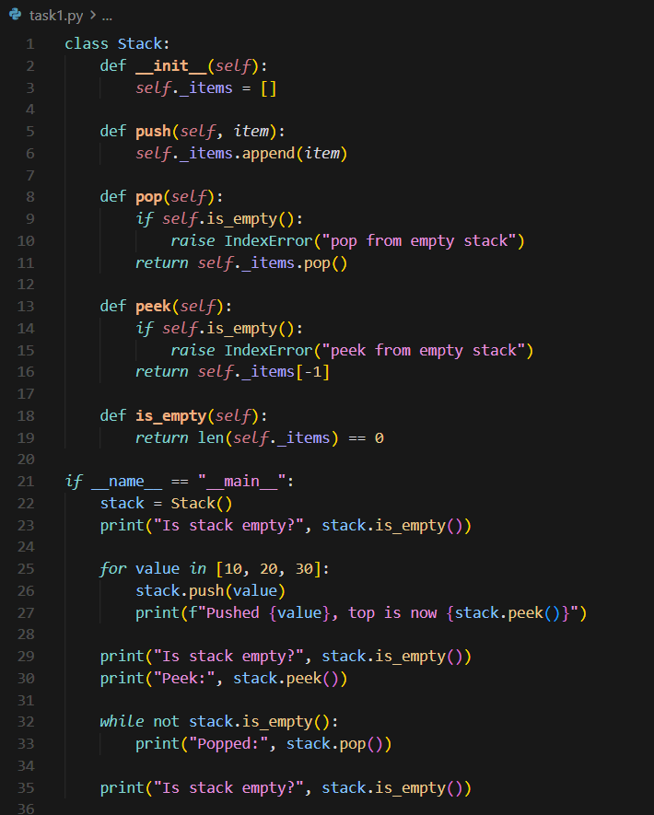

Output:
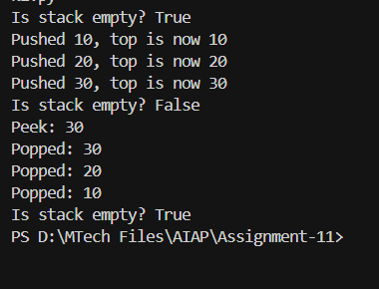
Task Description-2 – Queue Implementation
Task: Use AI to generate a Queue class with enqueue(), dequeue(), and is_empty().

Prompt:
Generate a Queue class with enqueue(), dequeue(), and is_empty().
Code:
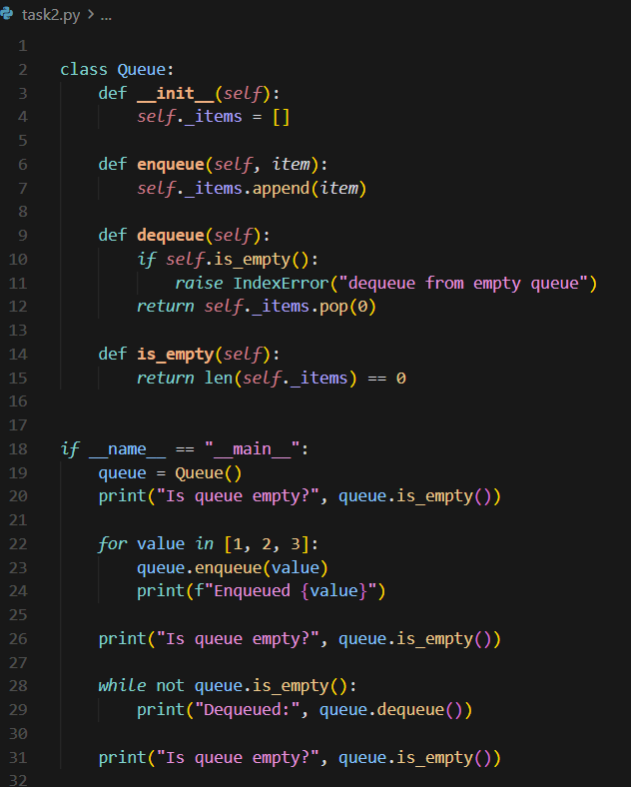

Output:
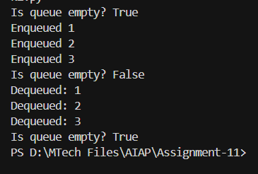
Task Description-3 – Linked List Implementation
Task: Ask AI to create a singly linked list with insert_at_end(), insert_at_beginning(), and display().

Prompt:
Create a singly linked list with insert_at_end(), insert_at_beginning(), and display().
Code:
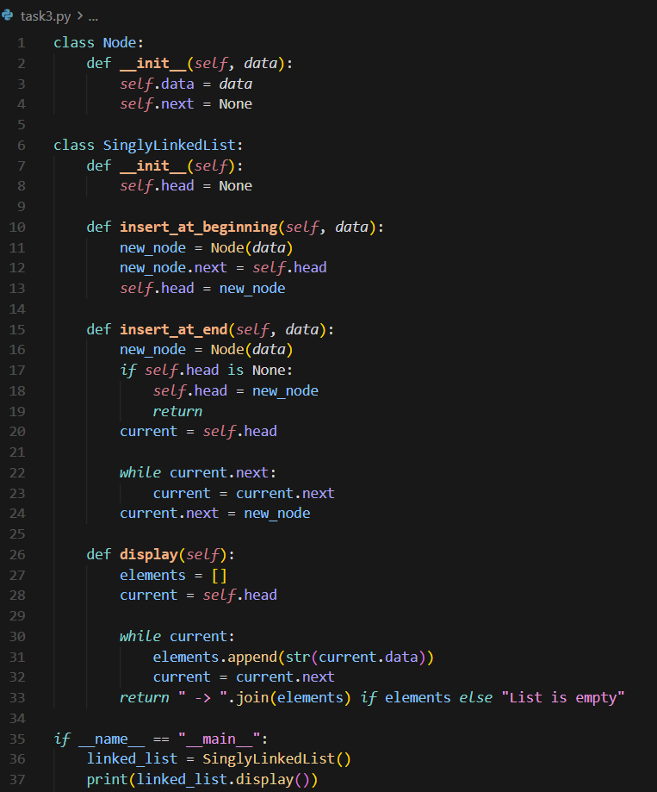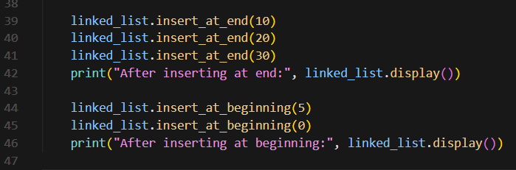

Output:
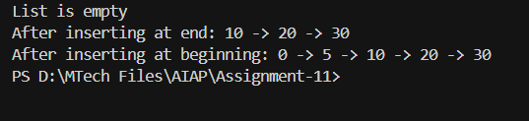

Task Description-4 – Binary Search Tree (BST)
Task: Ask AI to generate a simple BST with insert() and inorder_traversal().

Prompt:
Generate a simple BST with insert() and inorder_traversal().

Code:
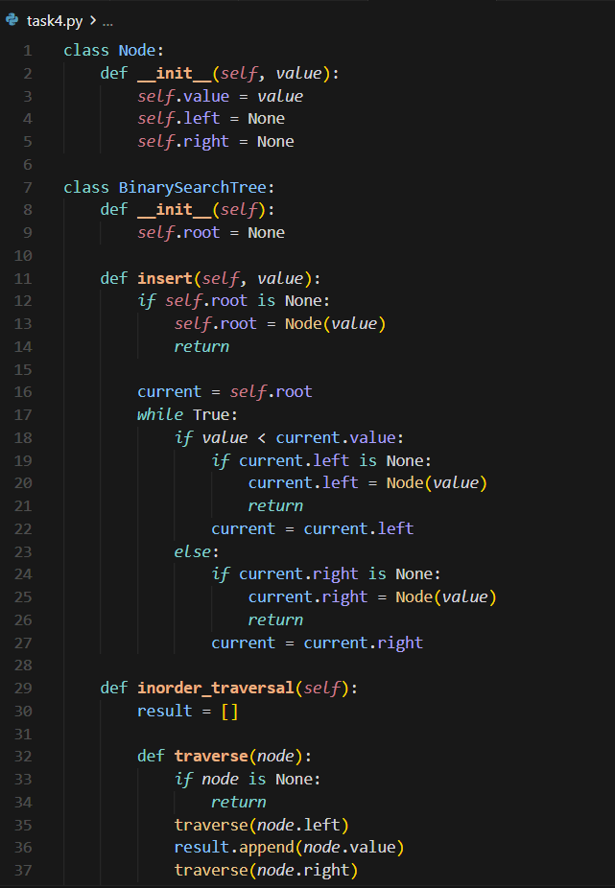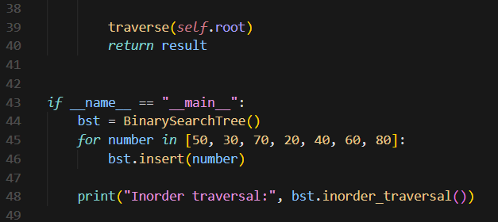

Output:
