AI Assisted Problem Solving Using Python

Date: 17/11/25
Name:Beulah Sathuluri
Mtech – 1st Year
HTNO: 2503B05123

Lab 10 – Code Review and Quality: Using AI to Improve Code Quality and Readability

Task Description -1 – Refactor Nested Conditionals
Task: Provide AI with the following nested conditional code and ask it to simplify and refactor for readability.

Python script.
def discount(price, category):
if category == "student":
if price > 1000:
return price * 0.9
else:
return price * 0.95
else:
if price > 2000:
return price * 0.85
else:
return price

Expected Output:
- Refactored code using cleaner logic, possibly a dictionary or separate helper functions.
Prompt:
Simplify and refactor the code for readability.
Code:
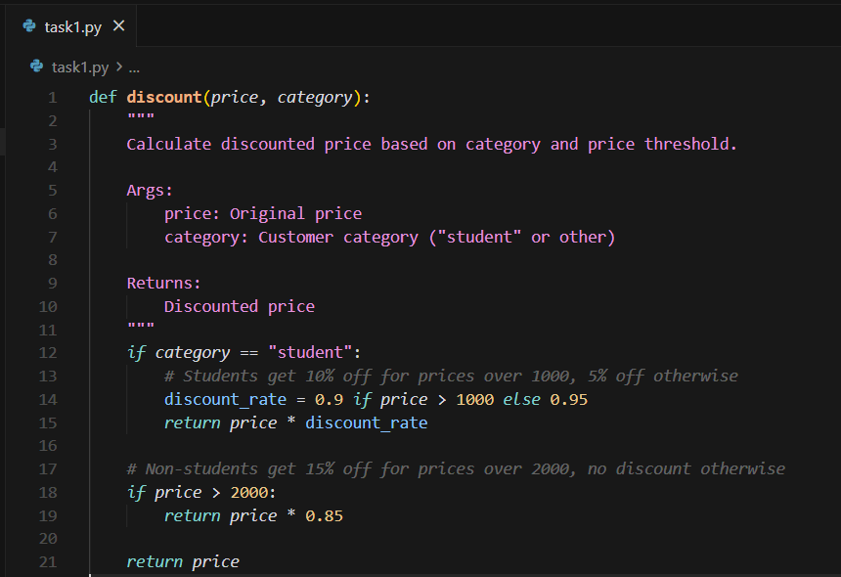
Task Description-2 – Optimize Redundant Loops
Task: Give AI this messy loop and ask it to refactor and optimize.

Python script
def find_common(a, b):
res = []
for i in a:
for j in b:
if i == j:
res.append(i)
return res

Expected Output:
Cleaner version using Python sets (set(a) & set(b))
Prompt:
Refactor and optimize the code
Code:
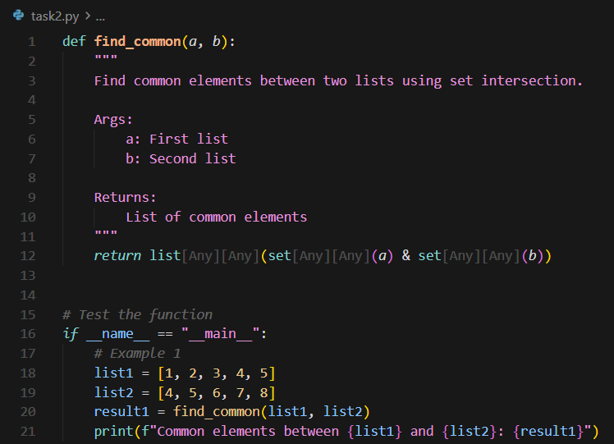
Output:
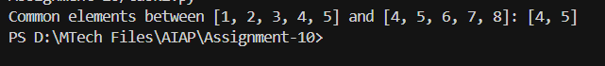

Task Description -3 – Improve Class Design
Task: Provide this class with poor readability and ask AI to improve:
- Naming conventions
- Encapsulation
- Readability & maintainability
Python Script
class emp:
def __init__(self,n,s):
self.n=n
self.s=s
def inc(self,p):
self.s=self.s+(self.s*p/100)
def pr(self):
print("emp:",self.n,"salary:",self.s)

Expected Output:
- Employee class with meaningful methods (increase_salary, display_info), formatted output, and added docstrings.

Prompt:
Improve the code’s naming convention, readability and maintainability
Code:
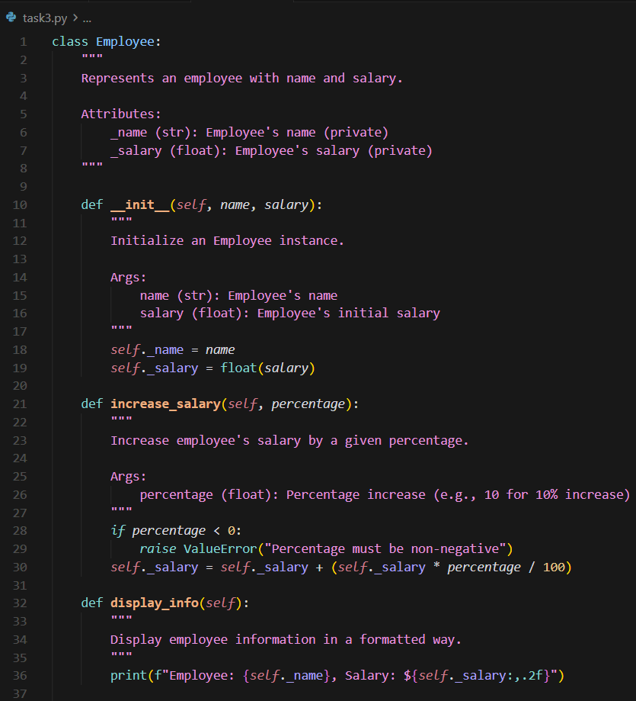
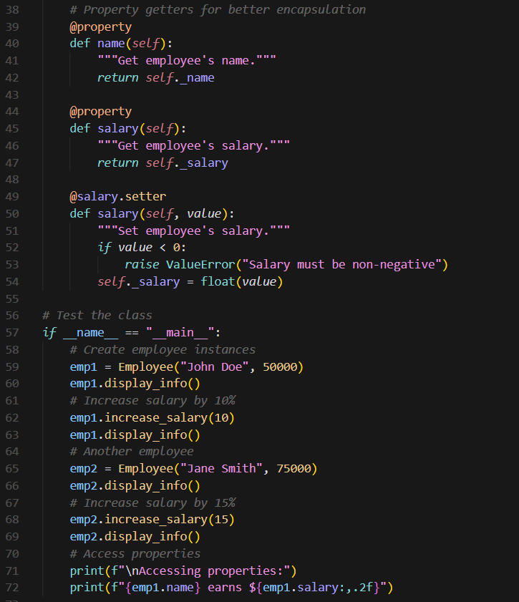
Output:
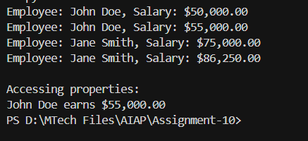

Task Description -4 – Modularize Long Function
Task: Give AI this long unstructured function and let it modularize into smaller helper functions.
Python Script
def process_scores(scores):
total = 0
for s in scores:
total += s
avg = total / len(scores)

highest = scores[0]
for s in scores:
if s > highest:
highest = s
lowest = scores[0]
for s in scores:
if s < lowest:
lowest = s
print("Average:", avg)
print("Highest:", highest)
print("Lowest:", lowest)
Expected Output:
- Split into functions: calculate_average, find_highest, find_lowest.
- Clean main process_scores() using helper functions.
Prompt:
Modularize the code into smaller helper functions. Split into functions: calculate_average, find_highest, find_lowest. Clean main process_scores() using helper functions.

Code:
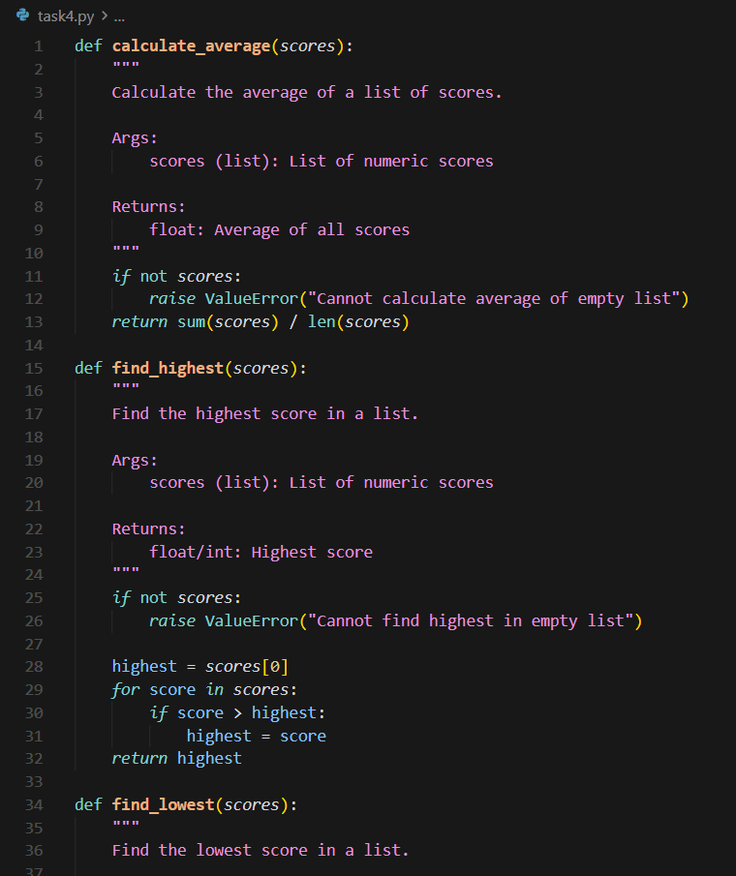
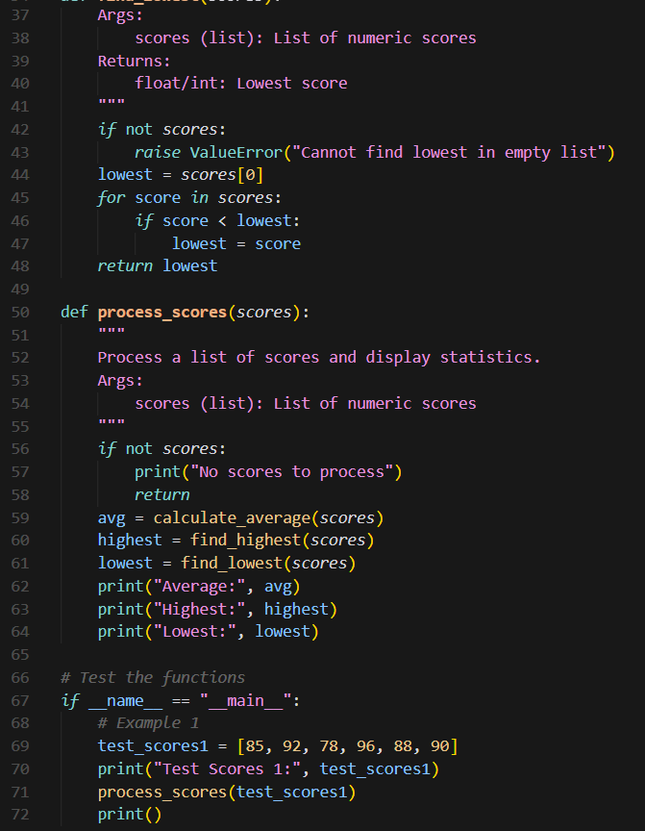
Output:
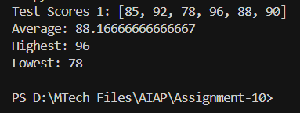

Task Description -5 – Code Review on Error Handling
Task: Provide AI with this faulty code and ask it to improve error handling, naming, and readability.
Python Script
def div(a,b):
return a/b
print(div(10,0))
Expected Output:
- Function with proper error handling using try-except.
- Better naming (divide_numbers).
- AI-generated docstring explaining error handling.
Prompt:
Improve error handling, naming, and readability of code. Function with proper error handling using try-except. Better naming (divide_numbers). AI-generated docstring explaining error handling.
Code:
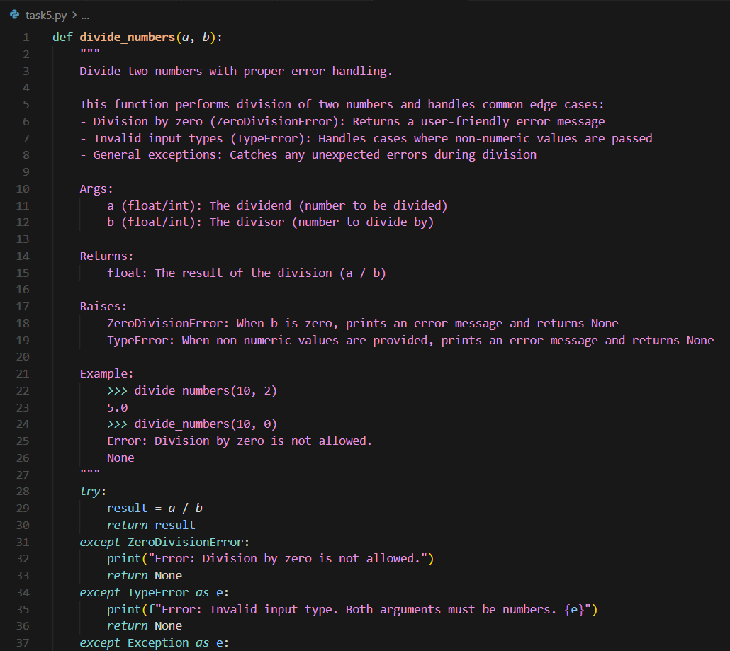
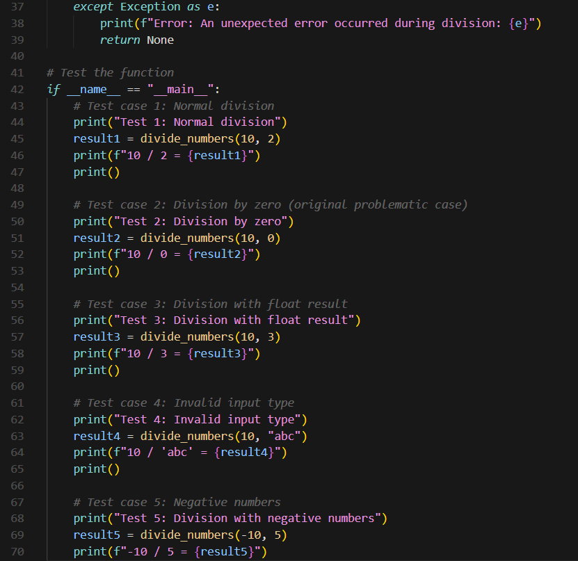

Output:
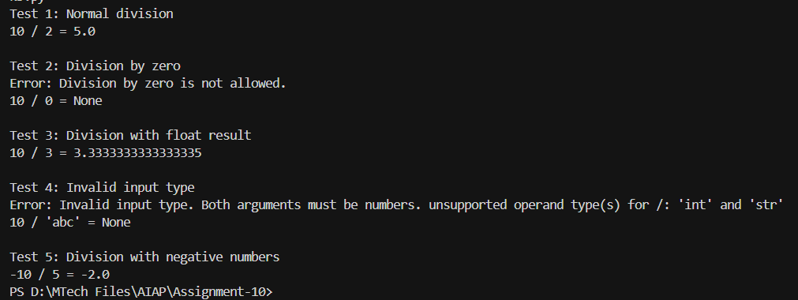

Task Description -6 – Complexity Reduction
Task: Use AI to simplify overly complex logic.

Sample Input Code:
def grade(score):
if score >= 90:
return "A"
else:
if score >= 80:
return "B"
else:
if score >= 70:
return "C"
else:
if score >= 60:
return "D"
else:
return "F"

Expected Output:
- Cleaner logic using elif or dictionary mapping.

Prompt:
Simplify overly complex logic using elif or dictionary mapping.

Code:
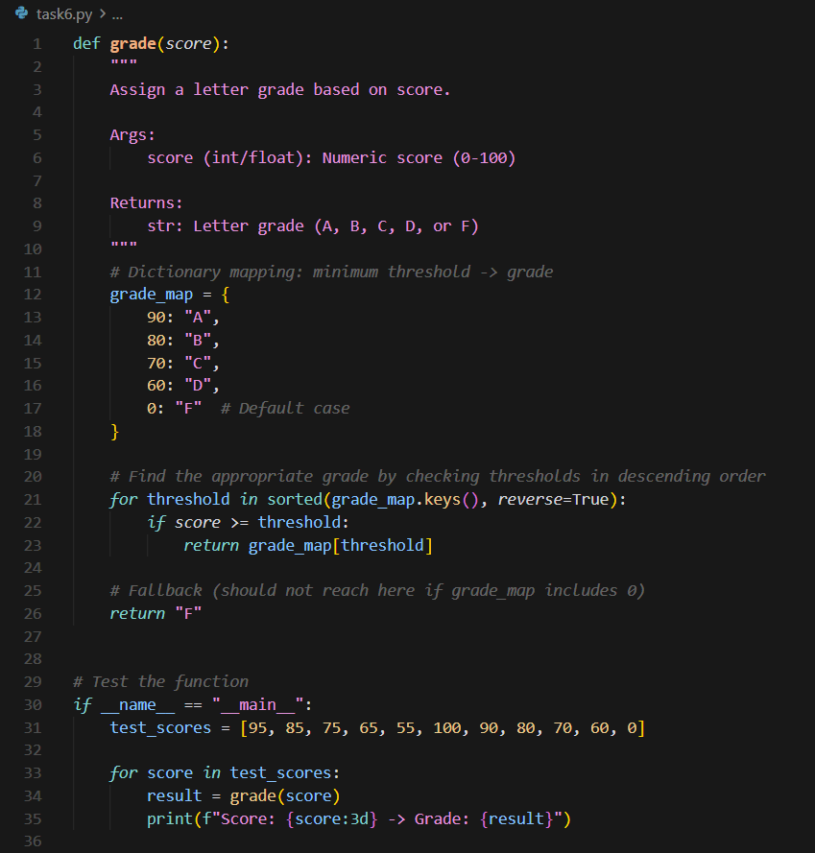

Output:
