AI Assisted Problem Solving Using Python

Name: Beulah Sathuluri
Mtech – 1st Year
HTNO: 2503B05123

Lab 9: Documentation Generation: Automatic documentation and code comments

Task Description-1 Basic Docstring Generation
- Write python function to return sum of even and odd numbers in the given list.
- Incorporate manual docstring in code with Google Style
- Use an AI-assisted tool (e.g., Copilot, Cursor AI) to generate a docstring describing the function.
- Compare the AI-generated docstring with your manually written one.

Expected Outcome-1: Students understand how AI can produce function-level documentation.

Code-1:
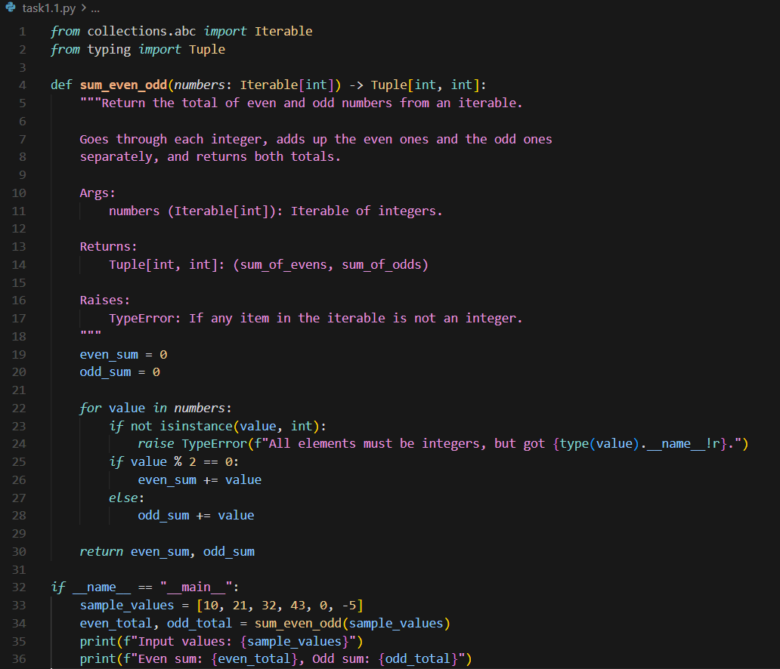

Code-2:
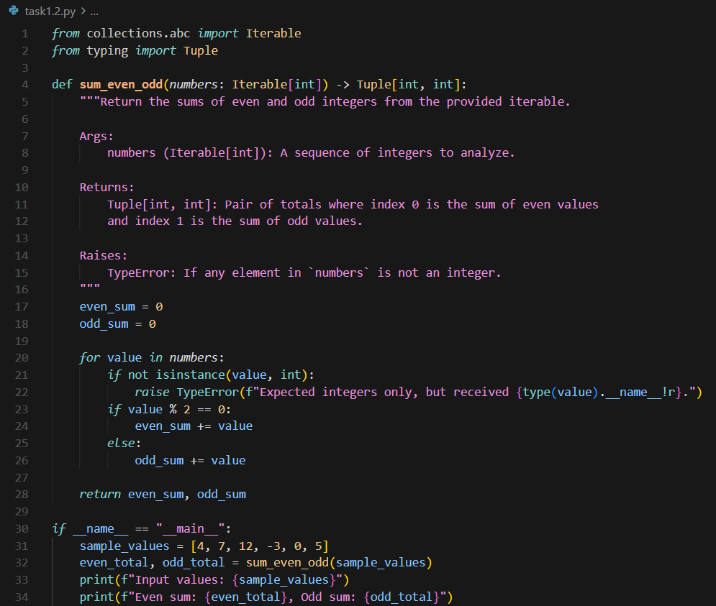

Output:
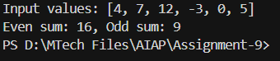

Explaination:
The first docstring is more natural and descriptive, explaining the function in a friendly, easy-to-read way. The second one is shorter and more formal, focusing on precision and structure. Overall, the first feels human-written for clarity, while the second feels professional and suited for technical documentation.

Task Description-2 Automatic Inline Comments
- Write python program for sru_student class with attributes like name, roll no., hostel_status and fee_update method and display_details method.
- Write comments manually for each line/code block
- Ask an AI tool to add inline comments explaining each line/step.
- Compare the AI-generated comments with your manually written one.

Expected Output-2: Students critically analyze AI-generated code comments.

Code-1:
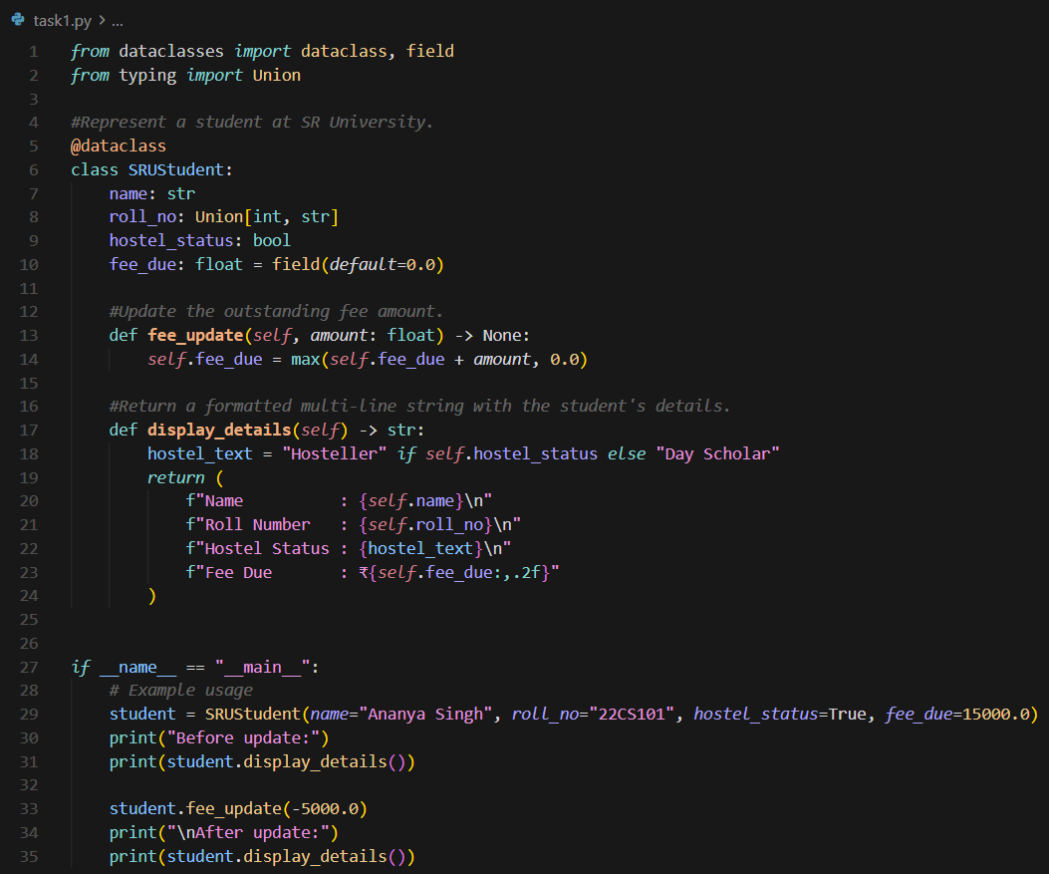

Code-2
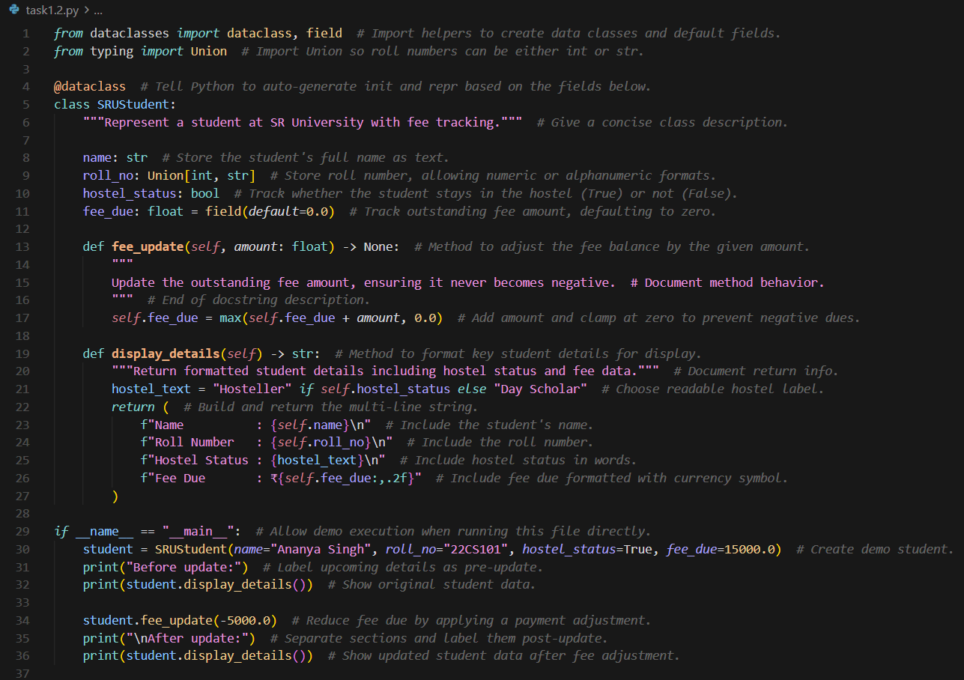
Output:
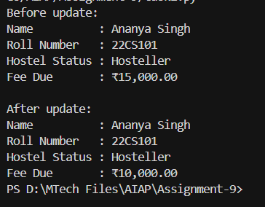

Explaination:
Manual comments in the highlight major sections such as class purpose, method intent, and example usage—they were supplied externally.
AI-generated comments in this file expand on every line to provide precise, in-line explanations generated programmatically.

Task Description-3
- Write a Python script with 3–4 functions (e.g., calculator: add, subtract, multiply, divide).
- Incorporate manual docstring in code with NumPy Style
- Use AI assistance to generate a module-level docstring + individual function docstrings.
- Compare the AI-generated docstring with your manually written one.

Expected Output-3: Students learn structured documentation for multi-function scripts

Code-1:
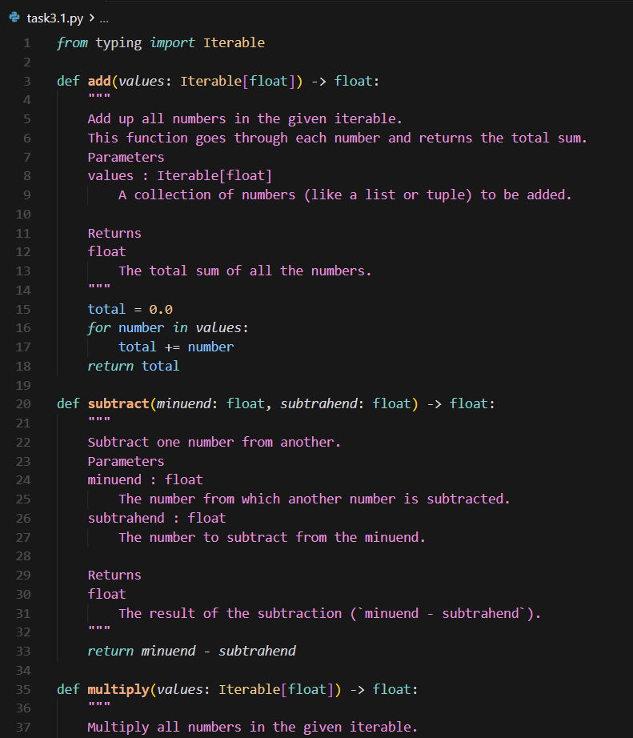
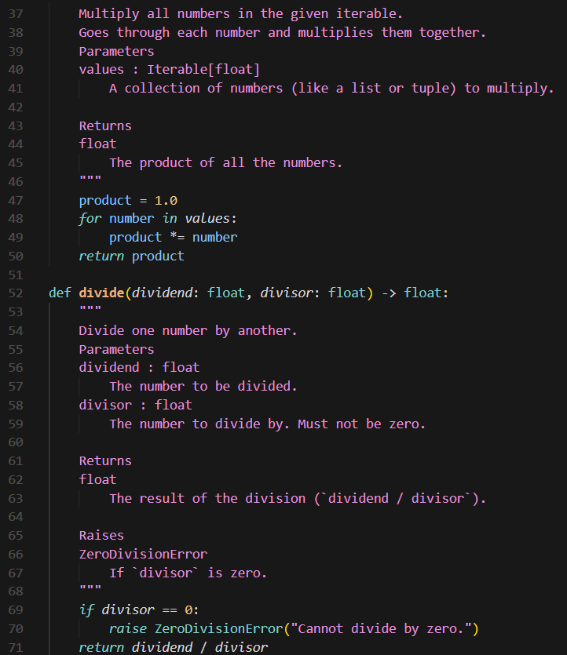
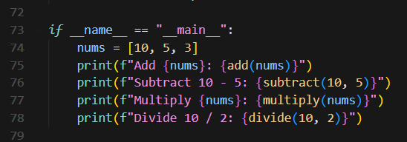

Code-2:
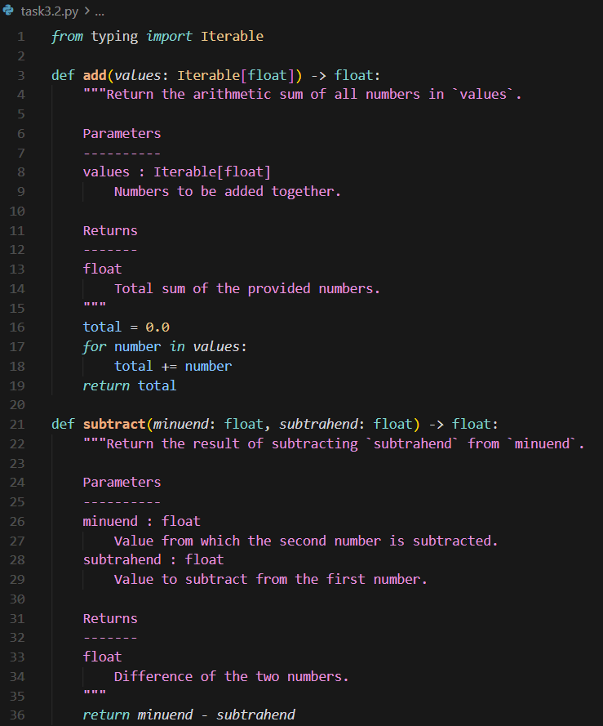
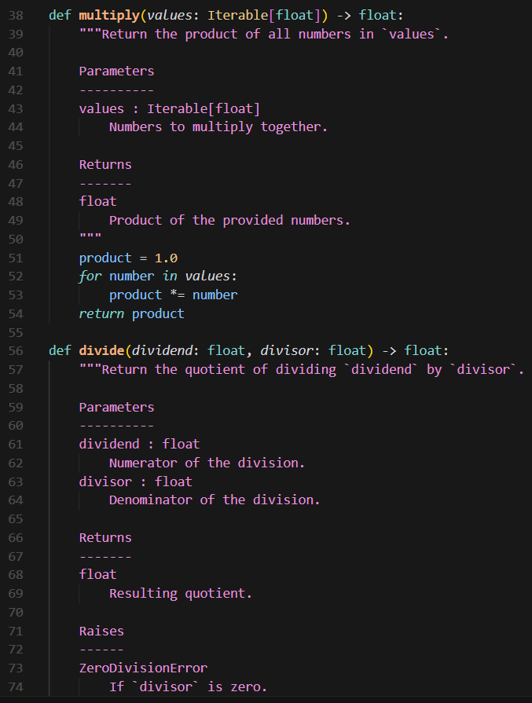
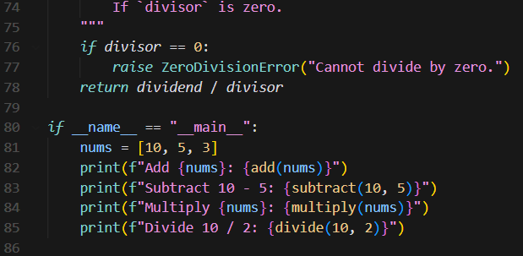

Output:
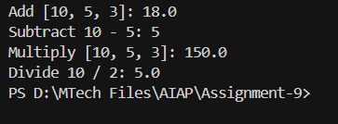

Push documentation whole workspace as .md file in GitHub Repository

