Template matching   
case 1: B/W orig search and template 5   
  
Matching correct…..for first 100 segments made on the original image  
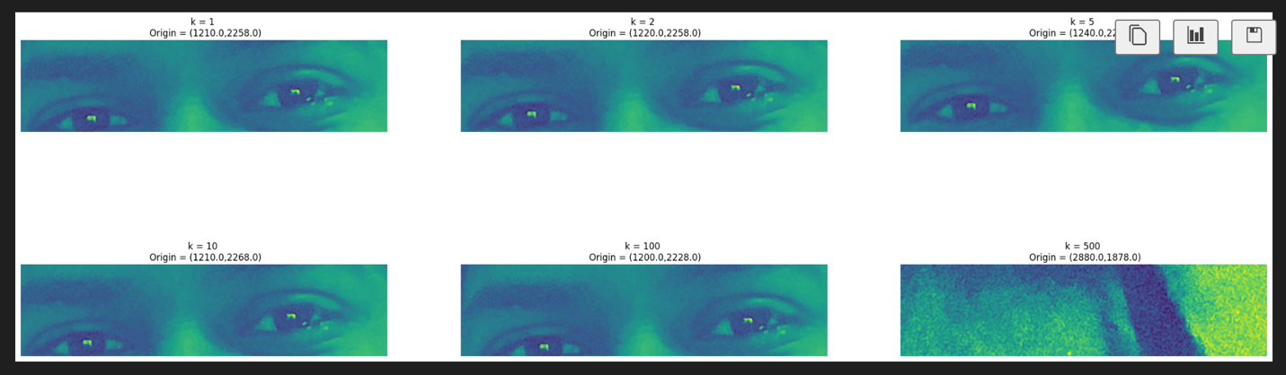

Case 2: B/W with my eyes and template 5

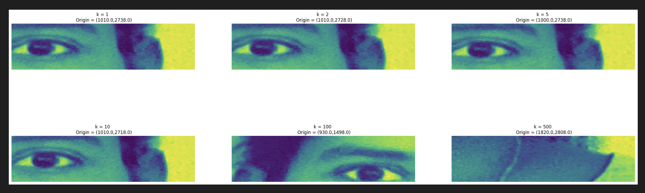

Case 3: B/W without eyes and template 5   
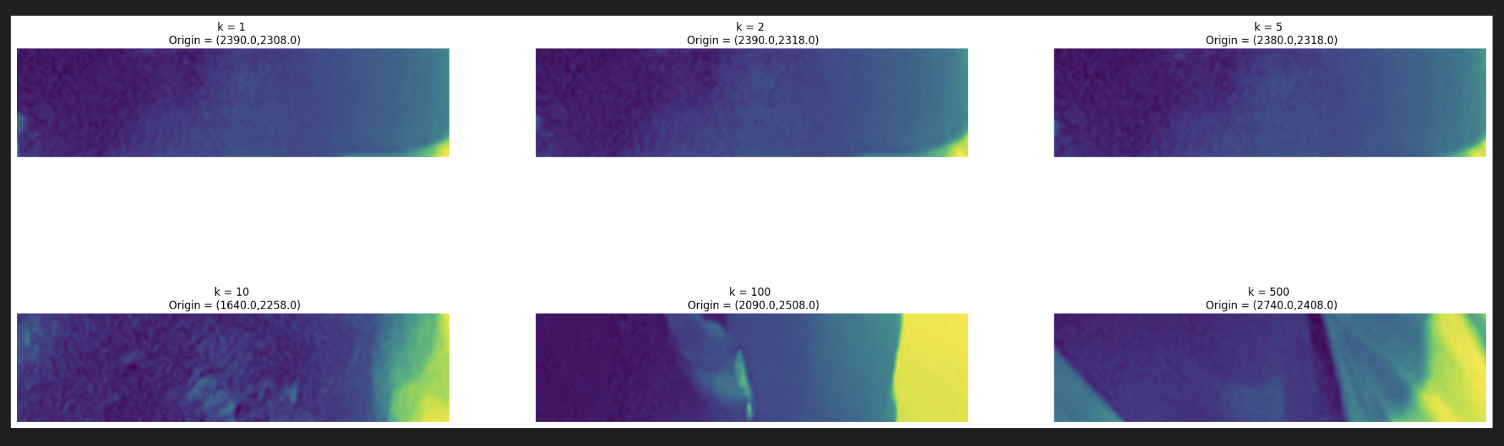

Case 4: RGB orig search and template 5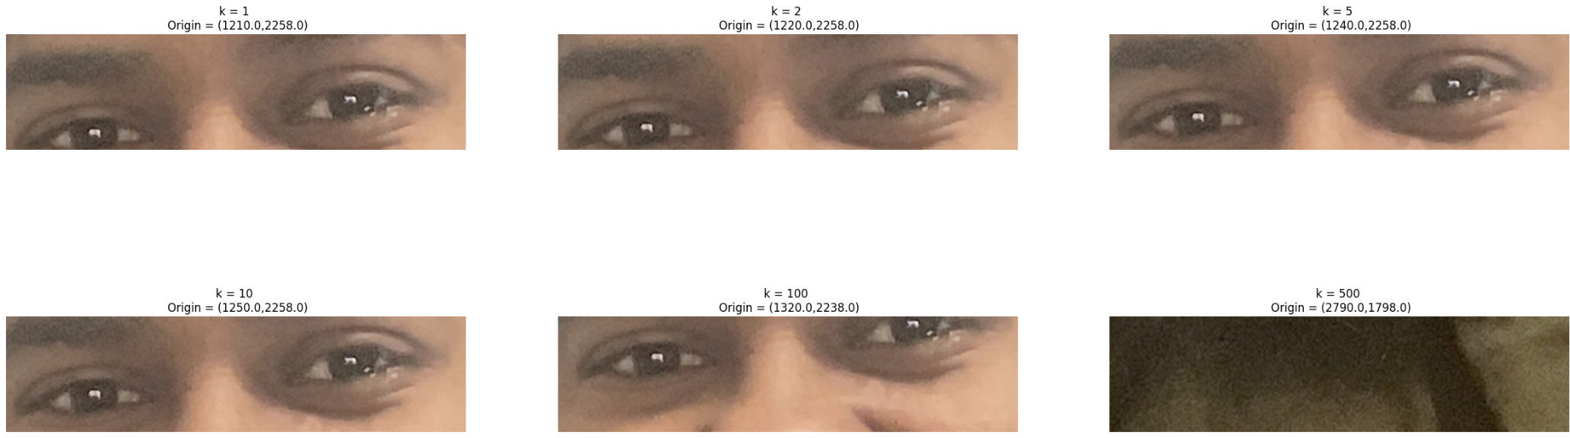  
  
Case 5: RGB with my eyes and template 5

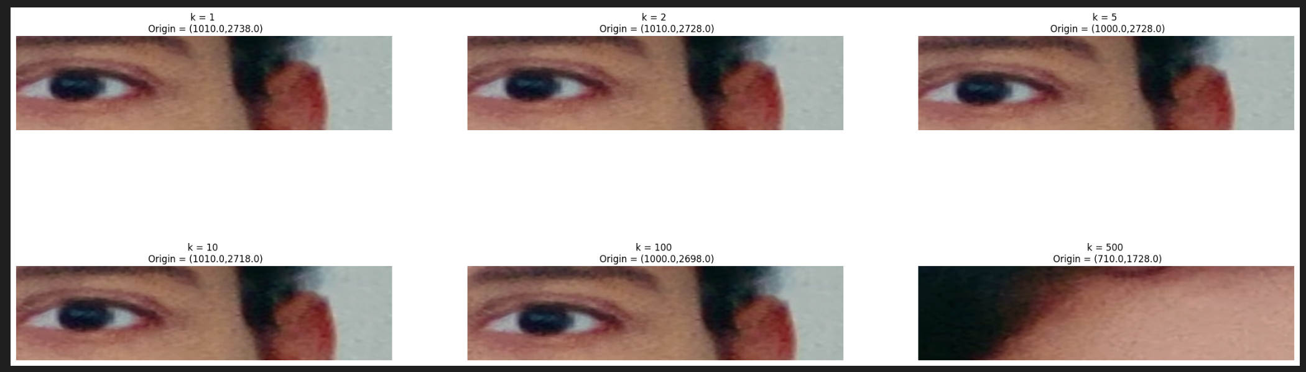

Case 6: RGB without eyes and template 5  
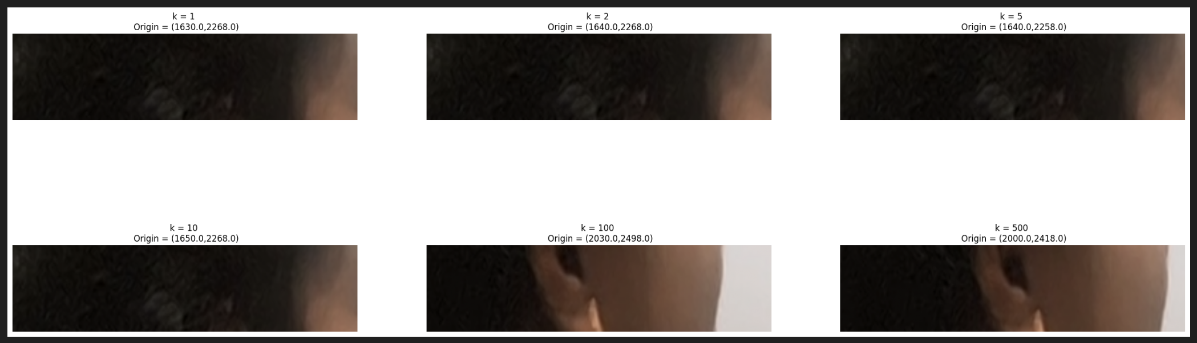

|  |  |
| --- | --- |
| Test cases | First 10 NCC values |
| Case 1 | 3.809047897200228e-06  3.742607781495227e-06  3.731953935592941e-06  3.721689984066277e-06  3.72044217486832e-06  3.709111980929872e-06  3.7061372120655064e-06  3.701377047063068e-06  3.6967214272875016e-06  3.694583149149703e-06 |
| Case 2 | 3.158916305671233e-06  3.1296775191801264e-06  3.122606723080575e-06  3.120976625992711e-06  3.116610140420355e-06  3.0986703269390226e-06  3.095847934363424e-06  3.0871806624433995e-06  3.070785480595239e-06  3.0693893350768608e-06 |
| Case 3 | 2.9267534142896424e-06  2.9257122369029538e-06  2.9186023269228535e-06  2.9181084909339086e-06  2.9180094634812896e-06  2.916077111169903e-06  2.9158221077173386e-06  2.915704296975963e-06  2.913718405600283e-06  2.912995978847894e-06 |
| Case 4 | 0.7317757450822272  0.7190676279634562  0.7164364979055208  0.715410432766347  0.7136987765513906  0.7112227269855715  0.710716901644539  0.7105874622149124  0.7093816728007355  0.7091090365285733 |
| Case 5 | 0.5671836315825461  0.562281762931046  0.5615579608809228  0.5601514092460809  0.5586647950409296  0.5572809491323315  0.5533739421088898  0.5529086151507654  0.5520941267686996  0.5518427932674087 |
| Case 6 | 0.5512050917426067  0.5509359563930639  0.5507286984889025  0.5504304888284763  0.5501443617704406  0.5499220340026659  0.5487778662281572  0.5485621165990923  0.5484613425677196  0.5478581337022127 |