**Lab 3: The MIPS datapath in Verilog: The Execute stage**

Introduction: This lab implements the third stage of the MIPS five stage pipeline. This stage consists of six components: adder, bottom_mux, alu_control, alu, top_mux, and ex_mem.

**adder:**

Adds two 32-bit inputs to output a 32-bit value. Takes in npcout and s_extendout to

output adder_out.

**bottom_mux:**

Implements a multiplexer that selects from two inputs (5 bits), a and b, based

on the sel input. Its inputs are instrout_1511 and instrout_2016 from ID/EX latch, and regdst.

The output is muxout, which is sent to EX/MEM latch.

**alu_control:**

Takes in 6 bit of s_extendout with alu_op and outputs select, which is the control.

for alu.v. This bridges machine language with assembly language.

**alu:**

Takes in rdata1 as its input as well as "b," which is the output of top_mux.

It outputs result, later known as aluout, and zero, which is then aluzero for ex_mem.v.

This handles the logical and arithmetic correspondence.

**top_mux:**

Implements a multiplexer that selects from two inputs (32 bits), a and b, based

on the sel input. Its inputs are rdata2 ID/EX latch and aluscr from alu_control.v

The output becomes the b input of alu.v

**ex_mem:**

This is the latch that receives signals form all the modules of the execute stage. Its outputs go to MEM/WB and FETCH.

Timing Diagram for adder

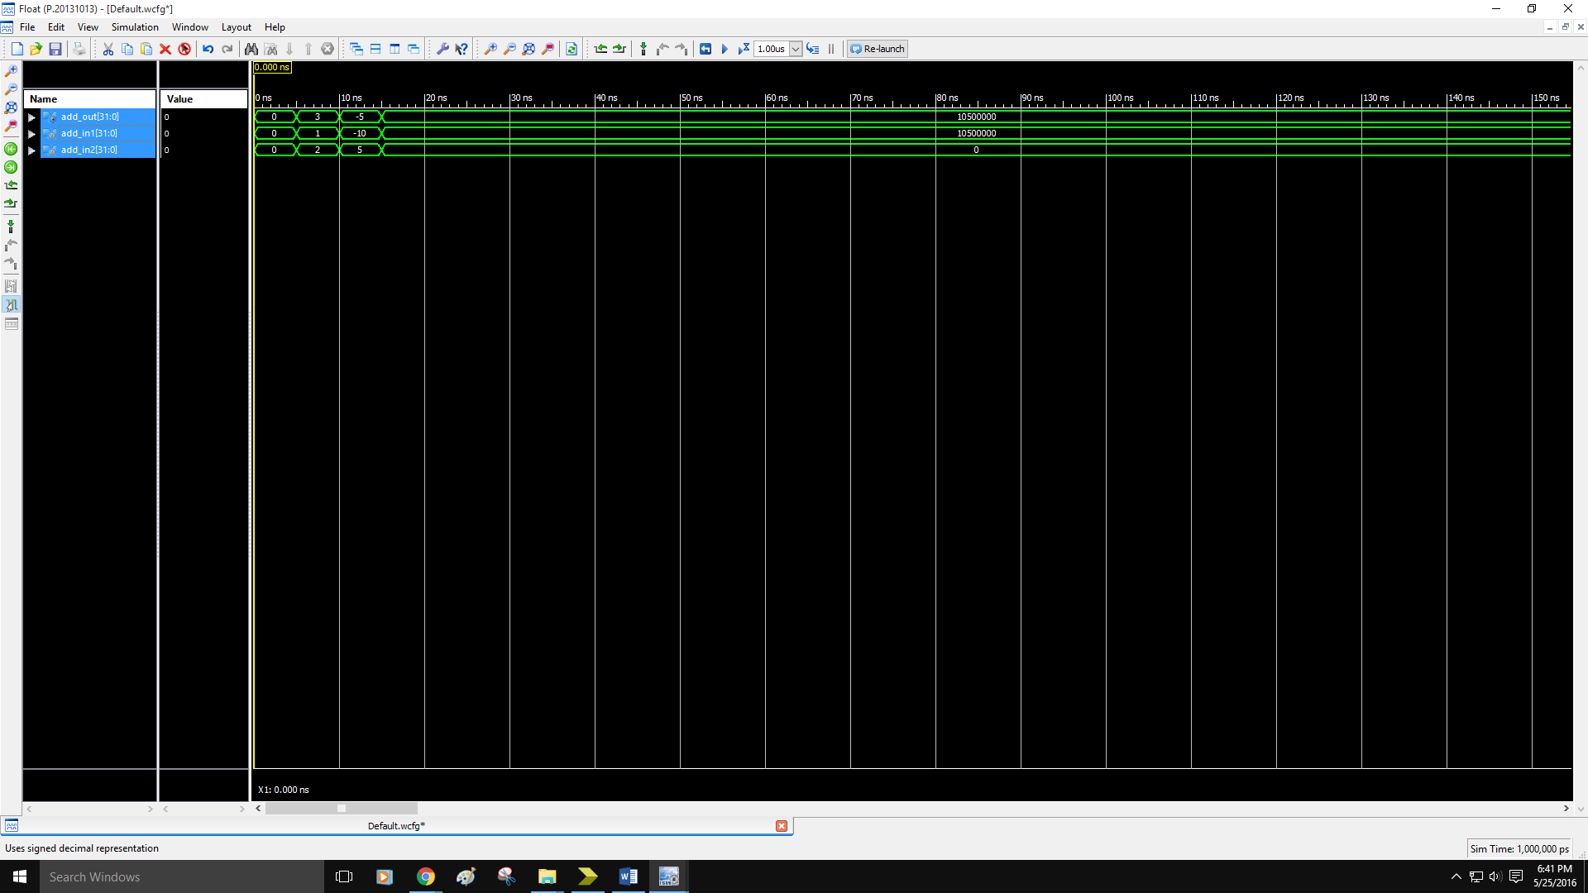

Timing Diagram for bottom_mux

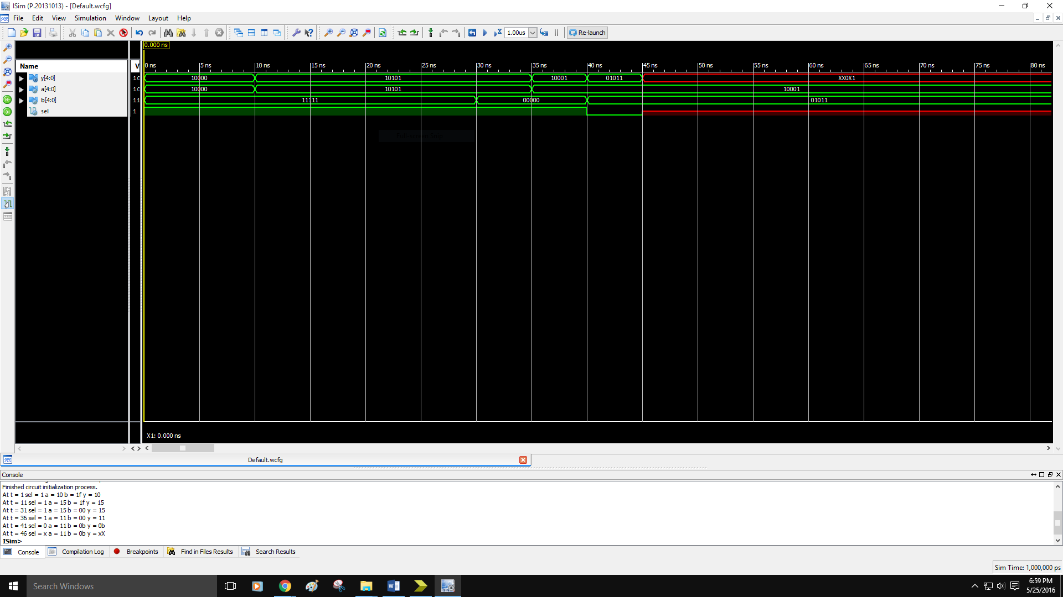

Timing Diagram for alu_control

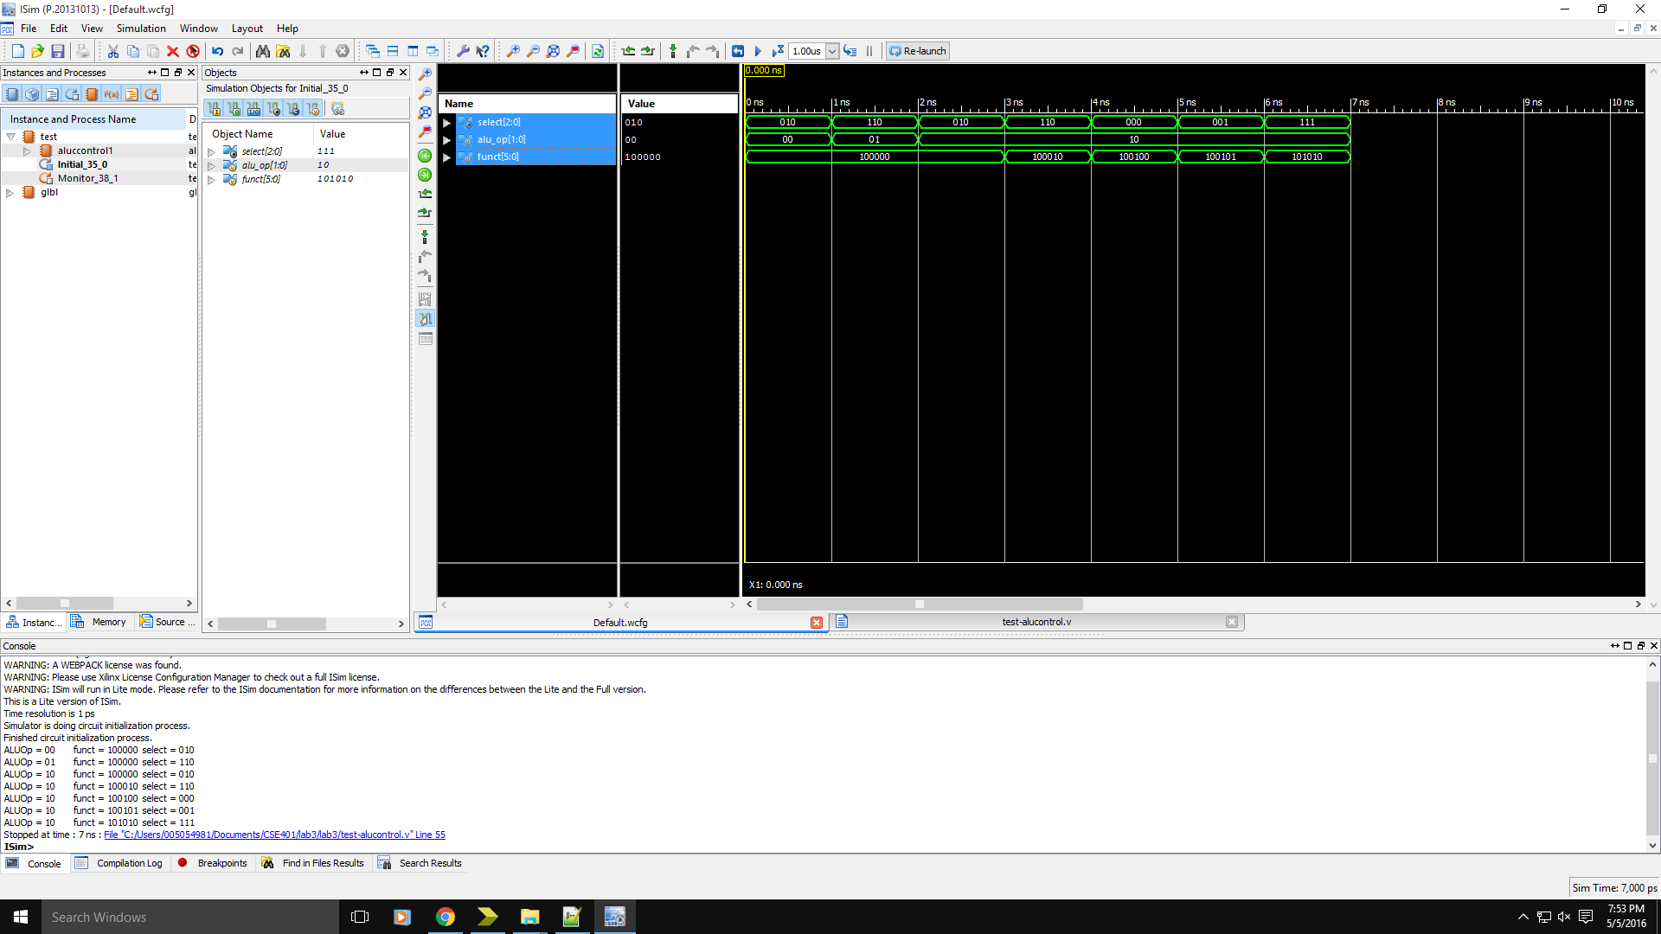

Timing Diagram for alu

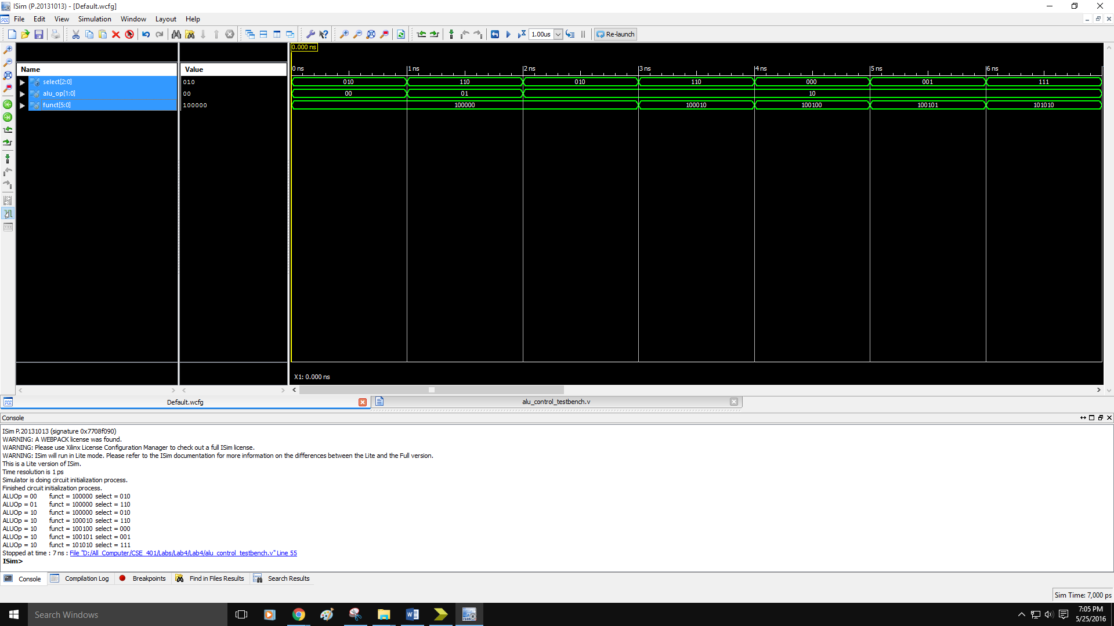

Timing Diagram for Pipeline Execute Stage

