**Lab 1 Multi-Barrel Shifter**

**Name:** Beverly Abadines

**I Goals**

1) Implement Verilog software onto FPGA board using ucf.

2) Practice bit shift and rotations

4) Distinguish when to use procedural and continuous assignment

5) Design RTL Combinational Circuit

6) Understand the conventions used on various datatypes

**II Design Process**

Both designs take in data_in, lr, and amount in order to output the rotated value, data_out. The number of bits to rotate is set by amount, while lr dictates whether to perform left rotation (lr ==1) or right rotation (lr ==0).

**Bidirectional (pre and post reverse)**

This design uses only a single left_rotator, two mux_2_to_1 and and two reverse. If lr == 1, then the datapath is as follows: data_in is the output of the first mux, which is the input of left_rotator and the input and output of the second mux. If lr == 0, then the reverse of data_in is the output of the first mux, which is the input of the left_rotator. It goes through a reversal again and is the input and output of the second mux. It is important to note that regardless whether the left rotate or right rotate is desired the reverse procedures still executes.



**Barrel_rotator (left and right)**

This uses both the right rotator and left rotator as well as a mux_2_to_1. If lr ==1 then the output is the left rotated value. If lr ==0, then the output is the right rotated value. Again regardless of the value of lr, both rotations will occur, but there will be a single output due to the mux.



**Truth Table**

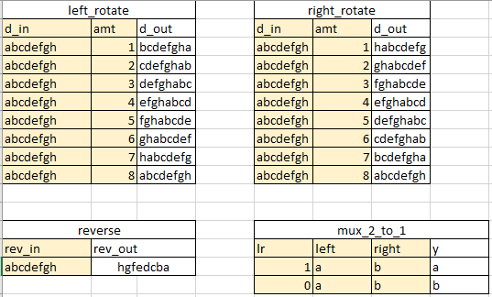

**III Program**

// Connects the Barrel_Rotator code to the physical layout onto the FPGA.

//////////////////////////////////////////////////////////////////////////////////

module **FPGA_Barrel_Rotator**(

output wire [7:0] led,

input wire [3:0] btn, // 3:1 amount, 0 lr

input wire [7:0] sw

);

Barrel_Rotator BR_Test(

.data_out(led),

.lr(btn[0]),

.amount(btn[3:1]),

.data_in(sw)

);

endmodule // FPGA_Barrel_Rotator

//// Connects the Bidirection_Rotation code to the physical layout onto the FPGA.

//////////////////////////////////////////////////////////////////////////////////

module **FPGA_Bidirection_Rotation**(

output wire [7:0] led,

input wire [3:0] btn, // 3:1 amount, 0 lr

input wire [7:0] sw

);

Bidirection_Rotation BR_Test(

.data_out(led),

.lr(btn[0]),

.amount(btn[3:1]),

.data_in(sw)

);

endmodule//FPGA_Bidirection_Rotation

// This is the complete design for the Barrel_rotator (left and right),

// which is suitable for simulation.

//////////////////////////////////////////////////////////////////////////////////

module **Barrel_Rotator**(

output [7:0] data_out,

input wire lr,

input wire [2:0] amount,

input [7:0] data_in

);

// internal signals

wire [7:0] left_out, right_out;

left_rotator left_rotator1(

.d_out(left_out), //output

.d_in(data_in), //inputs

.bit_amount(amount)

);

right_rotator right_rotator1(

.d_out(right_out), //output

.d_in(data_in), //inputs

.bit_amount(amount)

);

mux_2_to_1 mux_2_to_1_1(

.y(data_out), //output

.left(left_out),//inputs

.right(right_out),

.lr(lr)

);

endmodule // Barrel_Rotator

//// This is the complete design for the Bidirection_Rotation (pre and post reverse),

// which is suitable for simulation.

//////////////////////////////////////////////////////////////////////////////////

module **Bidirection_Rotation**(

output wire [7:0] data_out,

input wire lr,

input wire [2:0] amount,

input wire [7:0] data_in

);

// internal signals

wire [7:0] pre_rev_out, post_rev_out;

wire [7:0] pre_mux_out;

wire [7:0] right_out;

reverse pre_rev(

.rev_out(pre_rev_out), //output

.rev_in(data_in) //input

);

mux_2_to_1 pre_mux(

.y(pre_mux_out), //output

.right(data_in), //inputs

.left(pre_rev_out),

.lr(lr) // lr = 1 -> prev_rev_out, lr = 0 -> data_in

);

right_rotator right_rotator1(

.d_out(right_out), //output

.d_in(pre_mux_out), //inputs

.bit_amount(amount)

);

reverse post_rev(

.rev_out(post_rev_out), //output

.rev_in(right_out) //input

);

mux_2_to_1 post_mux(

.y(data_out), //output

.right(right_out),//input

.left(post_rev_out), // lr = 1 -> post_rev_out, lr = 0 -> right_out

.lr(lr)

);

endmodule // Bidirection_Rotation

// Left rotates the value d_in based on the bit_amount. The output is d_out.

//////////////////////////////////////////////////////////////////////////////////

module **left_rotator**(

output reg [7:0] d_out, // 8'b

input wire [7:0] d_in,

input wire [2:0] bit_amount // 3'b, enough to specify #'b to rotate

);

//In Verilog you can't use a variable as the end of range.

// https://verificationacademy.com/forums/systemverilog/range-must-be-bounded-constant-expressions

//assign d_out = {d_in[bit_amount +: 0], d_in[7+: 8]};

always @(*) begin

case(bit_amount)

3'd1: d_out = {d_in[6:0], d_in[7]};

3'd2: d_out = {d_in[5:0], d_in[7:6]};

3'd3: d_out = {d_in[4:0], d_in[7:5]};

3'd4: d_out = {d_in[3:0], d_in[7:4]};

3'd5: d_out = {d_in[2:0], d_in[7:3]};

3'd6: d_out = {d_in[1:0], d_in[7:2]};

3'd7: d_out = {d_in[0], d_in[7:1]};

default: d_out = d_in; // case 0

endcase

end

endmodule//left_rotator

/// Right rotates the value d_in based on the bit_amount. The output is d_out.

//////////////////////////////////////////////////////////////////////////////////

module **right_rotator**(

output reg [7:0] d_out, // 8'b

input wire [7:0] d_in,

input wire [2:0] bit_amount // 3'b, enough to specify #'b to rotate

);

//In Verilog you can't use a variable as the end of range.

// https://verificationacademy.com/forums/systemverilog/range-must-be-bounded-constant-expressions

//assign d_out = {d_in[bit_amount +: 0], d_in[7+: 8]};

always @(*) begin

case(bit_amount)

3'd1: d_out = {d_in[0], d_in[7:1]};

3'd2: d_out = {d_in[1:0], d_in[7:2]};

3'd3: d_out = {d_in[2:0], d_in[7:3]};

3'd4: d_out = {d_in[3:0], d_in[7:4]};

3'd5: d_out = {d_in[4:0], d_in[7:5]};

3'd6: d_out = {d_in[5:0], d_in[7:6]};

3'd7: d_out = {d_in[6:0], d_in[7]};

default: d_out = d_in; // case 0

endcase

end

endmodule//right_rotator

// Y, outputs the value based on lr. y = left if lr ==1, and right otherwise.

//////////////////////////////////////////////////////////////////////////////////

module mux_2_to_1(

output wire [7:0] y, // output of mux

input wire [7:0] left, right, // input a = 1'b1, b = 1'b0

input wire lr // select, left or right

);

assign y = lr ? left: right; // the type after assign must be WIRE

// if lr = 1, then y = left

// if lr = 0, then y = right

endmodule//mux_2_to_1

// Outputs the reverse order of rev_in as rev_out.

//////////////////////////////////////////////////////////////////////////////////

module **reverse**(

output wire [7:0] rev_out,

input wire [7:0] rev_in

);

//Generate loop index i must be defined as a genvar

genvar i;

// generate for loop is generating an instance for each iteration

generate for(i = 0; i < 8; i = i + 1) begin

assign rev_out[i] = rev_in[7-i];

end endgenerate

endmodule // reverse

**IV Results**   
**Bidirection and Barrel_Rotatator testbench**

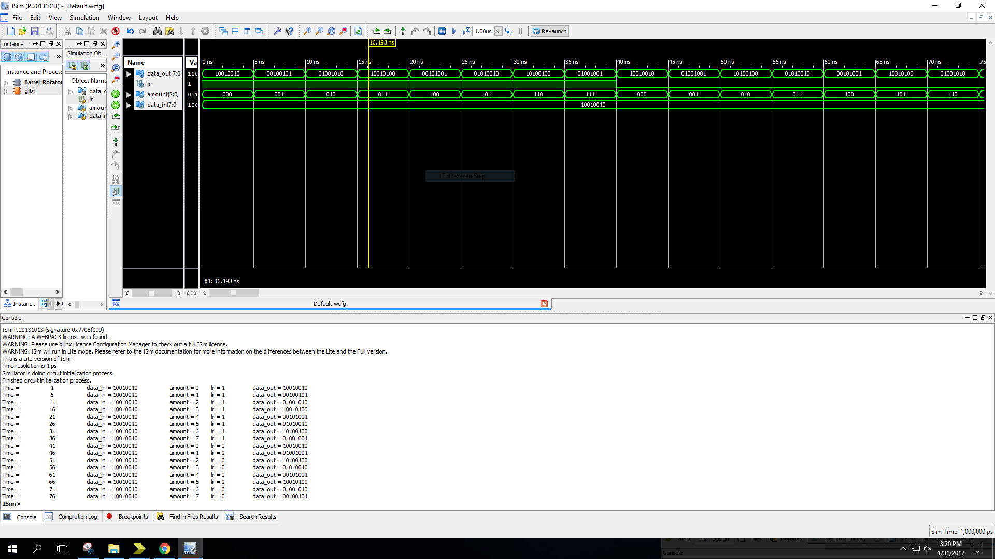

module Bidirection_Rotation_testbench; // Similar to Barrel_Rotator_testbench

// Inputs

reg lr;

reg [2:0] amount;

reg [7:0] data_in;

// Outputs

wire [7:0] data_out;

// Instantiate the Unit Under Test (UUT)

Bidirection_Rotation uut (

.data_out(data_out),

.lr(lr),

.amount(amount),

.data_in(data_in)

);

initial begin

// Initialize Inputs and check for left rotate first

data_in = 8'b10010010;

lr = 1;

amount = 3'b000;

#5;

amount = 3'b001;

#5

amount = 3'b010;

#5

amount = 3'b011;

#5

amount = 3'b100;

#5;

amount = 3'b101;

#5

amount = 3'b110;

#5

amount = 3'b111;

#5

lr = 0; // Now check for right rotate

amount = 3'b000;

#5;

amount = 3'b001;

#5

amount = 3'b010;

#5

amount = 3'b011;

#5

amount = 3'b100;

#5;

amount = 3'b101;

#5

amount = 3'b110;

#5

amount = 3'b111;

end

always @(data_out)

#1 $display ("Time = %d \t data_in = %b \t amount = %d \t lr = %b \t data_out = %b",

$time, data_in, amount, lr, data_out);

endmodule

**Left_rotator testbench**

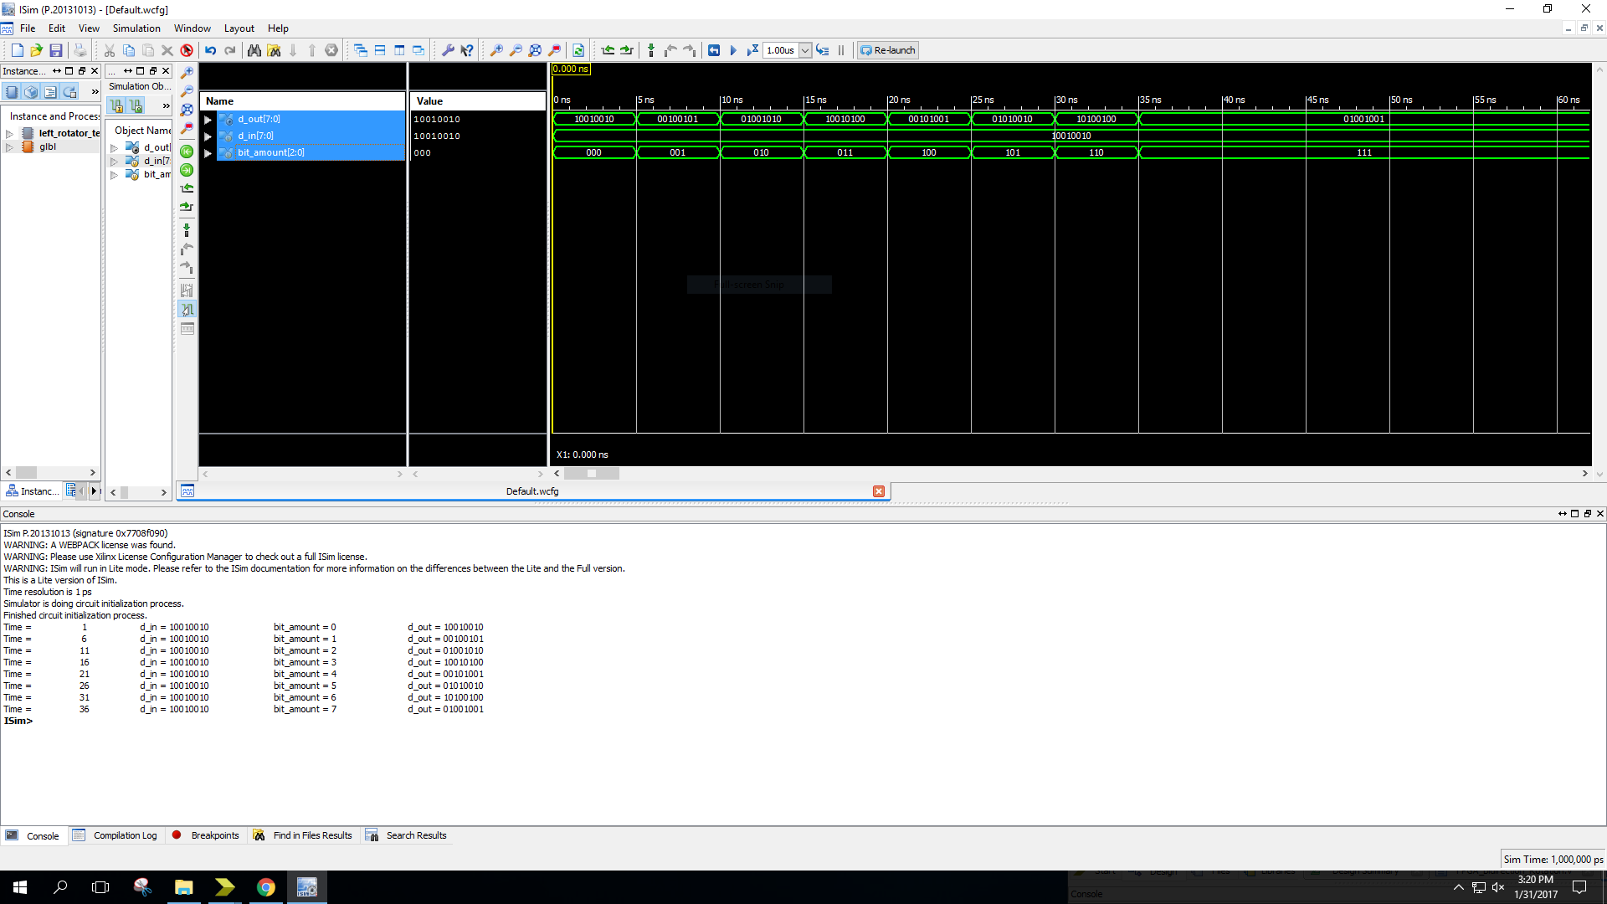

module left_rotator_testbench; // Similar to right_rotator_testbench

// Inputs

reg [7:0] d_in;

reg [2:0] bit_amount;

// Outputs

wire [7:0] d_out;

// Instantiate the Unit Under Test (UUT)

left_rotator uut (

.d_out(d_out),

.d_in(d_in),

.bit_amount(bit_amount)

);

initial begin

// Initialize Inputs

d_in = 8'b10010010;

bit_amount = 3'b000;

#5;

bit_amount = 3'b001;

#5

bit_amount = 3'b010;

#5

bit_amount = 3'b011;

#5

bit_amount = 3'b100;

#5;

bit_amount = 3'b101;

#5

bit_amount = 3'b110;

#5

bit_amount = 3'b111;

end

always @(d_out)

#1 $display ("Time = %d \t d_in = %b \t bit_amount = %d \t d_out = %b",

$time, d_in, bit_amount, d_out);

endmodule

**Right_rotator testbench**

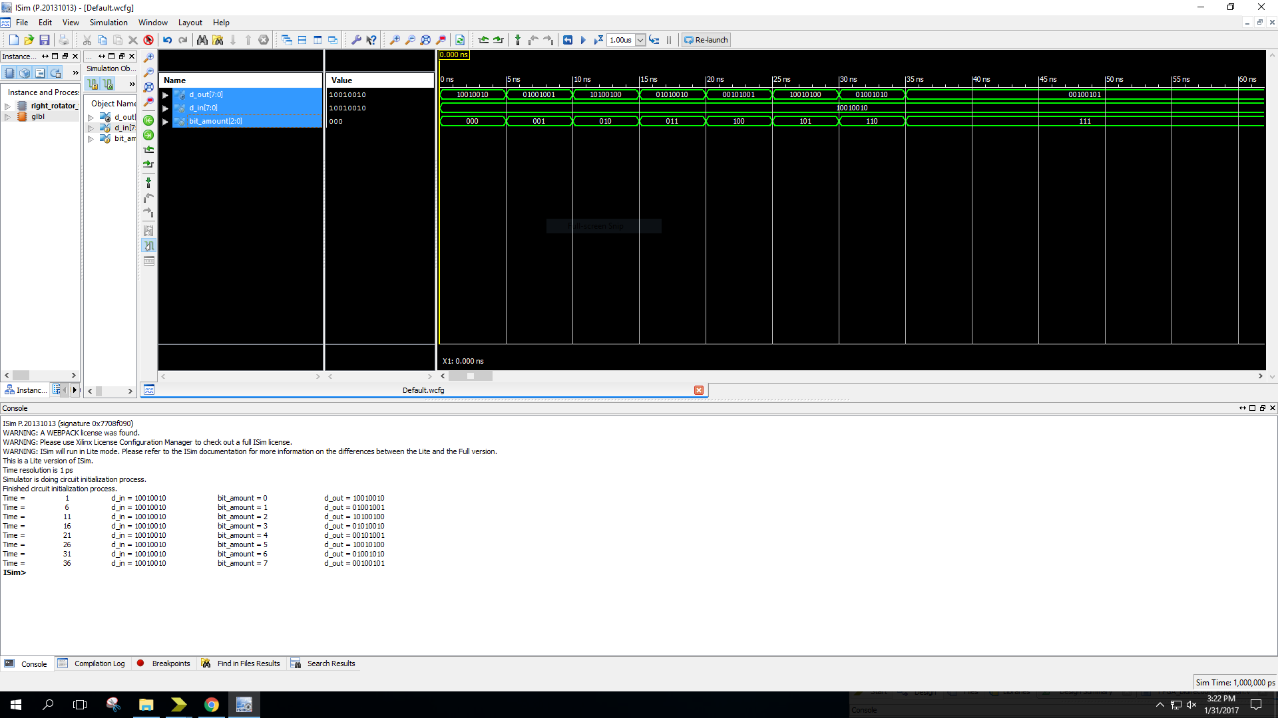

**Mux_2_to_1testbench**

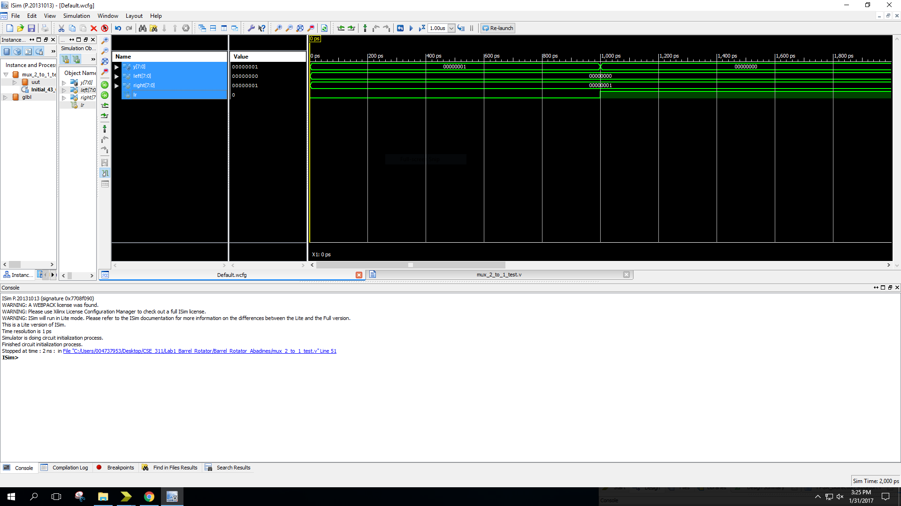

module mux_2_to_1_test;

// Inputs

reg [7:0] left;

reg [7:0] right;

reg lr;

// Outputs

wire [7:0] y;

// Instantiate the Unit Under Test (UUT)

mux_2_to_1 uut (

.y(y),

.left(left),

.right(right),

.lr(lr)

);

initial begin

// Initialize Inputs

left = 0;

right = 1;

lr = 0; //output right

#1;

lr =1; // output left

#1;

$stop;

end

endmodule

**Reverse testbench**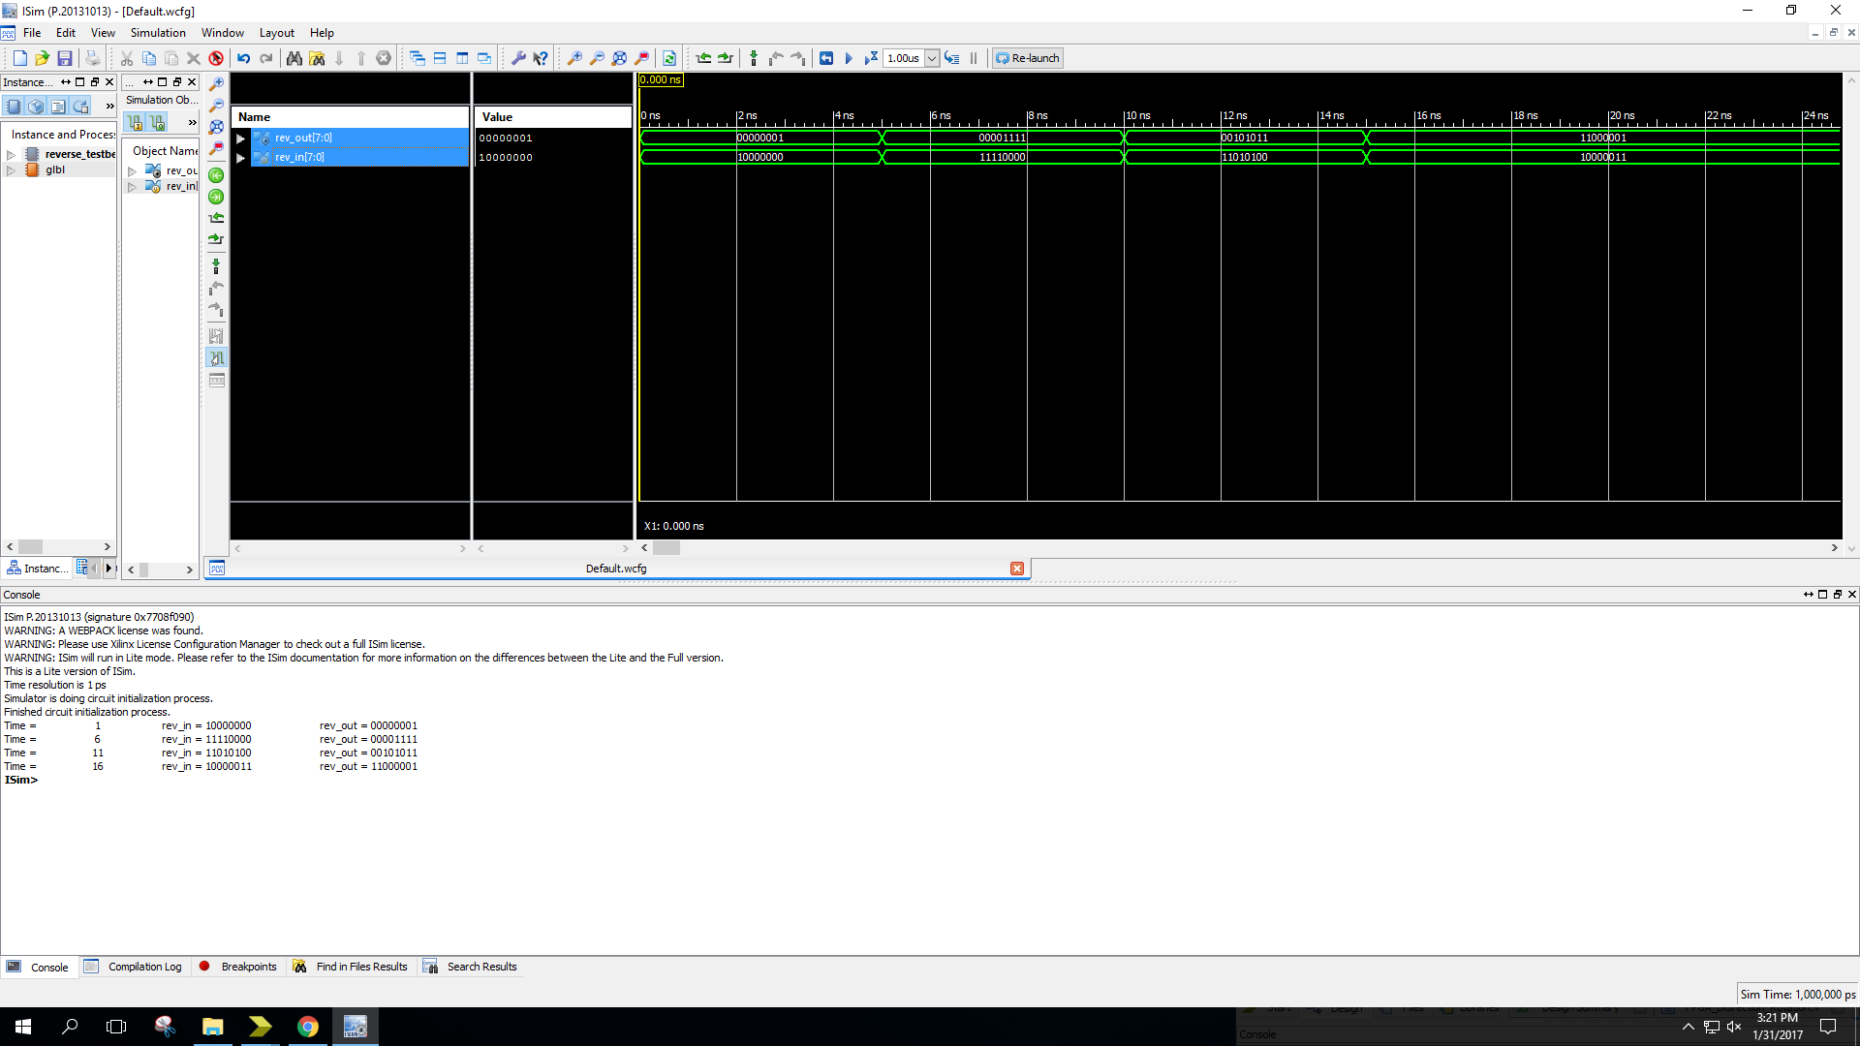

module reverse_testbench;

// Inputs

reg [7:0] rev_in;

// Outputs

wire [7:0] rev_out;

// Instantiate the Unit Under Test (UUT)

reverse uut (

.rev_out(rev_out),

.rev_in(rev_in)

);

initial begin

// Initialize Inputs

rev_in = 8'b10000000;

#5

rev_in = 8'b11110000;

#5

rev_in = 8'b11010100;

#5

rev_in = 8'b10000011;

end

always @(rev_out)

#1 $display ("Time = %d \t rev_in = %b \t rev_out = %b",

$time, rev_in, rev_out);

Endmodule

**V Problem**

1. I attempted to develop an algorithm for the left and right rotation instead of hardcoding the values based on the bit_amount, but Verilog was incapable of having a variable as the end range of the array. To solve the problem I hardcoded the values into a case statement.
2. Again, I did not want to hardcode values for the reverse module as well. In planning, I wished to develop an algorithm that can handle dynamic changes in parameters. I used a for loop to try to index values dynamically. Overall, I was able to run and compile the program using *genvar* index and a *generate* for loop.
3. I did not know how to connect the I/O signals to the I/O pins on the board. I used a default.ucf and commented out unnecessary ports.

**VI What you learned**

As robust as Verilog is as HDL, and as practical as it is for its ability to be used for real-world applications, it is not suitable for every algorithm. My first problem displays how an algorithm can work in theory, but fail in application.

Secondly, I learned that to distinguish little nuances based on datatypes and conditionals, and recognize the differences between combination logic circuits versus sequential circuits. (for loop, generate for loop, net group versus variable group, continuous versus procedural).

Lastly, I learned how to implement Verilog software into a tangible application, such as the FPGA.