SOLUTION DESIGN
Kafka POS Order Delivery
Delivering orders from Kafka to POS terminals through a WebSocket gateway: components, responsibilities and ownership

Author | Vincent Bevia
Date | 7 October 2026
Version | 1.0
Status | Draft for review
Reference implementation | kafka-demo-java

Contents
1. Executive summary 3
2. Solution overview 4
3. Components and responsibilities 5
3.1 Apache Kafka (broker) 5
3.2 Topics 5
3.3 OrderProducer (order service) 6
3.4 PosGateway 6
3.5 PosTerminal 7
3.6 Downstream consumers 7
4. Ownership matrix 8
5. Key design decisions 9
5.1 Consumers pull, using long polling 9
5.2 Key by terminal, not one topic or partition per terminal 9
5.3 Commit after storing, not after the terminal acknowledges 9
5.4 Report delivery as events 9
5.5 One consumer group per purpose 10
6. Message flows 11
7. Order lifecycle in the gateway 12
8. Delivery guarantees 13
9. Data contracts 14
10. Configuration reference 15
11. From demo to production 16
12. Running the reference implementation 17
Appendix: glossary 18

1. Executive summary
This document describes how orders are delivered from back-end services to point-of-sale (POS) terminals using Apache Kafka and a WebSocket gateway. The design is implemented end to end in the kafka-demo-java reference project, so every component described here exists as runnable code.
The central question it answers is who is responsible for what. Kafka is often assumed to "deliver" messages to their final destination. It does not: Kafka stores events durably and lets consumers read them, but it never learns what a consumer did with an event afterwards. Responsibility for the last mile to the POS therefore has to be owned explicitly by another component.

Key points
- Kafka is a durable, ordered event log. It distributes orders reliably to any number of consumers, but has no knowledge of whether an order reached a POS terminal.
- The PosGateway owns the last mile. It takes responsibility for each order from Kafka, delivers it over WebSocket, retries when needed and reports the outcome.
- Outcomes are events. Delivery results (QUEUED, DELIVERED, FAILED) are published on the order-status topic, so any service can follow an order without coupling to the gateway.
- An offline terminal never blocks the others. The gateway commits its Kafka position as soon as an order is safely stored, not when the POS acknowledges it.
- At-least-once end to end, effectively-once at the POS. Retries can produce duplicates; POS terminals deduplicate on order_id, so each order is processed once.

2. Solution overview
The solution consists of a Kafka broker with two topics, one producer, one gateway service, the POS terminals and any number of downstream consumers. Figure 1 shows the components and how data moves between them.
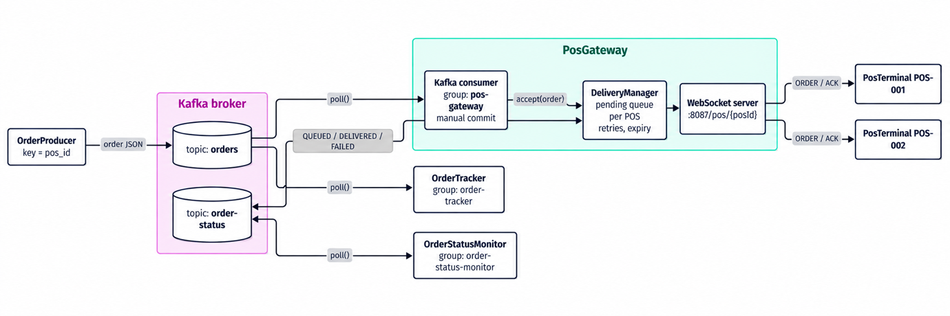
Figure 1. Components and data flow

End-to-end flow in five steps
- Publish. The order service (OrderProducer) publishes a new order to the orders topic, using the POS id as the message key.
- Store. Kafka appends the order to the partition chosen by the key and keeps it for the retention period, independently of who reads it.
- Take over. The PosGateway reads the order, stores it in its pending queue for that POS and commits its Kafka offset. From this point the gateway owns the order.
- Deliver. The gateway pushes the order over the terminal's WebSocket connection (immediately, or as soon as the terminal connects) and waits for an acknowledgement, retrying if necessary.
- Report. The gateway publishes each outcome to order-status, where downstream services (dashboards, the order service, alerting) consume it.

3. Components and responsibilities
Each component below is described by its role, what it is responsible for and, equally important, what it is not responsible for. Clear boundaries prevent two components from both assuming the other one handles a concern (for example, retries or deduplication).

3.1 Apache Kafka (broker)
Role | A durable, partitioned commit log. It is the system's source of truth for order events and the hand-over point between the order service and the gateway.
Responsible for | - Persisting every event durably for the configured retention period (7 days by default), whether or not it has been read.  - Preserving order within a partition. Events with the same key always go to the same partition.  - Serving the same events to any number of independent consumer groups.  - Storing each consumer group's committed offset (its "read up to here" marker) in the internal __consumer_offsets topic.  - Tracking consumer liveness through heartbeats and redistributing partitions when a consumer joins, leaves or fails (rebalancing).
Not responsible for | - Knowing whether a message was processed, or whether it reached its final destination.  - Pushing messages: consumers pull (with long polling, which makes delivery near-instant).  - Deleting messages after they are consumed. Consumption does not remove anything.  - Retries, business rules or validating message content.
Implemented by | confluentinc/cp-kafka:7.8 in KRaft mode (single node acting as broker and controller), defined in docker-compose.yaml.

3.2 Topics
Two topics carry all traffic. Choosing the message key is a design decision: the key determines the partition, and therefore the ordering guarantee.
Topic | Key | Value | Written by | Read by | Purpose
orders | pos_id | Order (JSON) | OrderProducer | pos-gateway, order-tracker | New orders to be executed on a terminal. Keying by pos_id keeps each terminal's orders in sequence.
order-status | order_id | OrderStatus (JSON) | PosGateway | order-status-monitor (and any other service) | Delivery outcome of each order. Keying by order_id keeps all status events of one order in sequence.

3.3 OrderProducer (order service)
Role | The source of orders. In production this is the order or checkout service; in the demo it is a command-line producer.
Responsible for | - Creating each order with a globally unique order_id (UUID), which later serves as the idempotency key.  - Assigning the target terminal (pos_id) and using it as the message key.  - Treating an order as published only after Kafka confirms the write (the delivery callback with partition and offset).
Not responsible for | - Knowing which gateway instance will deliver the order, or whether the terminal is online.  - Delivery confirmation. That arrives later, asynchronously, as an event on order-status.
Implemented by | OrderProducer.java

3.4 PosGateway
The gateway is the bridge between Kafka and the terminals and the owner of the last mile. It is built from three parts with distinct duties:
Part | Responsibility
Kafka consumer (group pos-gateway) | Reads orders, validates each order, hands it to the DeliveryManager and commits the offset manually (enable.auto.commit=false) once the batch is stored.
DeliveryManager | Keeps one pending queue per POS, pushes orders, retries, expires orders that cannot be delivered and publishes status events.
PosWebSocketServer | Accepts terminal connections on ws://host:8887/pos/{posId}, translates WebSocket events (connect, disconnect, ACK) into DeliveryManager calls and detects dead connections with pings.

Role | Takes responsibility for each order from Kafka and ensures it reaches the right terminal, or reports that it could not.
Responsible for | - Taking over each order: storing it as pending first, then committing the Kafka offset.  - Maintaining a pending queue per terminal, in Kafka order.  - Delivering to connected terminals, and flushing the queue when a terminal (re)connects.  - The retry policy: resend after 5 s without ACK, give up after 3 attempts or after 2 minutes offline.  - Ignoring duplicate deliveries from Kafka (an order already pending is not queued twice).  - Publishing QUEUED, DELIVERED and FAILED events, and rejecting invalid orders (no pos_id).
Not responsible for | - Creating or modifying orders.  - Executing the order on the terminal, or guaranteeing the terminal processes it only once.  - Long-term order history or follow-up actions on failures (refunds, alerts). Downstream services own those.
Implemented by | PosGateway.java, DeliveryManager.java, PosWebSocketServer.java

3.5 PosTerminal
Role | The endpoint that executes the order (prints it, shows it to staff, starts a payment).
Responsible for | - Keeping a connection to the gateway and reconnecting automatically after a network or gateway outage.  - Processing each order exactly once, by remembering processed order_ids (idempotency).  - Acknowledging each order after processing it, and acknowledging duplicates again without re-processing them.
Not responsible for | - Retrying or queueing. If an ACK is lost, the gateway resends.  - Talking to Kafka. Terminals only know the gateway.
Implemented by | PosTerminal.java (simulated terminal, with --flaky and --no-ack modes for testing failure scenarios)

3.6 Downstream consumers
OrderStatusMonitor | Consumes order-status (group order-status-monitor) and prints each outcome. It stands in for real consumers such as the order service updating an order's state, an operations dashboard, or alerting on FAILED events. It observes delivery but never influences it.
OrderTracker | The original demo consumer (group order-tracker, automatic offset commits). It reads orders independently of the gateway, which illustrates that each consumer group has its own position and receives every event.

4. Ownership matrix
The table assigns every concern in the delivery chain to exactly one owner. When something goes wrong, this is where to look first.
Concern | Owner | Mechanism
Creating the order and its unique id | OrderProducer | UUID order_id
Durable storage of order events | Kafka | Append-only log with retention (and replication in production)
Ordering of orders per terminal | OrderProducer + Kafka | Key = pos_id, so one terminal maps to one partition
Remembering what each consumer group has read | Kafka (on the consumer's behalf) | Committed offsets in __consumer_offsets. The consumer decides when to commit.
Taking over responsibility for an order | PosGateway | Store as pending, then commitSync()
Delivering the order to the terminal | PosGateway | WebSocket push, flush on reconnect
Retrying and deciding to give up | PosGateway | 5 s retry, 3 attempts, 2-minute offline limit
Ignoring duplicate reads from Kafka | PosGateway | Pending queue keyed by order_id
Processing the order only once | PosTerminal | Remembers processed order_ids
Confirming receipt | PosTerminal | ACK message over WebSocket
Reporting the outcome | PosGateway | Events on order-status
Acting on the outcome (UI, alerts, refunds) | Downstream services | Consume order-status

Rule of thumb
Kafka's responsibility ends when a consumer group commits its offset. Everything after that point (delivery, retries, confirmation) belongs to the consumer that committed, which is why the gateway must report outcomes explicitly.

5. Key design decisions

5.1 Consumers pull, using long polling
Kafka never pushes data to consumers. Each consumer calls poll(), which sends a fetch request that the broker holds open until data arrives or fetch.max.wait.ms (500 ms by default) expires. New events are therefore returned within milliseconds, while the consumer stays in control of its pace.
The value passed to poll() (1 s in the tracker, 500 ms in the gateway) is a maximum wait when there is no data, not a polling interval. When records are available, poll() returns immediately.
Why it matters: a slow consumer is never flooded, consumers can rewind and replay, and new consumer groups can read historical events.

5.2 Key by terminal, not one topic or partition per terminal
All orders share the orders topic and are keyed by pos_id. Many terminals share each partition, and each terminal's orders keep their sequence.
Rejected alternative: a topic or partition per terminal. With hundreds or thousands of terminals, this creates thousands of partitions, each costing broker files, memory and recovery time, and slowing down rebalances. Partitions are a unit of parallelism, not a per-entity queue.

5.3 Commit after storing, not after the terminal acknowledges
A consumer group commits a single offset per partition, meaning "everything before this point is done". If the gateway only committed after a terminal's ACK, one offline terminal would block every other terminal sharing its partition:
Offset | Order for | Situation | Effect if committing after ACK
10 | POS-A | Terminal offline, no ACK | Offset 10 cannot be committed
11 | POS-B | Terminal online, ACK received | Cannot commit 11 either, because that would also mark 10 as done. POS-B waits behind POS-A.

This is called head-of-line blocking. The design avoids it by committing once the order is in the gateway's pending store, and tracking delivery per terminal in that store instead.
Consequence
Because the offset is committed before delivery, the pending store becomes the only record of undelivered orders. In production it must be durable (database or Redis). The demo keeps it in memory for simplicity.

5.4 Report delivery as events
Offsets only say how far a consumer has read. To make delivery visible, the gateway publishes an event for every state change on order-status. Any service can subscribe without the gateway knowing about it, and the full history of an order's delivery is retained in Kafka.

5.5 One consumer group per purpose
The gateway, the tracker and the status monitor each use their own consumer group. Each group receives every event and keeps its own offset, so adding a new consumer (for example, analytics) never affects existing ones. Within a group, partitions are divided among instances, which is how the gateway scales horizontally.

6. Message flows
Figure 2 shows the three scenarios that matter most: the normal path, a terminal that is offline when the order arrives, and an acknowledgement that gets lost.
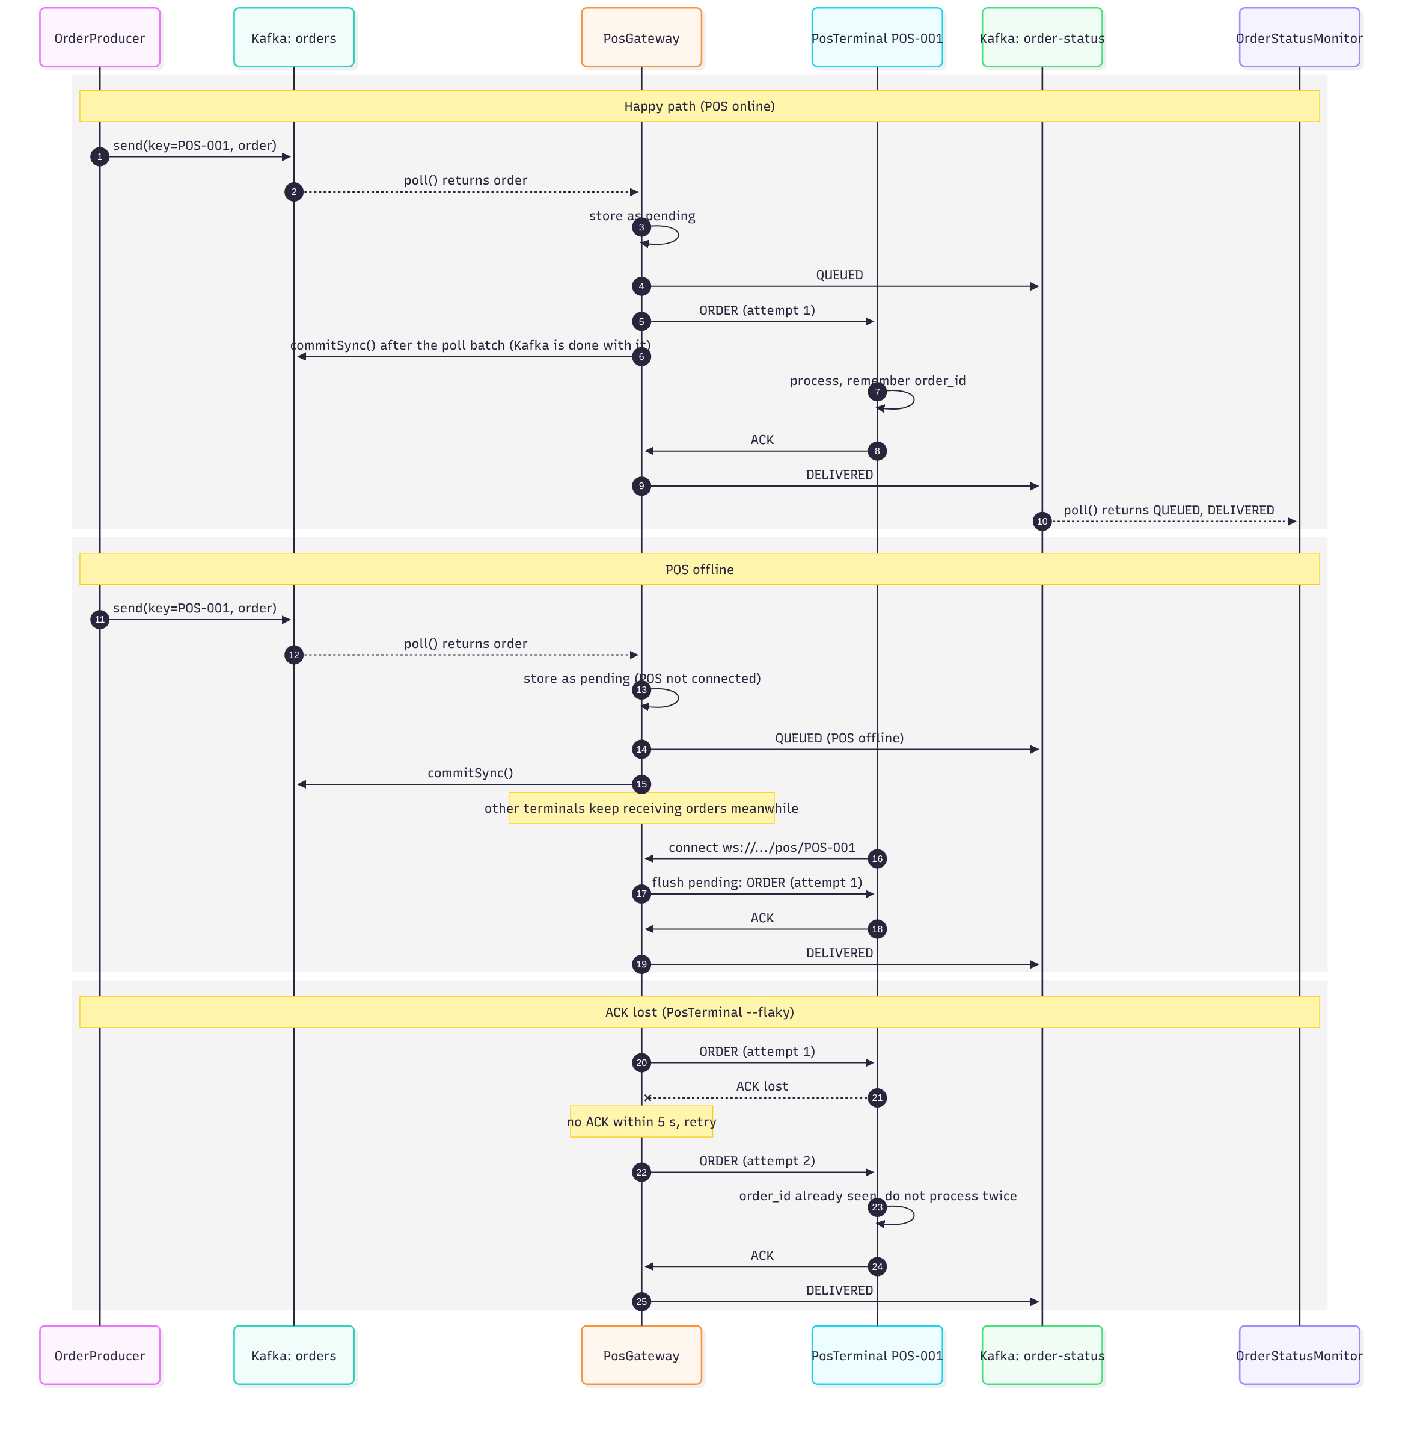
Figure 2. Message flows for the normal path, an offline POS and a lost ACK

Scenario A: normal path
The gateway reads the order, stores it, publishes QUEUED, pushes it to the connected terminal and commits its offset after the poll batch. The terminal processes the order, remembers its order_id and sends an ACK. The gateway removes the order from its queue and publishes DELIVERED.

Scenario B: terminal offline
The order is stored and the offset committed as before, so other terminals keep receiving their orders. The gateway publishes QUEUED ("POS offline"). When the terminal connects, its pending queue is flushed in order and the flow completes as in scenario A. After 2 minutes offline, the order is marked FAILED.

Scenario C: acknowledgement lost
The terminal processes the order but its ACK never arrives, so the gateway resends it after 5 seconds. The terminal recognises the order_id, skips processing and re-sends the ACK. Without this idempotency, the order would be printed (or charged) twice.

7. Order lifecycle in the gateway
Figure 3 shows every state an order can be in while the gateway owns it. Each transition into a final state publishes an event on order-status.
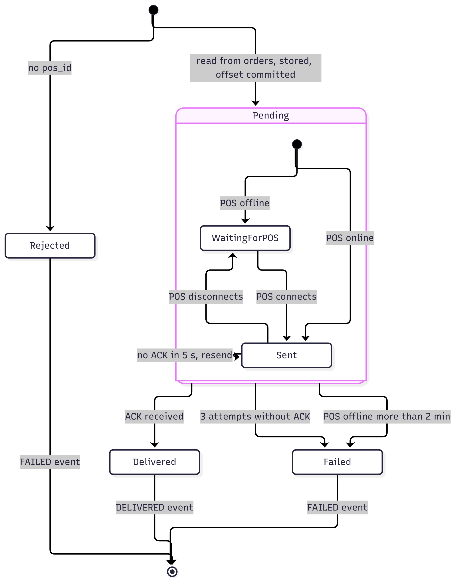
Figure 3. States of an order inside the PosGateway
Status event | Published when | Meaning for consumers
QUEUED | The order enters the pending store | The gateway has taken responsibility. The detail field says whether the POS was online.
DELIVERED | The POS acknowledges the order | The order reached the terminal and was processed. The detail field includes the number of attempts.
FAILED | No pos_id, 3 attempts without ACK, or POS offline for more than 2 minutes | Delivery will not happen without intervention. Downstream services should alert, retry later or compensate.

8. Delivery guarantees
Every hop in the chain is at-least-once: a message is never silently lost, but it may arrive more than once. Duplicates are neutralised by deduplicating on order_id at each receiving side.
Hop | Guarantee | How duplicates or losses are handled
OrderProducer → Kafka | At-least-once, effectively once per partition | The producer retries until Kafka confirms. Producer idempotence (enabled by default in current Kafka clients) prevents retry duplicates.
Kafka → PosGateway | At-least-once | If the gateway crashes before committing, it re-reads the batch. Orders already pending are ignored.
PosGateway → PosTerminal | At-least-once | Unacknowledged orders are resent. The terminal deduplicates on order_id and re-acknowledges.
End to end | Effectively once at the POS | Each order is executed once, provided the terminal's record of processed ids survives restarts.

Why not exactly-once?
Kafka's exactly-once semantics only cover reads and writes within Kafka. The WebSocket hop to a terminal is outside Kafka, so idempotent processing at the terminal is what makes duplicates harmless.

9. Data contracts
All messages are JSON with snake_case field names, so the Java services remain compatible with the original Python scripts.

Order (topic orders, key = pos_id)
{
"order_id": "d026929a-6a50-47dc-97f3-41355e8aab27",
"pos_id": "POS-001",
"user": "Vincent",
"item": "Office table",
"quantity": 1
}

OrderStatus (topic order-status, key = order_id)
{
"order_id": "d026929a-6a50-47dc-97f3-41355e8aab27",
"pos_id": "POS-001",
"status": "DELIVERED",
"detail": "acked by POS after 1 attempt(s)",
"timestamp": "2026-10-07T10:15:30.123Z"
}

WebSocket protocol between gateway and terminal
Direction | Message
Gateway → POS | {"type":"ORDER","order":{...},"attempt":1}
POS → Gateway | {"type":"ACK","order_id":"d026929a-..."}

Terminals connect to ws://<gateway-host>:8887/pos/{posId}. A newer connection for the same posId replaces the previous one.

10. Configuration reference
Setting | Value | Where | Effect
Bootstrap servers | localhost:19092 | All Kafka clients | External listener of the Docker broker. Override with KAFKA_BOOTSTRAP_SERVERS.
enable.auto.commit | false | PosGateway | The gateway commits manually, after storing each batch.
auto.offset.reset | earliest | All consumers | A new consumer group starts from the oldest retained event.
Poll timeout | 500 ms / 1 s | Gateway / other consumers | Maximum wait when there is no data.
WebSocket port | 8887 | PosGateway | Override with POS_GATEWAY_PORT.
Retry after | 5 s | DeliveryManager | Resend if no ACK within this time.
Max attempts | 3 | DeliveryManager | Then the order is FAILED.
Offline limit | 2 min | DeliveryManager | Orders for a terminal offline longer than this are FAILED.
Connection lost timeout | 10 s | PosWebSocketServer | Ping interval used to detect dead terminal connections.

11. From demo to production
The demo deliberately keeps infrastructure minimal. The table lists each simplification and what a production deployment needs instead.
Demo simplification | Production approach
Pending store kept in memory | Durable store (for example PostgreSQL or Redis) written before the offset is committed. Otherwise a gateway crash loses orders Kafka already considers handled.
Single gateway instance | Several instances share the pos-gateway group, each owning some partitions. Because a terminal may connect to a different instance than the one owning its partition, add routing: either a shared pending store that every instance can deliver from, or routing terminals to the instance that owns their partition.
Terminal remembers processed ids in memory | Persist processed order_ids on the terminal (or check against the back end) so deduplication survives restarts.
Plain WebSocket, no authentication | TLS (wss://) and terminal authentication (mutual TLS or signed tokens), so only genuine terminals receive orders.
Single broker, replication factor 1 | At least three brokers, replication factor 3, min.insync.replicas=2 and acks=all on producers.
Fixed retry interval | Exponential backoff, and a dead-letter topic for FAILED orders that need manual follow-up.
Untyped JSON | A schema registry (Avro, Protobuf or JSON Schema) to version message contracts safely.
Console output | Metrics and alerts on consumer lag, pending queue size per terminal, FAILED rate and connected terminals.

12. Running the reference implementation
Requirements: JDK 17 or later, Maven 3.9 or later, and Docker. Start each component in its own terminal, or run the classes from IntelliJ.
docker compose up -d # Kafka
mvn -q compile exec:java@status # status monitor
mvn -q compile exec:java@gateway # POS gateway
mvn -q compile exec:java@pos -Dexec.args="POS-001" # a terminal
mvn -q compile exec:java@producer -Dexec.args="POS-001 3" # send 3 orders

Scenarios to try
Scenario | How | What you should see
Offline terminal | Stop the terminal, send orders, restart it | QUEUED (POS offline), then DELIVERED on reconnect
Isolation | Keep POS-001 stopped, run POS-002 and send to it | POS-002's orders are delivered immediately
Lost ACK | Start the terminal with --flaky | A retry after 5 s, a duplicate ignored by the terminal, then DELIVERED
Unresponsive terminal | Start the terminal with --no-ack | 3 attempts, then FAILED

To inspect the gateway's position in Kafka (lag returns to 0 as soon as orders are stored, even while a terminal is offline):
docker exec -it kafka kafka-consumer-groups --bootstrap-server localhost:9092 \
--describe --group pos-gateway

Appendix: glossary
Term | Definition
Broker | A Kafka server that stores partitions and serves reads and writes.
Topic | A named stream of events, split into partitions.
Partition | An ordered, append-only log. Ordering is guaranteed only within one partition.
Key | Part of each message that determines its partition. Equal keys always go to the same partition.
Offset | The position of an event within a partition.
Consumer group | A set of consumer instances that share the work of reading a topic. Each group has its own offsets and receives every event.
Commit | A consumer telling Kafka how far its group has processed a partition.
Lag | The difference between the newest offset in a partition and the group's committed offset.
Long polling | A fetch request the broker holds open until data arrives or a timeout expires.
Head-of-line blocking | When one stuck message prevents the messages behind it from being processed.
At-least-once | Every message arrives, possibly more than once.
Idempotency | Processing the same message twice has the same effect as processing it once.
KRaft | Kafka's built-in consensus mode, which replaces ZooKeeper.

