From Unstructured Text to Knowledge Graph: An Automated Pipeline for Ontology Discovery, Entity Resolution, and Graph RAG via LLM-FalkorDB Integration
Alessandro Bevilacqua¹
¹ Department of Computer Science, University of Bari Aldo Moro, Via Orabona 4, 70125 Bari, Italy
Abstract
Research into Retrieval-Augmented Generation (RAG) has surged in both industry and academia, primarily due to the tendency of Large Language Models (LLMs) to hallucinate in technical or data-scarce domains. Graph RAG has emerged as a compelling solution, leveraging Knowledge Graphs (KGs) to ground LLM outputs. Unlike unstructured data, KGs provide a structured logical framework that enhances reasoning and enables Explainable AI (XAI) by providing traceable justifications.
In this study, we propose a novel framework to automate Graph RAG construction from unstructured text using LLMs and FalkorDB. Our pipeline first partitions documents by topic, after which an LLM constructs a validated ontology for each of them to guide entity and relation extraction. To ensure graph integrity, we convert entities and relations to text and then perform Entity Resolution by clustering text embeddings via HDBSCAN and employing an LLM to merge duplicates (if any) within each cluster. Finally, the resulting KGs (one for each main topic) are navigated through an LLM-orchestrated approach, with performance evaluated using an LLM-as-a-judge methodology. As a case study, we developed a specialized system based on GPT-5 nano, optimized to answer queries related to EmPULIA and the broader Italian Public Procurement Code (Codice degli Appalti). This case study is particularly compelling as the source material consists exclusively of highly technical, unstructured text documents, without access to structured datasets or alternative data formats.
// Dire risultati

Keywords
Knowledge Graph, Graph RAG, LLM, Entity Resolution, HDBSCAN, FalkorDB, CEUR-WS

Introduction and Motivations
The Graph RAG approach uses knowledge graphs to provide substantial improvements to LLMs in question-and-answer performance when reasoning about complex information. RAG techniques have shown promise in enabling LLMs to reason about private datasets, i.e. data that the LLM is not trained on and has never seen before, such as an enterprise’s proprietary research or business documents. However, the construction of Knowledge Graphs is not a simple operation - especially for complex domains - and requires attention to Entity Resolution, data consistency and scalability. The traditional methodology for KG construction, particularly when dealing with unstructured data, typically demands extensive manual effort. This human-centric process is not only time-consuming but also difficult to scale, creating a significant bottleneck for several applications. Recently, the paradigm has shifted toward LLM-driven KG construction, and many algorithms have been proposed. While current methods show promise in general-purpose applications, their efficacy diminishes in highly specialized or technical fields, such as biology and law. Consequently, the academic community is actively exploring more robust solutions. In this study, we propose an automated pipeline for LLM-driven Knowledge Graph construction, designed to significantly enhance LLM performance through a Graph RAG-based methodology. The EmPULIA case study serves as an ideal testing ground, as it allows us to evaluate our framework within a challenging and highly specialized domain.

Related Work
In the survey paper [1] 'Can Knowledge Graphs Reduce Hallucinations in LLMs?', the authors propose a comprehensive taxonomy for Knowledge Graph-Augmented Large Language Models, categorizing them into three primary types:
- Knowledge-aware inference: This method integrates KGs to provide structured symbolic knowledge to LLMs, primarily by incorporating them at the input level to enhance contextual understanding.
- Knowledge-aware training: This approach leverages KGs to optimize the model’s learning process, either by enhancing the quality of training data during pre-training or by fine-tuning the model to adapt to specific tasks or domains.
- knowledge-aware validation: It uses structured data as a fact-checking mechanism and provides a reference for the model to verify information.
Our pipeline is categorized under Knowledge-aware inference, a methodology that has been significantly advanced by the introduction of Microsoft’s GraphRAG [2] framework in 2024. Unlike traditional Knowledge Graph RAG systems that rely on simple neighborhood retrieval, this framework introduces hierarchical community detection. This allows the system to generate high-level summaries of interconnected data clusters, enabling efficient Global Queries and overcoming the contextual fragmentation often found in standard vector-based retrieval.
A notable recent development is KGGen [3], a text-to-knowledge-graph generator that employs LLMs to extract structured information from unstructured text. Its core technical innovation is a novel entity resolution approach that actively clusters and de-duplicates related entities during the extraction process. Unlike standard extractors that often produce sparse or redundant nodes, KGGen focuses on reducing sparsity to create more concise and generalizable entities and relations.

Proposed Approach
Our automated pipeline consists of two primary phases:
- Knowledge Graph Construction: Utilizing GPT-5 mini to extract and structure data.
- Entity resolution: using HDBSCAN to identify clusters, and GPT-5 mini to identify duplicate entities and relations.
- Inference: Implementing an orchestrator-based approach to integrate the generated KGs with GPT-5 mini for enhanced question answering accuracy and reducing the hallucination phenomenon.

Knowledge Graph Construction
The dataset comprises PDF documentation concerning the EmPulia e-procurement platform and the Italian Public Procurement Code. These documents were categorized by topic at the source; consequently, we elected to maintain this structure by developing a distinct Knowledge Graph (KG) for each thematic area. The topics are:
- CodiceAppalti: This represents the primary legislative foundation. It contains the statutory rules governing how Italian public administrations must award contracts for works, services, and supplies, defining principles such as transparency, competition, and legal thresholds.
- DisciplinaDiUtilizzo: This category encompasses the contractual and regulatory framework for the EmPulia platform itself. It outlines the legal terms, conditions for access, and the responsibilities of users (both public and private) when interacting with the digital system.
- FAQ: A collection of recurring queries and official answers.
- GuidePraticheOE: Technical documentation specifically tailored for businesses (suppliers). These guides explain the end-to-end workflow from the supplier's perspective.
- GuidePraticheSA: Technical documentation dedicated to public buyers (PA).
- Normativa: This includes secondary legislation, ministerial circulars, and ANAC (National Anti-Corruption Authority) guidelines.
To convert the PDF files into .txt files, we use the PdfReader library and then apply a preprocessing function that performs:
- Standardization: It normalizes Unicode (fixing different styles of accents/apostrophes) and removes non-printable characters often found in PDF exports.
- Spacing Cleanup: It removes unnecessary spaces before punctuation and around hyphens (e.g., changing "word - word" to "word-word").
- Structure Compression: It collapses three or more consecutive empty lines into a single line break to keep the text compact.
Adopting the terminology established in the survey 'LLM-Empowered Knowledge Graph Construction: A Survey' [4], we implemented a schema-based extraction framework, developing a tailored ontology for each KG to provide structural guidance throughout the process.
The creation of the ontology is entrusted to GPT-5 min; given a text, its primary objective is to generate an ontological schema using the JSON format, as it is a widely adopted language for LLM interactions. This choice is justified by the fact that LLMs undergo extensive pre-training on JSON-formatted data, such as web APIs and software configurations, making them highly proficient in this syntax compared to other structures. It has been demonstrated that JSON significantly reduces ambiguity and compels the model to function as a data processor rather than a creative writer. This approach is ideal for ensuring consistent, structured output while minimizing the risk of syntactic hallucinations. To manage document sets that are too large for single-stage processing, we adopted the following strategy for ontology discovery:

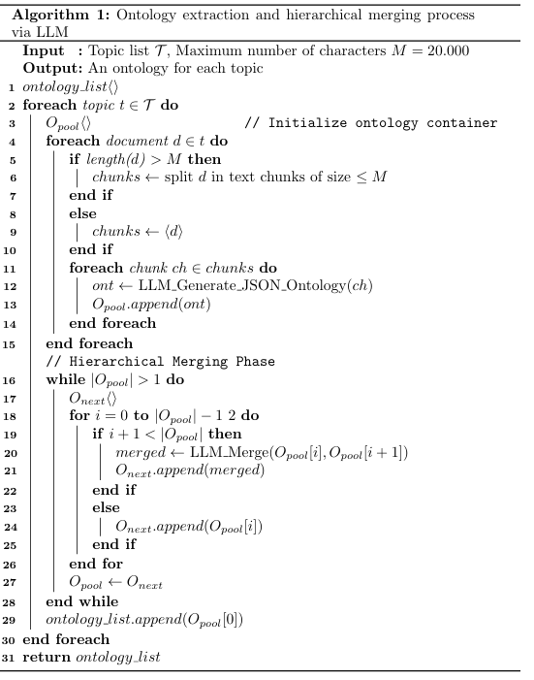
The algorithm processes documents by category, splitting those exceeding a character number threshold into smaller chunks. An LLM generates a JSON ontology for each chunk. These ontologies are then iteratively merged in a binary-tree style until a single, unified ontology is produced for each category.
Note: A sliding window approach is employed for document splitting, where each chunk overlaps with the previous one to prevent loss of context at the boundaries.

To ensure the generation of valid JSON ontologies, the GPT-5 mini model is prompted with a formal JSON schema, specific formatting constraints, and a one-shot example. Furthermore, if the generated JSON is invalid—either due to syntax errors (e.g., missing brackets) or schema violations (e.g., duplicate entities or missing identity attributes)—the LLM is prompted to regenerate the ontology, guided by a detailed description of the identified errors.
The next stage involves extracting data (entities and relations) based on the previously generated ontologies. We maintain the same chunk-based processing approach to ensure scalability. Using GPT-5 mini, the system enforces ontological consistency by validating the JSON output; any non-compliant results are sent back to the LLM for iterative correction.

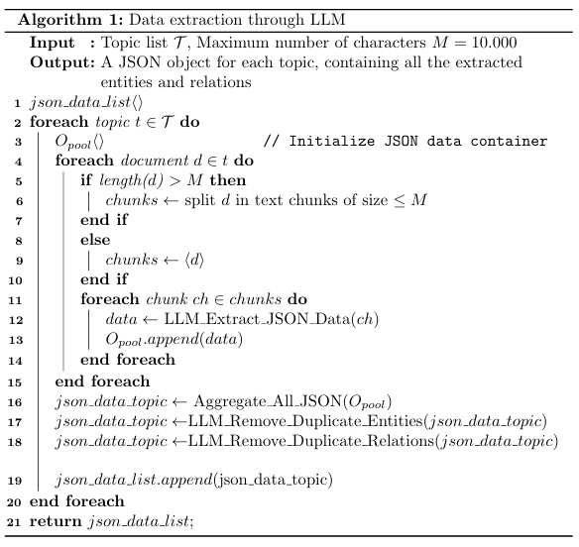
Once the LLM extracts data from each document/chunk for a specific topic, all entities and relations are merged into a single JSON object. Subsequently, any duplicate entities and relations are identified, and the LLM is prompted to merge them.
Note: Entities are considered duplicates if they share the same label and the same key attribute value. Relations are considered duplicates if they share the same label and connect the same source and target entities.

Entity resolution
We represent each entity and relation as text using their labels and attributes. For entities, we also incorporate all their 1-hop relations. Finally, these text descriptions are converted into embeddings using the text-embedding-3-small model.

Inference
- Download the latest Libertinus zip file here.
- Extract the files to a temporary directory, e.g. C:\\users\<username>\Downloads\Libertinus-7
- Open the Windows 10 “Settings” from the Start menu and switch to the Personalization / Fonts it should display the currently installed fonts, each as a directory.
- Navigate to the directory C:\\users\<username\Downloads\Libertinus-7\Downloads\Libertinus-7\static\OTF
- Select all files with extension .otf and drag and drop them to the field “Drag and drop to install” of the selected settings menu.
- Close the windows; the fonts should now be installed.
For more detailed instructions, see this guide.

Other information useful to replicate the approach
- Download the latest Libertinus zip file here.
- Extract the files to a temporary directory, e.g. ~/Downloads/Libertinus-7
- Open the Font Book app.
- Navigate to the directory e.g. ~/Downloads/Libertinus-7/static/OTF
- Drag and drop all .otf files to the Font Book window.
- The fonts should now be installed.
For more detailed instthis guide.

Evaluation

Subsetction 1
For each proceedings volume published with CEUR-WS, the titles of its papers should either all use the emphasizing capitalized style or the regular English (or native language) style. Check with the editors of your volume which style you should adopt.

Do not insert line breaks in your title.

Subsection 2…
Each author must be defined separately for accurate metadata identification. Multiple authors may share one affiliation. Authors’ names should not be abbreviated; use full first names wherever possible. Include authors’ e-mail addresses whenever possible.
Author names can have some kinds of marks and notes:
- affiliation mark: a superscript number following the author’s last name.
The author names and affiliations could be formatted in two ways:
- Group the authors per affiliation.
- Use an explicit mark to indicate the affiliations.

…
Keywords should be separated by commas.

Conclusion and limitations
You should use the pre-defined styles for sections (Heading 1), subsections (Heading 2), and subsubsections (Heading 3).
There should be no empty lines before section headings. The template already adds the necessary spacing before them.

References
- Agrawal, G., Kumarage, T., Alghamdi, Z., & Liu, H. (2024). Can Knowledge Graphs Reduce Hallucinations in LLMs?: A Survey. arXiv preprint arXiv:2404.14446.
- Edge, D., Trinh, H., Cheng, N., Bradley, J., Chao, A., Mody, A., Truitt, S., Metropolitansky, D., Ness, R. O., & Larson, J. (2024). From Local to Global: A Graph RAG Approach to Query-Focused Summarization. arXiv preprint arXiv:2404.16130.
- Mo, B., Yu, K., Kazdan, J., Cabezas, J., Mpala, P., Yu, L., Cundy, C., Kanatsoulis, C., & Koyejo, S. (2024). KGGen: Extracting Knowledge Graphs from Plain Text with Language Models. arXiv preprint arXiv:2410.12154.

- H. Bian, "LLM-Empowered Knowledge Graph Construction: A Survey," Xidian University, Xi’an, China, Tech. Rep., 2024.

- J. Cohen (Ed.), Special issue: Digital Libraries, volume 39, 1996.
- D. Kosiur, Understanding Policy-Based Networking, 2nd. ed., Wiley, New York, NY, 2001.
- D. Harel, First-Order Dynamic Logic, volume 68 of Lecture Notes in Computer Science, Springer-Verlag, New York, NY, 1979. doi:10.1007/3-540-09237-4.
- I. Editor (Ed.), The title of book one, volume 9 of The name of the series one, 1st. ed., University of Chicago Press, Chicago, 2007. doi:10.1007 3-540-09237-4.
- I. Editor (Ed.), The title of book two, The name of the series two, 2nd. ed., University of Chicago Press, Chicago, 2008. doi:10.1007/3-540-09237-4.
- A. Z. Spector, Achieving application requirements, in: S. Mullender (Ed.), Distributed Systems, 2nd. ed., ACM Press, New York, NY, 1990, pp. 19–33. doi:10.1145/90417. 90738.
- B. P. Douglass, D. Harel, M. B. Trakhtenbrot, Statecarts in use: structured analysis and object-orientation, in: G. Rozenberg, F. W. Vaandrager (Eds.), Lectures on Embedded Systems, volume 1494 of Lecture Notes in Computer Science, Springer-Verlag, London, 1998, pp. 368–394. doi:10.1007/3-540-65193-4_29.
- D. E. Knuth, The Art of Computer Programming, Vol. 1: Fundamental Algorithms (3rd. ed.), Addison Wesley Longman Publishing Co., Inc., 1997.
- S. Andler, Predicate path expressions, in: Proceedings of the 6th. ACM SIGACT-SIGPLAN symposium on Principles of Programming Languages, POPL ’79, ACM Press, New York, NY, 1979, pp. 226–236. doi:10.1145/567752.567774.
- S. W. Smith, An experiment in bibliographic mark-up: Parsing metadata for xml export, in: R. N. Smythe, A. Noble (Eds.), Proceedings of the 3rd. annual workshop on Librarians and Computers, volume 3 of LAC ’10, Paparazzi Press, Milan Italy, 2010, pp. 422–431. doi:99.9999/woot07-S422.
- M. V. Gundy, D. Balzarotti, G. Vigna, Catch me, if you can: Evading network signatures with web-based polymorphic worms, in: Proceedings of the first USENIX workshop on Offensive Technologies, WOOT ’07, USENIX Association, Berkley, CA, 2007.
- D. Harel, LOGICS of Programs: AXIOMATICS and DESCRIPTIVE POWER, MIT Research Lab Technical Report TR-200, Massachusetts Institute of Technology, Cambridge, MA, 1978.
- K. L. Clarkson, Algorithms for Closest-Point Problems (Computational Geometry), Ph.D. thesis, Stanford University, Palo Alto, CA, 1985. UMI Order Number: AAT 8506171.
- D. A. Anisi, Optimal Motion Control of a Ground Vehicle, Master’s thesis, Royal Institute of Technology (KTH), Stockholm, Sweden, 2003.
- H. Thornburg, Introduction to bayesian statistics, 2001. URL: http://ccrma.stanford.edu/jos/bayes/bayes.html.
- R. Ablamowicz, B. Fauser, Clifford: a maple 11 package for clifford algebra computations, version 11, 2007. URL: http://math.tntech.edu/rafal/cli11/index.html.
- Poker-Edge.Com, Stats and analysis, 2006. URL: http://www.pkredge.com/statsYYFWWQ.php.
- B. Obama, A more perfect union, Video, 2008. URL: http://video.google.com/videoplay? docid=6528042696351994555.
- D. Novak, Solder man, in: ACM SIGGRAPH 2003 Video Review on Animation theater Program: Part I - Vol. 145 (July 27–27, 2003), ACM Press, New York, NY, 2003, p. 4. URL: http://video.google.com/videoplay?docid=6528042696351994555. doi:99.9999/woot07-S422.
- N. Lee, Interview with bill kinder: January 13, 2005, Comput. Entertain. 3 (2005). doi:10.1145/1057270.1057278.
- J. Scientist, The fountain of youth, 2009. Patent No. 12345, Filed July 1st., 2008, Issued Aug. 9th., 2009.
- B. Rous, The enabling of digital libraries, Digital Libraries 12 (2008). To appear.
- M. Saeedi, M. S. Zamani, M. Sedighi, A library-based synthesis methodology for reversible logic, Microelectron. J. 41 (2010) 185–194.
- M. Saeedi, M. S. Zamani, M. Sedighi, Z. Sasanian, Synthesis of reversible circuit using cycle-based approach, J. Emerg. Technol. Comput. Syst. 6 (2010).
- M. Kirschmer, J. Voight, Algorithmic enumeration of ideal classes for quaternion orders, SIAM J. Comput. 39 (2010) 1714–1747. URL: http://dx.doi.org/10.1137/080734467. doi:10.1137/080734467.
- L. Hörmander, The analysis of linear partial differential operators. IV, volume 275 of Grundlehren der Mathematischen Wissenschaften [Fundamental Principles of Mathematical Sciences], Springer-Verlag, Berlin, Germany, 1985. Fourier integral operators.
- L. Hörmander, The analysis of linear partial differential operators. III, volume 275 of Grundlehren der Mathematischen Wissenschaften [Fundamental Principles of Mathematical Sciences], Springer-Verlag, Berlin, Germany, 1985. Pseudodierential operators.
- IEEE, Ieee tcsc executive committee, in: Proceedings of the IEEE International Conference on Web Services, ICWS ’04, IEEE Computer Society, Washington, DC, USA, 2004, pp. 21–22. doi:10.1109/ICWS.2004.64.
- TUG, Institutional members of the TEX users group, 2017. URL: http://www.tug.org/instmem.html .
- R Core Team, R: A language and environment for statistical computing, 2019. URL: https://www.R-project.org.
- S. Anzaroot, A. McCallum, UMass citation field extraction dataset, 2013. URL: http://www.iesl.cs.umass.edu/data/data-umasscitationfield.

EmPULIA is the official regional purchasing center and e-procurement platform for the Puglia Region in Italy, managed by InnovaPuglia S.p.A.
© 2023 Copyright for this paper by its authors. Use permitted under Creative Commons License Attribution 4.0 International (CC BY 4.0).
Entity resolution is the data management process of identifying, linking, and merging disparate records that represent the same real-world entity—such as a person, organization, or product—across different data sources.

