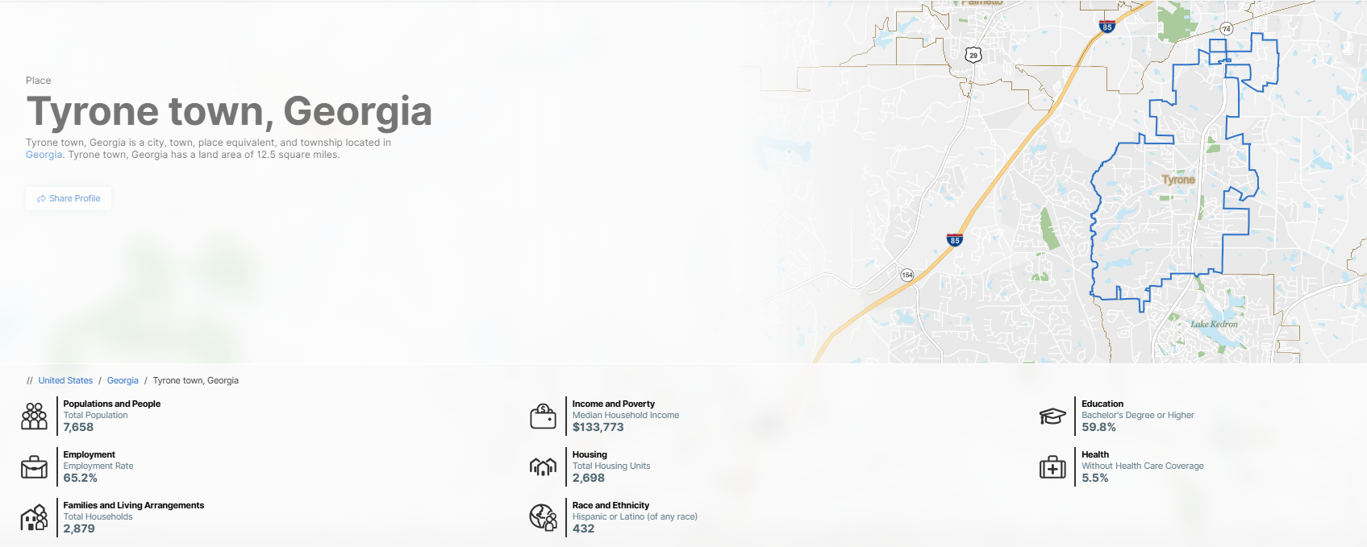

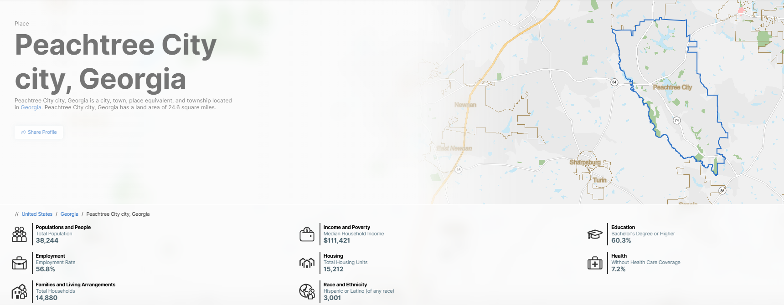
Support for Candices Postop Care

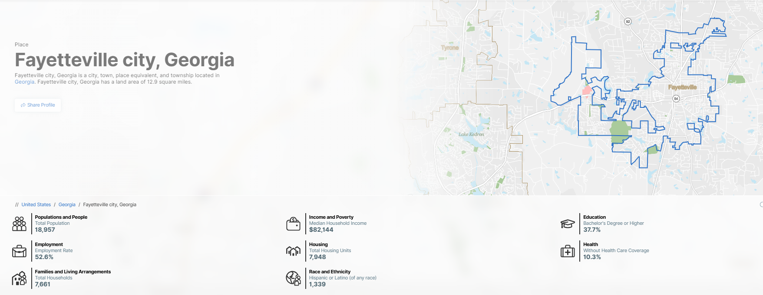
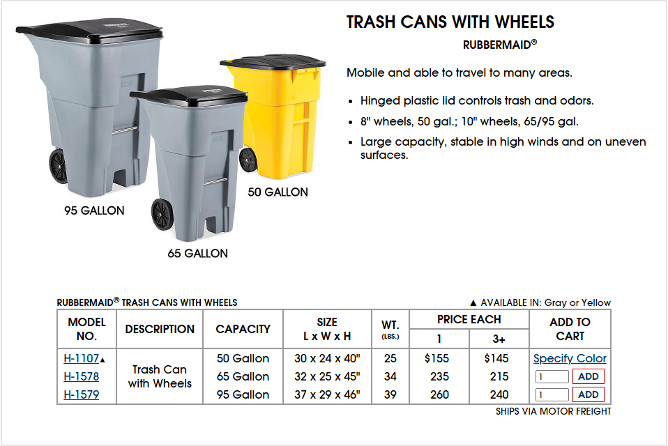
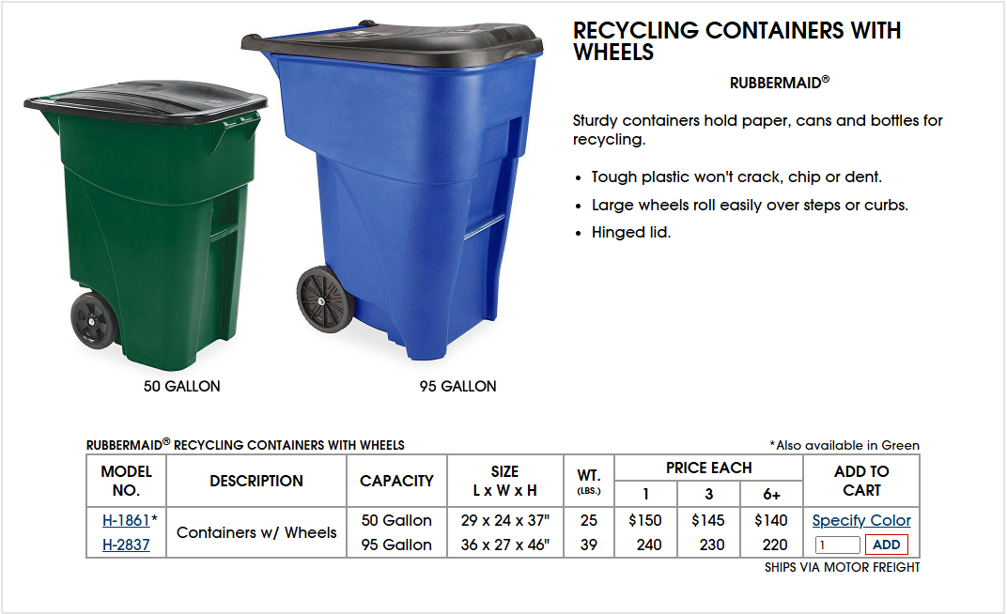

Dear Curbell Plastics Team,
I am looking to create a custom 95-gallon transparent wheeled trash can for a specific project and would like to explore your capabilities in fabricating this product. Below are the specifications for the trash can:
1. Dimensions:
- Capacity: 95 gallons (~360 liters).
- Height: ~45 inches.
- Width: ~27 inches.
- Depth: ~34 inches.
- Wall Thickness: ~0.1–0.25 inches.
2. Design Features:
- Hinged or detachable lid (same material or opaque UV-stabilized plastic).
- Heavy-duty rubber/plastic wheels (~8–10 inches in diameter).
- Molded handles for tilting/maneuvering.
- Optional drainage holes.
3. Additional Notes:
- The can should have a smooth, polished finish for easy cleaning and visibility.
- I am interested in the possibility of branding (e.g., logo placement) and would like to understand your customization options.
Please let me know if you can assist with this project. I am interested in receiving an initial prototype and discussing bulk production if the prototype meets our requirements.
Looking forward to your response.
Best regards,
Jacob Bevier
Brag & Bev L.L.C.
Email: bevier19jac@icloud.com
Phone: 760 490-3416

