Self-Righting Automatic Dumpster Cleaning Device
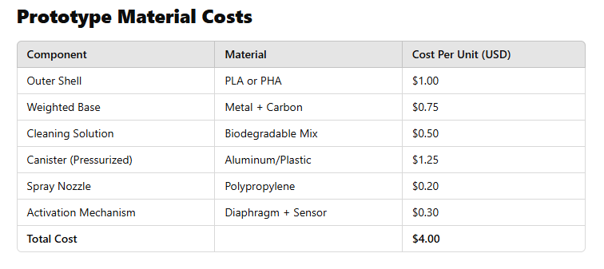
  - Biodegradable foam adheres to walls, 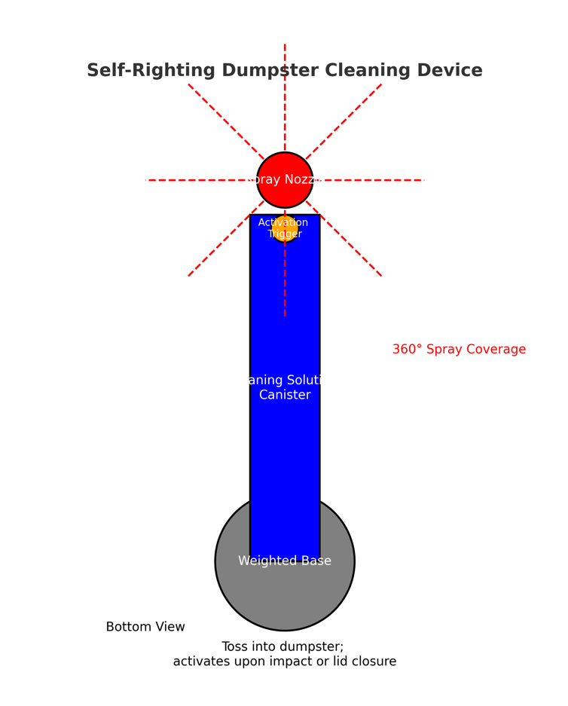

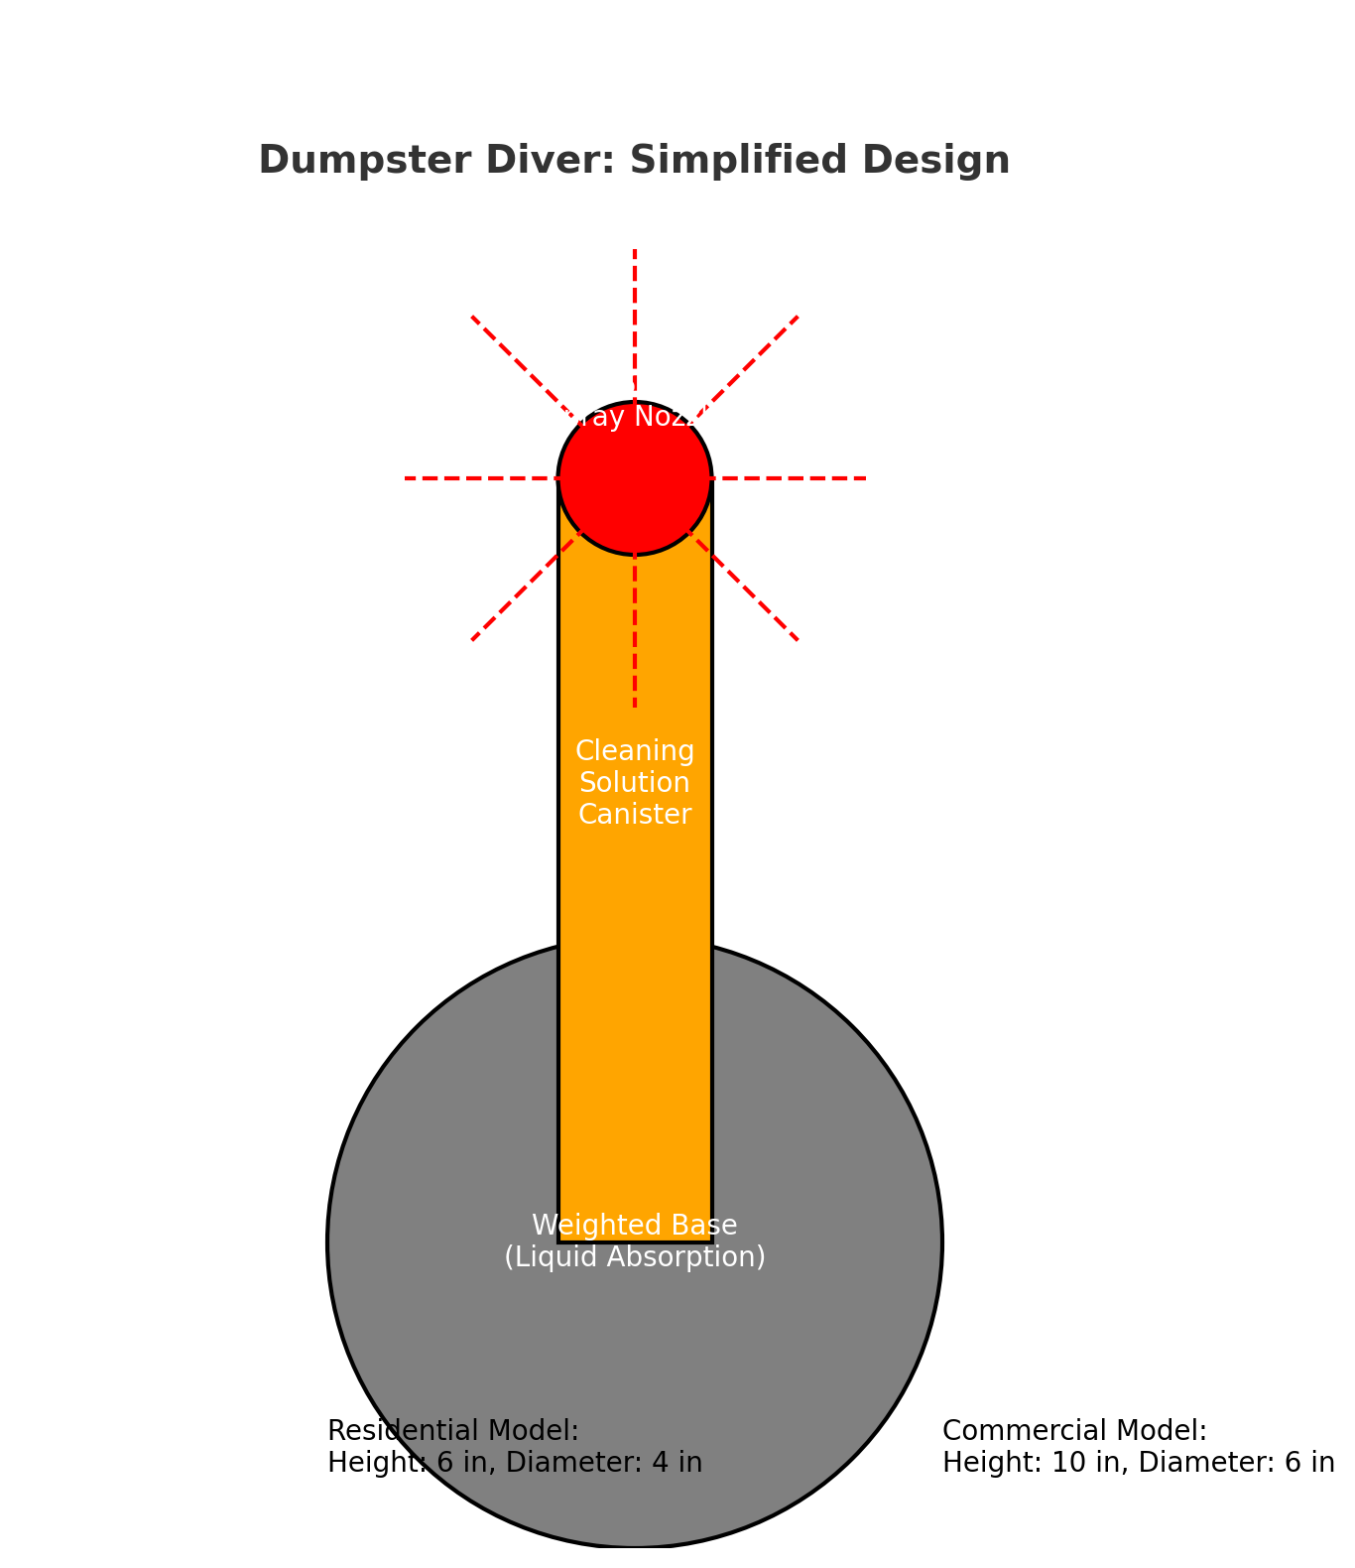 Production Process
1. Materials
Base Components
- Outer Shell:

