Splash/Streak-be-Gone Toilet Liner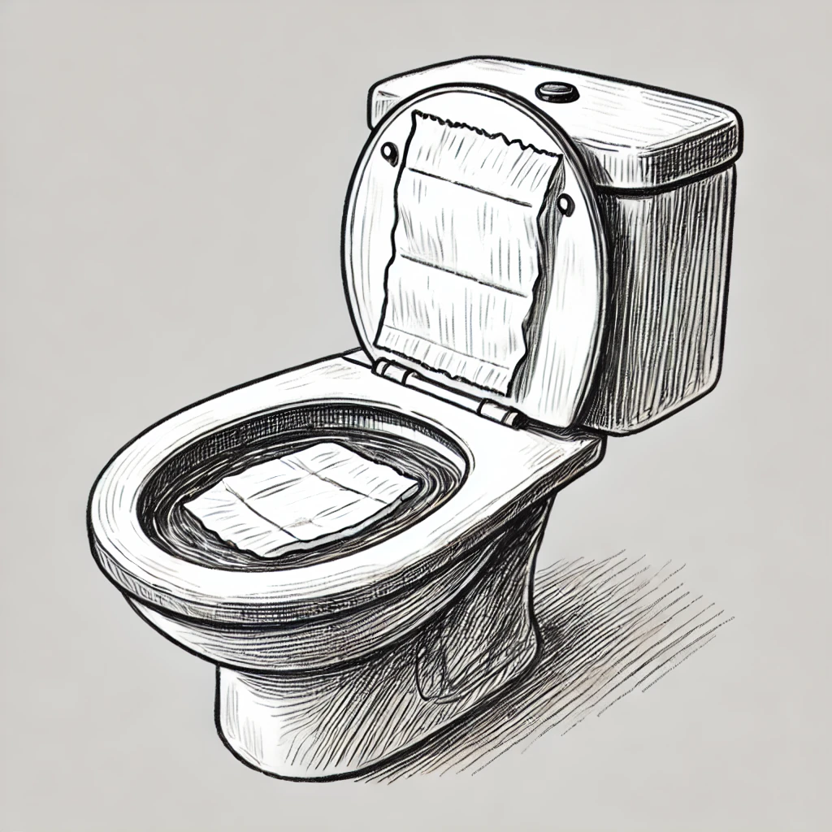
1. Executive Summary
- Product Name: Splash/Streak-Be-Gone Toilet Liner
- Product Description: A flushable, pre-formed liner designed to float on top of the water in a toilet bowl, cradling waste to prevent both streaks inside the bowl and the dreaded splashback (splash onto the user). The liner dissolves upon flushing, leaving no residue.
- Mission Statement: To provide an eco-friendly, convenient, and effective solution for maintaining a cleaner toilet and a more hygienic experience, preventing streaks and splashback without chemicals or extensive cleaning efforts.

2. Market Research
- Target Market:
  - Homeowners & Renters: Individuals looking for an easy and eco-friendly solution to prevent streaks and splashback in the toilet bowl.
  - Businesses & Offices: Restaurants, retail locations, and office buildings where cleanliness and hygiene are essential.
  - Eco-Conscious Consumers: Those who prioritize environmentally friendly products and seek alternatives to harsh chemicals and cleaning agents.
  - Anyone looking to avoid splashback: This product addresses an often-overlooked issue with toilet hygiene: the discomfort of splashback.
- Current Competition:
  - Traditional Toilet Cleaners: Toilet cleaning tablets, sprays, and scrubbers used after each toilet use.
  - Flushable Toilet Wipes and Toilet Paper: These products help with cleaning but do not address streak or splashback prevention directly.
- Unique Selling Proposition (USP):
  - Splash/Streak-Be-Gone is the first flushable, biodegradable liner specifically designed to prevent both streaks inside the toilet bowl and the dreaded splashback that can occur when waste hits the water. It provides a simple, chemical-free solution to cleaner toilets and a more comfortable bathroom experience.

3. Product Development
- Material Options:
  - Biodegradable, flushable materials such as bamboo fiber, plant-based polymers, or other eco-friendly materials.
  - The material must be strong enough to cradle waste while floating on top of the water but dissolve quickly after flushing.
- Design Features:
  - Pre-formed design to fit the surface area of the toilet bowl and float on top of the water.
  - A user-friendly “drop-and-go” design for easy placement before use.
  - Dissolves quickly after flushing, leaving no residue behind.
- Splash & Streak Prevention:
  - The liner’s floating design cradles waste, preventing splashes from hitting the user and reducing streaks on the bowl’s interior. It absorbs some of the impact of waste hitting the water, ensuring that the user remains dry and comfortable.

4. Marketing Strategy
- Branding:
  - Logo & Tagline: "Splash/Streak-Be-Gone" with a logo conveying cleanliness, comfort, and eco-friendliness. Tagline could be “Flush Away the Mess, Keep the Clean (and the Comfort).”
  - Emphasize the dual benefits of splashback and streak prevention in all branding materials.
- Distribution Channels:
  - Retail Partnerships: Target large retailers like Walmart, Target, and Home Depot to stock the product in cleaning and personal care aisles.
  - Online Sales: Sell through e-commerce platforms like Amazon and your own website.
  - Subscription Service: Offer customers a subscription option to receive regular shipments of the product, ensuring constant availability.
- Advertising:
  - Social Media Campaigns: Focus on eco-conscious communities, cleaning enthusiasts, and people seeking a hassle-free toilet solution.
  - Influencer Marketing: Collaborate with home improvement or eco-friendly influencers to spread awareness.
  - In-store Promotions: Sampling campaigns at retailers to encourage trial and adoption.
- Public Relations: Promote the product’s eco-friendly benefits and splash/streak prevention features through media outlets focused on home care, sustainability, and new innovations in hygiene.

5. Manufacturing Plan
- Suppliers:
  - Source biodegradable, flushable materials from trusted suppliers with a focus on sustainability and product performance.
  - Partner with manufacturers experienced in producing disposable, biodegradable products.
- Production Costs:
  - Estimate production costs based on raw material sourcing, manufacturing processes, and packaging.
  - Ensure that production is scalable for retail and online orders.
- Packaging:
  - Design eco-friendly packaging that is simple, informative, and aligns with the product's eco-conscious branding.
  - Ensure packaging is easy to store and use for consumers, while clearly indicating the dual benefits of streak and splashback prevention.

6. Financial Projections
- Startup Costs:
  - Product prototyping and initial testing.
  - Patent filing and legal fees.
  - Initial marketing and branding budget (advertising, influencer partnerships).
  - Manufacturing setup (material sourcing, initial production runs).
- Revenue Streams:
  - Direct Sales: Through the website, subscription service, and online platforms.
  - Wholesale: Retail sales to stores, both national and local.
- Pricing Strategy:
  - Price competitively with other toilet cleaning and hygiene products while highlighting the added value of splashback and streak prevention.
  - Offer discounts for bulk purchases or subscription services.
- Projected Revenue:
  - Year 1: Initial launch, moderate growth through online channels and early retail distribution.
  - Year 2 and Beyond: Expand reach through major retailers, increased brand awareness, and consistent subscription service growth.

7. Funding Requirements
- Initial Investment Needed:
  - Estimate initial funding needs to cover prototyping, patenting, initial manufacturing, marketing, and website development.
  - Consider seeking $150,000 - $200,000 in startup funds for the first year to cover these expenses.
- Funding Sources:
  - Personal savings, crowdfunding (Kickstarter or Indiegogo), or seeking investment from angel investors or venture capitalists interested in eco-friendly products.

8. Exit Strategy
- Acquisition Potential:
  - Large home goods companies or toilet product manufacturers could acquire the product if it becomes successful in the market.
  - Potential for licensing the patent to larger cleaning product companies, generating passive income from royalties.
- Licensing Opportunities:
  - License the product to major national brands looking to add a unique and eco-friendly product to their portfolio, creating ongoing revenue streams.

