|  |  |
| --- | --- |
| Ex No: 02 | **BASIC SQL COMMANDS** |
| Date | 01.08.2023 |

**Aim:**

To execute all the basic SQL commands such as select, insert, update and delete.

# Description:

## The basics SQL commands are

## Select Statement: To select the data from a table.

## Syntax: select column_1, column_2 from table_name;

## Insert Statement: To insert the values into a particular table.

## Syntax: insert into table_name values (value1, value2);

## Update Statement: To Update the records or values in the table.

## Syntax: update tablename set columnname = value where condition;

## Delete Statement: To delete an entire row and to delete a particular value in the table.

## Syntax: delete from tablename;

## Syntax: delete from tablename where condition;

## Create Statement: To create a table with specified columns with specified datatypes.

## Syntax: create table table_name(column_1, column_2, column_3);

## Drop Statement: To delete a entire table with the existing data.

## Syntax: drop table table_name;

## Alter Statement: To alter a table like adding, modifying and droping the column.

## Syntax: alter table table_name add column_5;

**Basic SQL Commands Questions:**

**User Table:**

|  |  |  |  |  |
| --- | --- | --- | --- | --- |
| **UserID** | **Name** | **Email** | **Password** | **Phone** |
| 1 | John Smith | john.smith@example.com | password1 | 12345678901 |
| 2 | Jane Doe | jane.doe@example.com | p@ssw0rd | 98765432101 |
| 3 | Michael Lee | michael.lee@example.com | 12345678 | 44332211000 |
| 4 | Sarah Adams | sarah.adams@example.com | sAdams123 | 11223344556 |
| 5 | David Wang | david.wang@example.com | dWang2023 | 65432109876 |
| 6 | Emily Chen | emily.chen@example.com | chen123 | 91827364560 |
| 7 | Alex Kim | alex.kim@example.com | kimAlex22 | 55566677788 |
| 8 | Lisa Lopez | lisa.lopez@example.com | lisa123 | 99900011122 |

Event Table:

|  |  |  |  |  |  |
| --- | --- | --- | --- | --- | --- |
| **EventID** | **Name** | **Date** | **Time** | **VenueID** | **Description** |
| 1 | Concert in Park | 15-08-2023 | 18:00 | 101 | Enjoy a live concert in the city park. |
| 2 | Movie Night | 20-08-2023 | 20:30 | 102 | Movie night under the stars. |
| 3 | Sports Tournament | 05-09-2023 | 14:00 | 103 | Join us for an exciting sports tournament. |
| 4 | Art Exhibition | 10-09-2023 | 12:00 | 104 | Explore various artworks by local artists. |
| 5 | Food Festival | 25-09-2023 | 11:00 | 105 | A celebration of diverse cuisines. |
| 6 | Comedy Show | 01-10-2023 | 19:30 | 106 | Laugh your heart out at our comedy show. |
| 7 | Tech Conference | 15-10-2023 | 09:00 | 107 | Join tech experts for informative sessions. |
| 8 | Dance Workshop | 05-11-2023 | 16:00 | 108 | Learn various dance styles in this workshop. |

|  |  |  |  |  |  |
| --- | --- | --- | --- | --- | --- |
| **VenueID** | **Name** | **Address** | **City** | **State** | **Country** |
| 101 | City Park | 123 Park Street | New York | NY | USA |
| 102 | Open Field | 456 Meadow Lane | Los Angeles | CA | USA |
| 103 | Sports Arena | 789 Stadium Road | Chicago | IL | USA |
| 104 | Art Gallery | 101 Art Avenue | San Francisco | CA | USA |
| 105 | Event Center | 555 Celebration Boulevard | Miami | FL | USA |
| 106 | Comedy Club | 777 Laughter Street | Houston | TX | USA |
| 107 | Convention Center | 999 Tech Avenue | Seattle | WA | USA |
| 108 | Dance Studio | 222 Rhythm Road | Boston | MA | USA |

Event table:

|  |  |  |  |  |  |
| --- | --- | --- | --- | --- | --- |
| **TicketID** | **EventID** | **UserID** | **SeatNumber** | **Price** | **Status** |
| 1 | 1 | 1 | A1 | 25 | Booked |
| 2 | 1 | 2 | B2 | 25 | Booked |
| 3 | 2 | 3 | C3 | 15 | Booked |
| 4 | 2 | 4 | D4 | 15 | Booked |
| 5 | 3 | 5 | A2 | 10 | Booked |
| 6 | 3 | 6 | B3 | 10 | Booked |
| 7 | 4 | 7 | C4 | 8.5 | Booked |
| 8 | 4 | 8 | D5 | 8.5 | Booked |

**Questions:**

1. Retrieve the details of users whose names contain "Smith."

Query: select * from user_1128 where Name like ‘%smith’;

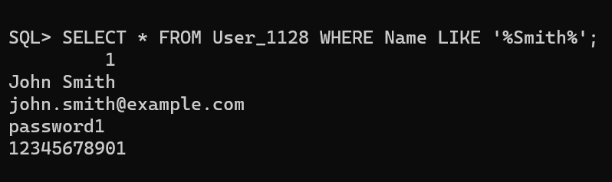

1. Display the details of users whose passwords are not equal to "password1."

Query: select * from user_1128 where Password !=’password1’;

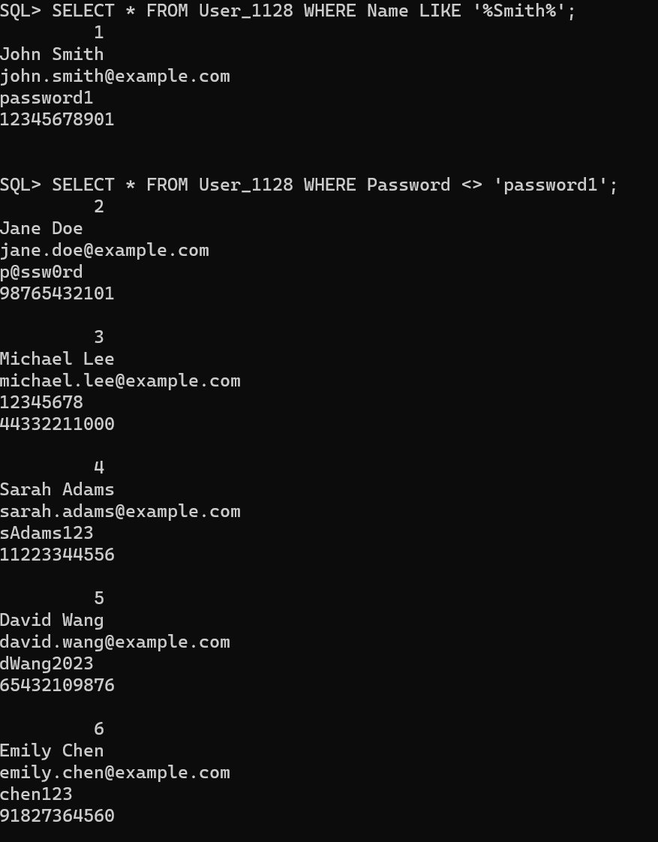

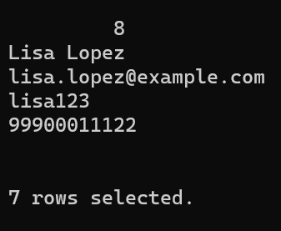

1. Display the details of users whose email addresses end with "@example.com" and have a phone number starting with "+9876."

Query: select * from user_1128 where email like ‘[%@example.com](mailto:%25@example.com)’ and phone like ‘9876%’;



1. Display the details of users whose UserID is either 2, 4, or 6.

Query: select * from user_1128 where user_ID in (2,4,6);

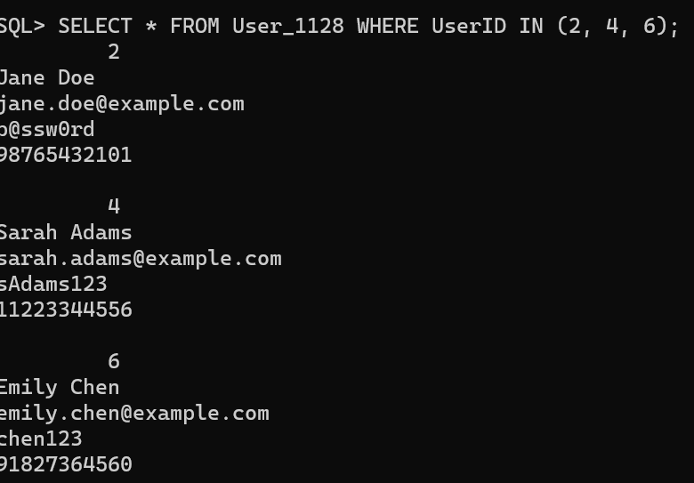

1. Retrieve the details of events that are scheduled to take place after September 15, 2023.

Query: select * from event_1128 where date_e > ’15-Sep-2023’;

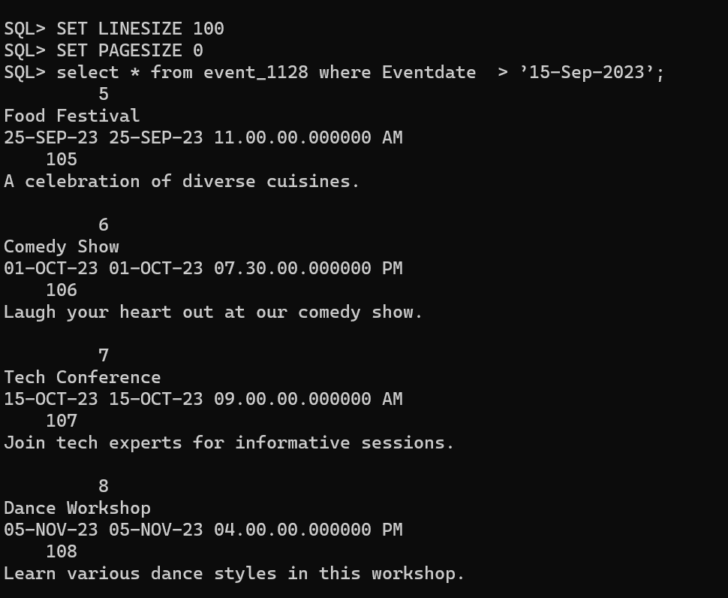

6. Retrieve the details of events that are scheduled to take place after September 10, 2023, and have a Venue ID greater than 105.

Query: select * from event_1128 where date_e > ’10-Sep-2023’ and venue_ID > 105;

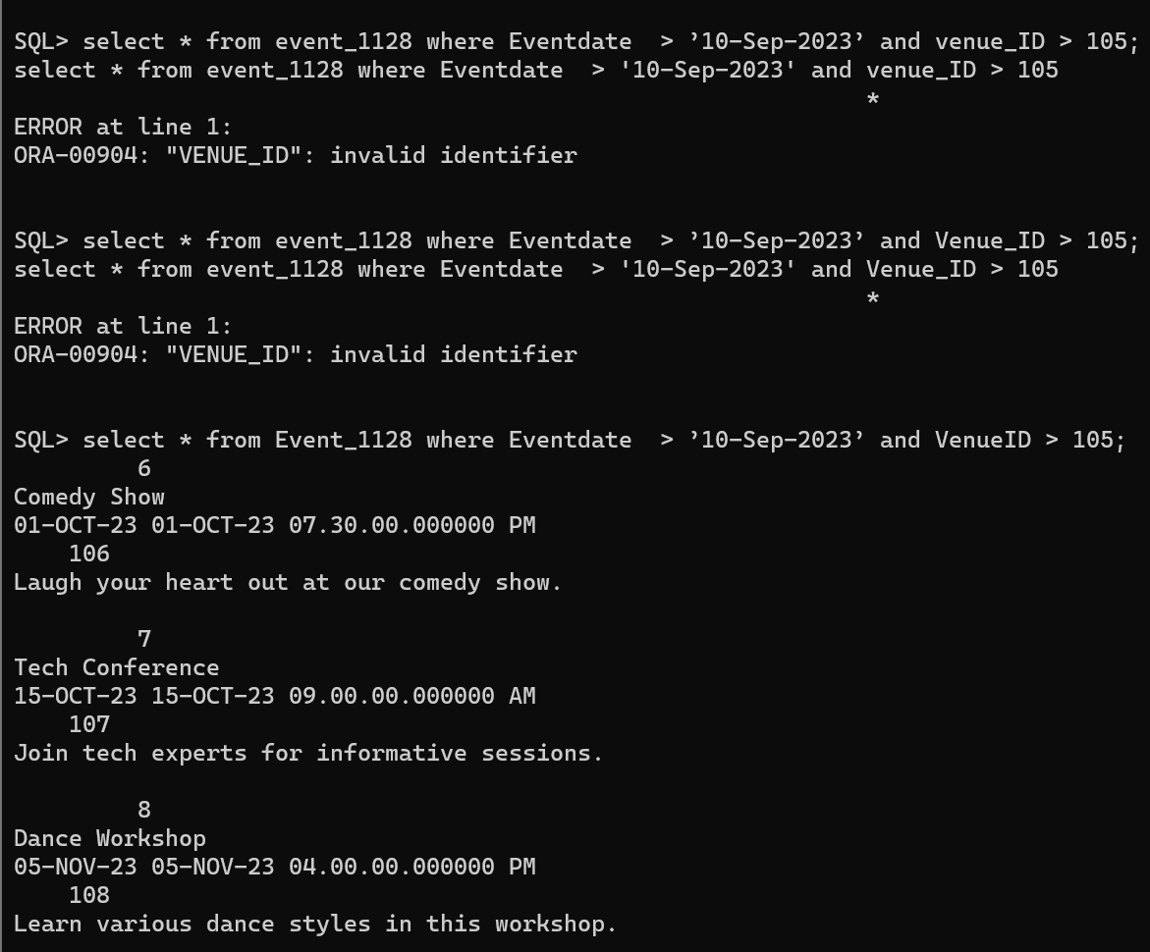

7. Retrieve the details of events that have a name containing "Concert" or "Show" in their name.

Query: select*from event_1128 where name like ‘%Concert%’ or name like ‘%Show%’;

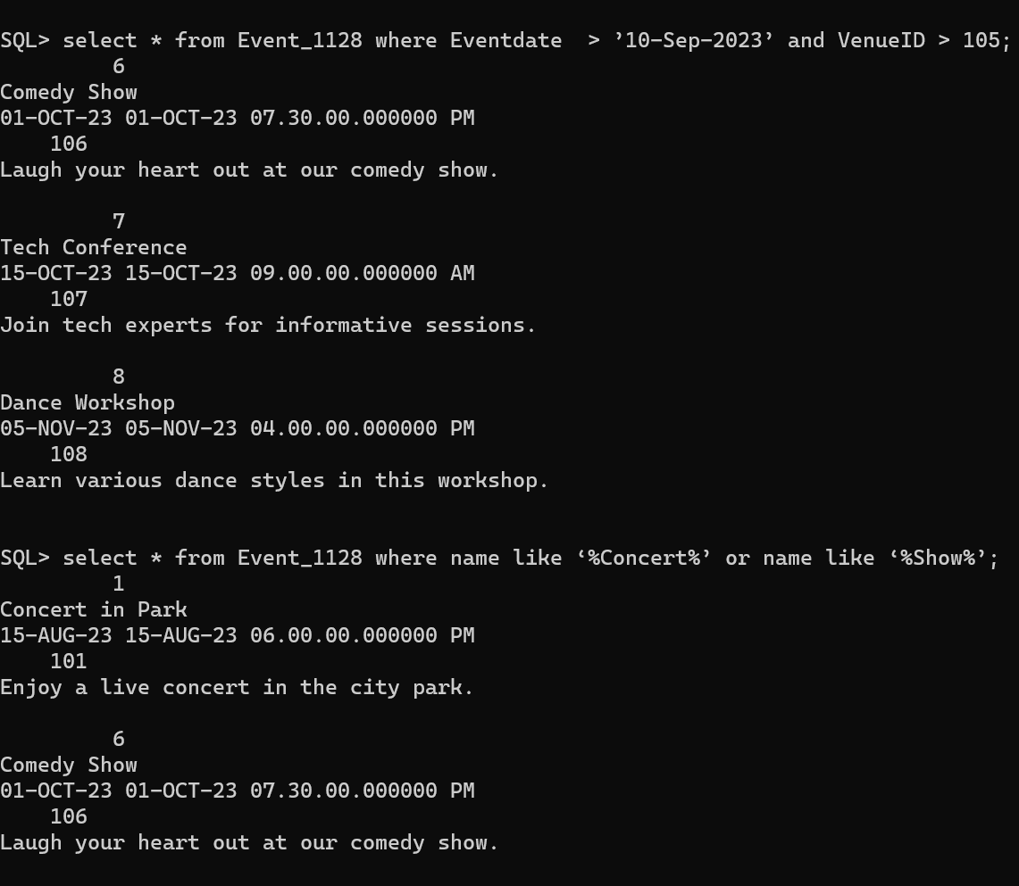

8. Increase the ticket prices for all booked tickets by 5 units.

Query: UPDATE Ticket_1128 SET Price = Price + 5 WHERE Status = 'Booked';

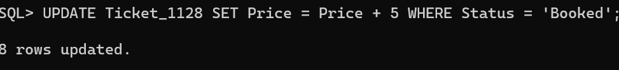

9. Reduce the ticket prices for EventID 2 by 10 units.

Query: UPDATE Ticket_1128 SET Price = Price - 10 WHERE EventID = 2;

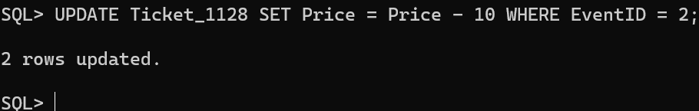

10. Double the ticket prices for tickets with a status of "Booked" and an EventID of 1.

Query: UPDATE Ticket_1128 SET Price = Price * 2 WHERE Status = 'Booked' AND EventID = 1;



11. Increase the ticket prices for tickets with a status of "Booked" and a price less than 20 by 5 units.

Query: UPDATE Ticket_1128 SET Price = Price + 5 WHERE Status = 'Booked' AND Price < 20;



12. Increase the VenueID for EventID 3 to 110.

Query: UPDATE Event_1128 SET VenueID = 110 WHERE EventID = 3;

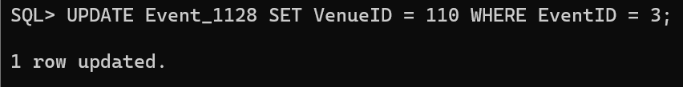

13. Retrieve the details of events that are scheduled to take place on or after 20-09-2023.

Query: SELECT * FROM Event_1128 WHERE Date >= TO_DATE('2023-09-20', 'YYYY-MM-DD');

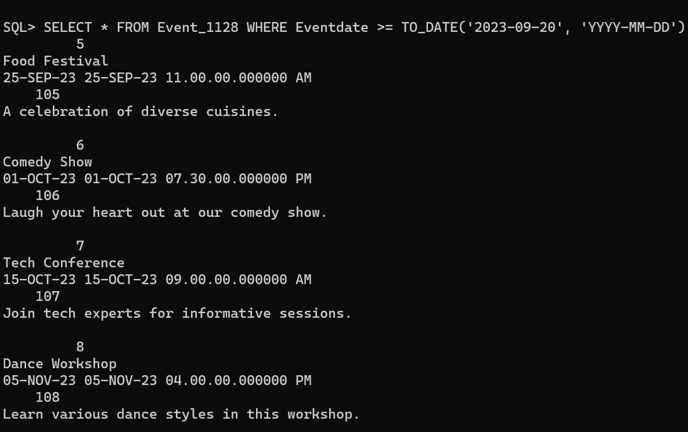

14. Delete the event with EventID 2.

Query: delete from event_1128 where event_ID = 2;

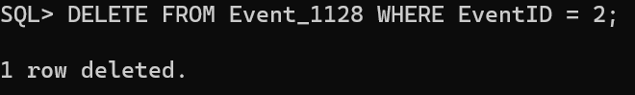

15. Display the details of events that have a description containing the word "workshop."

Query: SELECT * FROM Event_1128 WHERE Description LIKE '%workshop%';

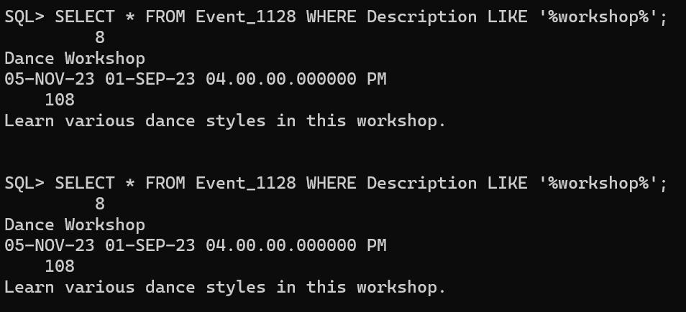

**Result:**

The basic sql commands are executed successfully and displayed using sql.