**20CS2016L - Database Management Systems Lab**

**URK21CS1128**

|  |  |
| --- | --- |
| **Ex.No: 09** | **Database Normalization** |
| **Date: 18.10.23** |

**Aim:**

To normalize the table for a given application.

**Descriptions:**

Database Normalization is a technique that helps in designing the schema of the database in an optimal manner. The normalization process is used to reduce the redundancy in a relation or set of relations. Anomalies in insertion, deletion, and update which can be caused by relation redundancy can be avoided by normalization. The process is incremental, and higher degrees of database normalization cannot be performed until the preceding levels are met.

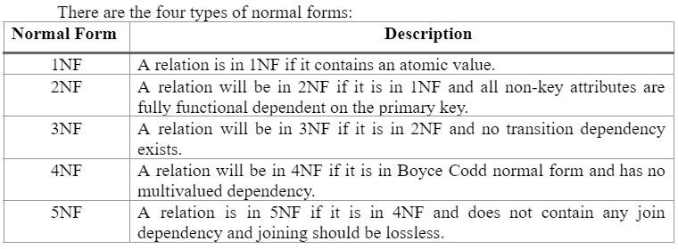

**20CS2016L - Database Management Systems Lab**

**URK21CS1128**

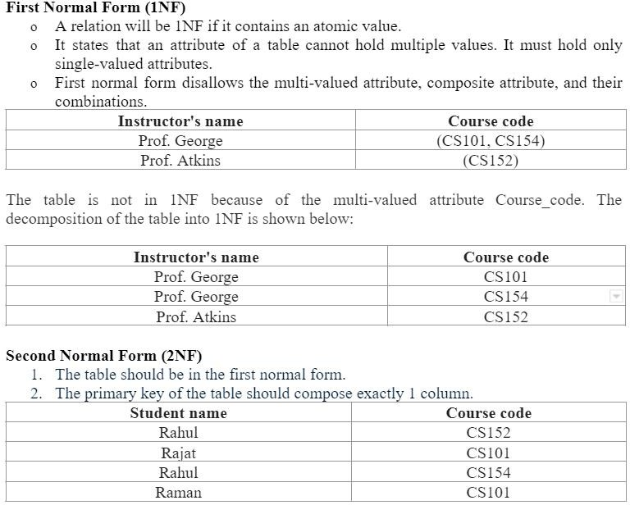

As per the second normal form definition, our enrollment table above isn’t in the second normal form. To achieve the same (1NF to 2NF), we can rather break it into 2 tables:

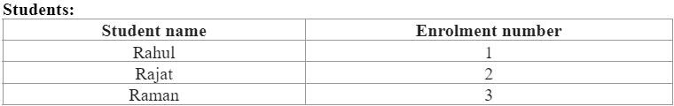

The second column is unique and it indicates the enrollment number for the student. Clearly, the enrollment number is unique. Now, we can attach each of these enrollment numbers with course codes.

**20CS2016L - Database Management Systems Lab**

**URK21CS1128**

**Third Normal Form:**

In the third normal form, the following conditions are required:

* The table should be in the second normal form.
* There should not be any functional dependency.

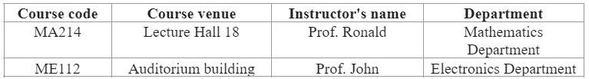

Third normal incorporates functional dependency by decomposing the table into 2 separate tables:

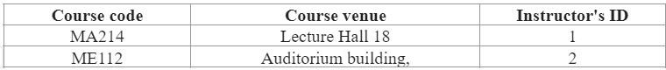

Here, the third column is the ID of the professor who’s taking the course.

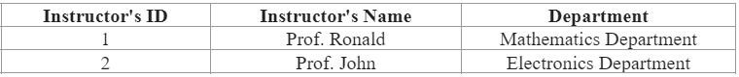

**Boyce-Codd Normal Form (BCNF):**

Boyce-Codd Normal form is a stronger generalization of third normal form. A table is in Boyce- Codd Normal form if and only if at least one of the following conditions are met for each functional dependency A → B:

* A is a superkey.
* It is a trivial functional dependency.

**Fourth normal form:**

A table is said to be in fourth normal form if there is no two or more, independent and multi valued data describing the relevant entity.

**Fifth normal form:**

A table is in fifth Normal Form if:

* It is in fourth normal form.
* It cannot be subdivided into any smaller tables without losing some form of information.

**20CS2016L - Database Management Systems Lab**

**URK21CS1128**

**Questions:**

1. **Normalize the following table to 1NF**

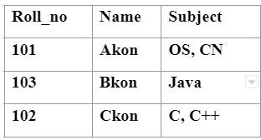

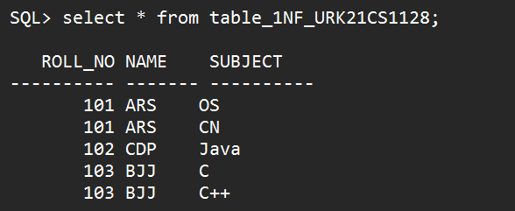

1. **Normalize the following ‘Student’ table to 1NF**

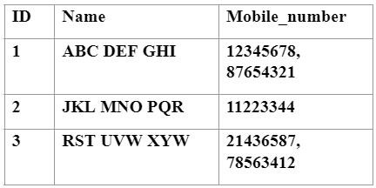

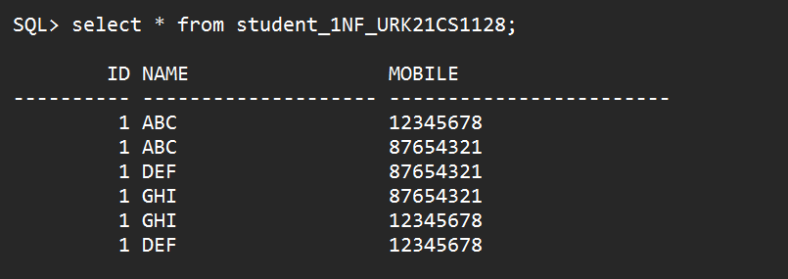

**20CS2016L - Database Management Systems Lab**

**URK21CS1128**

**3.Normalize the following table to 2NF**

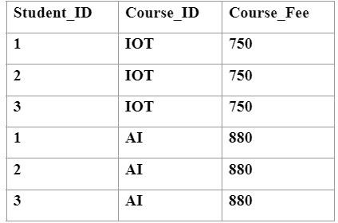

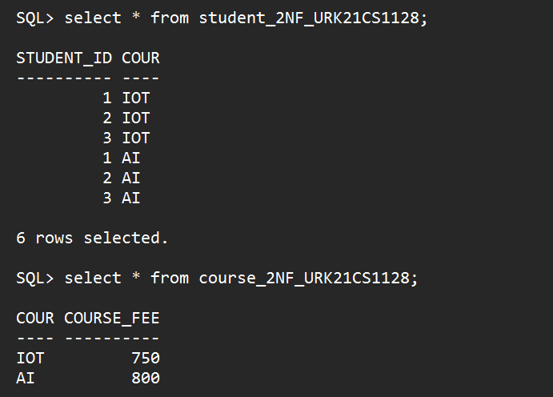

**4.Normalize the following table to 2NF**

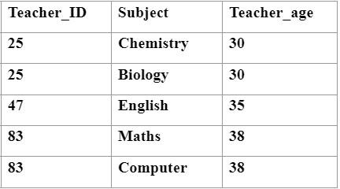

**20CS2016L - Database Management Systems Lab**

**URK21CS1128**

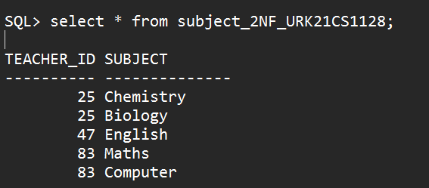

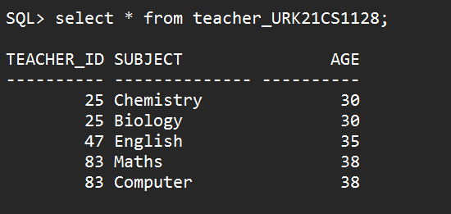

**5.Normalize the following table to 3NF**

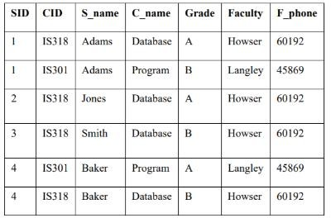

**20CS2016L - Database Management Systems Lab**

**URK21CS1128**

**20CS2016L - Database Management Systems Lab**

**URK21CS1128**

**20CS2016L - Database Management Systems Lab**

**URK21CS1128**

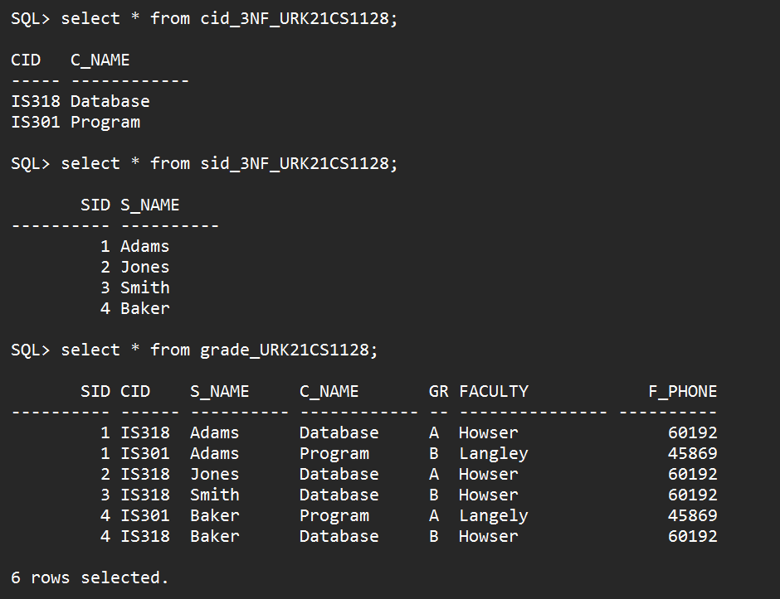

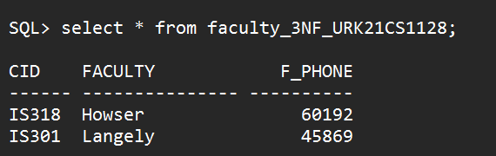

**20CS2016L - Database Management Systems Lab**

**URK21CS1128**

**6.Normalize the following table to 3NF**

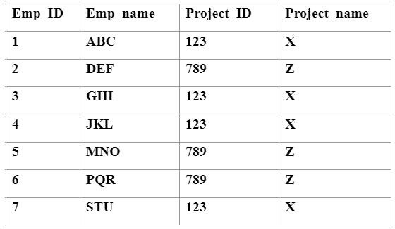

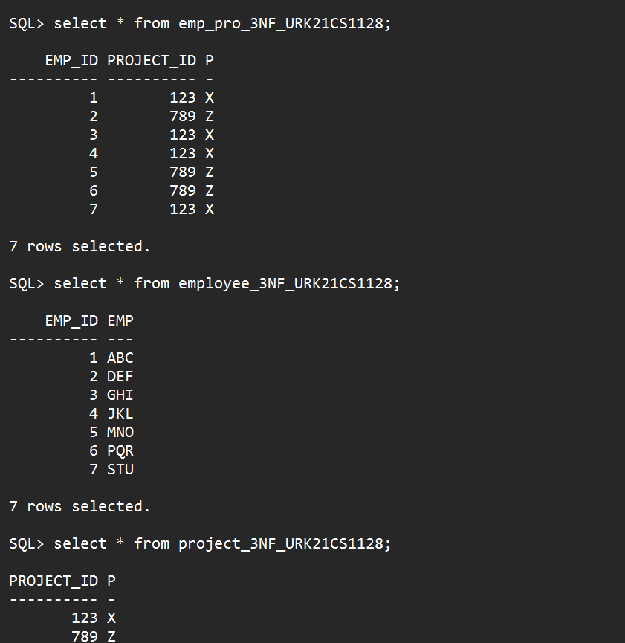

**20CS2016L - Database Management Systems Lab**

**URK21CS1128**

**7.Normalize the following table to BCNF**

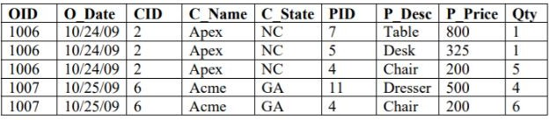

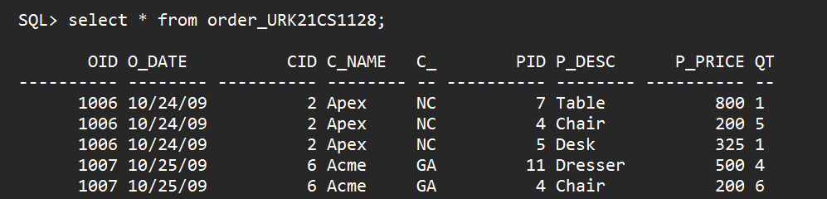

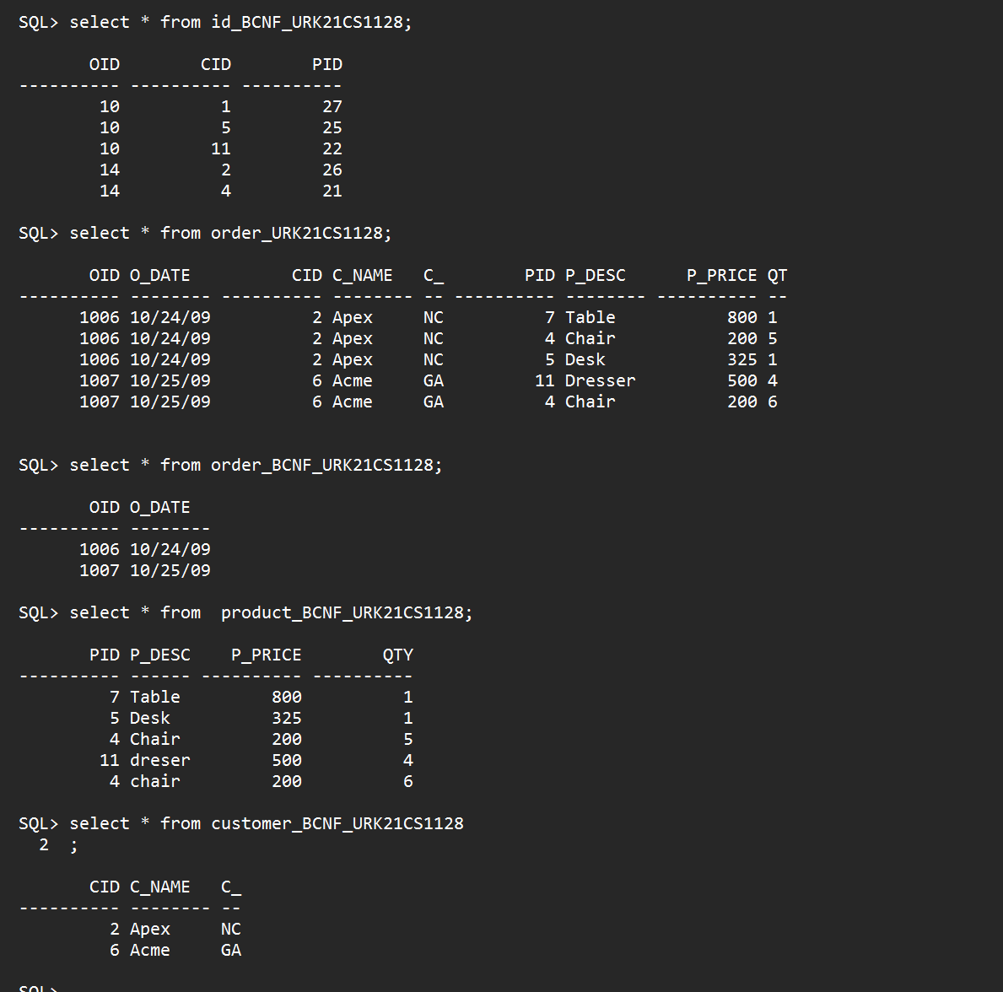

**20CS2016L - Database Management Systems Lab**

**URK21CS1128**

**8.Normalize the following table to BCNF**

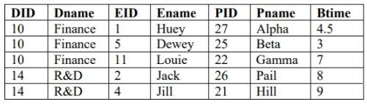

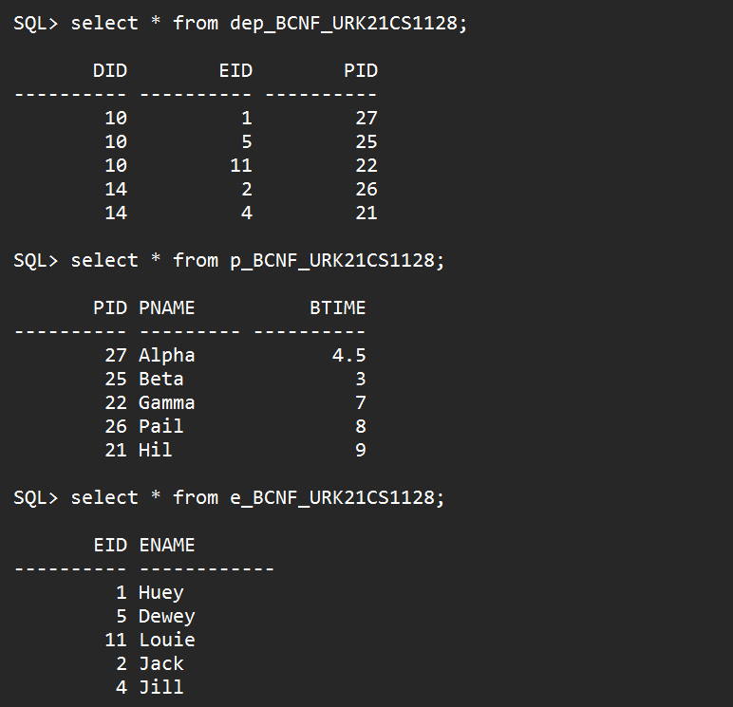

**20CS2016L - Database Management Systems Lab**

**URK21CS1128**

**20CS2016L - Database Management Systems Lab**

**URK21CS1128**

**9.Normalize the following table to 4NF**

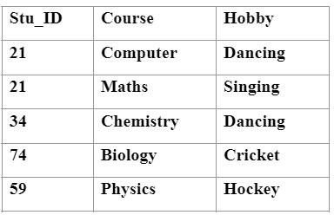

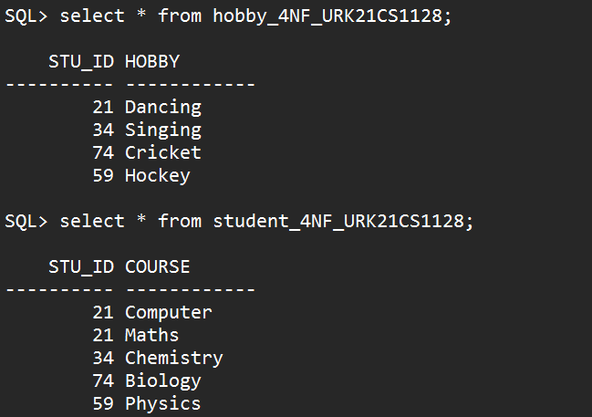

**20CS2016L - Database Management Systems Lab**

**URK21CS1128**

**10.Normalize the following table to 5NF**

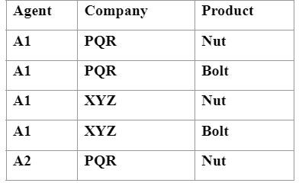

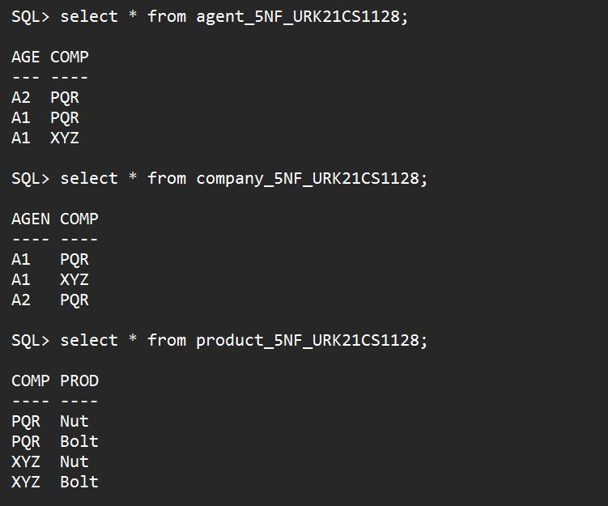

**Result:**

All the questions are executed using Database Normalization method successfully and each showed the valid output.