This document is a coursework report for the Web Applications Development (WAD) module by the student with ID 00011829 for Semester 1 at Westminster International University in Tashkent (WIUT).

GitHub repository link: https://github.com/BexTuychiev/wad_coursework_11829

Development plan:  
  
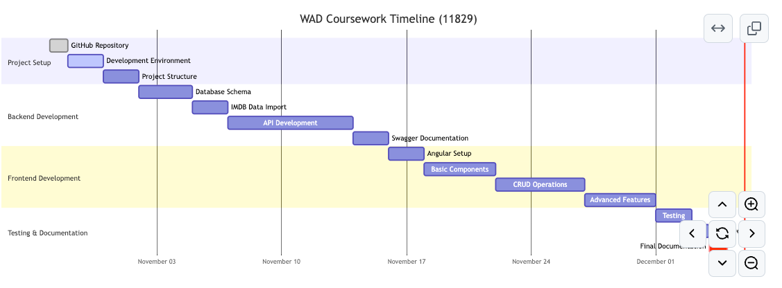

(Of course, I couldn’t follow the timeline, but I managed to create this chart at the start of November, and can be seen in the coursework’s GitHub repository).

# API (Backend) screenshots

Here is the screenshot of my Swagger UI after everything was set up successfully and no endpoints were run yet:

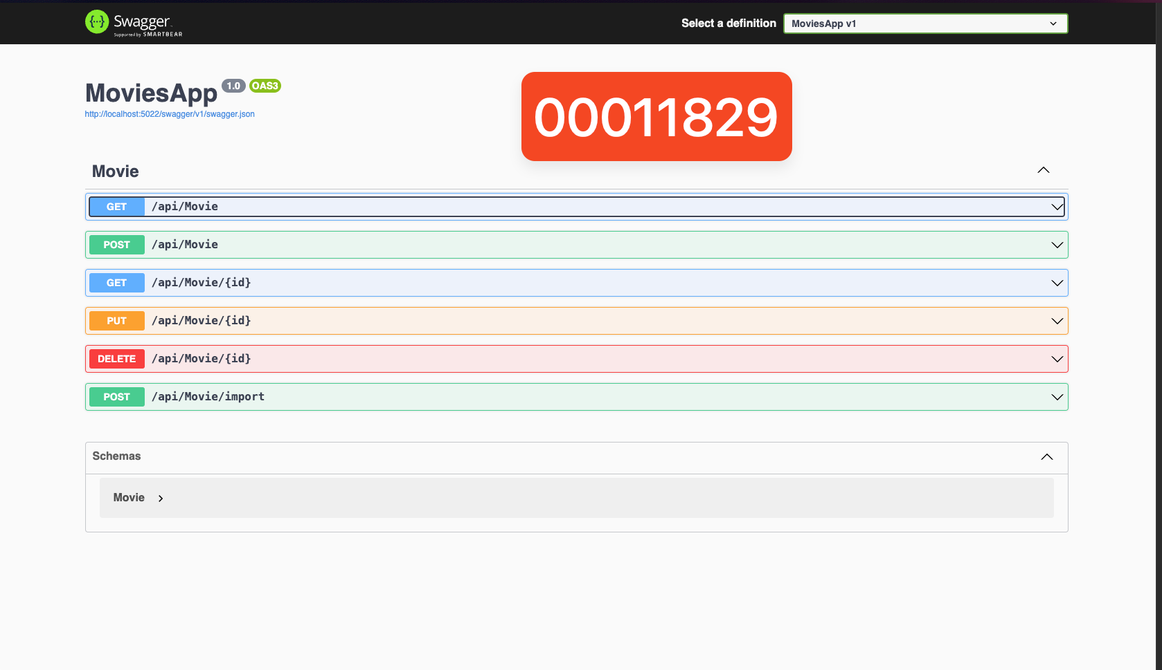

Since my app is a movies app, I decided to use [the IMDB top 1000 movies dataset from Kaggle](https://www.kaggle.com/datasets/harshitshankhdhar/imdb-dataset-of-top-1000-movies-and-tv-shows). It was in a CSV format, so I wrote a quick python script to convert it into a desirable JSON format (suitable for my application, see scripts/csv_to_json.py file). Then, I created the necessary components to enable the “Import” endpoint in the API. The below screenshot shows the swagger Ui state after I click on “Try it out” and then “Execute”:

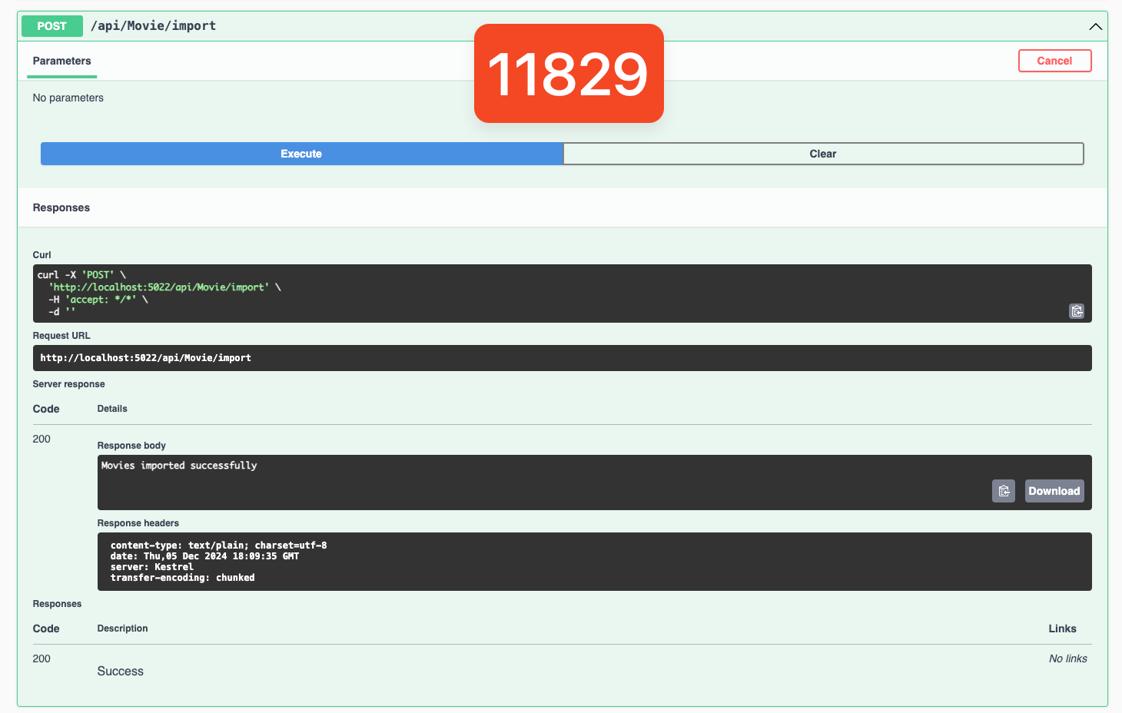

As you can see, I got a success message telling me the movies were imported. So, let’s check out one of the movies (this is the GET endpoint before running it):

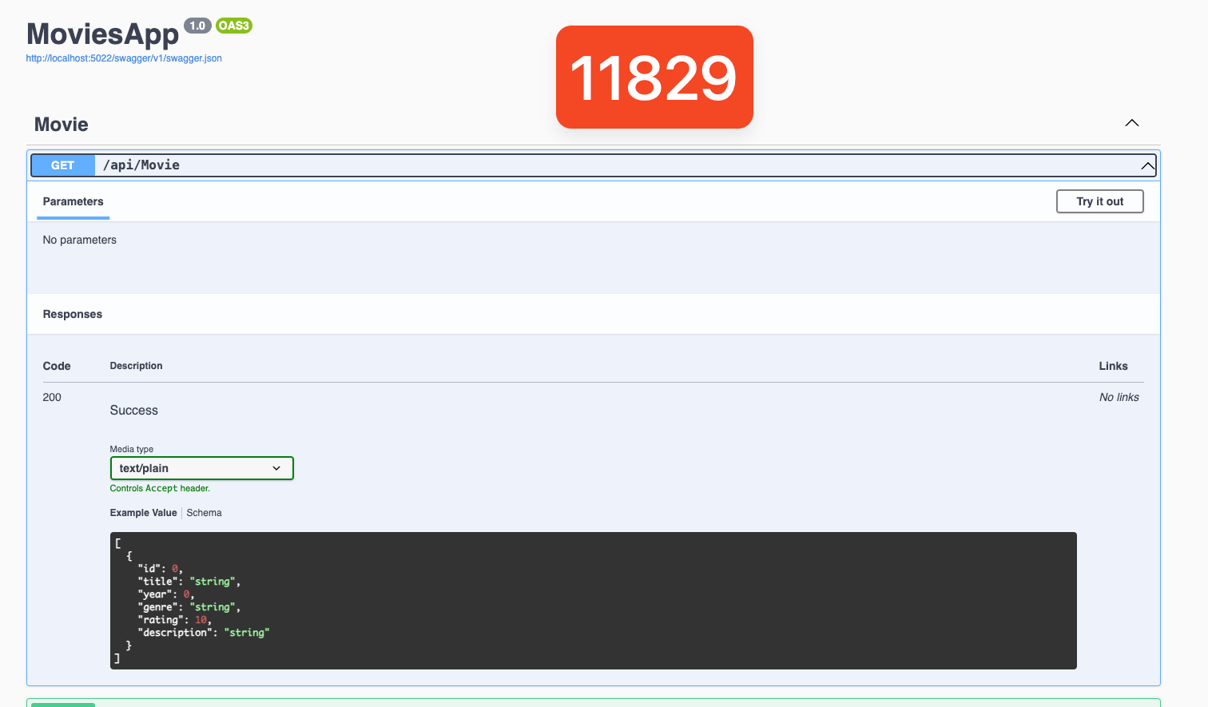

Here is the same endpoint after running it:

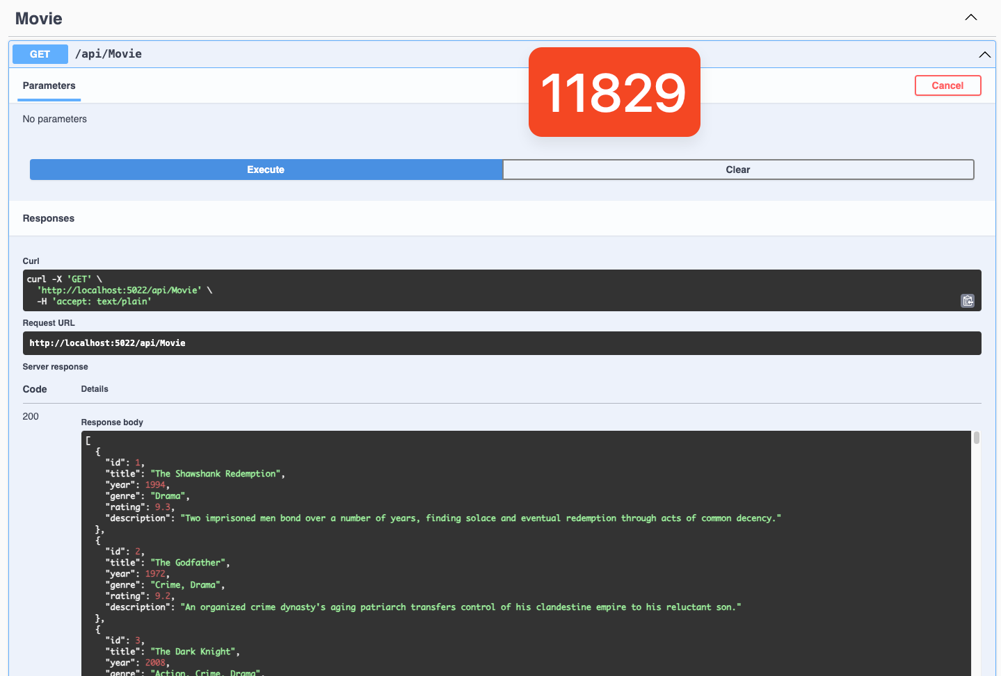

As you can see, the imported movies are present. Now, I will try to add a new movie with a POST request:

BEFORE:  
  
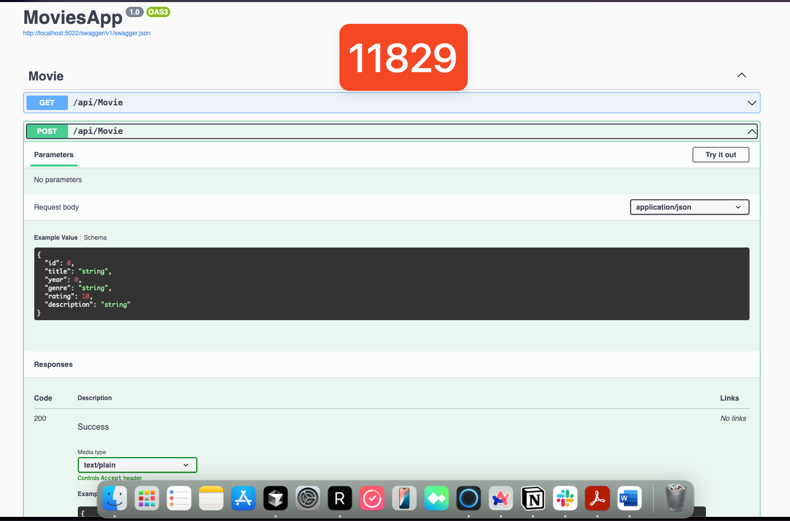

After:  
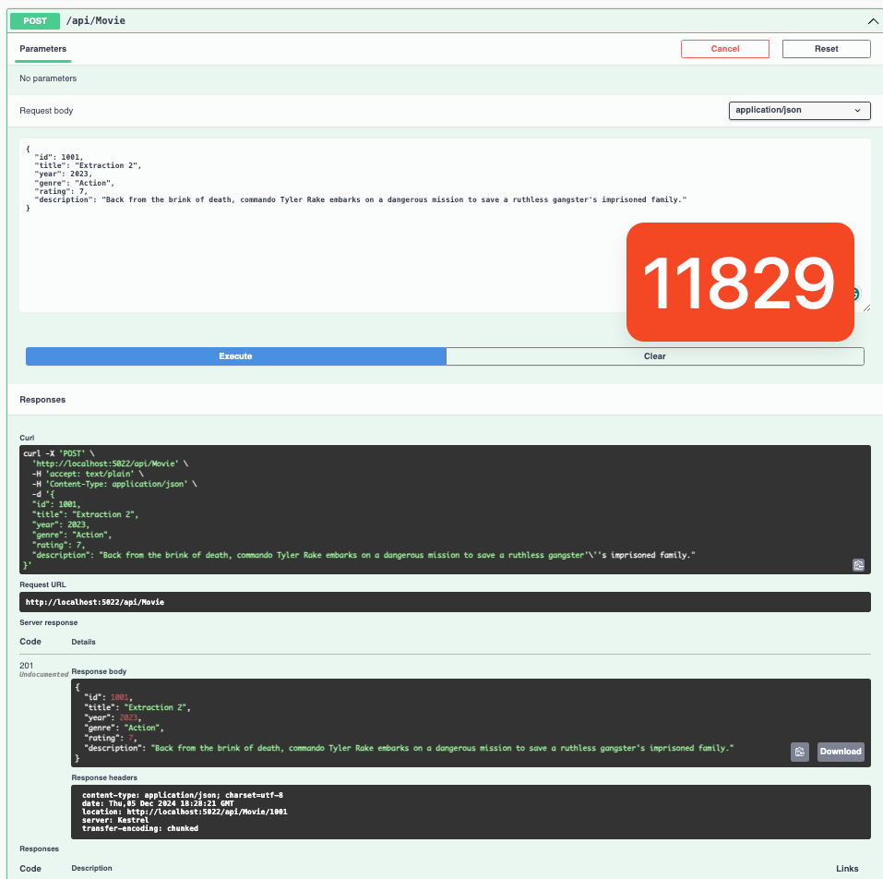

Now, I will try to get a movie using its ID. Let me try the one I just added with id 1001:

Before:  
  
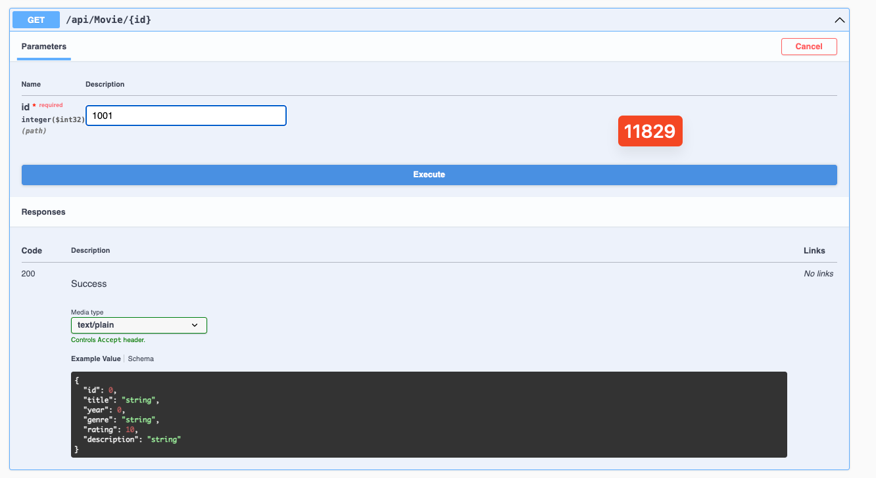

After:

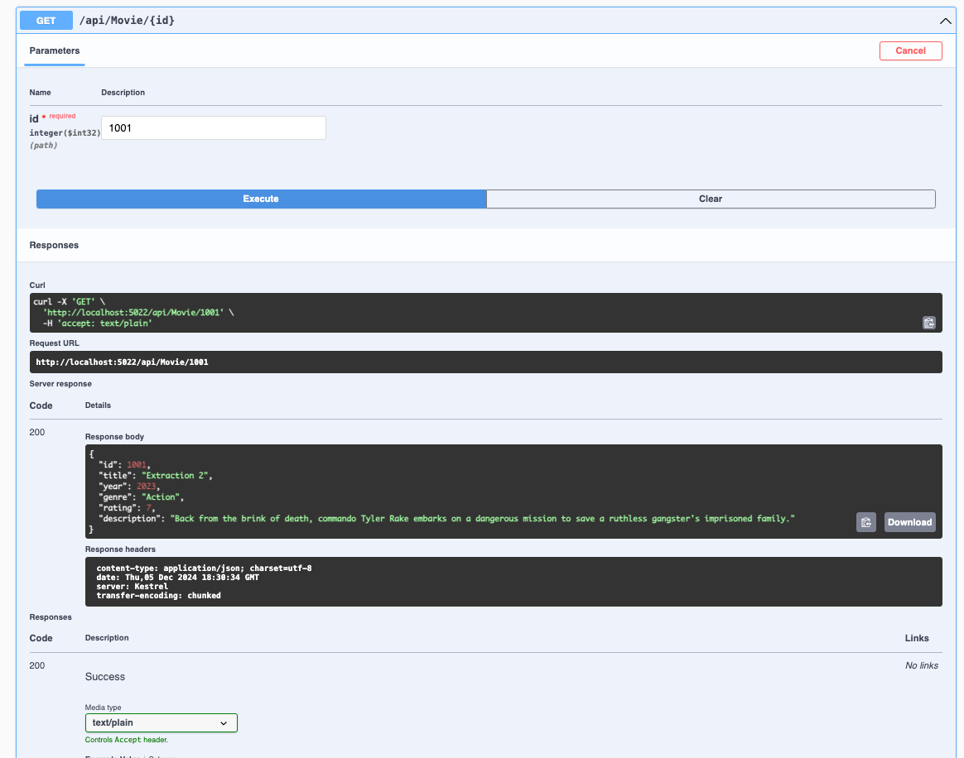

Now, I will update the details of one of the films using a PUT request:

Before:

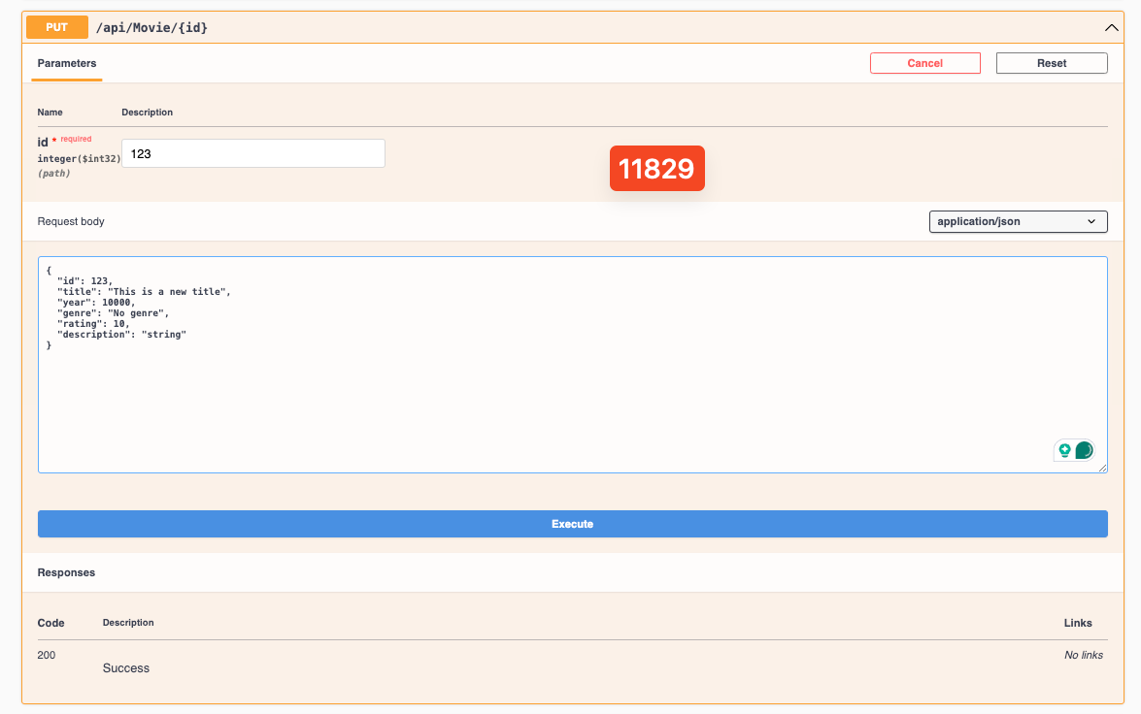

As you can see, I am updating a movie with 123 ID with some gibberish content. Here is what the endpoint looks like after execution:

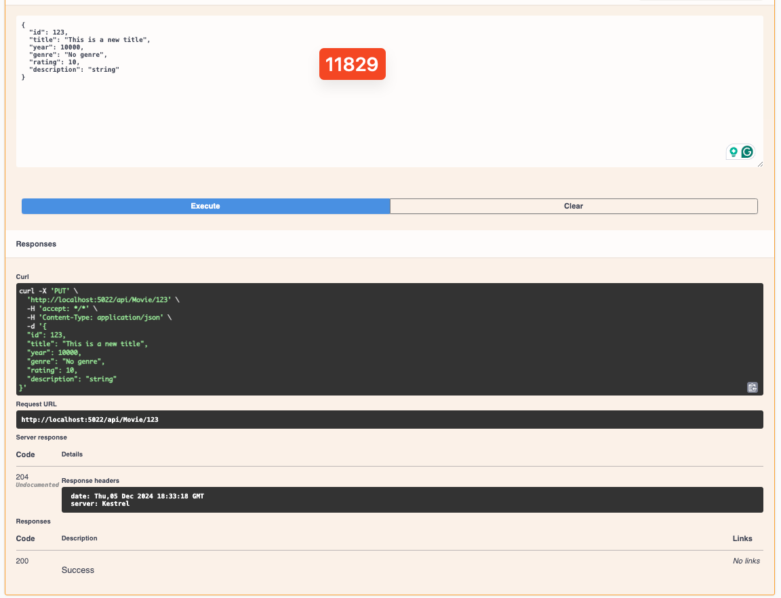

Now, I will delete this movie since it makes no sense to keep it in my database:

Before:

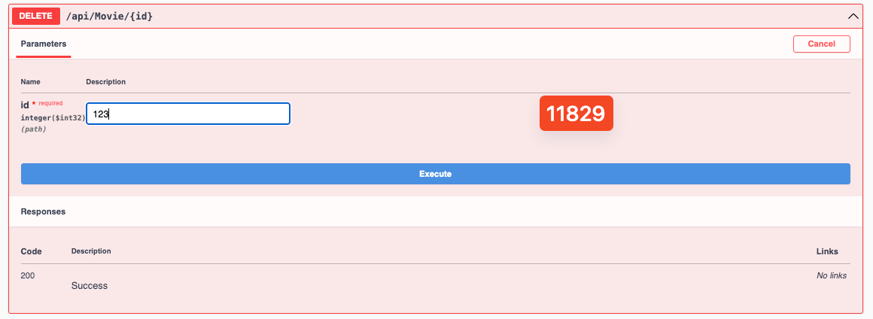

After:

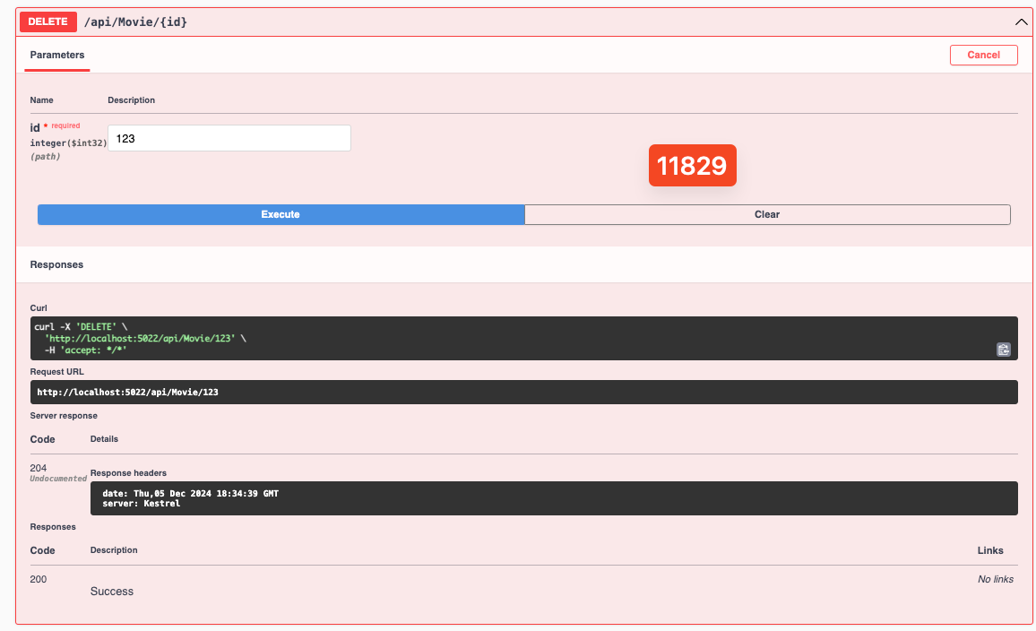

To double-check, let’s do a GET request for that deleted movie:

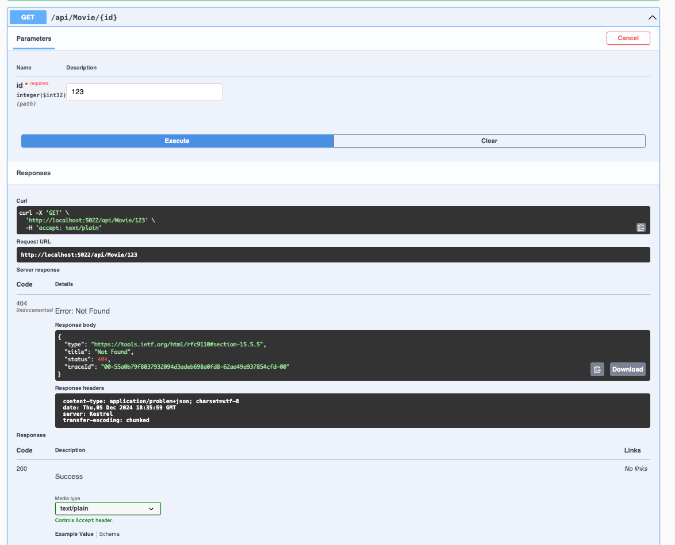

As you can see, I got a not found error.